A Modular, Risk-Gated Multi-Strategy System
for Limit-Order-Book Trading
Team 1 · QuantiFi 2026 (UTEFA) · Strategy Abstract
Submitted algorithm: Team1QuantiFi2026.py (final version v10)
Abstract. We describe the algorithm Team 1 submitted to QuantiFi 2026, a tick-level limit-order-book (LOB) trading contest with 26 products, in which teams are ranked on out-of-sample (OOS) PnL together with breadth, depth and communication. The algorithm is a portfolio of ten causal modules, each owning a disjoint set of products and drawn from one of five strategy families matched to how each product behaved historically: (i) market making around fixed or cross-implied fair values; (ii) relative value across eight voucher (call-option) strikes using a leave-one-out implied-volatility smile; (iii) EMA-anchored z-score mean reversion; (iv) slope- and breakout-based trend following; and (v) mean reversion that blends a fixed and an adaptive centre. A root risk layer enforces position limits net of in-flight orders and an intraday drawdown kill switch on the three trend products, and engineering safeguards handle platform behaviours we measured with probe strategies. On the official backtest over days −2, −1 and 0 the algorithm earned 523,191.5 COINS; all 18 traded products ended positive and 53 of 54 product-days were profitable. In local stress replays, removing every passive fill lowered PnL by about 1% and a cost of 1 COIN per unit traded lowered it by about 11%, so returns come mainly from the signals rather than from fill assumptions.
Keywords: limit order book · market making · implied-volatility smile · mean reversion · trend following · drawdown control

1 Introduction
QuantiFi 2026 simulates a limit order book for 26 products over 10,000 ticks per day. On every tick the algorithm receives the order books, recent trades and its own positions, and returns limit orders; any state it needs later must be serialised into a string (traderData). Teams receive three historical days (−2, −1 and 0), and PnL is scored as the average over several unseen out-of-sample runs.
Because the score is an average over unseen runs, we aimed to maximise expected OOS PnL rather than backtest PnL. That objective favours many modest, independent edges over one large edge that may not persist. Four principles guided the design:
- Model follows product. Each product was first classified by how its price behaves (anchored, priced off related products, mean-reverting or trending) and only then assigned a model.
- Causal and simple. Signals use only the current state and stored memory, with few parameters per module.
- Isolation. No two modules trade the same product, so each module earns the same PnL inside the portfolio as on its own, can be tested or removed independently, and cannot disrupt another module if it fails.
- Explicit risk bounds. Hard position caps, limits that count orders still in flight, and a drawdown kill switch where directional risk is concentrated.

2 Market Environment and Design Evidence
2.1 Product universe. The 26 products fall into five groups: AMETHYST and five pearl products (PINK, GOLDEN, BLUE, BLACK and WHITE_PEARLS); the underlying LYCHEE and ten call-option vouchers VOUCHER_6800–8100 (8 days to expiry at day −2, with no exercise or settlement); products whose prices oscillate around a level (PEANUT_BUTTER, MANGOSTEEN, TOFFEE_CAKE, JELLY); two persistently trending products (PAPER_LANTERNS, TELLURIUM); and FRUIT_BASKET, a basket of DRAGONFRUIT, GRANADILLA and MANGOSTEEN with unpublished weights. Figure 1 maps the 18 traded products onto modules.
2.2 Three findings that shaped the design. Development research on days −2 and −1 (with exploratory analysis on day −2 only) produced three findings that constrain every module:
- The spread trap. Short-horizon (1–50 tick) round trips that cross the spread lost money on every product and every anchor we tested. A tradable signal must predict moves that are large relative to the half-spread, so our aggressive modules rely on slow signals (hundreds to thousands of ticks) or on cross-sectional mispricing.
- Inventory drift beats spread capture. Quoting both sides of the 24 products whose prices drift earned 29.4k COINS of spread on day −2 but lost 56.4k on inventory marked against drifting prices. We therefore make markets only where the fair value is fixed or can be implied from other books.
- Behaviour is product-specific. One mean-reversion rule applied unchanged to the 16 non-option products was profitable on both days for only 5 of them and lost up to 35k COINS on a trending product (FRUIT_BASKET). No single rule fits all products, hence one module per product group.
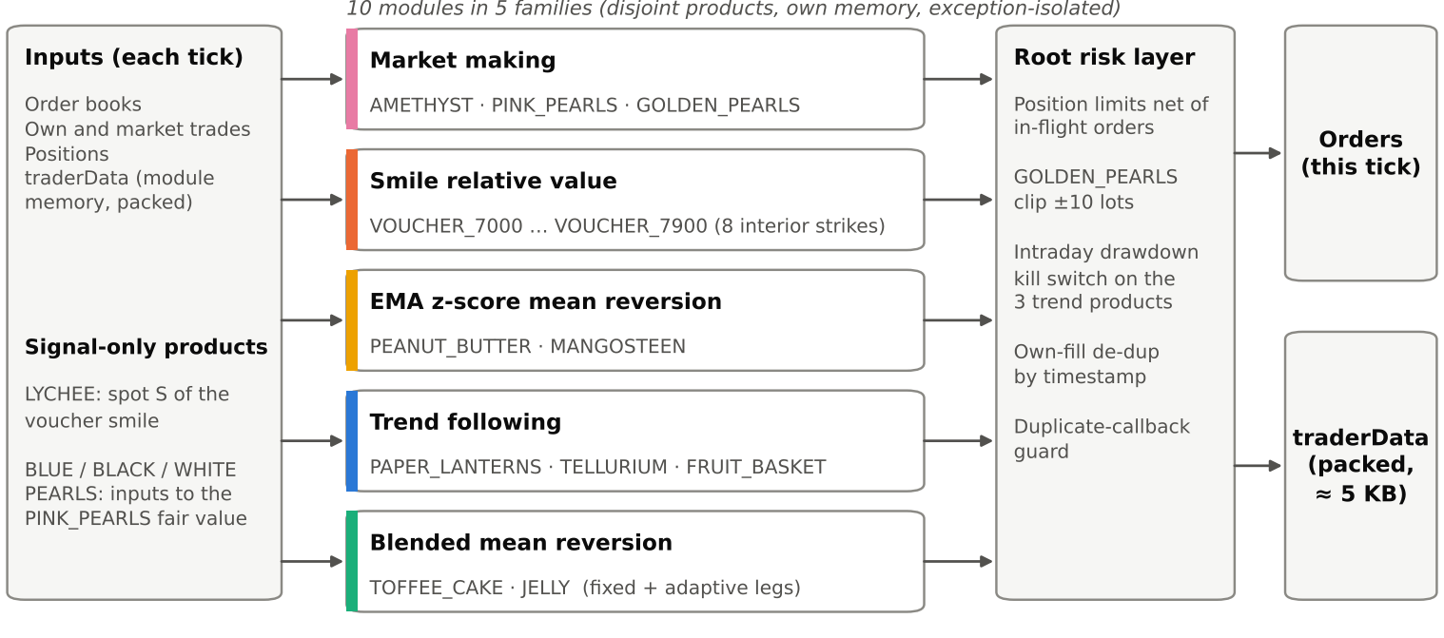
Figure 1. System architecture. On each tick, ten modules in five families propose orders for disjoint sets of products; the root risk layer checks and adjusts them before submission, and all module memory is packed into traderData. Colours identify strategy families and are reused in Figure 3.
2.3 Platform behaviour measured with probes. The rules leave several execution details open, so we submitted small probe strategies to the official platform. They showed that (a) unfilled orders live for a single tick; (b) traderData larger than about 8.5 KB is lost; and (c) the own-trades feed re-sends the latest batch of fills on every call until a newer fill arrives. Findings (b) and (c) drive the safeguards in Section 4.3.
2.4 Untraded products. Eight products receive no orders, each for a documented reason. LYCHEE’s best short-horizon signal (about 1.1 price points) is smaller than its half-spread (about 2 points), so it serves only as the spot input of the voucher model. BLUE, BLACK and WHITE_PEARLS co-move with the other pearls only contemporaneously (no lead–lag; none of 13 tested configurations was accepted), so they feed the PINK_PEARLS fair value instead. The wing strikes VOUCHER_6800 and VOUCHER_8100 lost money in development, and a leave-one-out smile must extrapolate there. Candidates for DRAGONFRUIT and GRANADILLA were fragile or negative.

3 Strategy Modules
Table 1 summarises the modules; the subsections explain each signal. Below, q is the position, mid the mid-price and EMA_{h} an exponential moving average with half-life h ticks.
Table 1. Modules, signals and key parameters (MM = market making, RV = relative value, MR = mean reversion).
Product(s) | Family | Signal and execution | Key parameters
AMETHYST | MM | Passive quotes at the touch, never through fair 10,000 | cap 50, size 5 per side
PINK_PEARLS | MM | Passive quotes around 50,000 − Σ other four pearl mids | width 2, skew 2, cap 20
GOLDEN_PEARLS | MM | A–S-style quotes around an EMA fair, inventory skew | EMA₂₀, skew 2, k_{σ} 1, size 10, |q| ≤ 10
8 vouchers (7000–7900) | Smile RV | Leave-one-out quadratic smile; take mispriced quotes | edge 7.0, min. 4 strikes, cap 50 each
PEANUT_BUTTER | EMA MR | z-score vs EMA anchor; exit at anchor frozen at entry | EMA₅₀₀, |z| ≥ 2, hold ≤ 1,000, cap 50
MANGOSTEEN | EMA MR | z-score vs EMA; entry tested on executable price | EMA₅₀₀, |z| ≥ 2, hold ≤ 1,000, cap 40
PAPER_LANTERNS | Trend | 50-tick OLS slope, hysteresis, forecast gate | slope 0.05 / 0.02, horizon 50, cap 50
TELLURIUM | Trend | Breakout of a confirmed swing pivot, trailing stop | pivot reversal 10, cap 40
FRUIT_BASKET | Trend | EMA₅₀ − EMA₂₀₀ crossover on its own mid | band ½ spread, warm-up 500, cap 40
TOFFEE_CAKE, JELLY | Blended MR | Fixed-centre leg + adaptive EMA leg, best level only | 5,000±40 / 2,000±80; EMA₃₀₀₀; 25+25

3.1 Market making (AMETHYST, PINK_PEARLS, GOLDEN_PEARLS). These products have a fair value that is fixed or recoverable from other books, so the edge lies in supplying liquidity rather than predicting direction (finding 2). AMETHYST is quoted at the best bid and ask, clipped to 9,999 and 10,001 so that it never trades through its fair value of 10,000, the value used in the official example. The five pearl mids sum to approximately 50,000, so PINK_PEARLS takes 50,000 minus the other four mids as a fair value that is less noisy than its own mid, and quotes ±2 around fair − 2q/20. GOLDEN_PEARLS uses an Avellaneda–Stoikov-style maker [1]:
r_{t} = EMA₂₀(mid)_{t} − s·q_{t} / cap, δ_{t} = max(1, k_{σ}·σ̂_{t}), bid = ⌊r_{t} − δ_{t}⌋, ask = ⌈r_{t} + δ_{t}⌉,
with s = 2, k_{σ} = 1, cap = 20 and σ̂² an EWMA (half-life 200) of squared one-tick mid changes. Quotes are kept passive and the root layer clips the position to ±10 lots. The family earns little (1% of PnL) but was positive for every product on every day.
3.2 Voucher smile relative value. Vouchers on the same underlying should be consistent with one smooth volatility smile [4]; a strike that deviates from its neighbours is likely mispriced. With a zero rate, the Black–Scholes [2] call price depends on volatility and time only through the total volatility w = σ√T:
C(S, K, w) = S·N(d₁) − K·N(d₁ − w), d₁ = [ln(S/K) + w²/2] / w.
Each tick we invert every strike’s mid for its implied w_{k} (safeguarded Newton). For each target strike k we then fit a least-squares quadratic in moneyness x = ln(K/S) to the other strikes only:
ŵ_{−k}(x) = a + b·x + c·x², fair_{k} = C(S, K_{k}, ŵ_{−k}(x_{k})),
and buy when fair_{k} − ask ≥ 7 or sell when bid − fair_{k} ≥ 7, closing once the mid returns to fair_{k}. Leaving the target strike out stops a mispriced quote from pulling the fit toward itself, and a strike is traded only when at least four other strikes yield a valid implied volatility. Because only w enters, no expiry assumption is needed. In development tests every threshold from 4 to 10 was profitable on both days, the sign-reversed signal lost heavily, and a one-tick execution delay kept about 95% of PnL. Delta-hedging with LYCHEE was rejected: the net delta averaged only 2–6 LYCHEE lots, and hedging cost more than it saved.
3.3 EMA z-score mean reversion (PEANUT_BUTTER, MANGOSTEEN). These prices oscillate around a slowly moving level. The deviation from a lagged EMA anchor A is scaled by an EWMA of squared deviations:
d_{t} = mid_{t} − A_{t−1}, A = EMA₅₀₀(mid), z_{t} = d_{t} / √EWMA(d²)_{t−1}, enter against the move when |z_{t}| ≥ 2.
For PEANUT_BUTTER (volatility half-life 1,000 ticks, 300-tick warm-up) the exit target is the anchor frozen at entry, so a drifting EMA cannot move the take-profit level away from an open trade, and a 1,000-tick maximum holding time caps exposure if reversion fails. MANGOSTEEN enters only when the executable price (ask for a buy, bid for a sell) lies beyond A ± 2 standard deviations, and exits when the mid crosses back over A or after 1,000 ticks.
3.4 Trend following (PAPER_LANTERNS, TELLURIUM, FRUIT_BASKET). These products show persistent intraday drifts that a mean-reversion rule would fight (finding 3), the setting in which time-series momentum works [3]. Each product uses the trend detector that suits its price path:
- PAPER_LANTERNS: slope β_{t} of an OLS line through the last 50 mids. A position opens at full size when |β_{t}| > 0.05 price units per tick and is held until β_{t}·side ≤ 0.02; the gap between the two bands (hysteresis) prevents flipping around a single threshold. A forecast gate takes a price level only if the fitted value plus 50 ticks of slope beats that level by more than half the current spread.
- TELLURIUM: a causal directional-change detector confirms a swing high or low once price reverses by 10 from the extreme; confirmed pivots are never revised, so no future data is used. When the latest confirmed pivot is a swing low, a long opens as soon as the mid breaks above the preceding swing high (mirror image for shorts). The stop starts at that swing low and trails each newly confirmed low, and each setup is traded only once.
- FRUIT_BASKET: d_{t} = EMA₅₀(mid) − EMA₂₀₀(mid), both from prior ticks. After a 500-tick warm-up the target is +40 lots when d_{t} exceeds half the bid–ask spread and −40 lots when it is below minus half the spread; the position is flattened once d_{t} changes sign against it.
3.5 Blended mean reversion (TOFFEE_CAKE, JELLY). Both products reverted around stable centres on the development days, and a placebo test confirmed the TOFFEE_CAKE edge: none of 100 random-entry placebos matched it, and the opposite (momentum) rule lost money. Because a fixed centre is risky if the level shifts out of sample, each 50-lot limit is split into two 25-lot legs: a fixed-centre leg trading the band 5,000 ± 40 (TOFFEE_CAKE) or 2,000 ± 80 (JELLY), and an adaptive leg trading |z| ≥ 2 around EMA₃₀₀₀ (z as in Section 3.3). Each leg exits at its own anchor; the leg targets are summed into one order per product, sent only at the best bid or ask and net of working orders. If the level drifts, the adaptive leg keeps trading while exposure to a broken fixed centre is capped at half the limit.

4 Risk Management and Engineering
4.1 Position and order control. Every module has a hard cap (10–50 lots), and before any order is sent the root layer reserves capacity for orders that may still be working, so position limits hold even if every outstanding order fills.
4.2 Intraday drawdown kill switch. Trend following carries the largest directional risk and 41.6% of PnL, so its three products are guarded. For each product p the switch tracks the product’s own intraday PnL, built from our fills and marked at the mid, together with its running peak:
PnL_{t} = cash_{t} + q_{t}·mid_{t}, peak_{t} = max_{s ≤ t} PnL_{s}, stop p for the day if peak_{t} − PnL_{t} > KILL_DD_{p}.
KILL_DD_{p} is 1.5× the largest intraday drawdown of p on days −2 and −1: 20,275.5, 40,680 and 765 COINS for TELLURIUM, FRUIT_BASKET and PAPER_LANTERNS. When triggered, the product is flattened by crossing the touch and receives no further orders that day. Orders sent in the last five ticks are remembered and reduced by reported fills, and the flatten size is
q_{flatten} = |q_{t}| − (same-side orders that may still be working),
so a flatten can never push the position through zero. The switch did not fire on any of the three historical days; it is insurance against an OOS regime worse than any we observed.
4.3 Engineering safeguards.
- Own-fill de-duplication. Because the platform re-sends the latest fills (Section 2.3), a fill is booked only if its timestamp is newer than the last one booked. This fix came from a real failure: v8 earned 523,191.5 COINS locally but about 333k on the platform, because re-sent fills were counted repeatedly in the kill switch’s PnL and triggered it falsely. A probe isolated the cause, and the fix (v9, kept in v10) restored the platform result to exactly 523,191.5 COINS.
- Duplicate-callback guard. A repeated call with an already-processed timestamp returns no orders and leaves memory unchanged.
- Compact state. Module memory is packed losslessly (a key dictionary and compact JSON) to a peak of about 5 KB, below the measured limit of about 8.5 KB.
- Isolation and dependencies. Each sub-system runs inside its own exception guard, so a failure skips only that part for one tick; the file imports only datamodel and the Python standard library.

5 Results
5.1 Official backtest. On the official platform backtest, v10 earned 225,130 COINS on day −2, 188,395 on day −1 and 109,666.5 on day 0, a total of 523,191.5 COINS (Figure 2). Table 2 splits the result by strategy family and Figure 3 by product.
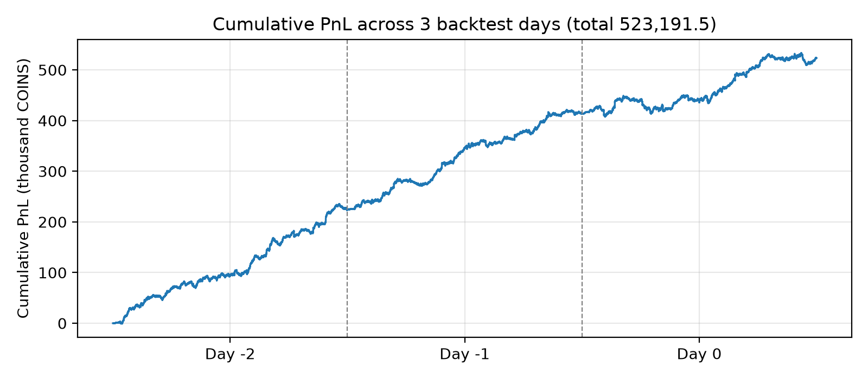
Figure 2. Cumulative PnL of the full algorithm over the three official backtest days (thousand COINS; dashed lines mark day boundaries).
Table 2. Official backtest PnL (COINS) by strategy family and day.
Family | Products | Day −2 | Day −1 | Day 0 | Total | Share
Trend following | 3 | 96,222 | 91,426 | 29,884 | 217,532 | 41.6%
Smile relative value | 8 | 56,192 | 30,298 | 33,639 | 120,129 | 23.0%
Blended mean reversion | 2 | 39,063 | 37,526 | 27,613 | 104,202 | 19.9%
EMA z-score mean reversion | 2 | 30,754 | 27,707 | 17,798 | 76,259 | 14.6%
Market making | 3 | 2,899 | 1,438 | 732.5 | 5,069.5 | 1.0%
Total | 18 | 225,130 | 188,395 | 109,666.5 | 523,191.5 | 100%
Three patterns stand out. Breadth: all 18 traded products are profitable in total, and 53 of 54 product-days are positive (the only loss is MANGOSTEEN on day −2, −538 COINS). Concentration: trend following supplies 41.6% of PnL, which is why the kill switch guards exactly those three products. Decay: daily PnL falls from day −2 to day 0, mainly in the trend family (96,222 to 29,884 COINS), while the smile family recovers on day 0 and the other families decline more gently.
5.2 Robustness to execution assumptions. Local fills are simulated, so we re-ran days −2 and −1 under alternative execution models (Table 3). PnL barely moves under stricter passive-fill rules, half liquidity or a one-tick delay, and falls only 1.0% when every passive fill is removed. A cost of 1 COIN per unit traded has the largest effect (−11.4%), consistent with signals that exceed the spread by a wide margin.
Table 3. Local replay PnL (COINS) under execution stress, days −2 and −1. The base model reproduces the official result.
Execution scenario | Day −2 | Day −1 | Total | vs base
Base (same-tick matching; equals official result) | 225,130 | 188,395 | 413,525 | —
Strict: passive fills need a strictly better price | 224,547.5 | 187,487 | 412,034.5 | −0.4%
Half: half of each historical trade’s volume | 223,443.5 | 187,537 | 410,980.5 | −0.6%
Next tick: passive orders match next tick’s trades | 225,444 | 188,130 | 413,574 | +0.0%
Take-only: no passive fills at all | 222,231 | 186,957 | 409,188 | −1.0%
Cost: 1 COIN per unit traded | 198,187 | 168,129 | 366,316 | −11.4%
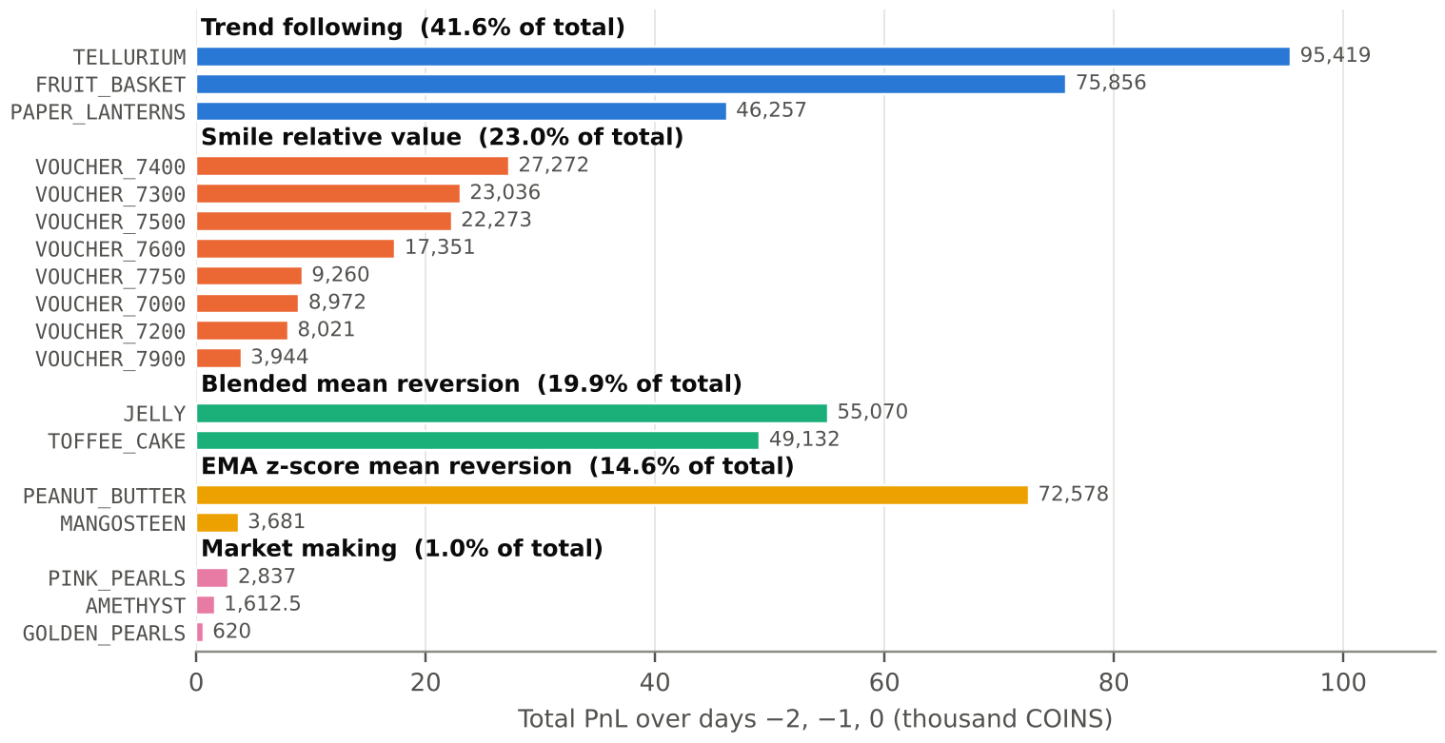
Figure 3. Total official backtest PnL by product, grouped by strategy family (COINS). All 18 traded products are positive; the eight untraded products contribute zero.

6 Limitations, Out-of-Sample Risk and Future Work
All parameters were chosen on the three available days, so every number above is in-sample and we have no OOS PnL to report. We relied instead on design choices that should carry over: causal, mostly scale-free signals (z-scores, smile residuals, slopes); five families rather than one; fixed levels paired with adaptive ones; and smaller exposure where evidence was thin (fixed-centre legs halved to 25 lots, GOLDEN_PEARLS clipped to ±10). The main remaining exposures are the fixed thresholds and centres (KILL_DD; AMETHYST 10,000; TOFFEE_CAKE 5,000; JELLY 2,000), which may act too early or too late if volatility or price levels change, and the trend family’s reliance on persistent intraday drifts.
Future work. (1) Scale KILL_DD and the fixed bands with rolling volatility so that thresholds adapt to new regimes; (2) delta-hedge voucher inventory with LYCHEE when the net delta is large, and revisit the wing strikes with a constrained smile; (3) test basket-versus-component and cross-pearl relative-value trades on the untraded products.

7 Conclusion
Our algorithm combines ten product-specific modules from five strategy families with causal risk controls and platform-verified engineering. It earned 523,191.5 COINS on the official backtest with every traded product profitable, and its returns hold up under every fill assumption we could test.
References
[1] M. Avellaneda and S. Stoikov, “High-frequency trading in a limit order book,” Quantitative Finance, 8(3):217–224, 2008.
[2] F. Black and M. Scholes, “The pricing of options and corporate liabilities,” Journal of Political Economy, 81(3):637–654, 1973.
[3] T. J. Moskowitz, Y. H. Ooi and L. H. Pedersen, “Time series momentum,” Journal of Financial Economics, 104(2):228–250, 2012.
[4] J. Gatheral, The Volatility Surface: A Practitioner’s Guide, Wiley, 2006.

