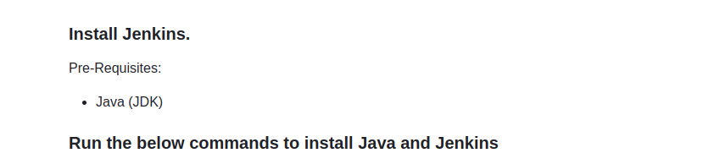
sudo apt update
sudo apt install openjdk-17-jre

java -version

curl -fsSL https://pkg.jenkins.io/debian/jenkins.io-2023.key | sudo tee \
/usr/share/keyrings/jenkins-keyring.asc > /dev/null
echo deb [signed-by=/usr/share/keyrings/jenkins-keyring.asc] \
https://pkg.jenkins.io/debian binary/ | sudo tee \
/etc/apt/sources.list.d/jenkins.list > /dev/null
sudo apt-get update
sudo apt-get install jenkins

allow port 8080 jenkins port to access via web

In ubuntu s

sudo ufw allow 8080

for AWS

in ec2 instance in which jenkins installed need to allow inbound tcp 8080 port for access.

