When Background Noise Has Meaning
  - Environmental Sound Classification under Semantic Interference
Qihan Zhu SID 550489593
ELEC5305 Acoustics, Speech and Signal Processing
11 November 2026

Abstract
Environmental recordings can contain two recognisable events, although a classifier must often return one label. This project asks how different audio representations fail under generic noise and a competing labelled event at controlled relative power. A handcrafted SVM, compact log-Mel CNN and frozen LAION-CLAP receive identical mixtures from all five official ESC-50 folds. White noise strongly disrupts the SVM, whereas CLAP retains much higher performance under background noise yet assigns 60–67% of its errors to a competing event at +5 dB. Training with ordinary noise gives limited transfer to event competition; local feedback on the same frozen checkpoint adds no confirmed primary benefit. Two further analyses refine this conclusion: about one-third of CLAP’s original captures retain the target at rank two, and small subsets matched on measured acoustic proxies retain a CLAP disadvantage but inconclusive CNN contrasts. These are controlled behavioural comparisons, not causal isolation of semantic meaning. The contribution is a reproducible DSP experiment that identifies where robustness gains transfer, where decisions move, and which explanations the data cannot establish.

Contents
1 Introduction 1
2 Literature review 2
3 Methods 3
4 Results 5
5 Discussion 8
6 Conclusion 10
7 Implementation, reproduction and attribution 10
References 11
Project materials. Project website, working code and run instructions, and code demonstration video.

1 Introduction
A dog bark mixed with white noise contains one designated event and an acoustically nonspecific interferer. A dog bark mixed with an alarm contains two plausible class identities. Both mixtures can have the same power ratio while producing different errors. This distinction matters beyond single-label benchmarks, and work on structured acoustic scenes motivates looking beyond Gaussian noise [11]. Spectrogram CNNs and audio–language pretraining offer different representations [5, 7]; the reviewed methods do not by themselves establish how their decisions move toward a known competing class under identical mixtures. This study uses all 2,000 five-second ESC-50 clips, covering 50 classes assembled from Freesound [4], as targets and competing events, DEMAND recordings [12] as real backgrounds, and generated white noise.
The main research question is: How do handcrafted, supervised spectrogram and pretrained audio–language representations fail under generic noise versus a competing labelled event at controlled relative power? Error destinations and the transfer of noise augmentation are subordinate tests of this question. The intended contribution is to explain measured failure patterns rather than identify a universally best model. In particular, CLAP’s large external pretraining makes equal-data or equal-training-cost comparisons inappropriate.
Every system receives the same mixtures. Each mixture has a clean control with the same gain, allowing changes induced by interference to be distinguished from errors already present after rescaling. The study covers one benchmark, three fixed systems, four interference types and three relative levels. The proposal’s power convention is retained as a sensitivity analysis, and negative results are reported alongside positive ones.

2 Literature review

2.1 From course DSP to environmental-sound classification
The course’s audio-feature material distinguishes temporal energy and zero-crossing measurements from spectral descriptors and MFCCs [1]. These quantities compress a waveform into interpretable measurements. Their advantage is that a failure can be related to a change in a descriptor. Their limitation is that averaging descriptors across time discards event order and can mix properties from multiple sources.
The STFT lecture separates window length, hop size and FFT size [2]. The window controls the time–frequency trade-off, the hop controls frame spacing, and the FFT size controls frequency-grid spacing. Increasing the FFT length by zero padding does not recover frequency detail absent from a short window. These distinctions determine what transient and spectral information reaches both the handcrafted and CNN systems.
Piczak’s environmental-sound CNN learns local spectro-temporal patterns from segmented spectrograms and their deltas [5]. This motivates a learned time–frequency reference alongside the handcrafted baseline. Its strengths are locality and trainable features, while the small labelled dataset limits supervision. The official ESC-50 record reports 39.60% accuracy for the MFCC/ZCR SVM and 64.50% for Piczak’s CNN [4, 5]. Its supervised-results table also lists 98.25% for a model pretrained with natural-language supervision [4]. That protocol differs from frozen zero-shot evaluation. These are context, not matched implementations; the present CNN retains the representation principle rather than reproducing its architecture.
Salamon and Bello show that augmentation can improve environmental-sound CNN classification, with effects that depend on the augmentation and class [6]. This makes augmentation a testable intervention rather than a universal robustness guarantee. Here the question is whether training against white noise transfers to a second labelled event, and whether event-mixture training produces different trade-offs. Tokozume et al.’s between-class (BC) learning mixes different-class sounds and trains the output to match their proportions [8]. Our semantic augmentation instead keeps the designated target label: it tests target retention under interference, not soft mixture-label prediction.

2.2 Audio–language models and structured interference
CLAP learns a shared audio–text space and supports zero-shot classification by comparing audio embeddings with textual class descriptions [7]. It supplies a pretrained reference without fitting an ESC-50 classifier, and its text scores reveal whether a competing label gains prominence. External training data and prompt sensitivity complicate interpretation, so the checkpoint and core prompt remain fixed. The revised paper reports 88.0–91.0% after excluding overlapping evaluation audio [7]; our specified checkpoint and prompt use all 2,000 clips, so these are not matched reproductions.
PAT refines both modalities through audio–text feedback, including prompt weighting and frame-level audio reweighting, and evaluates robustness to degraded audio [9]. The fixed prompt ensemble tests the text side with cached audio unchanged. A separate local-feedback extension ports the released inference arithmetic to the same frozen LAION checkpoint, retaining uniform prompts. Its per-frame projection and preset coefficients are project choices; this is a PAT-style adaptation, not an official or full PAT reproduction.
Mix-CLAP’s noise-aware audio-language formulation motivates the joint interest in robustness and deployment cost [10]. It is contextual literature rather than a reproduced system. RSA-Bench further motivates realistic structured backgrounds, but evaluates speech perception and reasoning under simulated acoustic scenes [11]. Its task differs from ESC-50 classification, so it supports the research motivation without supplying a directly comparable baseline.

2.3 Gap, method choice and concepts clarified
These works establish useful representations and robustness methods, but do not by themselves answer this project’s controlled comparison of generic corruption and a known competing class. Three complementary systems are therefore retained: interpretable DSP features, a task-trained spectrogram model and a frozen audio–language representation. Holding the input mixtures fixed makes their failure patterns comparable, while separate cost measurements preserve the practical deployment question. Public code is used where reimplementation would add nothing to the question: the official LAION-CLAP architecture and pretrained weights are used without fine-tuning through the project inference wrapper, and PAT supplies the released prompt list and the feedback arithmetic adapted here. Piczak’s network is not reproduced, and the STFT, features and mixer are written for this project so that every processing step can be inspected.
Three distinctions guide interpretation: relative power is not perceived dominance because hearing is frequency dependent [3]; class scores are not calibrated event probabilities; and logistic coefficient shrinkage is not a percentage of a mechanism explained, partly because of non-collapsibility [13].

3 Methods

3.1 Data and evaluation splits
ESC-50 contains 2,000 five-second clips, 50 balanced classes and five official folds [4]. For test fold $k$, the next cyclic fold is validation and the remaining three support model selection. A fresh model is then fitted on the four non-test folds. Scaling and Mel normalisation use the corresponding training partition. Four source IDs cross official folds, affecting nine target clips; official assignments remain intact, but those sources cannot supply semantic distractors. The resulting evaluation is not perfectly source-independent. The dataset’s partly class-dependent preprocessing is a further caveat [4].

3.2 Signal processing and classifiers
At 44.1 kHz, the custom STFT uses a periodic Hann window of 1,024 samples, hop 512 and FFT length 1,024:
$$X(m,k)=\sum_{n=0}^{1023}{x}[n+512m]w[n]e^{−j2πkn/1024}.$$
Only the final incomplete frame is zero-padded. Windowing and framing are checked against SciPy and an actual execution of the course’s unchanged MyStft.m. After reconciling frame alignment, window and one-sided output, the relative complex error on one ESC clip is approximately $2.6×{10}^{−16}$. This validates corresponding frames, not identical default boundary policies.
System | Representation | Fitting and scoring
SVM | Means/SDs of RMS, ZCR, centroid, spread, roll-off, flux, 20 MFCCs and deltas: 92 values | RBF kernel; training-only scaling; nine $C,γ$ candidates selected by clean validation
CNN | 64 log-Mel bands; three convolution blocks (16/32/64 channels); 256-dimensional embedding | 36,258 parameters; Adam; at most 40 epochs, patience 8; clean validation chooses duration
CLAP | HTSAT-tiny/RoBERTa, non-fusion 630k-audioset-best.pt; unit embeddings | Frozen; 48-kHz resampling; official int16 truncation; cosine scores for the sound of {label}
CLAP’s official frontend repeat-pads the canonical five-second input to ten seconds, and one fixed template serves every class so that prompt wording is not an uncontrolled variable. MFCCs decorrelate log-Mel energies by a cosine transform; the CNN retains the time–frequency map instead. The core CNN seed is 5305; repetitions use 5306 and 5307. Score magnitudes and absolute embedding distances are not compared across architectures.

3.3 Controlled mixing and power sensitivity
Every target receives white noise, a segment from three DEMAND recordings (traffic, station, metro) [12], and one same- and one different-coarse-category ESC distractor. Semantic partners have a different fine label and source, and come from the held-out fold, so neither supervised model has seen the interfering recording. Pairing is seeded, uses zero offset and stays fixed across +10, +5 and 0 dB. The noise waveform or segment also stays fixed across levels.
Let $M_{x},M_{d}$ be activity masks using frames within 40 dB of each signal’s peak frame energy, and let $P(z;M)$ be mean-square power on mask $M$; a five-second average would understate sparse events such as a door knock. Here $L$ denotes SNR for noise backgrounds and SIR for labelled-event mixtures. Mixing uses
$$α=\sqrt{\frac{P(x;M_{x})}{{10}^{L/10}P(d;M)}}, y=g(x+αd), g=min\left(1,\frac{0.99}{max|x+αd|}\right).$$
The control is $gx$. The default own convention uses $M=M_{d}$; the proposal’s target convention uses $M=M_{x}$. Sparse distractors caused very large gains under the latter, motivating the documented change and full two-protocol comparison. Ratios are numerically verified. There are 24,000 own and 23,991 target mixtures: three zero-energy pairs exclude nine target-protocol rows. At 0 dB the two events have equal power, so the single designated label is ambiguous and this level serves as a stress test.

3.4 Metrics, uncertainty and extension design
Accuracy and macro-F1 are averaged over official test folds; macro-F1 is reported because degraded systems can concentrate their predictions on a few classes. Capture rate is the fraction of errors assigned to the distractor; capture counts over all trials are also retained. The margin is target score minus distractor score. Representation displacement compares a mixture with its gain-matched control, standardising handcrafted features by training-fold scales or using within-model cosine distance.
Paired comparisons reuse the same target clips. For rank, acoustic-matching and local-feedback intervals, 2,000 bootstrap draws resample original target recordings, keeping clips from one source together. These pointwise 95% intervals condition on fitted models, selected calibration rules and observed partners; shared interferers remain a dependency. Earlier overlap replication uses clip-based paired intervals. Fold and seed SDs describe spread, not confidence intervals. Holm correction is applied separately to 12 replication and 156 intervention tests; the latter family was amended after early white-noise results but before semantic results.
For the extension, SVM/CNN training uses either white-noise or semantic augmentation drawn only from training partitions. CNN augmentation probability is 0.5, with +5/+10/+15 dB training views; clean validation and architecture remain fixed. All three seeds are retained. A separate 300-entry fixed prompt ensemble reuses CLAP audio embeddings. No test-label prompt search or CLAP fine-tuning is performed.
The local-feedback extension follows the released PAT inference arithmetic. The frozen audio tower yields 32 frame features, mapped into the joint space by the model’s own audio projection. Each class text attends to the frames and each frame to the class texts, producing text-guided and audio-guided scores that are added to the pooled prompt-ensemble score. These sums are not cosine similarities. The preset version fixes the attention temperature at 64 and the text-/audio-guided weights at 0.2 and 0.05 before evaluation, without labels; these are heuristic project choices. The calibrated version selects among 321 settings for each test fold using clean clips from other folds, excluding shared source recordings. The selected setting is used for every interference condition in that fold. This labelled calibration is not zero-shot. Four primary contrasts—two versions against the ensemble in both semantic conditions at own/+5 dB—share one Holm correction.

4 Results

4.1 Core robustness and error destinations
Table 1: Clean: fold mean $±$ SD (%). Capture: pooled captures/errors at own/+5 dB, 2,000 targets per condition; CNN seed 5305. The denominator is errors, not all trials.
 | Clean (%) |  | Capture (%; captures/errors)
System | Accuracy | Macro-F1 | Same category | Different category
SVM | 48.90 $±$ 4.21 | 47.96 $±$ 4.07 | 18.53 (283/1527) | 15.89 (246/1548)
CNN | 67.90 $±$ 3.65 | 66.61 $±$ 3.91 | 31.26 (403/1289) | 27.53 (362/1315)
CLAP | 81.75 $±$ 2.58 | 79.49 $±$ 3.28 | 66.95 (632/944) | 60.30 (612/1015)
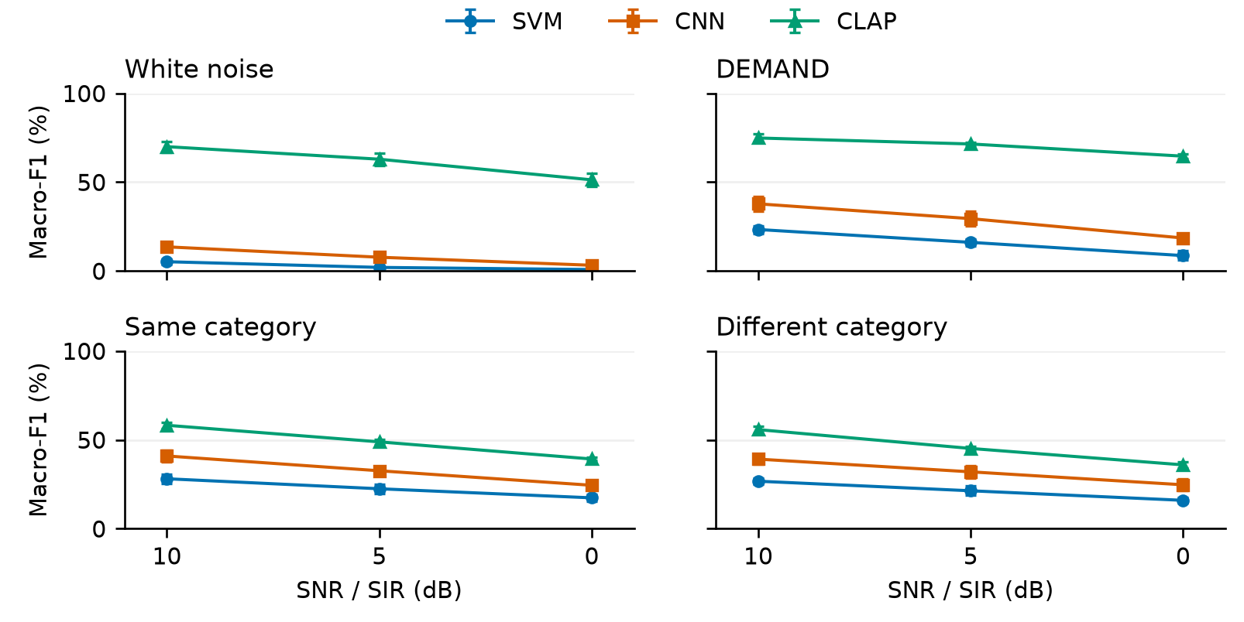
Figure 1: Own-activity robustness: mean macro-F1 with five-fold SD, not a confidence interval. Each condition/level has 2,000 targets. Lower relative level means stronger interference. Target-protocol curves are in the repository.
At +5 dB, SVM macro-F1 is 2.03% under white noise versus 22.47% under same-category interference. CLAP instead reaches 71.49% under DEMAND versus 48.86% under same-category interference. Equal nominal power does not give equal degradation; semantic mixtures add a known competing label.
Error destinations distinguish the systems (Table 1). The designated distractor receives 66.95% and 60.30% of CLAP’s errors, against 18.53% and 15.89% for the SVM; uniform confusion over 49 wrong labels would give about 2%. For CLAP at own/+5 dB, the same-category median target–distractor cosine margin is $0.0873$, with 38.05% negative, and median embedding displacement is $0.1905$ for correct versus $0.4087$ for incorrect trials; this is association, not causation. For the SVM, median standardised ZCR displacement is 3.16 under white noise against 0.25–0.29 under the other three conditions, consistent with broadband noise changing zero crossings and spectral-shape descriptors.
Figure 2 extends these comparisons across levels. Capture rises as the SIR falls for every system, from 56.25% to 71.45% of CLAP’s same-category errors, while median margins move toward zero at 0 dB. The most frequent CLAP captures at +5 dB among pairs whose control was correct, selected from observed counts, are door knock to keyboard typing (10 of 11 pairs) and can opening to clock alarm (6 of 6). Figure 3 shows larger median displacement among misclassified mixtures in all 12 system/condition comparisons; individual distributions overlap. White noise displaces the SVM and CNN most, whereas CLAP’s misclassified semantic mixtures move about as far as its misclassified white-noise mixtures (medians 0.41–0.43).
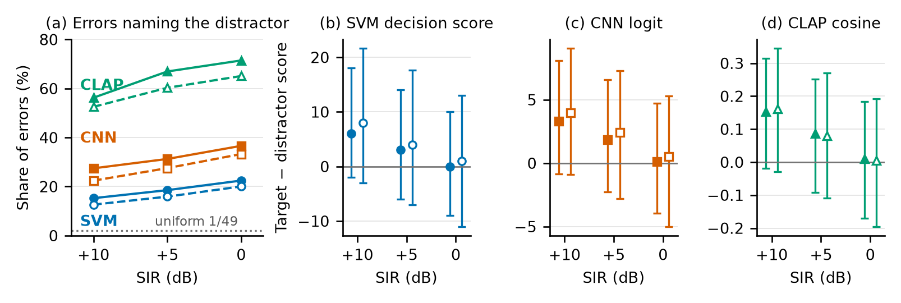
Figure 2: Own-activity semantic interference across levels. (a) Share of each system’s errors that name the designated distractor; the dotted line is uniform confusion over 49 wrong labels. (b–d) Median target-minus-distractor score with interquartile range; scales are specific to each system. Filled/open markers: same/different category; panel (a) also uses solid/dashed lines. Each level uses 2,000 targets; margin bars show their score IQR, not a confidence interval.
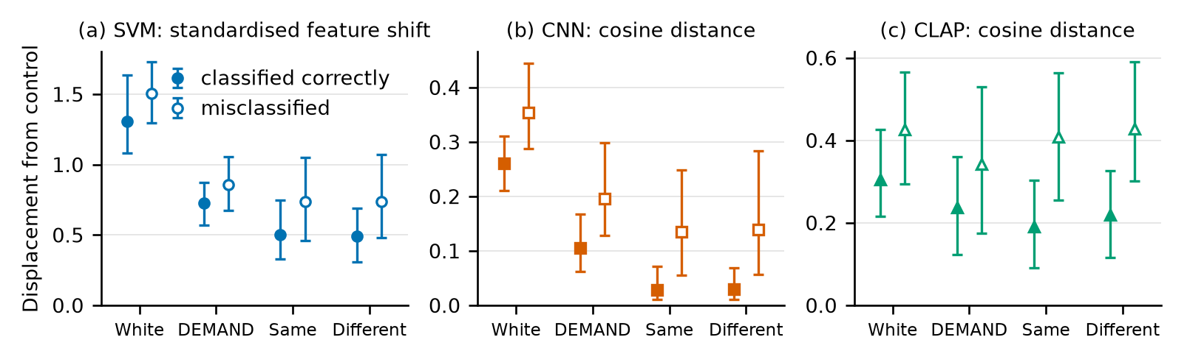
Figure 3: Displacement of each mixture from its gain-matched control at own/+5 dB: median and interquartile range for correctly classified (filled) and misclassified (open) mixtures. Each condition has 2,000 trials partitioned by outcome (correct groups: 108–1,479 trials; errors: 521–1,892). These are descriptive, outcome-conditioned distributions; scales differ across systems.

4.2 Overlap, training interventions and readout
Across all targets at own/+5 dB, the core CNN has higher macro-F1 under a same-category event than DEMAND (32.60% versus 29.46%), but many pairs overlap little in time. When at least 80% of target-active samples also contain active interference, paired semantic-minus-DEMAND accuracy differences are negative for all three seeds. For seed 5305, the differences are $−3.28$ points on 1,464 same-category targets and $−2.94$ on 1,465 different-category targets. Both additional seeds pass Holm correction; seed 5305 does not ($p=0.0604$). The direction replicates without confirmation for every seed. This subset comparison uses accuracy, rather than the whole-set macro-F1 above. Target-power semantic macro-F1 is 0.47–2.35 points lower than own power; slightly different retained cohorts prevent attribution solely to the power mask.
Table 2: CNN augmentation: mean macro-F1 $±$ sample SD across three seeds. Own power; interference at +5 dB. Clean uses the original clips.
Training | Clean | White | DEMAND | Same | Different
Clean | 65.78 $±$ 0.75 | 7.48 $±$ 0.42 | 30.92 $±$ 1.35 | 32.99 $±$ 0.34 | 31.41 $±$ 0.51
White noise | 64.65 $±$ 0.61 | 43.95 $±$ 2.67 | 33.80 $±$ 2.19 | 33.46 $±$ 0.98 | 32.10 $±$ 1.05
Semantic | 61.70 $±$ 2.40 | 9.91 $±$ 0.24 | 33.62 $±$ 1.55 | 36.05 $±$ 0.83 | 33.73 $±$ 0.86
White-noise augmentation changes CNN white-noise macro-F1 from 7.48% to 43.95%, but same-category performance only from 32.99% to 33.46%. Semantic training reaches 36.05% while clean performance falls to 61.70%. Direct CNN semantic-over-white augmentation accuracy advantages do not pass the 156-test correction. SVM augmentation and all individual seeds are retained in the repository.
Fixed prompt ensembling raises CLAP clean accuracy from 81.75% to 92.90%. At own/+5 dB, same-category captures change from 632 to 645 while other errors fall from 312 to 189. The net improvement therefore comes from fewer other-class errors, not fewer captures; a larger fraction of the remaining errors can name the distractor despite higher accuracy.
Table 3: CLAP readouts: clean and own/+5-dB same-category interference, each with 2,000 trials. Accuracy, macro-F1 and target top-two inclusion are percentages; captures and other errors are counts. Calibrated uses non-test clean labels.
Readout | Clean acc. | Same acc. | Same F1 | Captures | Other errors | Target top-2
Single prompt | 81.75 | 52.80 | 48.86 | 632 | 312 | 70.00
Fixed ensemble | 92.90 | 58.30 | 55.50 | 645 | 189 | 78.20
Local: preset | 92.90 | 58.25 | 55.46 | 644 | 191 | 76.90
Local: calibrated | 92.85 | 58.20 | 55.47 | 645 | 191 | 76.10
The new extraction path exactly reproduces the original single-prompt and fixed-ensemble predictions. Against the ensemble at own/+5 dB, preset feedback changes accuracy by $−0.05$ points for same-category and $+0.20$ for different-category interference; calibration changes it by $−0.10$ and $+0.75$ points respectively. None of the four primary tests passes Holm correction (smallest adjusted $p=0.735$), and all pointwise source-cluster intervals include zero. Same-category captures remain at 644–645. Across all 2,000 same-category trials, target top-two inclusion is 78.20% for the ensemble, 76.90% for preset feedback and 76.10% after calibration. Thus no improvement in target retention is confirmed. This concerns the port in Section 3.4, not published PAT or its weighted prompt ensemble.
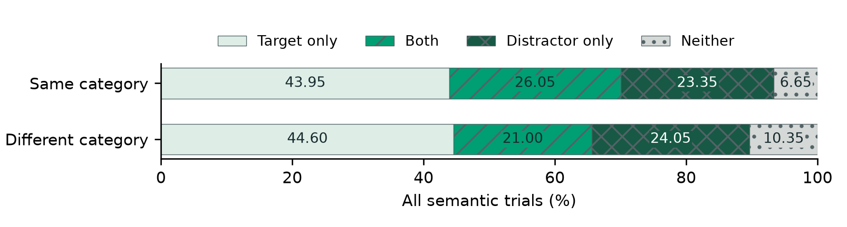
Figure 4: Single-template CLAP at own/+5 dB. Exact top-two membership of the two designated labels, among all 2,000 semantic trials per type. The four outcomes partition the trials; returned extra labels are not exhaustively annotated events.
Among original argmax captures, the target remains second in 236/632 (37.34%) same-category and 203/612 (33.17%) different-category cases. These denominators differ from the all-trial percentages in Figure 4. Gain-matched controls contain both labels in the top two in only 5.40% and 1.70%. Target-power results show similar partial recovery. Rank inclusion is not a calibrated detector or proof that the model perceptually heard both sources.

4.3 Spectral and temporal overlap
Spectral and temporal descriptors cover all 47,991 mixtures, including 12,000 DEMAND rows. The repository retains additional descriptor checks and sensitivity analyses.
To compare the same target under semantic interference and DEMAND, the primary analysis retains pairs with differences at most 0.10 in target-active spectral cosine, 0.05 in the interference-dominated time–frequency fraction, and 0.10 in activity overlap. Selection uses acoustics only, identically for all three systems. These are acoustic proxies from the project frontend, not CLAP’s internal frontend or a perceptual masking model.
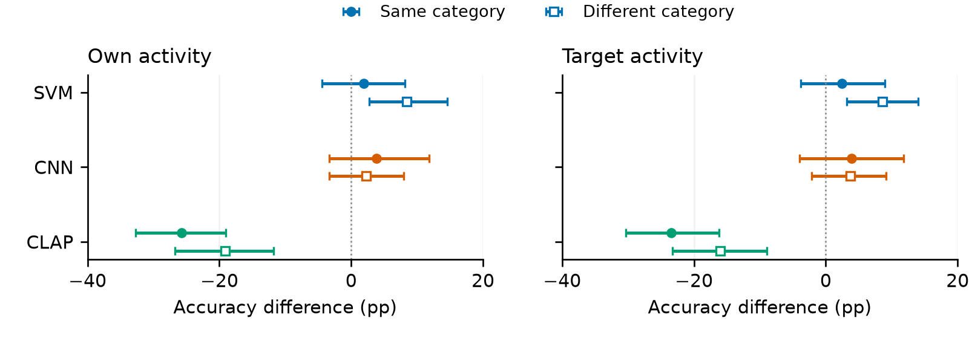
Figure 5: Semantic minus DEMAND accuracy at +5 dB, with pointwise 95% target-source cluster intervals (2,000 resamples). Own: 210/178 targets, 199/168 source clusters, 49/48 classes; target: 205/187 targets, 195/178 clusters, 49/47 classes (same/different). Filled circles: same category; open squares: different category.
Across both power conventions, CLAP remains about 16–26 accuracy percentage points below DEMAND, whereas all four CNN intervals include zero. Only about 9–10.5% of the benchmark remains. These selected populations differ from the larger high-overlap subsets; the new comparison is not a causal decomposition or a reversal on identical targets. Unmeasured acoustics and salience remain plausible explanations.

4.4 Deployment cost
Table 4: Median CPU query time (ms) on the same Apple M3, one numerical thread, batch one. Each pass contains 250 class/fold-balanced clips and three repetitions per model. Both model orders are retained.
System | First pass | Reversed order
SVM | 15.00 | 11.29
CNN | 3.07 | 2.44
CLAP | 69.30 | 50.86
Query cost includes preprocessing and scoring, excluding file access, model loading and one-off preparation. Absolute times drift, but the CNN/SVM/CLAP ordering persists. CNN and CLAP have 36,258 and 158,334,169 parameters respectively; external pretraining is excluded. Local feedback adds about 2.6–2.7 ms per query in a separate identical-clip panel: ensemble medians are 59–60 ms, versus 62–63 ms for either aligned version. Both orders, each with 750 queries per readout, are retained. Encoding the clean clips and calibrating on cached scores are separate one-off costs.

5 Discussion

5.1 What the evidence answers
The three questions receive direct answers. First, the same nominal power degrades the systems differently: at +5 dB the SVM falls to 2.03% macro-F1 under white noise but keeps 22.47% under a same-category event, whereas CLAP keeps 71.49% under DEMAND but falls to 48.86% under a same-category event. Second, white-noise augmentation protects mainly against nonspecific noise: CNN macro-F1 rises from 7.48% to 43.95% under white noise but only from 32.99% to 33.46% under a same-category event. Third, when CLAP fails it usually predicts the interferer, in 66.95% and 60.30% of its errors.
These answers describe observed behaviour. The SVM’s white-noise sensitivity can be traced to interpretable descriptors, as the course feature material anticipates [1], but displacement magnitude alone does not determine a decision; direction relative to class boundaries also matters.
Clean accuracy is 48.90% for our SVM and 67.90% for our CNN, respectively 9.30 and 3.40 points above the historical 39.60%/64.50% records [4, 5]. Feature conventions, architecture and training differ, so these are contextual comparisons rather than evidence of a controlled improvement. ESC-50’s 81.30% crowdsourced human accuracy is also a different evaluation, not a matched human-parity test [4].
The CNN comparison depends on which mixtures are retained. When temporal overlap is high, all three seeds give negative semantic-minus-DEMAND accuracy estimates, subject to the uncertainty qualification in Section 4.2. The smaller subsets selected for acoustic closeness have intervals spanning zero; because they contain different targets, they cannot show that acoustic adjustment removed an effect on the same population.

5.2 How the interventions relate to prior work
The strong white-noise benefit and limited semantic transfer extend the augmentation question raised by Salamon and Bello [6]. Their reported augmentation benefits do not imply invariance to every corruption. BC learning trains a proportional two-class target [8]; our retained-target objective asks a different robustness question. Semantic training here exchanges some clean performance for semantic point-estimate gains. The corrected direct comparison remains inconclusive, so it would be misleading to recommend semantic training as uniformly superior.
Fixed ensembling raises clean CLAP accuracy from 81.75% to 92.90% on the same clips, confirming sensitivity to the textual readout. PAT reports LAION-CLAP improving from 89.00% to 93.00% on ESC-50 (Table 1) [9]. Because the protocols are not matched, this is literature context; similar clean scores do not establish a ceiling under interference.
Local feedback was intended to preserve the target, but no primary gain was established. For the calibrated version, maximising clean accuracy provides no direct reward for retaining the target against a competing event. The port also uses uniform prompts and a project-chosen frame projection rather than the complete published method. These differences may limit transfer, but they have not been tested separately. They are hypotheses about this adaptation, not demonstrated mechanisms or evidence against PAT.
The ranking analysis helps interpret these captures. In the original single-prompt analysis, approximately one-third of captures retain the target at rank two, so losing first place need not remove it from the returned pair. The single-label result is unchanged. CLAP scores every class description [7], making the interferer another plausible answer. The residual deficit after acoustic matching is consistent with competition, but incomplete descriptors, small selected populations and reused interferers prevent causal attribution to semantic meaning.
RSA-Bench motivates structured backgrounds [11], although its tasks and scenes preclude direct numerical comparison. Mix-CLAP motivates measuring noise robustness and deployment cost [10]; neither system is reproduced here.

5.3 Limitations and how to resolve them
Because each target has one partner per category type and the background segments come from only three DEMAND recordings, the stability of the comparisons across mixtures is unknown. Repeating the experiment with new pairings and backgrounds would address this sampling limit. Both recordings start together in the mix, although the audible events may occur at different times. With only three tested levels, locating decision transitions would require a finer sweep of offsets and SIR within fixed pairs.
Source reuse and unknown CLAP pretraining overlap restrict generalisation, while stronger semantic claims would require independently validated acoustic controls and multi-event annotations at 0 dB. A repetition should also prespecify own-power mixing, top-two readout and acoustic thresholds, which were adopted after earlier results.

6 Conclusion
At own/+5 dB, white noise reduces the SVM to 2.03% macro-F1 while CLAP retains 62.91%. A same-category event leaves the SVM at 22.47% but takes CLAP from 71.49% under DEMAND to 48.86%, with about two-thirds of its errors naming the interferer. Across three CNN seeds, white-noise augmentation raises white-noise F1 from 7.48% to 43.95%, but same-category F1 only from 32.99% to 33.46%. Fixed prompt ensembling raises clean CLAP accuracy to 92.90% while same-category captures increase from 632 to 645; local feedback adds no confirmed gain. The original single-prompt target remains second in 33–37% of captures, a ranking diagnostic rather than calibrated detection. Deployment evaluation should distinguish noise robustness from retention amid competing events. Why CLAP is captured remains open: residual differences after acoustic matching require independently validated controls to support a semantic explanation.

7 Implementation, reproduction and attribution

7.1 Real code demonstration
The execution video reconstructs can opening plus clock alarm at own/+5 dB from source WAVs, checks SIR and peak level, and runs fold-matched SVM/CNN and single-template frozen CLAP. It shows fresh predictions, ranks and both audio outputs; historical results are read afterwards for verification. The author confirmed that representative website examples were recognisable without obvious distortion; this was not a listening-accuracy measurement.
This illustrative failure case, its source attribution and reproduction commands are documented in the run guide; aggregate conclusions use the complete experiment.

7.2 Implementation contribution and learning
Project code covers framing/STFT, features, compact CNN integration, controlled mixing, manifests, paired evaluation and diagnostics. External components are numerical/learning libraries, ESC-50/DEMAND and frozen LAION-CLAP; PAT supplies the prompt list and feedback arithmetic. Versions and attribution are in the repository.
Course STFT validation, explicit activity masks and fold-local scaling connect the implementation to time–frequency resolution, sparse-event power and leakage prevention.

7.3 Reproduction and attribution
The project website links the report, figures, audio, video and working code. The repository preserves both power protocols, all seeds, score definitions and provenance; large datasets and weights are obtained from documented external sources.
Demo sources are LG’s “Can Open.WAV” (CC BY) and hookhead’s “alarm clock.aif” (CC0), redistributed through ESC-50 (CC BY-NC 3.0), mixed and PCM16-exported. The linked clip has audio but no author narration; it is not the completed narrated submission.
AI acknowledgement. I used OpenAI Codex (GPT-6 Astra) and Anthropic Claude (model version not recorded) for substantial code implementation/revision, experiment orchestration, numerical checking, figure/report/slide generation and drafting, incorporating Claude’s code and reviews. This extended beyond language editing. I approved the scope, requested analyses in response to the lecturer’s feedback and listened to representative mixtures. I remain responsible for the submission and its explanation, under the University’s AI acknowledgement guidance.

References
[1] C. Jin, ELEC5305 Lecture 3: Sound Synthesis Models and Audio Features, University of Sydney, 2026. Course material, pp. 33–38, 50–51, 62–64.
[2] C. Jin, ELEC5305 Lecture 4: STFT, University of Sydney, 2026. Course material, pp. 2, 15, 24–25, 31, 87; accompanying MyStft.m.
[3] C. Jin, ELEC5305 Lecture 6, University of Sydney, 2026. Course material, pp. 2–5: hearing sensitivity and frequency weighting.
[4] K. J. Piczak, “ESC: Dataset for Environmental Sound Classification,” ACM Multimedia, 2015. doi:10.1145/2733373.2806390. Official folds and caveats: https://github.com/karolpiczak/ESC-50.
[5] K. J. Piczak, “Environmental Sound Classification with Convolutional Neural Networks,” MLSP, 2015. doi:10.1109/MLSP.2015.7324337.
[6] J. Salamon and J. P. Bello, “Deep Convolutional Neural Networks and Data Augmentation for Environmental Sound Classification,” IEEE Signal Processing Letters, 2017. doi:10.1109/LSP.2017.2657381.
[7] Y. Wu et al., “Large-Scale Contrastive Language-Audio Pretraining with Feature Fusion and Keyword-to-Caption Augmentation,” ICASSP, 2023; revised arXiv v4, 2024 (Table 4 and Appendix H). https://arxiv.org/abs/2211.06687v4.
[8] Y. Tokozume, Y. Ushiku and T. Harada, “Learning from Between-class Examples for Deep Sound Recognition,” ICLR, 2018. https://arxiv.org/abs/1711.10282.
[9] A. Seth et al., “PAT: Parameter-Free Audio-Text Aligner to Boost Zero-Shot Audio Classification,” NAACL, 2025, pp. 12376–12394. https://aclanthology.org/2025.naacl-long.616/.
[10] W. Kohno et al., “Mix-CLAP: Adaptive Fusion of Knowledge-Distilled Audio Embeddings for Noise-Aware Audio-Language Models,” ICASSP, 2026. Official conference record, paper 4206.
[11] Y. Zhang et al., “RSA-Bench: Benchmarking Audio Large Models in Real-World Acoustic Scenarios,” Findings of ACL, 2026, pp. 18350–18374. https://aclanthology.org/2026.findings-acl.913/.
[12] J. Thiemann et al., “The Diverse Environments Multi-Channel Acoustic Noise Database (DEMAND),” POMA, 2013. doi:10.1121/1.4799597; data: Zenodo 1227121.
[13] N. A. Schuster et al., “Noncollapsibility and its role in quantifying confounding bias in logistic regression,” BMC Medical Research Methodology, 2021. doi:10.1186/s12874-021-01316-8.

