COSC 364: Asg1

[Company name] | [Company address]

RIP Routing protocol implemetation

Charlie hunter (27380476)

Charlie hunter (27380476)

2021

# Project Contribution:

## Bach Vu (x%)

-

-

-

-

-

## Charlie Hunter (x%)

-

-

-

-

-

# Questions

### Which aspects of your overall program (design or implementation) do you consider particularly well done?

### Which aspects of your overall program (design or implementation) could be improved?

### How have you ensured atomicity of event processing?

### Have you identified any weaknesses of the RIP routing protocol?

Test 1 – Basic Functionality test.

The first test conducted can be seen on the network below in *figure 1.* This test was to test the basic functionality of code. Firstly router one and router two where ran and connected to one another. After this router three was ran, and router one and two both found a shorter path to each other via router three. The process of router one can be seen below in *figures 2 3, 4* and *5*.

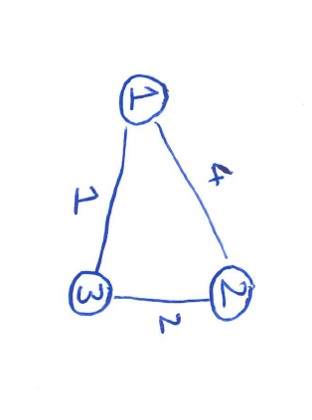

Figure 1 – Basic functionality test network

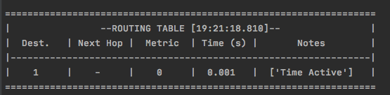

Figure 2 – router one starting

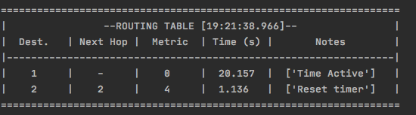

Figure 3 – router one connecting to router two

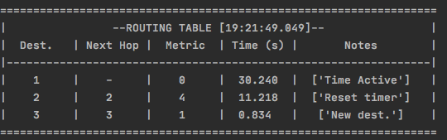

Figure 4 – router one connecting to router three

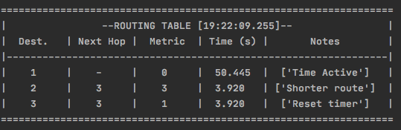

Figure 5 – router one connecting to router 2 via router 3 for a smaller cost

Test 2 – split horizon and poisoned reverse

The second test conducted can be seen below on figure 6. The purpose of this test was to test split horizon with poisoned reverse. Firstly all routers where ran so that they could all converge. Once convergence has occurred router three was turned off. Once routers one and two both receive nothing from

