Java instrumentation

**Components of Java Instrumentation**

Agent – a jar file containing agent and transformer class files

Agent Class – A java class file, containing a method named “premain”

Manifest - A java class file implementing the interface ClassFileTransformer

**Java Instrumentation Project Execution (IDE: IntelliJ IDEA)**

1. Compile the program and prepare the Java Jar file (agent jar)
2. Select Built -> Built Artifacts -> action built
3. Find JavaInstrumemtation.jar in classes\artifacts\JavaInstrumentation_jar, and rename it to instrumentation.jar
4. Move the jar file to project root.
5. Execute the instrumentation.jar using command, java -cp .;./lib/javassist-3.14.0-GA.jar -javaagent:./instrumentation.jar com.javapapers.java.instrumentation.TestInstrumentation

**Output of the Java instrumentation project**

Target code

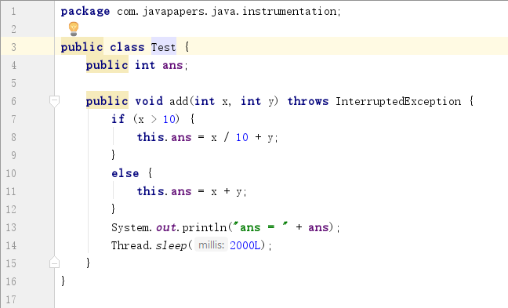

Test cases

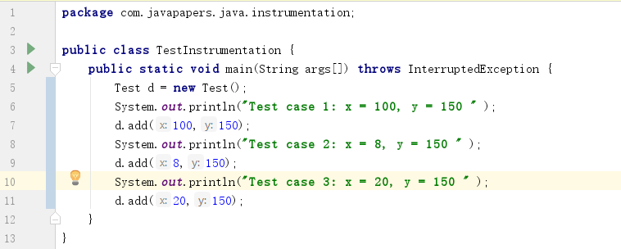

Before instrumentation

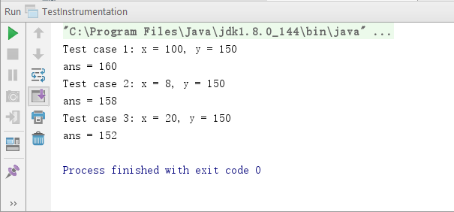

Insert code to track execution



After instrumentation

