**BASIC SETUP**

As an aspiring XCOM modder you need 4 tools/things to create/change XCOM code and get it working:

1. Any text editor to write your code.
2. UE Explorer to search through and study original code within XComGame.upk or XComStrategyGame.upk.
3. Compiler to turn your code in text form into a compiled version (object form) – the one with .u extension which will go into CookedPCConsole.
4. XComClassOverrider installed and optionally (recommended) XCOM ModBridge installed.
5. A bunch of so called XCOM stubs/dummy script files. These are .uc files created from original XCOM code (well LW code actually) that contain only necessary declarations/definitions of variables and functions.

**Ad. 1**. Any text editor would do, even Notepad. But at least Notepad++ is recommended with additional plug-in/extension Unrealscript Highlighter. <http://www.mediafire.com/file/c8v5aj2j3jt32c9/Unrealscript+Highlighter.zip>

This is the fastest to set up and you can start with that. However our true recommendation is to use **Visual Studio** (VS) to get access to coding support it provides – there is a trade off though as it requires c.a. 7 GB of disk space.

You would want a version of VS that supports UnrealEngine 3 syntax (which is used by XCOM). The last VS release that supported UnrealEngine 3 (UE3) was Visual Studio 2013. There are already newer versions but you would have problems installing nFringe plug-in which is necessary to provide support for UE3.

**Ad.2.** You can download UE Explorer from this link <http://eliotvu.com/portfolio/download/21/ue-explorer>. You will need to decompress UPK files other than XComGame.upk and XComStrategyGame.upk before loading them to UE Explorer. You can use a tool from UPK Utils set or grab one here: http://wiki.tesnexus.com/index.php/Modding_Tools_-_XCOM:EU_2012#UPK_Decompressor

**Ad.3.** The compiler is Unreal Development Kit v. 2011-09. For instructions scroll down to UDK-2011-09 section of the tutorial.

**Ad.4.** Installation of ModBridge has been explained on the nexusmods site and for PC version it is as simple as:

1. Copy *XComModBridge.u* to XEW\XComGame\CookedPCConsole folder (hint: you can create a subfolder in CookedPCConsole to hold your mod/mods; game will find any .u files in the subfolders)
2. Copy *DefaultModBridge.ini* to XEW\XComGame\Config (hint: subfolder will not work here ☺ )

**Ad.5.** A ready set of XCOM dummy scripts is included in the download pack. You should extract two “XCom..” folders into …\UDK-2011-09\Development\src, so that you have   
…\UDK-2011-09\Development\src\XComGame   
…\UDK-2011-09\Development\src\XComStrategyGame

The list of classes is not complete but contains most of what is needed to mod functions related to most common gameplay effects. Be prepared though to expand the list whenever compiler prompts you (usually returning error like: “bad command” or “reference not found”, or “… is not a class”). Most of common compiler errors are covered by “**UDK Errors Explained”** guide.

At some point you might be asked to expand some native class-file like Actor.uc (Engine package/folder) or Object.uc (Core package/folder). Do not hesitate – it is just adding a line or two ☺ You cannot break anything – and you can always delete what you have added, can’t you?

**VISUAL STUDIO 2013 – INSTALLATION GUIDE**

1. Go to <https://my.visualstudio.com/downloads> - you need a microsoft account, so if you do not have one on live.com, register first.
2. Type “2013” into search field:

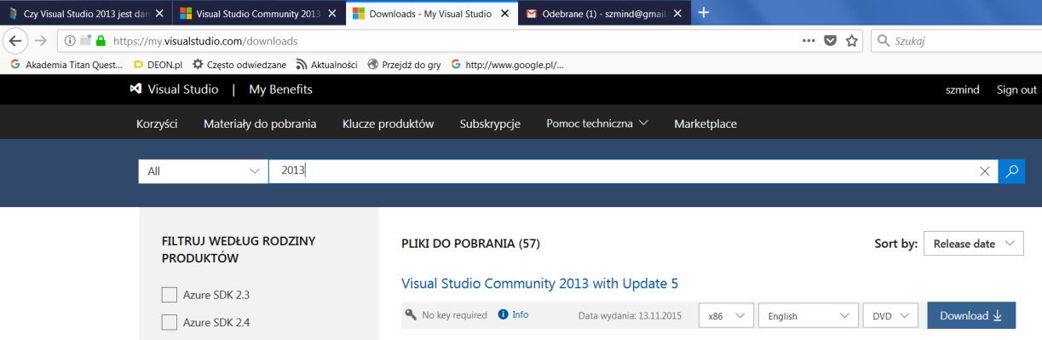

1. Download and install VS Community 2013
2. During installation you can deselect all the “Optional features” to save space.
3. Launch newly installed VS and perform initial stuff (login). Then close and continue with installation of nFringe extension – below.
4. Download latest release of nFringe (v.1.3.0.5 at the moment I am writing this) from:

<http://pixelminegames.com/nfringe/releases/>

1. Install it and reboot your system. After reboot, launch VS and check if the installation of nFringe succeeded. Choose: Tools 🡪Extensions and Updates.

You should see **Pixelmine** extension as below:

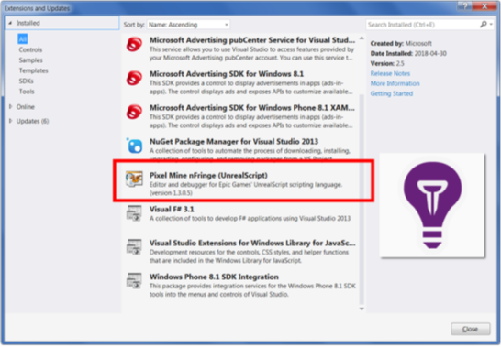

1. At some point (early after installation) you might be asked by Pixelmine/nFringe to input license-key. This is an artifact, no longer relevant ☺ Just select option ‘non-commercial use’ or so, provide any ‘name’ and ‘e-mail’. The e-mail needs not even to be true/real. Confirmation link will be sent to the e-mail but this confirmation is not necessary at all to use the extension. So just force-push through the procedure and forget.

**VISUAL STUDIO 2013 – PROJECT SETUP**

Time to get used to your usual modder’s setup/environment. You may get confused by terms like solution/project and what it is up to. But once you set it up you can forget it ☺. Let’s go through it step by step.

Our goal of the whole procedure is to create a ‘solution’ (which may contain numerous ‘projects’) and then create a ‘project’ within the ‘solution’.

Click “New Project” on the Start Page to the left. Alternatively select “New Project” from FILE in the Menu.

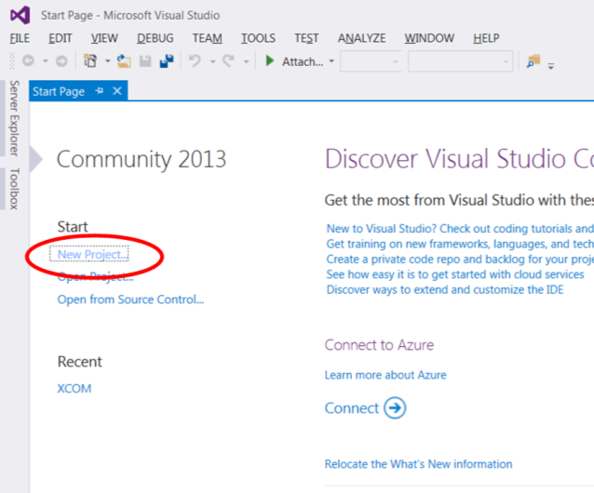

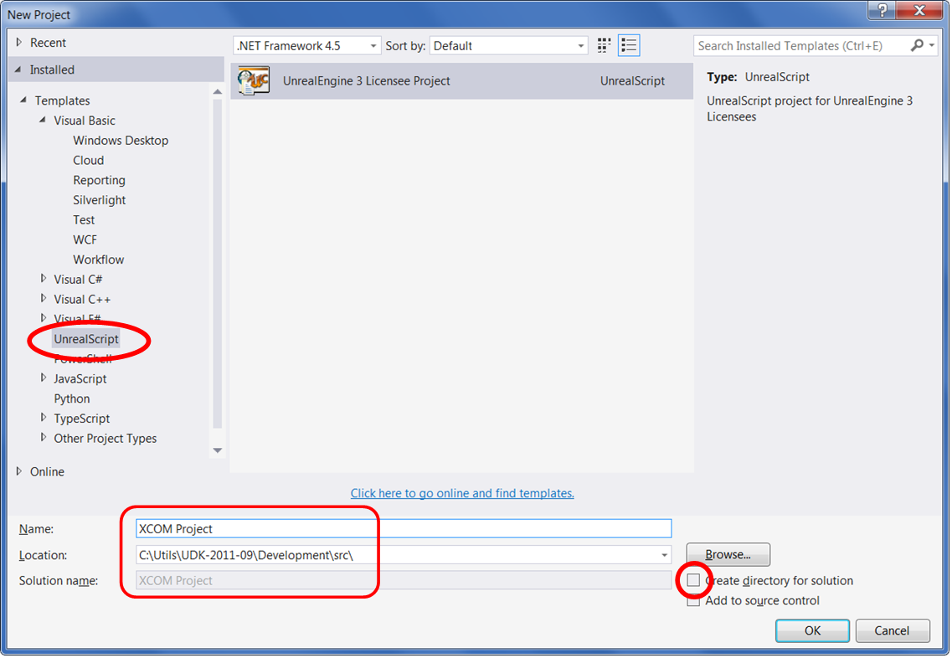

**It is very useful to set ‘Location’ at …\UDK-2011-09\Development\src**

Anyway - try to remember for a while the location you set. Now close VS and go to that location. You will find a folder there with your specified project name. Go into it, grab two files named e.g. “XCOM Project.sln” and “XCOM Project.ucproj” and move them to   
**…\UDK-2011-09\Development\src**

Now double-click the .sln file. It will be opened in VS. To the right you should see a list of subfolders in Development\src

If you do not see that – right-click XCOM Project and select Reload Project.

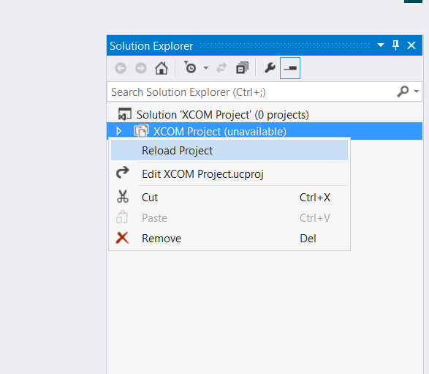

It should now look like

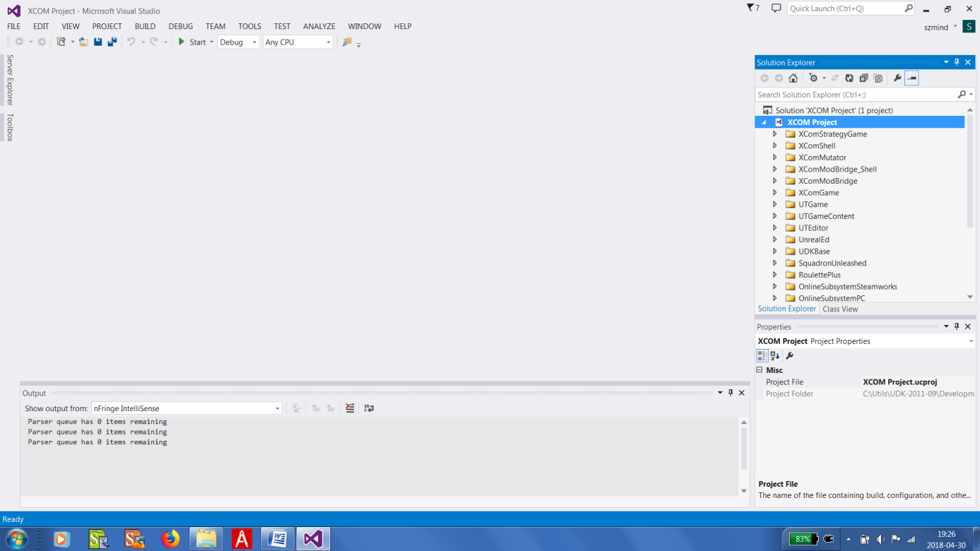

That is all. You can explore through the list of classes using that Solution Explorer. If you happen to close it – you can bring it back from View menu - > Solution Explorer.

For creating new code with Visual Studio read the **Example Mod** document.

**UDK-2011-09**

You could compile your code with any version of Unreal Development Kit (UDK) but only code compiled with version not newer than used by Firaxis will work. XCOM EW has been created using **Unreal Development Kit (UDK) release 2011-09.** That has been figured out by Amineri (eternal credits to her).

1. Firstly grab UDK-2011-09 here:

<https://www.nexusmods.com/xcom/mods/485>

1. After installation you should first extract the XCOM-stubs archive into …\UDK-2011-09\Development\src

Of course that “…” in front of “…\UDK” is path to where you have installed the UDK.

1. As a test and introduction to using UDK you should now try compiling those XCOM-stubs ☺. First create a shortcut to UDK.exe which is located in:

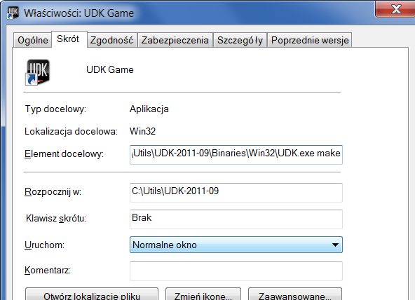

**Add “make” at the end: “….UDK.exe make”.**

1. You should also **tell compiler what it should auto-compile** with every run.
   1. Go to ….\UDK-2011-09\UDKGame\Config
   2. Open “DefaultEngine.ini” located there.
   3. Add 2 new “+EditPackages=..” lines as on the screen-shot below (one for XComGame and another for XComStrategyGame).
   4. Later on you will add here also a similar line for your own mod ☺

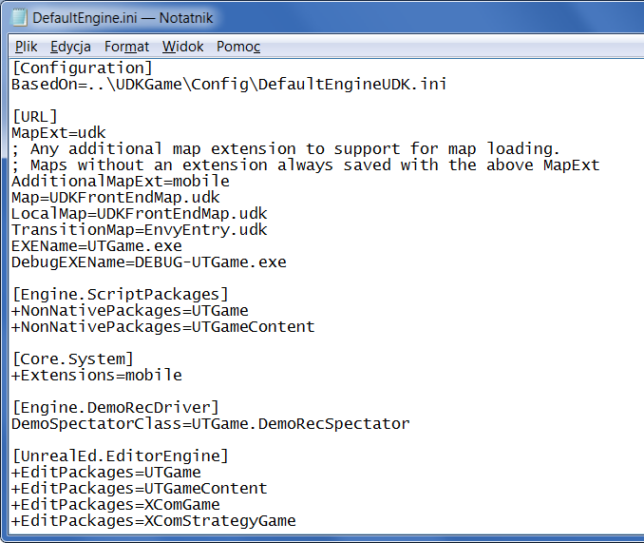

1. Now run UDK with a shortcut created earlier. A black console-like compiler window will pop-up and compiler will automatically check for any updated packages (folders or mods in other words) and recompile them. For now those new packages are XComGame and XComStrategyGame.
2. If you get some red errors – do not worry. It is quite normal to get them and very educational to fix them ☺ Compiler hints a quite good at telling you what is wrong with your code. In case of still not being sure go to section **“UDK errors”** for most common errors, see how I used to solve it when learning myself and apply suitable solution, and recompile. Repeat until you get only “yellows” which is a success. If you happen to get “green” – congrats!