## Evidence tests cases

SQL QUERY RESULT 1:

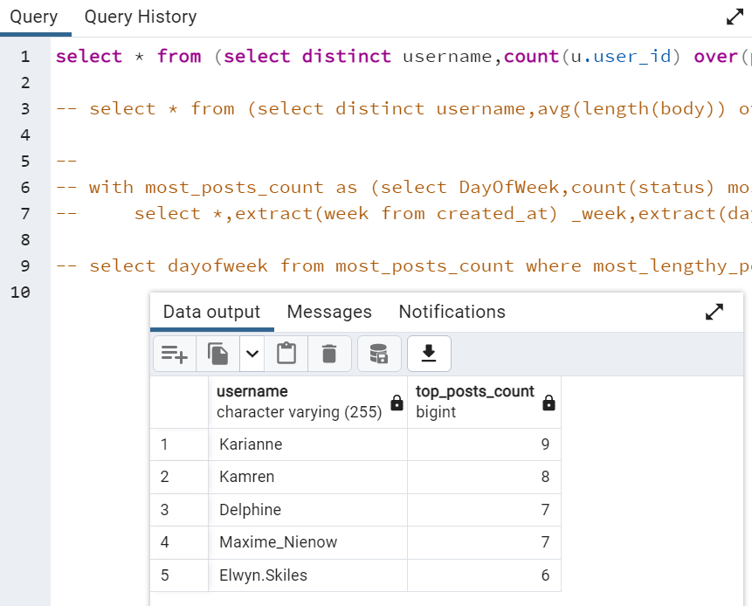

SQL QUERY RESULT 2:

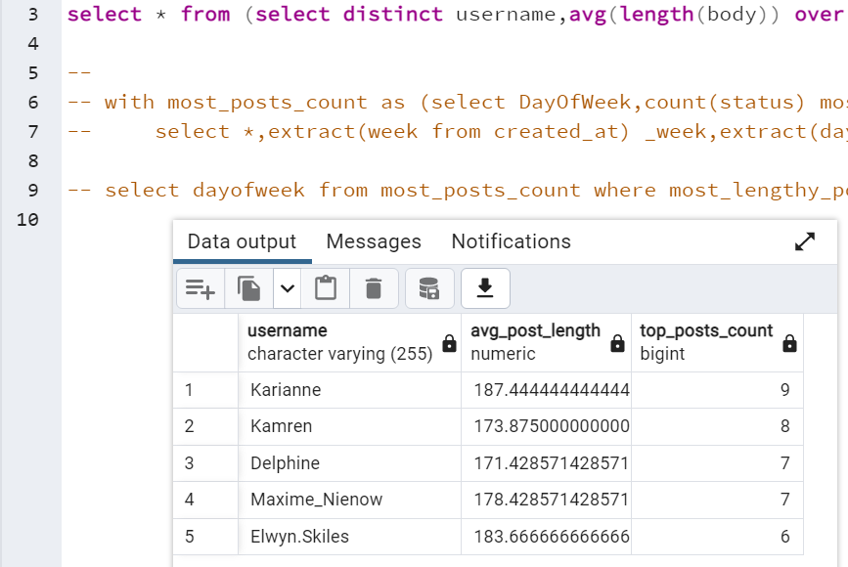

SQL QUERY RESULT 3:

