Lab 1: Getting Started with Python (Part-1) (Installation, variables, conditions)

Python is simple to use, but it is a real programming language, offering much more structure and support for large programs than shell scripts or batch files can offer. On the other hand, Python also offers much more error checking than C, and, being a very-high-level language, it has high-level data types built in, such as flexible arrays and dictionaries. Because of its more general data types of Python is applicable to a much larger problem domain than Awk or even Perl, yet many things are at least as easy in Python as in those languages.
Python allows you to split your program into modules that can be reused in other Python programs. It comes with a large collection of standard modules that you can use as the basis of your programs or as examples to start learning to program in Python. Some of these modules provide things like file I/O, system calls, sockets, and even interfaces to graphical user interface toolkits like Tk.
Python is an interpreted language, which can save you considerable time during program development because no compilation and linking is necessary. The interpreter can be used interactively, which makes it easy to experiment with features of the language, to write throw-away programs, or to test functions during bottom-up program development.
Installation:
There are a multitude of installation methods: you can download official Python distributions from Python.org, install from a package manager, and even install specialized distributions for scientific computing, Internet of Things, and embedded systems.
Microsoft Store package: The most straightforward installation method on Windows involves installing from the Microsoft Store app. This is recommended for beginner Python users looking for an easy-to-setup interactive experience.
Full Installer: This approach involves downloading Python directly from the Python.org website. This is recommended for intermediate and advanced developers who need more control during the setup process.

Windows Subsystem for Linux (WSL): The WSL allows you to run a Linux environment directly in Windows. You can learn how to enable the WSL by reading the Windows Subsystem for Linux Installation Guide for Windows 10.
Follow these steps to download the full installer:
- Open a browser window and navigate to the Python.org Downloads page for Windows.
- Under the “Python Releases for Windows” heading, click the link for the Latest Python 3 Release - Python 3.x.x. As of this writing, the latest version was Python 3.14.2.
- 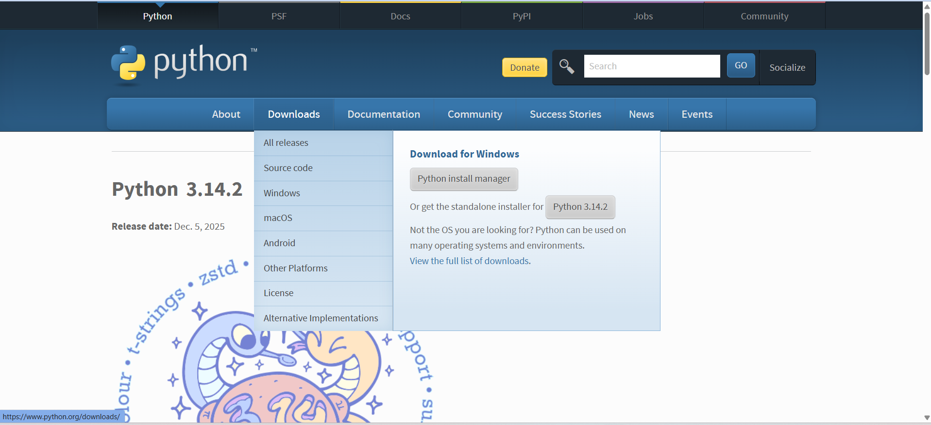
- Scroll to the bottom and select either Windows x86-64 executable installer for 64-bit or Windows x86 executable installer for 32-bit. If you aren’t sure whether to select the 32-bit or the 64-bit installer, then you can expand the box below to help you decide.
Once you’ve chosen and downloaded an installer, run it by double-clicking on the downloaded file.

Variables:
Variables are containers for storing data values.
Creating Variables:
Python has no command for declaring a variable. A variable is created the moment you first assign a value to it.
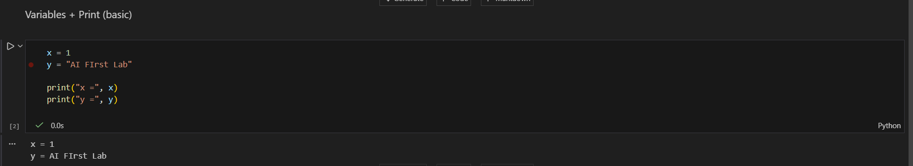
Variables do not need to be declared with any particular type, and can even change type after they have been set. An example below,
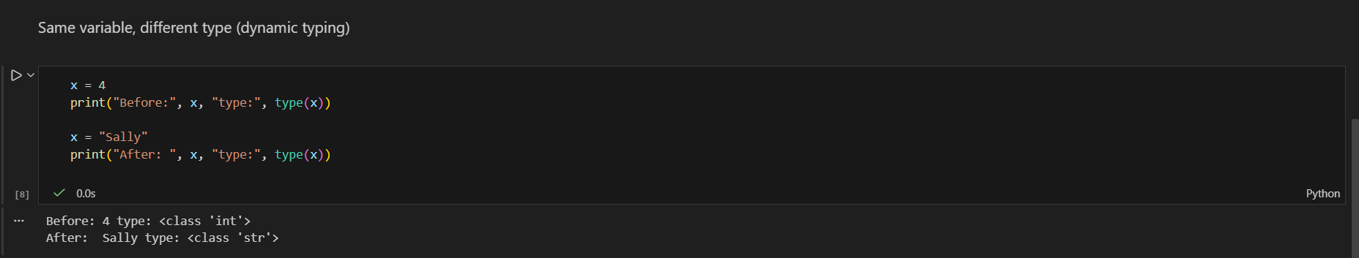

Casting:
If you want to specify the data type of a variable, this can be done with casting.
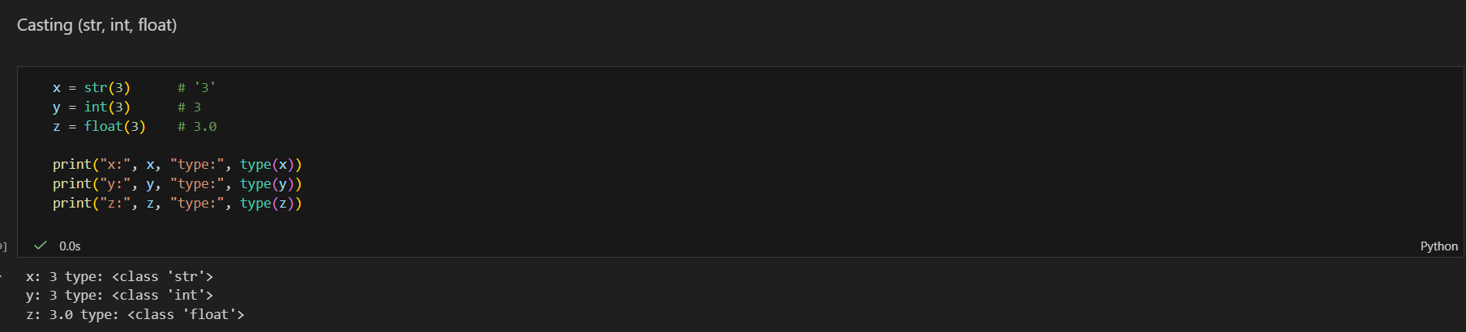

Get the Type:
You can get the data type of a variable with the type() function.
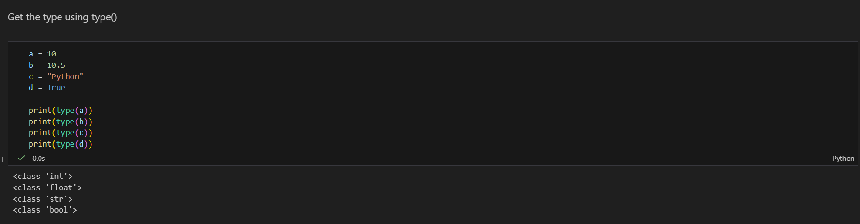

Strings:
Besides numbers, Python can also manipulate strings, which can be expressed in several ways. They can be enclosed in single quotes ('...') or double quotes ("...") with the same result 2. \ can be used to escape quotes:
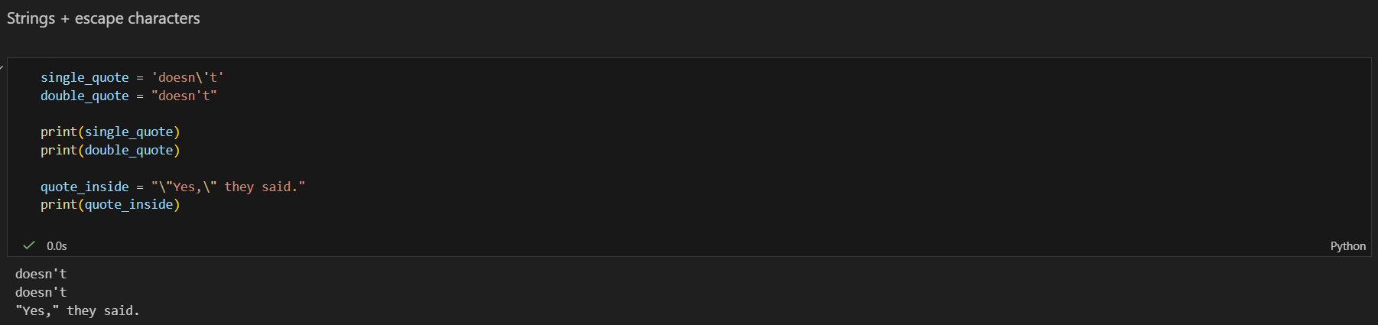
In the interactive interpreter, the output string is enclosed in quotes and special characters are escaped with backslashes. While this might sometimes look different from the input (the enclosing quotes could change), the two strings are equivalent. The string is enclosed in double quotes if the string contains a single quote and no double quotes, otherwise it is enclosed in single quotes. The print() function produces a more readable output, by omitting the enclosing quotes and by printing escaped and special characters:
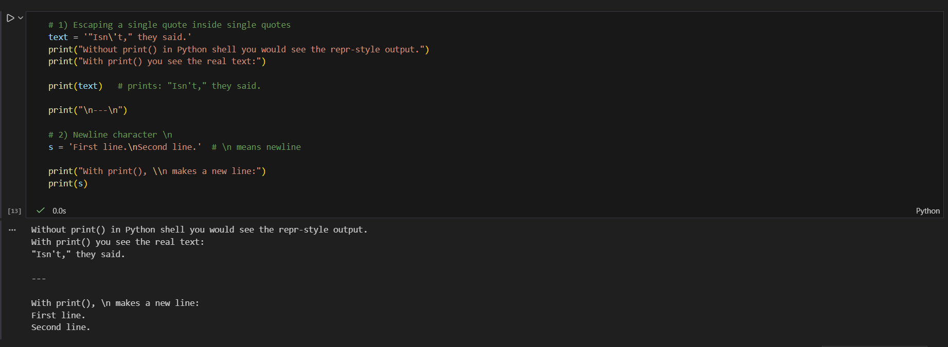

Flow Control:
Python uses the usual flow control statements known from other languages, with some twists.
if Statements:
Perhaps the most well-known statement type is the if statement. For example:
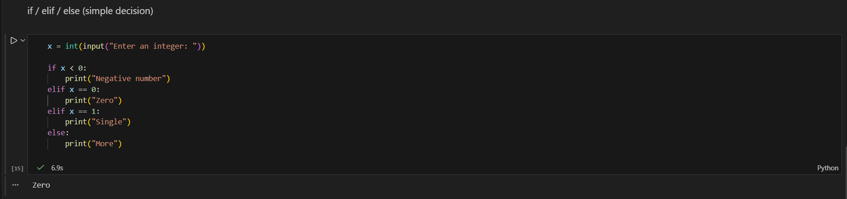
There can be zero or more elif parts, and the else part is optional. The keyword ‘elif’ is short for ‘else if’, and is useful to avoid excessive indentation. An if … elif … elif … sequence is a substitute for the switch or case statements found in other languages.

Exercise:
Write a program in python to evaluate grade according to marks.

