Lab 2: Getting Started with Python (Part-2) (Collection, Loops)

Collections:
Collections in Python are containers that are used to store collections of data, for example, list, dict, set, tuple etc. These are built-in collections. Several modules have been developed that provide additional data structures to store collections of data. One such module is the Python collections module.
Python collections module was introduced to improve the functionalities of the built-in collection containers. Python collections module was first introduced in its 2.4 release.

Lists:
Python knows a number of compound data types, used to group together other values. The most versatile is the list, which can be written as a list of comma-separated values (items) between square brackets. Lists might contain items of different types, but usually the items all have the same type.

Like strings (and all other built-in sequence types), lists can be indexed and sliced:
All slice operations return a new list containing the requested elements. This means that the following
- slice returns a shallow copy of the list:
- The built-in function len() also applies to lists:
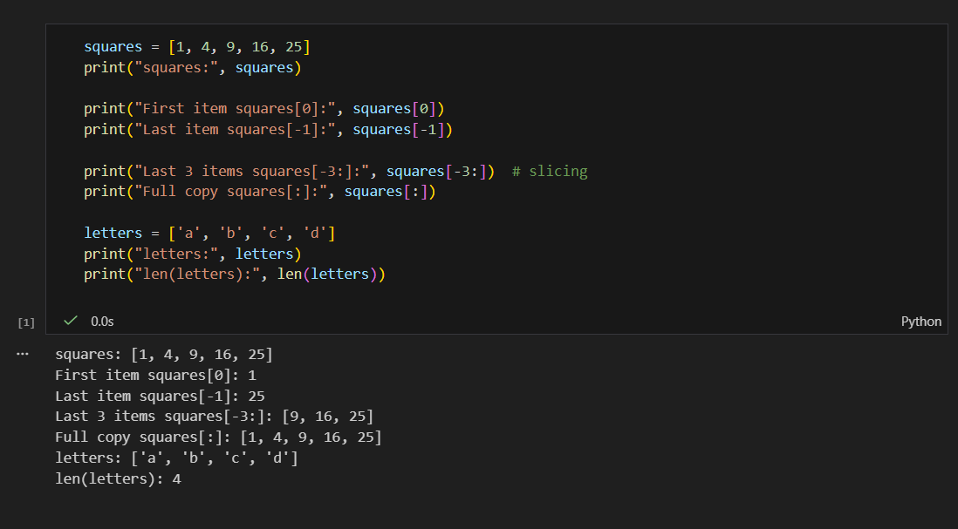

It is possible to nest lists (create lists containing other lists), for example:
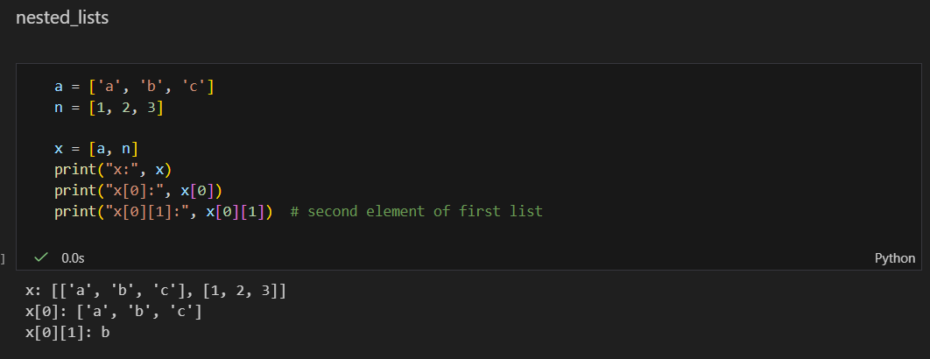

The list data type has some more methods. Here are all of the methods of list objects:
- list.append(x)
Add an item to the end of the list. Equivalent to a[len(a):] = [x].
- list.extend(iterable)
Extend the list by appending all the items from the iterable. Equivalent to a[len(a):] = iterable.
- list.insert(i, x)
Insert an item at a given position. The first argument is the index of the element before which to insert, so a.insert(0, x) inserts at the front of the list, and a.insert(len(a), x) is equivalent to a.append(x).
- list.remove(x)
Remove the first item from the list whose value is equal to x. It raises a ValueError if there is no such item.
- list.pop([i])
Remove the item at the given position in the list, and return it. If no index is specified, a.pop() removes and returns the last item in the list. (The square brackets around the i in the method signature denote that the parameter is optional, not that you should type square brackets at that position. You will see this notation frequently in the Python Library Reference.)
- list.clear()
Remove all items from the list. Equivalent to del a[:].
- list.index(x[, start[, end]])
Return zero-based index in the list of the first item whose value is equal to x. Raises a ValueError if there is no such item.
- The optional arguments start and end are interpreted as in the slice notation and are used to limit the search to a particular subsequence of the list. The returned index is computed relative to the beginning of the full sequence rather than the start argument.
- list.count(x)
Return the number of times x appears in the list.

- list.sort(*, key=None, reverse=False)
Sort the items of the list in place (the arguments can be used for sort customization, see sorted() for their explanation).
- list.reverse()
Reverse the elements of the list in place.
- list.copy()
Return a shallow copy of the list. Equivalent to a[:].

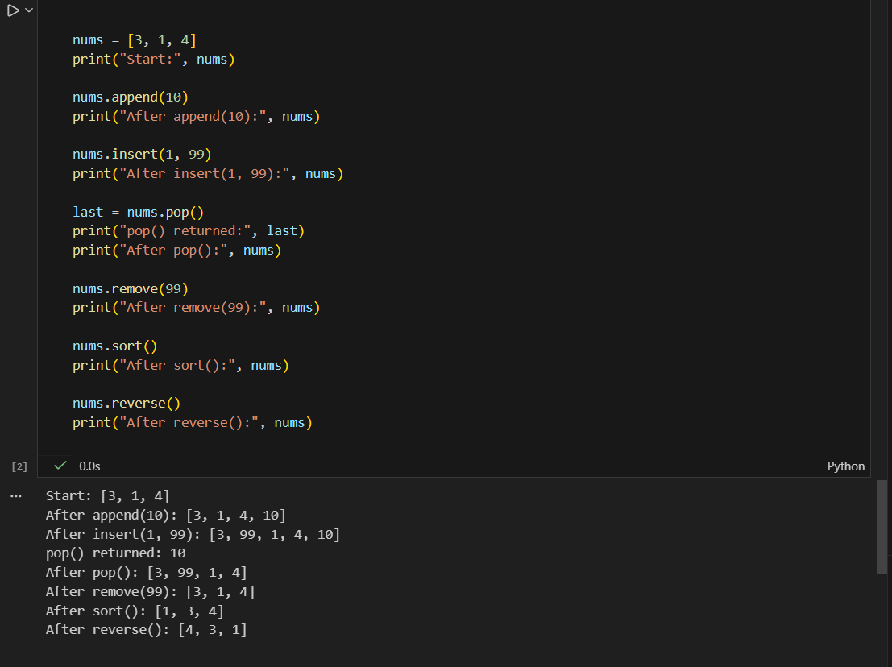

Tuples:
We saw that lists and strings have many common properties, such as indexing and slicing operations. They are two examples of sequence data types (see Sequence Types — list, tuple, range). Since Python is an evolving language, other sequence data types may be added. There is also another standard sequence data type: the tuple.
A tuple consists of a number of values separated by commas, for instance:
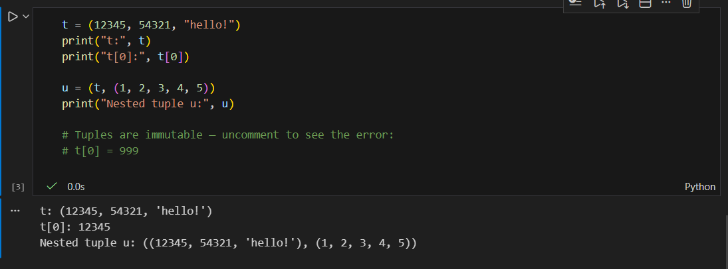
As you see, on output tuples are always enclosed in parentheses, so that nested tuples are interpreted correctly; they may be input with or without surrounding parentheses, although often parentheses are necessary anyway (if the tuple is part of a larger expression). It is not possible to assign to the individual items of a tuple, however it is possible to create tuples which contain mutable objects, such as lists.
Though tuples may seem similar to lists, they are often used in different situations and for different purposes. Tuples are immutable, and usually contain a heterogeneous sequence of elements that are accessed via unpacking (see later in this section) or indexing (or even by attribute in the case of namedtuples). Lists are mutable, and their elements are usually homogeneous and are accessed by iterating over the list.
A special problem is the construction of tuples containing 0 or 1 items: the syntax has some extra quirks to accommodate these. Empty tuples are constructed by an empty pair of parentheses; a tuple with one item is constructed by following a value with a comma (it is not sufficient to enclose a single value in parentheses). Ugly, but effective.

Sets:
Python also includes a data type for sets. A set is an unordered collection with no duplicate elements. Basic uses include membership testing and eliminating duplicate entries. Set objects also support mathematical operations like union, intersection, difference, and symmetric difference.
Curly braces or the set() function can be used to create sets. Note: to create an empty set you have to use set(), not {}; the latter creates an empty dictionary, a data structure that we discuss in the next section.
Here is a brief demonstration:
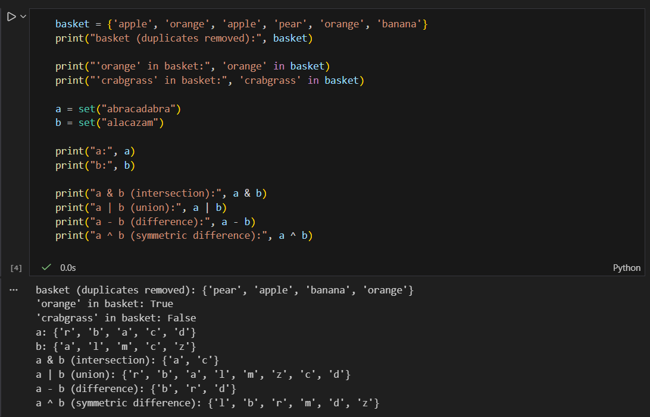

Dictionaries:
Another useful data type built into Python is the dictionary (see Mapping Types — dict). Dictionaries are sometimes found in other languages as “associative memories” or “associative arrays”. Unlike sequences, which are indexed by a range of numbers, dictionaries are indexed by keys, which can be any immutable type; strings and numbers can always be keys. Tuples can be used as keys if they contain only strings, numbers, or tuples; if a tuple contains any mutable object either directly or indirectly, it cannot be used as a key. You can’t use lists as keys, since lists can be modified in place using index assignments, slice assignments, or methods like append() and extend().
It is best to think of a dictionary as a set of key: value pairs, with the requirement that the keys are unique (within one dictionary). A pair of braces creates an empty dictionary: {}. Placing a comma- separated list of key: value pairs within the braces adds initial key: value pairs to the dictionary; this is also the way dictionaries are written on output.
The main operations on a dictionary are storing a value with some key and extracting the value given the key. It is also possible to delete a key: value pair with del. If you store using a key that is already in use, the old value associated with that key is forgotten. It is an error to extract a value using a non-existent key.
Performing list(d) on a dictionary returns a list of all the keys used in the dictionary, in insertion order (if you want it sorted, just use sorted(d) instead). To check whether a single key is in the dictionary, use the in keyword.
Here is a small example using a dictionary:
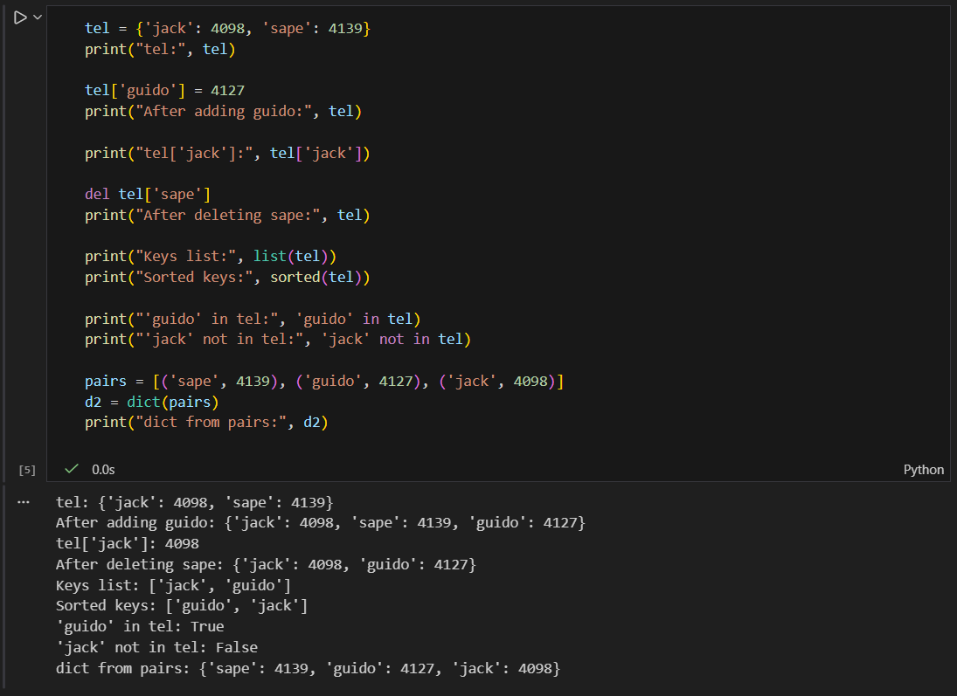

Loops:

For:
A for loop is used for iterating over a sequence (that is either a list, a tuple, a dictionary, a set, or a string). This is less like the for keyword in other programming languages, and works more like an iterator method as found in other object-orientated programming languages.
With the for loop we can execute a set of statements, once for each item in a list, tuple, set etc.

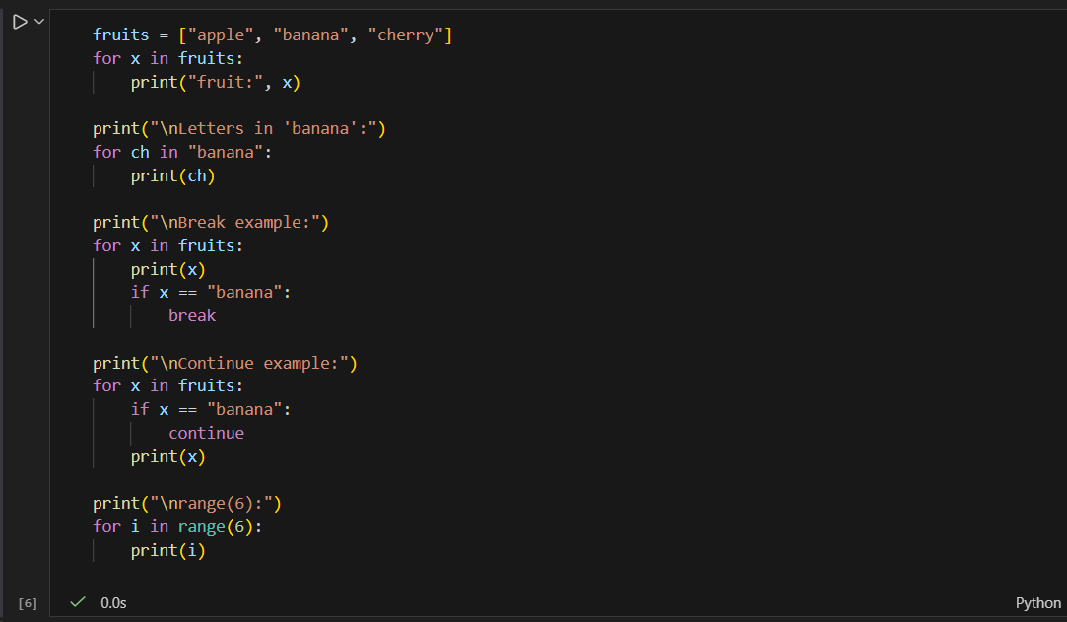

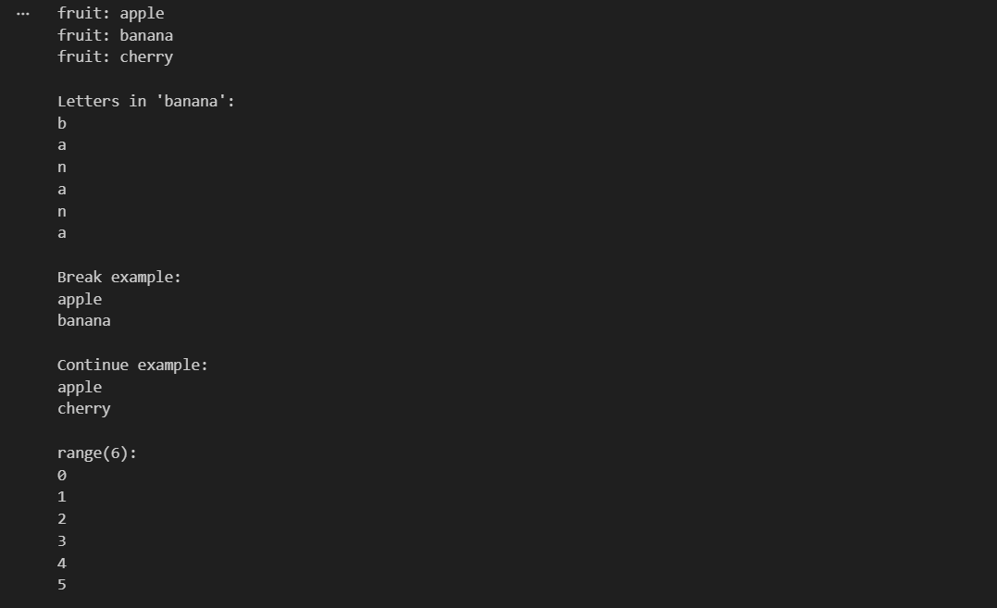

while:
With the while loop we can execute a set of statements as long as a condition is true.
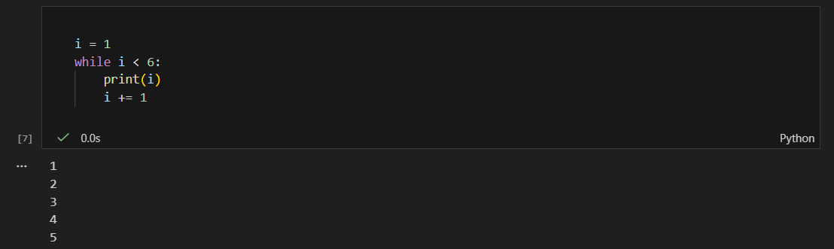

Exercise 1:
Dr. John Wesley has a spreadsheet containing a list of student’s ID, marks, class and name.
Your task is to help Dr. Wesley calculate the average marks of the students.

Average = Sum of all marks/Total Students

Note:
- Columns can be in any order. IDs, marks, class, and name can be written in any order in the spreadsheet.
- Columns names are ID, MARKS, CLASS and NAME. (The spelling and cast type of these names
won’t change).

Input Format:
The first line contains an integer N, the total number of students The second line contains the names of the columns in any order.
The next N lines contains the MARKS, IDs, NAME and class, under their respective column names.

Constraints:
0 < N <= 100
Output Format: Print the average marks of the list corrected to 2 decimal places.

Functions:
A function is a block of code which only runs when it is called. You can pass data, known as parameters, into a function. A function can return data as a result.
In Python a function is defined using the def keyword:

def my_function():

print("Hello from a function")
To call a function, use the function name followed by parenthesis:

def my_function():

print("Hello from a function")

my_function()

Arguments
Information can be passed into functions as arguments. Arguments are specified after the function name, inside the parentheses. You can add as many arguments as you want, just separate them with a comma.
The following example has a function with one argument (fname). When the function is called, we pass along a first name, which is used inside the function to print the full name:

def my_function(fname): print(fname+"Refsnes")

my_function("Emil") my_function("Tobias") my_function("Linus")
By default, a function must be called with the correct number of arguments. Meaning that if your function expects 2 arguments, you have to call the function with 2 arguments, not more, and not less.

def my_function(fname,lname): print(fname+ "" +lname)

my_function("Emil", "Refsnes")
If you try to call the function with 1 or 3 arguments, you will get an error.

Arbitrary Arguments, *args
If you do not know how many arguments that will be passed into your function, add a * before the parameter name in the function definition.
This way the function will receive a tuple of arguments, and can access the items accordingly:

def my_function(*kids):

print("The youngest child is " + kids[2])

my_function("Emil", "Tobias", "Linus")

Keyword Arguments
You can also send arguments with the key = value syntax. This way the order of the arguments does not matter.

def my_function(child3, child2, child1): print("The youngest child is " + child3)

my_function(child1 = "Emil", child2 = "Tobias", child3 = "Linus")
The phrase Keyword Arguments are often shortened to kwargs in Python documentations.

Arbitrary Keyword Arguments, **kwargs
If you do not know how many keyword arguments that will be passed into your function, add two asterisk:
** before the parameter name in the function definition.
This way the function will receive a dictionary of arguments, and can access the items accordingly:

def my_function(**kid):

print("His last name is " + kid["lname"])

my_function(fname = "Tobias", lname = "Refsnes")
Arbitrary Kword Arguments are often shortened to **kwargs in Python documentations.

Default Parameter Value
The following example shows how to use a default parameter value. If we call the function without argument, it uses the default value:
def my_function(country = "Norway"): print("I am from " + country)

my_function("Sweden") my_function("India") my_function() my_function("Brazil")

Return Values
To let a function return a value, use the return statement:

def my_function(x):

return 5 * x

print(my_function(3)) print(my_function(5)) print(my_function(9))

The pass Statement
function definitions cannot be empty, but if you for some reason have a function definition with no content, put in the pass statement to avoid getting an error.

def myfunction(): pass

Classes:
Python is an object oriented programming language. Almost everything in Python is an object, with its properties and methods. A Class is like an object constructor, or a "blueprint" for creating objects.
To create a class, use the keyword class:

class MyClass: x = 5
Now we can use the class named MyClass to create objects:

p1=MyClass() print(p1.x)

The init () Function
The examples above are classes and objects in their simplest form, and are not really useful in real life applications. To understand the meaning of classes we have to understand the built-in init () function. All classes have a function called init (), which is always executed when the class is being initiated. Use the init () function to assign values to object properties, or other operations that are necessary to do when the object is being created:

class Person:

def init (self,name,age): self.name=name

self.age=age

p1=Person("John", 36)

print(p1.name) print(p1.age)

Objects can also contain methods. Methods in objects are functions that belong to the object. Let us create a method in the Person class:
class Person:
def init (self, name, age): self.name = name
self.age = age

def myfunc(self):
print("Hello my name is " + self.name)
p1 = Person("John", 36) p1.myfunc()

The self Parameter
The self parameter is a reference to the current instance of the class, and is used to access variables that belongs to the class. It does not have to be named self , you can call it whatever you like, but it has to be the first parameter of any function in the class:
class Person:
def init (mysillyobject, name, age):
mysillyobject.name = name mysillyobject.age = age
def myfunc(abc):
print ("Hello my name is " + abc.name)
p1 = Person("John", 36) p1.myfunc()

Exercise:

Task # 01:
In this challenge, the user enters a string and a sub-string. You have to print the number of times that the sub-string occurs in the given string. String traversal will take place from left to right, not from right to left.
Note: String letters are case-sensitive.

Input Format:
The first line of input contains the original string. The next line contains the sub-string.

Constraints:
1<= len(string) <= 200

Output Format: Output the integer number indicating the total number of occurrences of the sub-string in the original string.

Task # 02:
Count the occurrences of each character in the input_str.

Input:
Take an input from user named input_str.

Output:
Print each character and its count.

Sample:
IN: aabcd
OUT: a:2, b:1, c:1, d:1

