Lab 3: OOP in Python (Part-4) (Functions, Classes, Inheritance, Polymorphism)
Inheritance allows us to define a class that inherits all the methods and properties from another class.
Parent class is the class being inherited from, also called base class.
Child class is the class that inherits from another class, also called derived class.
Any class can be a parent class, so the syntax is the same as creating any other class:
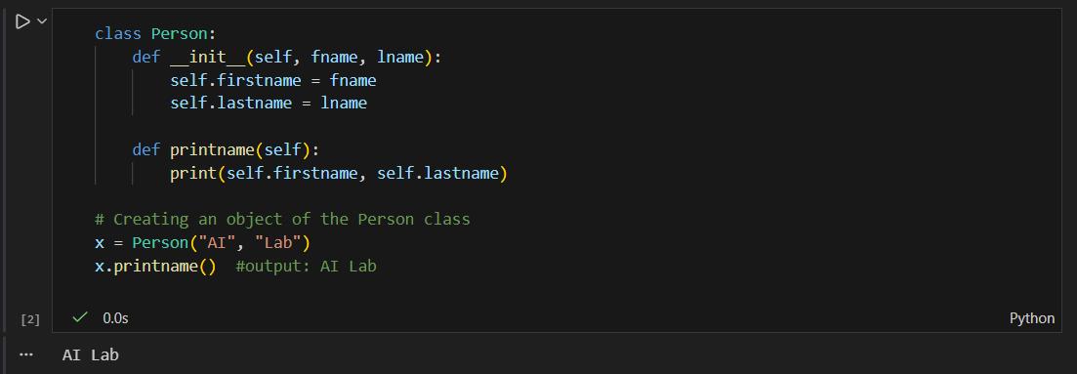
To create a class that inherits the functionality from another class, send the parent class as a parameter when creating the child class:
Now the Student class has the same properties and methods as the Person class.
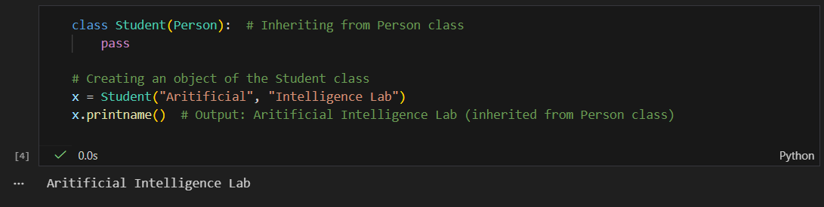
So far we have created a child class that inherits the properties and methods from its parent. We want to add the init () function to the child class (instead of the pass keyword). When you add the init () function, the child class will no longer inherit the parent's init () function. To keep the inheritance of the parent's init () function, add a call to the parent's init () function:
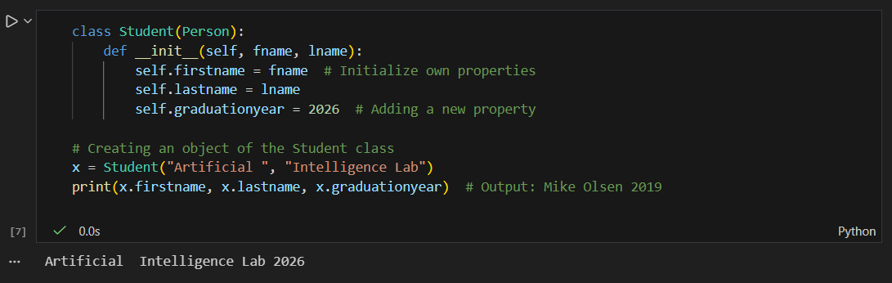Python also has a super() function that will make the child class inherit all the methods and properties from its parent:
By using the super() function, you do not have to use the name of the parent element, it will automatically inherit the methods and properties from its parent. Add a property called graduationyear to the student class.
In the example below, the year 2026 should be a variable, and passed into the Student class when creating student objects. To do so, add another parameter in the init () function.
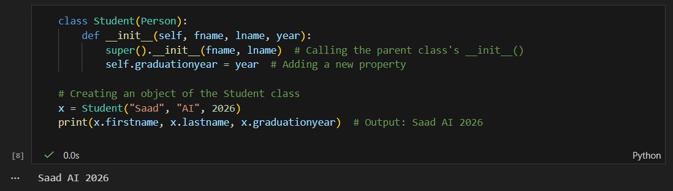
Task1:
Create a base class Shape with an abstract method calculate_area(). Implement the calculate_area() method in the following subclasses:
- Rectangle (Length × Width)
- Square (Side²)
- Circle (π × Radius²)
- Cylinder (2πr(r + h))
Test your classes by creating objects for each shape and calculating their areas.

Implementing Lambda Expressions & Generator functions
Lambda:
A lambda function is a small anonymous function. A lambda function can take any number of arguments but can only have one expression.
lambda arguments : expression
The expression is executed and the result is returned:
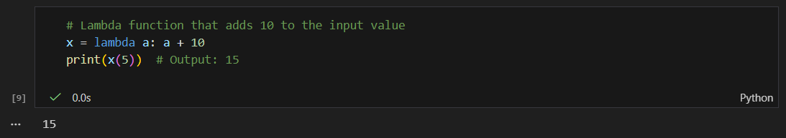Lambda functions can take any number of arguments:
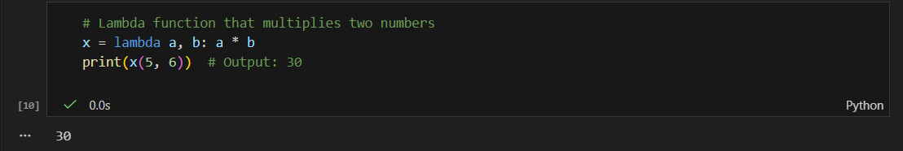The power of lambda is better shown when you use them as an anonymous function inside another function. Say you have a function definition that takes one argument, and that argument will be multiplied with an unknown number:
def myfunc(n):
return lambda a: a * n
Use that function definition to make a function that always doubles the number you send in:
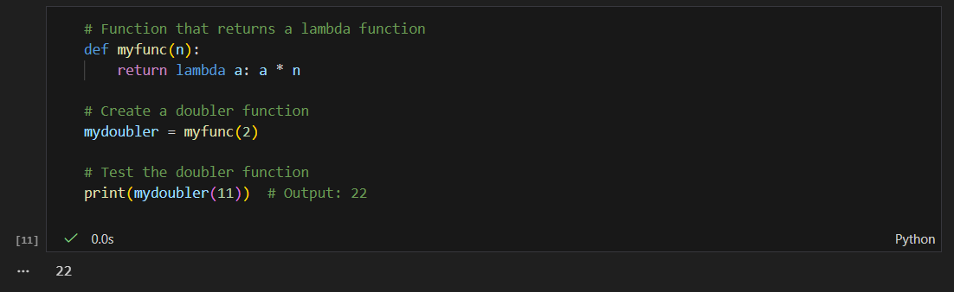

Generator functions:
Generator functions are a special kind of function that return a lazy iterator. These are objects that you can loop over like a list. However, unlike lists, lazy iterators do not store their contents in memory.
Generators are used to create iterators, but with a different approach. Generators are simple functions which return an iterable set of items, one at a time, in a special way.
When an iteration over a set of item starts using the for statement, the generator is run. Once the generator's function code reaches a "yield" statement, the generator yields its execution back to the for loop, returning a new value from the set. The generator function can generate as many values (possibly infinite) as it wants, yielding each one in its turn.
Here is a simple example of a generator function which returns 7 random integers: import random:
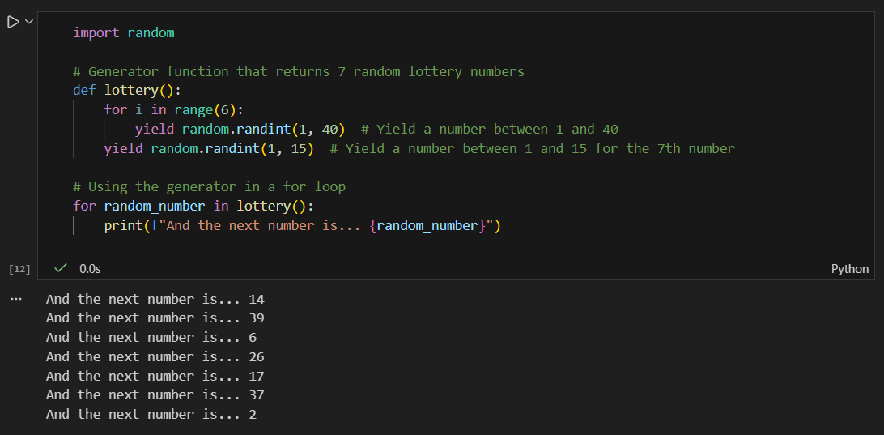
This function decides how to generate the random numbers on its own, and executes the yield statements one at a time, pausing in between to yield execution back to the main for loop.
- yield: Pauses the function execution and returns a value to the caller. The function can resume where it left off when called again.
- for loop: The loop iterates over the generator, automatically calling the generator function and getting the next value each time.

Tasks:
- Implement a lambda expression to calculate square of given number.
- Implement a lambda expression to calculate the length of passed string.
- Create a generator function that returns 5 random numbers between 1 and 100. Use a for loop to print the numbers.
- Implement a generator function that returns the Fibonacci sequence up to a given limit n. Use a for loop to print the sequence.

