Lab 4: Implementing Graph Algorithms (Part-1) (DFS, BFS)

(Open-Ended)

Graph:
Graphs are networks consisting of nodes connected by edges or arcs. In directed graphs, the connections between nodes have a direction, and are called arcs; in undirected graphs, the connections have no direction and are called edges. We mainly discuss directed graphs. Algorithms in graphs include finding a path between two nodes, finding the shortest path between two nodes, determining cycles in the graph (a cycle is a non-empty path from a node to itself), finding a path that reaches all nodes (the famous "traveling salesman problem"), and so on. Sometimes the nodes or arcs of a graph have weights or costs associated with them, and we are interested in finding the cheapest path.
There's considerable literature on graph algorithms, which are an important part of discrete mathematics. Graphs also have much practical use in computer algorithms. Obvious examples can be found in the management of networks, but examples abound in many other areas. For instance, caller-callee relationships in a computer program can be seen as a graph (where cycles indicate recursion, and unreachable nodes represent dead code).
Few programming languages provide direct support for graphs as a data type, and Python is no exception. However, graphs are easily built out of lists and dictionaries. For instance, here's a simple graph, the graph and graph's arcs:
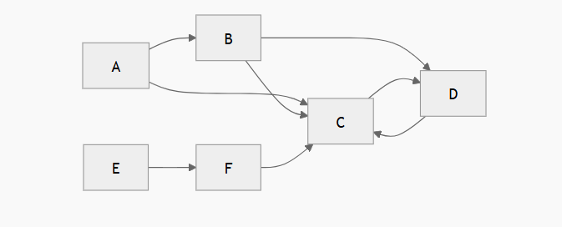
graph's arcs

A | -> | B
A | -> | C
B | -> | C
B | -> | D
C | -> | D
D  F -> C | -> | C
E | -> | F

This graph has six nodes (A-F) and eight arcs. It can be represented by the following Python data structure:
graph = {'A': ['B', 'C'],'B': ['C', 'D'],
'C': ['D'],'D': ['C'], 'E': ['F'], 'F': ['C']}

This is a dictionary whose keys are the nodes of the graph. For each key, the corresponding value is a list containing the nodes that are connected by a direct arc from this node. This is about as simple as it gets (even simpler, the nodes could be represented by numbers instead of names, but names are more convenient and can easily be made to carry more information, such as city names).
Let's write a simple function to determine a path between two nodes. It takes a graph and the start and end nodes as arguments. It will return a list of nodes (including the start and end nodes) comprising the path. When no path can be found, it returns None. The same node will not occur more than once on the path returned (i.e. it won't contain cycles). The algorithm uses an important technique called backtracking: it tries each possibility in turn until it finds a solution.
def find_path(graph, start, end, path=[]): path = path + [start]
if start == end: return path
if not graph.has_key(start): return None
for node in graph[start]: if node not in path:
newpath = find_path(graph, node, end, path) if newpath: return newpath
return None

A sample run (using the graph above):
>>> find_path(graph, 'A', 'D') ['A', 'B', 'C', 'D']
>>>

Breadth First Search or BFS
Breadth First Traversal (or Search) for a graph is similar to Breadth First Traversal of a tree (See method 2 of this post). The only catch here is, unlike trees, graphs may contain cycles, so we may come to the same node again. To avoid processing a node more than once, we use a Boolean visited array. For simplicity, it is assumed that all vertices are reachable from the starting vertex.
For example, in the following graph, we start traversal from vertex 2. When we come to vertex 0, we look for all adjacent vertices of it. 2 is also an adjacent vertex of 0. If we don’t mark visited vertices, then 2 will be processed again and it will become a non-terminating process. A Breadth First Traversal of the following graph is 2, 0, 3, 1.

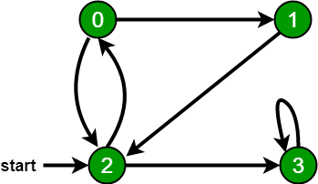

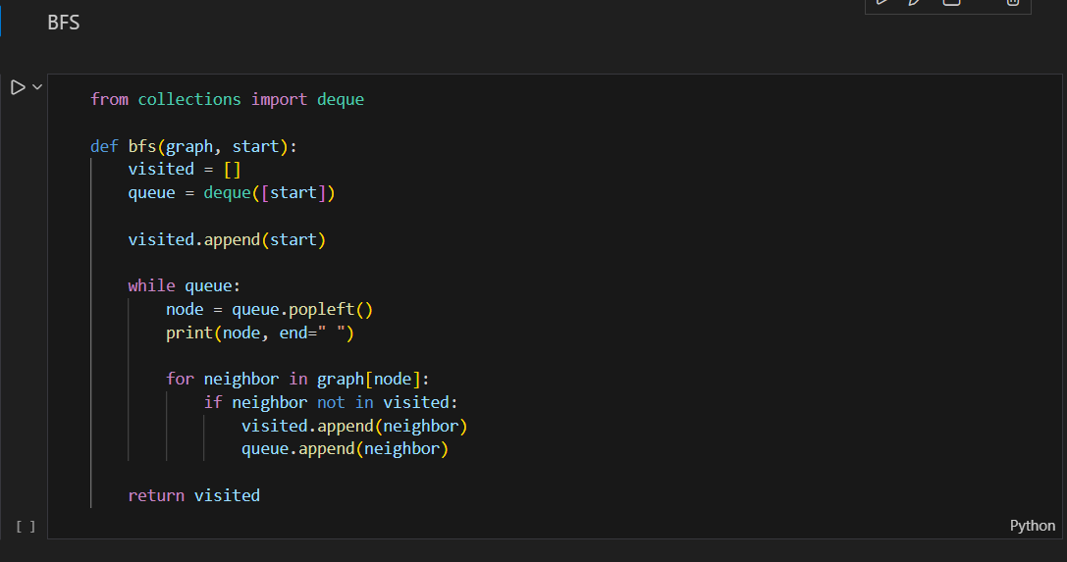

Depth First Search or DFS
Depth First Traversal (or Search) for a graph is similar to Depth First Traversal of a tree. The only catch here is, unlike trees, graphs may contain cycles, a node may be visited twice. To avoid processing a node more than once, use a Boolean visited array.
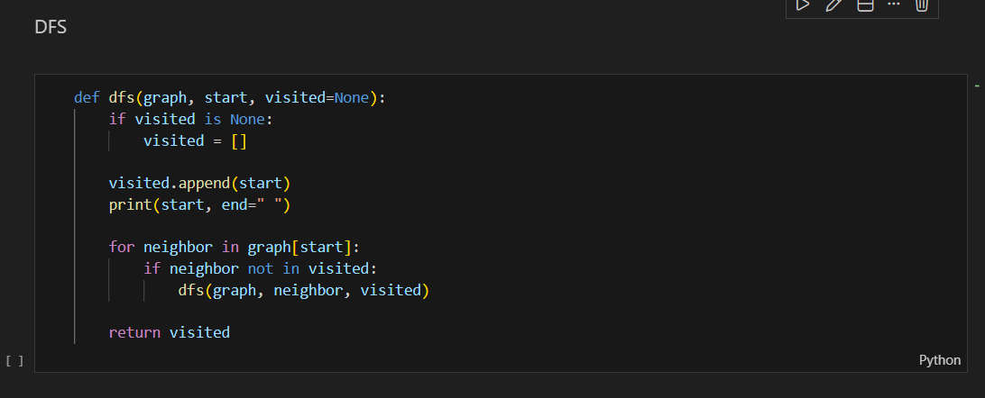

Task:
Using the graph below graph code implements BFS and DFS.

