Lab 07: Implementing Sorting Algorithms
Sometimes, data we store or retrieve in an application can have little or no order. We may have to rearrange the data to correctly process it or efficiently use it. Over the years, computer scientists have created many sorting algorithms to organize data.
- Bubble Sort
- Selection Sort
- Insertion Sort
- Merge Sort
- Heap Sort
- Quick Sort
- Sorting in Python

Bubble Sort
This simple sorting algorithm iterates over a list, comparing elements in pairs and swapping them until the larger elements "bubble up" to the end of the list, and the smaller elements stay at the "bottom".
def bubble_sort(arr):
n = len(arr)
for i in range(n):
swapped = False
for j in range(0, n - i - 1):
if arr[j] > arr[j + 1]:
arr[j], arr[j + 1] = arr[j + 1], arr[j]
swapped = True
if not swapped:
break
return arr
numbers = [64, 34, 25, 12, 22, 11, 90]
print("Original list:", numbers)
sorted_numbers = bubble_sort(numbers.copy())
print("Sorted list :", sorted_numbers)
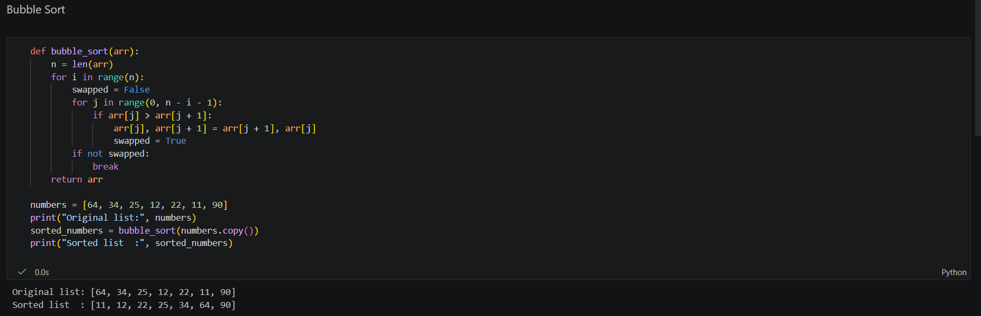

Time Complexity
In the worst case scenario (when the list is in reverse order), this algorithm would have to swap every single item of the array. Our swapped flag would be set to True on every iteration. Therefore, if we have n elements in our list, we would have n iterations per item - thus Bubble Sort's time complexity is O(n^2).

Selection Sort
This algorithm segments the list into two parts: sorted and unsorted. We continuously remove the smallest element of the unsorted segment of the list and append it to the sorted segment.
def selection_sort(arr):
n = len(arr)
for i in range(n):
min_index = i
for j in range(i + 1, n):
if arr[j] < arr[min_index]:
min_index = j
arr[i], arr[min_index] = arr[min_index], arr[i]
return arr
numbers = [29, 10, 14, 37, 13]
print("Original list:", numbers)
sorted_numbers = selection_sort(numbers.copy())
print("Sorted list :", sorted_numbers)
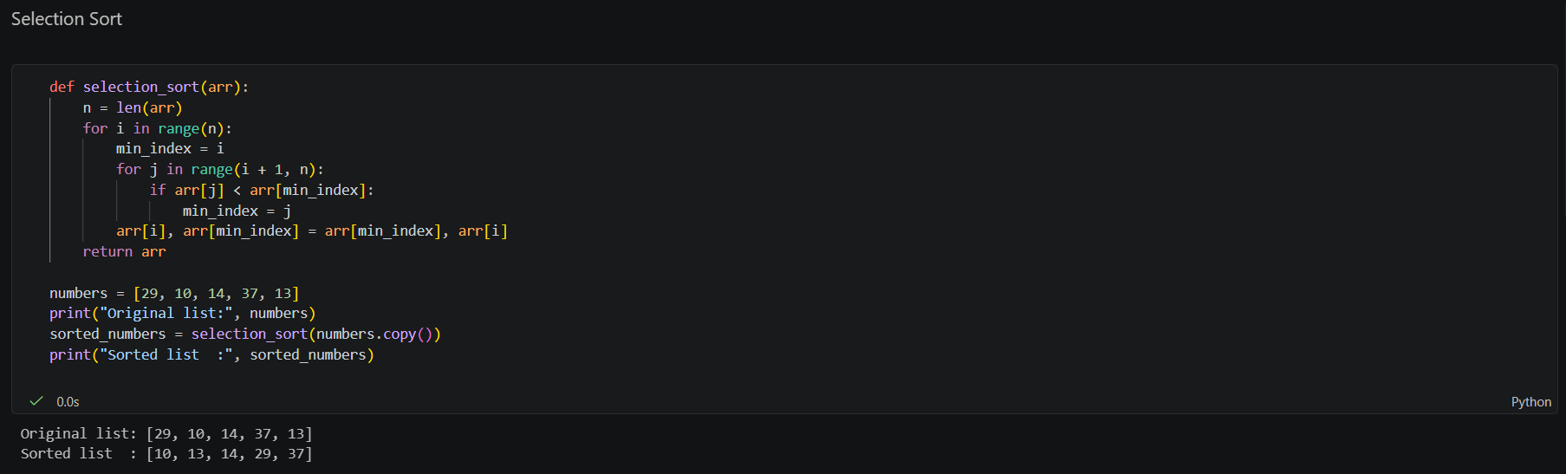

Time Complexity
We can easily get the time complexity by examining the for loops in the Selection Sort algorithm. For a list with n elements, the outer loop iterates n times. The inner loop iterate n-1 when i is equal to 1, and then n-2 as i is equal to 2 and so forth. The amount of comparisons are (n - 1) + (n - 2) + ... + 1, which gives Selection Sort a time complexity of O(n^2).

Insertion Sort
Like Selection Sort, this algorithm segments the list into sorted and unsorted parts. It iterates over the unsorted segment, and inserts the element being viewed into the correct position of the sorted list.
def insertion_sort(arr):
for i in range(1, len(arr)):
key = arr[i]
j = i - 1
while j >= 0 and arr[j] > key:
arr[j + 1] = arr[j]
j -= 1
arr[j + 1] = key
return arr
numbers = [12, 11, 13, 5, 6]
print("Original list:", numbers)
sorted_numbers = insertion_sort(numbers.copy())
print("Sorted list :", sorted_numbers)
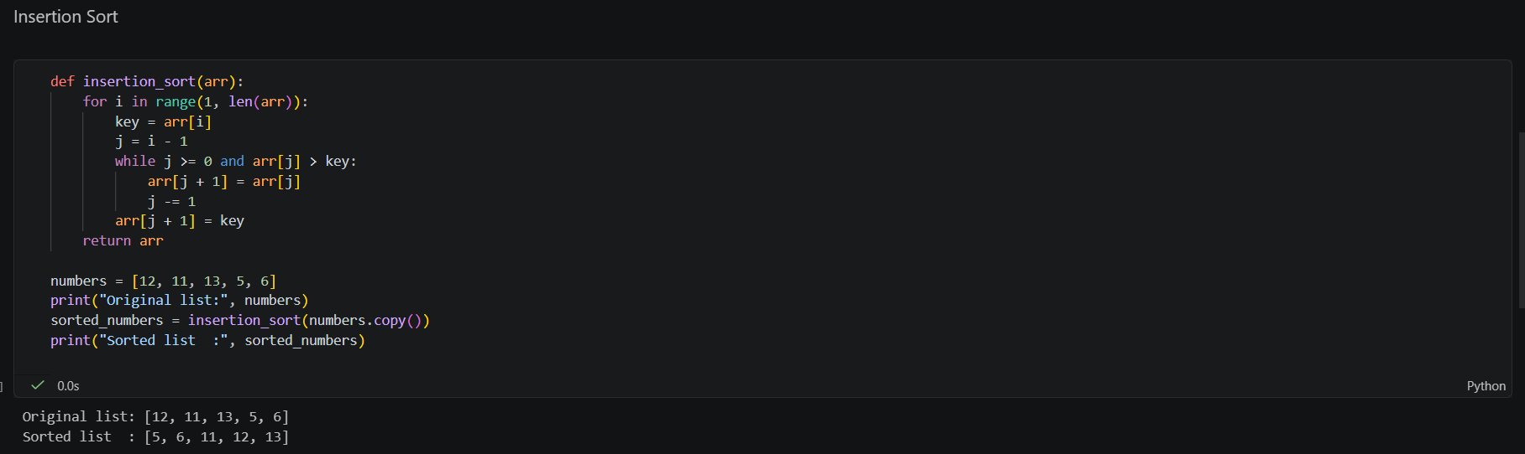

Time Complexity
In the worst case scenario, an array would be sorted in reverse order. The outer for loop in Insertion Sort function always iterates n-1 times. In the worst case scenario, the inner for loop would swap once, then swap two and so forth. The amount of swaps would then be 1 + 2 + ... + (n - 3) + (n - 2) + (n - 1) which gives Insertion Sort a time complexity of O(n^2).

Heap Sort
This popular sorting algorithm, like the Insertion and Selection sorts, segments the list into sorted and unsorted parts. It converts the unsorted segment of the list to a Heap data structure, so that we can efficiently determine the largest element.

import heapq
def heap_sort(arr):
heap = arr.copy()
heapq.heapify(heap)
sorted_list = []
while heap:
sorted_list.append(heapq.heappop(heap))
return sorted_list
numbers = [12, 11, 13, 5, 6, 7]
print("Original list:", numbers)
sorted_numbers = heap_sort(numbers)
print("Sorted list :", sorted_numbers)
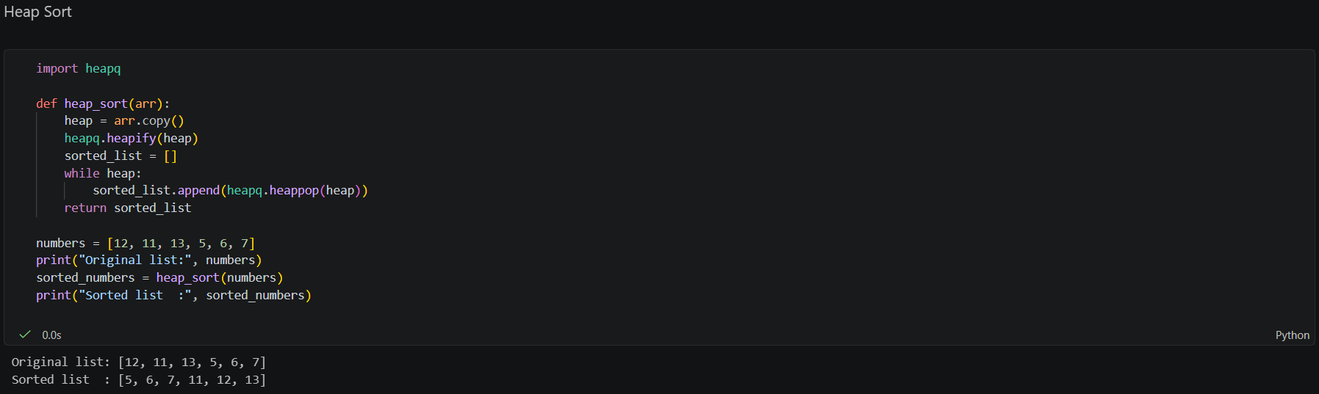

Time Complexity
Let's first look at the time complexity of the heapify function. In the worst case the largest element is never the root element, this causes a recursive call to heapify. While recursive calls might seem dauntingly expensive, remember that we're working with a binary tree. Visualize a binary tree with 3 elements, it has a height of 2. Now visualize a binary tree with 7 elements, it has a height of 3. The tree grows logarithmically to n. The heapify function traverses that tree in O(log(n)) time. The heap_sort function iterates over the array n times. Therefore the overall time complexity of the Heap Sort algorithm is O(nlog(n)).

Merge Sort
This divide and conquer algorithm splits a list in half, and keeps splitting the list by 2 until it only has singular elements. Adjacent elements become sorted pairs, then sorted pairs are merged and sorted with other pairs as well. This process continues until we get a sorted list with all the elements of the unsorted input list.
def merge_sort(arr):
if len(arr) <= 1:
return arr
mid = len(arr) // 2
left = merge_sort(arr[:mid])
right = merge_sort(arr[mid:])
merged = []
i = j = 0
while i < len(left) and j < len(right):
if left[i] < right[j]:
merged.append(left[i])
i += 1
else:
merged.append(right[j])
j += 1
merged.extend(left[i:])
merged.extend(right[j:])
return merged
numbers = [38, 27, 43, 3, 9, 82, 10]
print("Original list:", numbers)
sorted_numbers = merge_sort(numbers.copy())
print("Sorted list :", sorted_numbers)
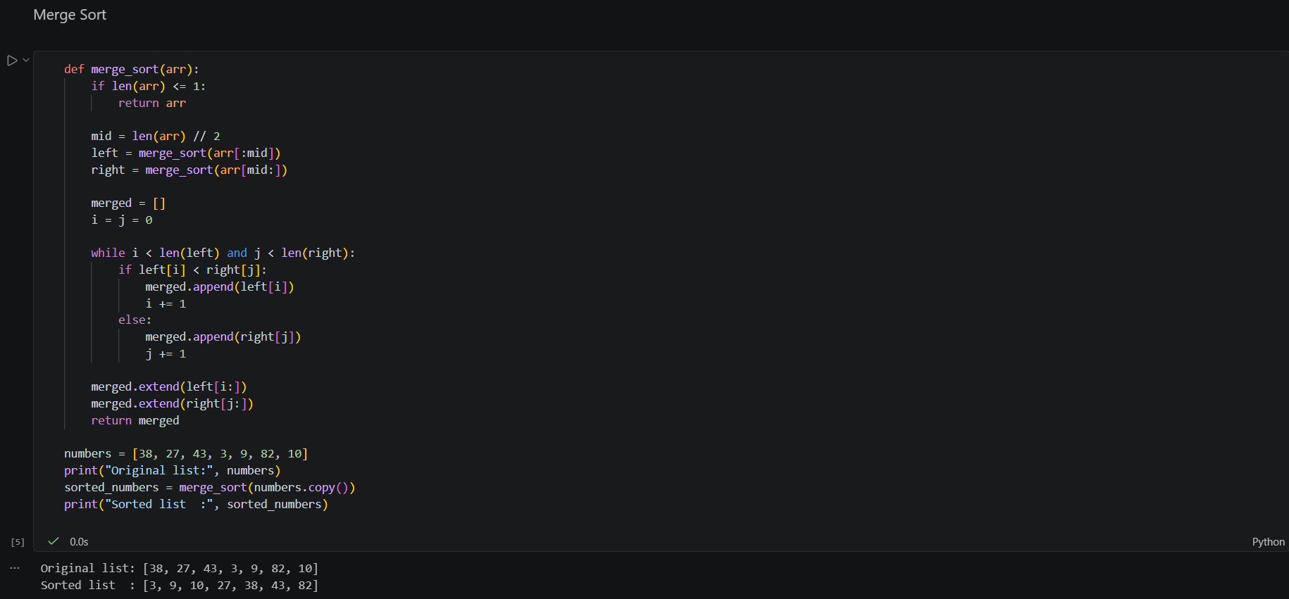

Time Complexity
Let's first look at the merge function. It takes two lists, and iterates n times, where n is the size of their combined input. The merge_sort function splits its given array in 2, and recursively sorts the sub-arrays. As the input being recursed is half of what was given, like binary trees this makes the time it takes to process grow logarithmically to n. Therefore the overall time complexity of the Merge Sort algorithm is O(nlog(n)).

Quick Sort
This divide and conquer algorithm is the most often used sorting algorithm covered in this article. When configured correctly, it's extremely efficient and does not require the extra space Merge Sort uses. We partition the list around a pivot element, sorting values around the pivot.
def quick_sort(arr):
if len(arr) <= 1:
return arr
pivot = arr[len(arr) // 2]
left = [x for x in arr if x < pivot]
middle = [x for x in arr if x == pivot]
right = [x for x in arr if x > pivot]
return left + middle + right
numbers = [10, 7, 8, 9, 1, 5]
print("Original list:", numbers)
sorted_numbers = quick_sort(numbers.copy())
print("Sorted list :", sorted_numbers)
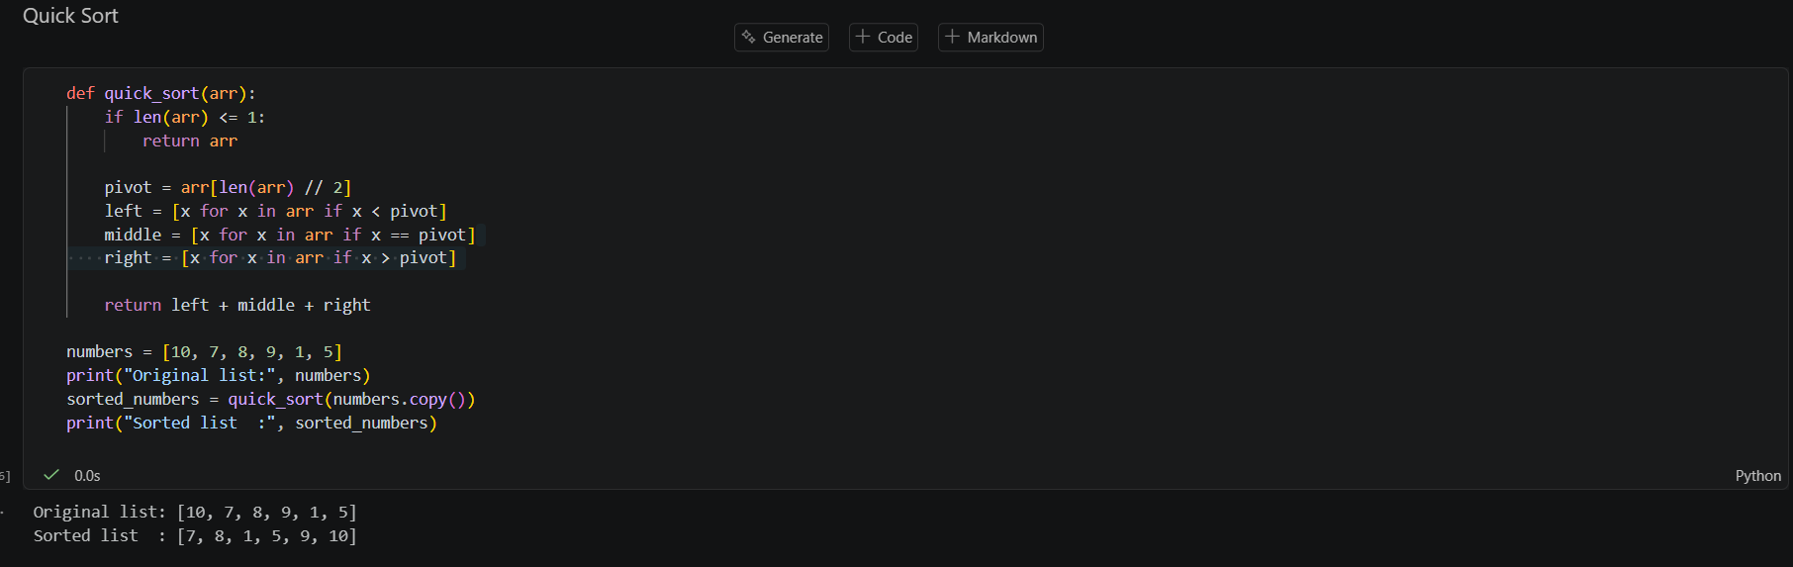

Time Complexity
The worst case scenario is when the smallest or largest element is always selected as the pivot. This would create partitions of size n-1, causing recursive calls n-1 times. This leads us to a worst case time complexity of O(n^2).

Python's Built-in Sort Functions
While it's beneficial to understand these sorting algorithms, in most Python projects you would probably use the sort functions already provided in the language. We can change our list to have it's contents sorted with the sort() method:
numbers = [2, 1, 1, 3, 1, 2, 2]
print("Original list:", numbers)
numbers.sort()
print("Sorted list :", numbers)
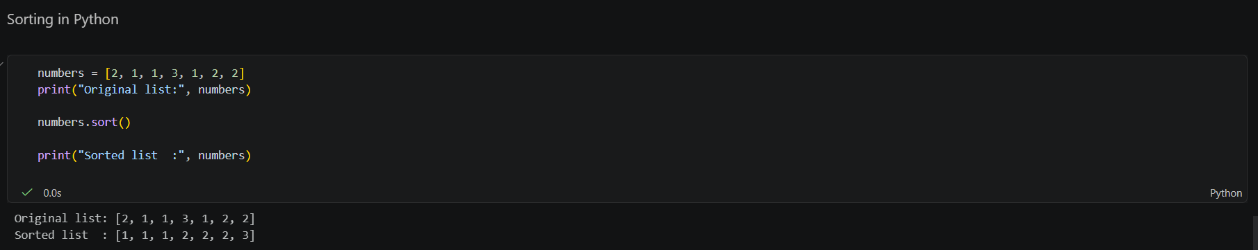

Exercise:
In this lab, you will go beyond basic implementation and design a smart sorting framework that can analyze input data and automatically select the most suitable sorting algorithm.

