

Lab Journal: 1
Date: 29 / 01 / 26

Student : Abdul Rafay
Enrollment : 01-131232-004

Department of Software Engineering

Bahria University, Islamabad

Web Engineering (Spring - 2026)
Teacher: Subas Bilal.

Comments:

Signature

Lab_01: Introduction to Web Engineering.

Objective:
- Discuss about different Web Servers.
- Perform all the tasks.
- Create a CV page.

Task 1:
A web server is software (sometime hardware) that:
- Receive requests from clients (usually browsers).
- Process the request using the protocols.
- Send back the response in form of requested resource file.

Web Servers:
Apache: A cross platform (Win, Linux, Mac), best for beginners, share hosting. It provides a bit slower experience.
IIS (Internet Information Service): A Web server by Microsoft. Best for the ASP.NET, C#. Work only for Windows.
LiteSpeed: A Linux base server provides much higher speed than Apache for the Linux based system.
Caddy: A cross-platform web server provides high speed. It is simple and secure.

Task 2:
Code:
<html>
<head>
<title>Web Lab</title>
<head>
<body>
<h1>Abdul Rafay</h1>
<p>My name is <u>Abdul Rafay</u><br>
I am a Engineering student at <a href="https://bahria.edu.pk"><i><b>BUIC</b></i></a><br>
<b>I am currently working on:</b>
<ul>
<li>2D Game development.
<li>3D Games Learning.
<li>Pakistan Esports Organization.
</ul>
My <a href="CV.html">CV</a>
</p>
</body>
</html>

Screen Shots:
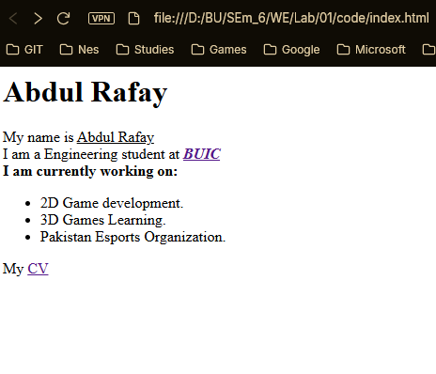

Task 3:
Code:
<html>
<head>
<title>Abdul Rafay</title>
</head>
<body>
<p><h1>Abdul Rafay</h1><p>
<p><h3>Islamabad, Pakistan<h3><p>
<p><h3>rafay0820188@gmail.com</h3></p>
<hr>
<p><h2>Objective<h2></h2>
Looking to learn and gain experience.</p>
<br>
<p><h2>Educations</h2>
BSE.</p>
<br>
<p><h2>Skills</h2>
<ul>
<li>Game Development
<li>Teamwork
<li>.....
</ul></p>
<br>
<p><h2>Experience</h2>
Fresher, Student</p>
<br>
<p><h2>Projects</h2>
have done the projects includes:
<ul>
<li>BlockChain
<li>Console Game Dev
<li>Basic Antivirus Software
<li>Cyber Security (currently working on that)
</ul></p>
<br>
<p><h2>Github</h2>
<a href="https://github.com/CharlieFour">CharlieFour</a></p>
</body>
</html>
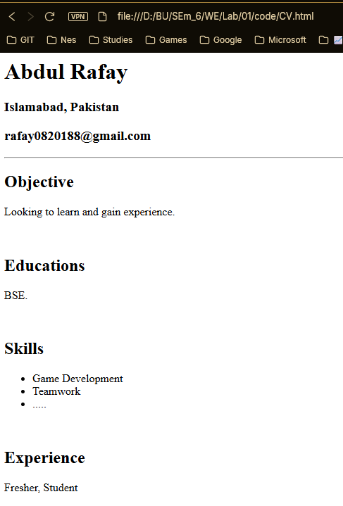

Conclusion:
At the end of this lab I learn about the Web Servers, able to understand and write html web page code.

