Lab Task: Set up Node.js and implement backend authentication (user login and registration) Backend

Lab Objectives
By the end of this lab, students will be able to: - Set up a Node.js backend using Express - Connect a Node.js application to MongoDB Atlas using Mongoose - Implement user authentication (Signup & Login) - Use bcrypt for password hashing - Use JSON Web Tokens (JWT) for authentication - Test API endpoints using Postman

Software / Tools Required
- Node.js (installed)
- Visual Studio Code
- MongoDB Atlas account
- Postman

Lab Description
In this lab, you will create the backend of a MERN application focused on user authentication. The backend will support user signup and login using secure password hashing and JWT-based authentication, with data stored in MongoDB Atlas.
References:
https://www.youtube.com/watch?v=F9gB5b4jgOI&t=154s
https://www.youtube.com/watch?v=O3BUHwfHf84&t=3553s

Step 1: Project Setup
- Create a new folder named:
- NEW MERN
- Open the folder in Visual Studio Code.
- Inside the project folder, create another folder named:
- backend
- Open the terminal in VS Code and navigate to the backend folder.

Step 2: Initialize Node Project
Run the following commands in the terminal:
npm init -y
npm install express mongoose dotenv jsonwebtoken bcryptjs
npm install nodemon -D
These packages are used for: - express – web framework - mongoose – MongoDB object modeling - dotenv – environment variables - jsonwebtoken – authentication tokens - bcryptjs – password hashing - nodemon (-D) – development tool to auto-restart the server on file changes

Step 3: Folder Structure
Create the following folder structure inside NEW MERN folder in VS CODE:
backend
│── models
│ └── User.js
│── routes
│ └── auth.js
│── .env
│── server.js
│── package.json

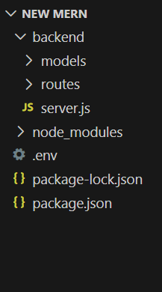

Step 4: MongoDB Atlas Setup
- Create an account on MongoDB Atlas.
- Create a new Cluster.
- Create a database user (username & password).
- Whitelist your IP address.
- Copy the connection string.

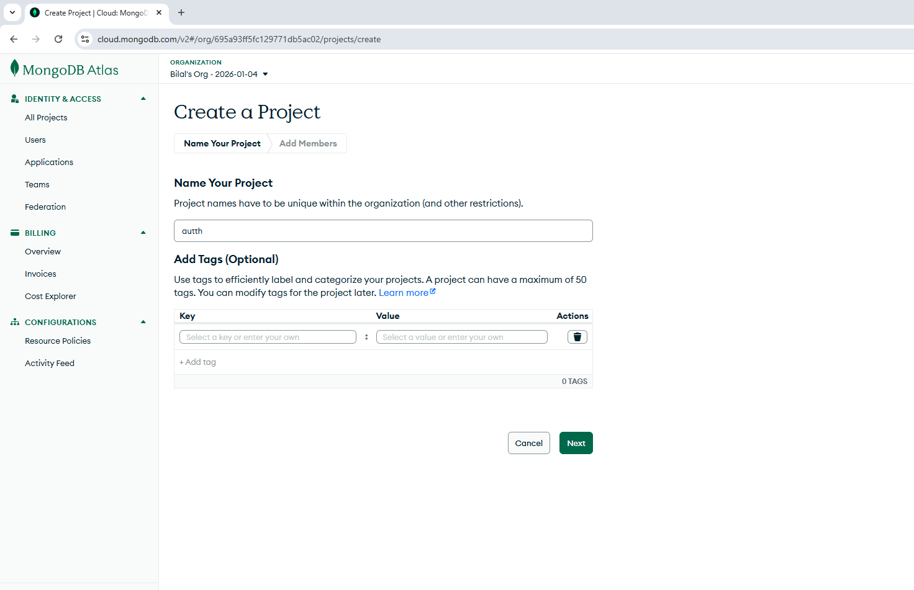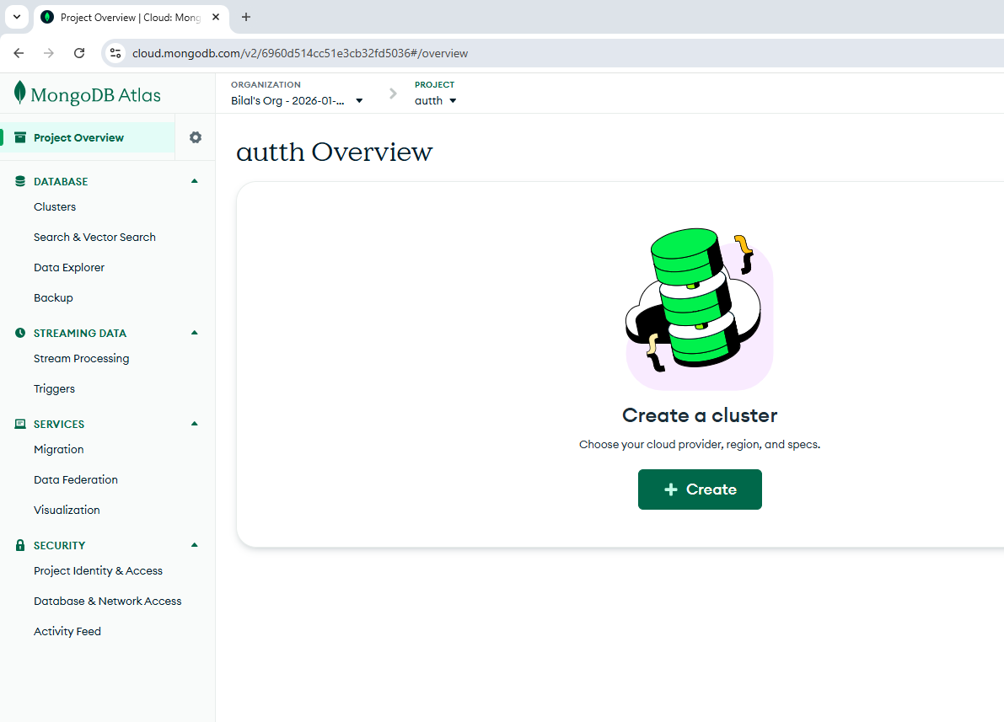
Create a cluster
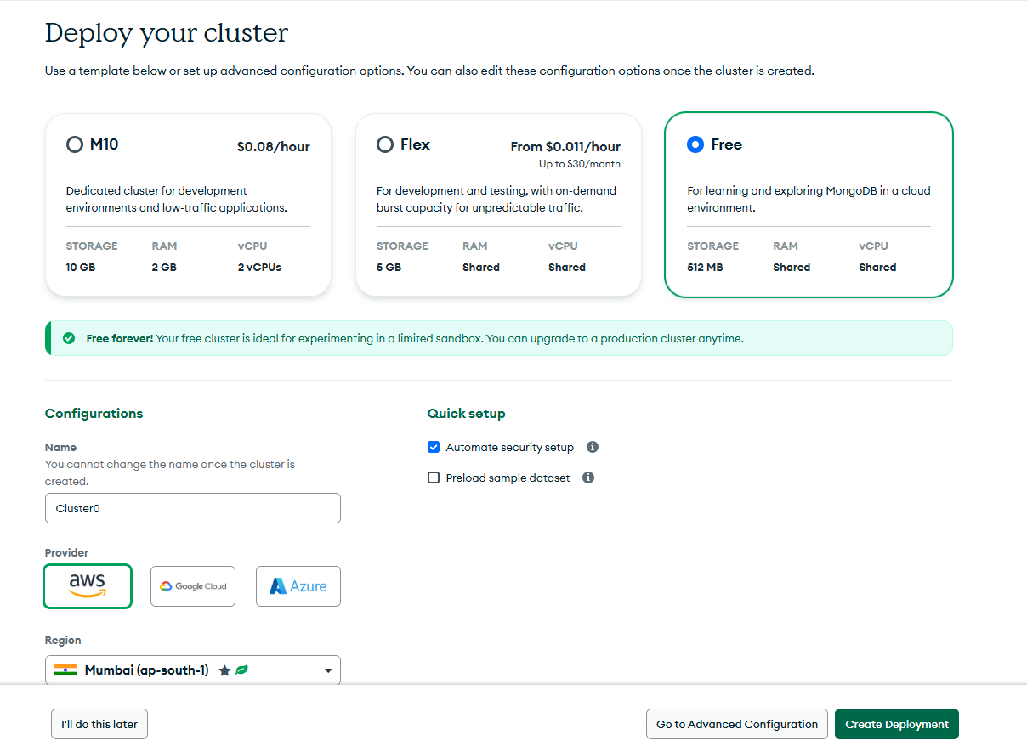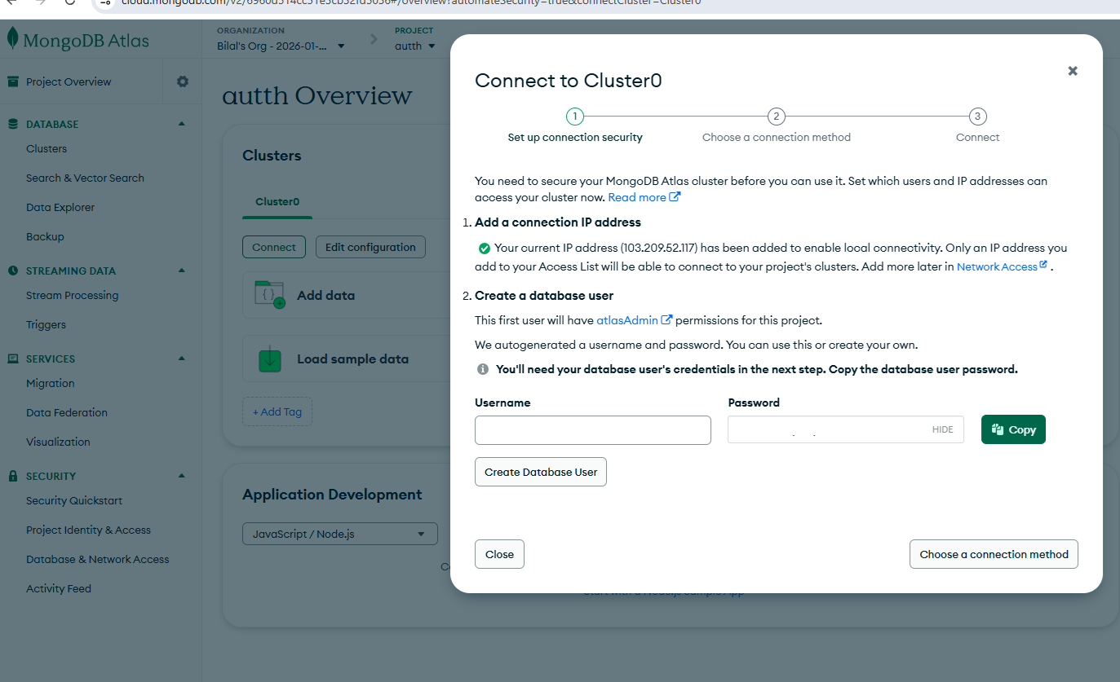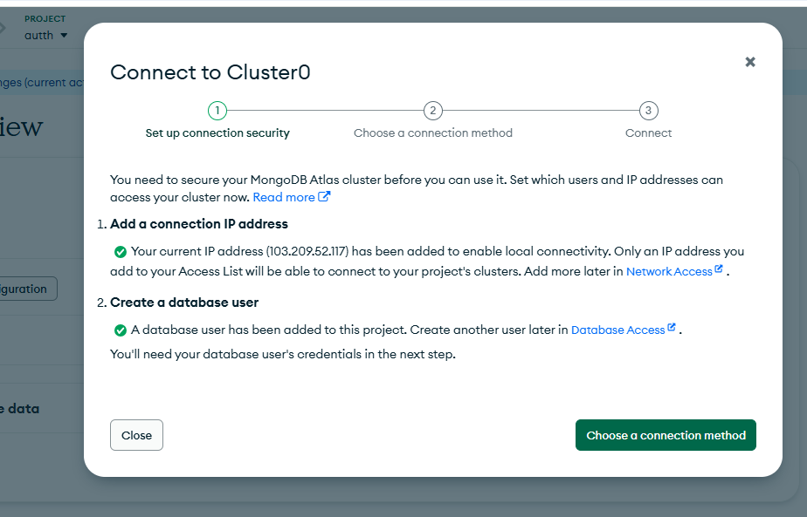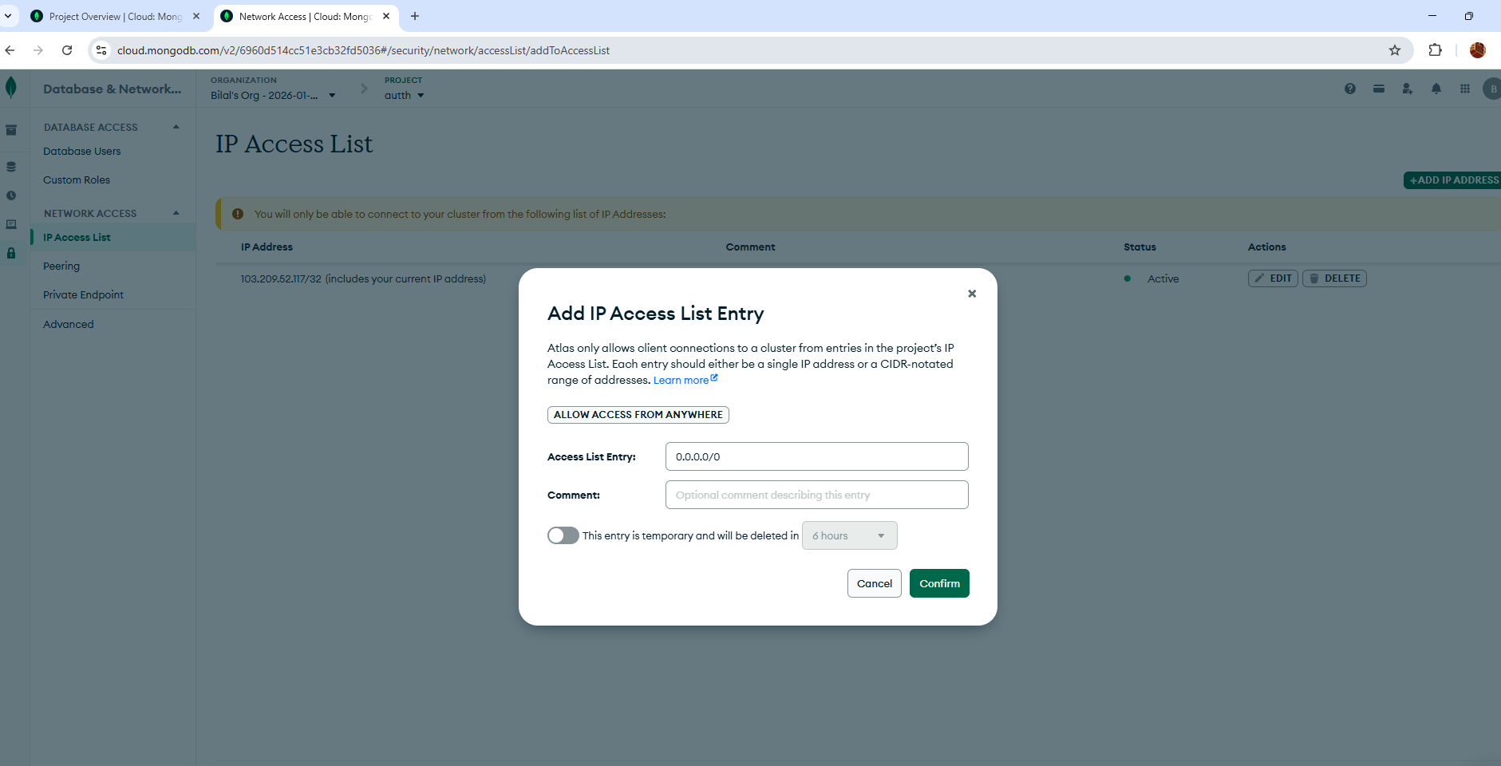

Step 5: Environment Configuration (.env)
Create a .env file inside the backend folder and add the following:
MONGO_URI=mongodb+srv://<username>:<password>@clusterauth.one6ent.mongodb.net/
PORT=5000
JWT_SECRET=G7s9vQ2mLz8wX4pR6fT1bN0kY3uH5aD
Replace <username> and <password> with your MongoDB Atlas credentials.

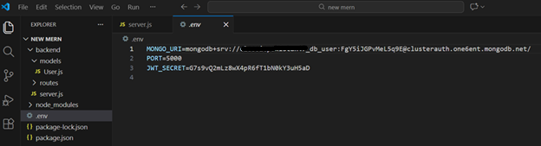

Step 6: Package.JSON

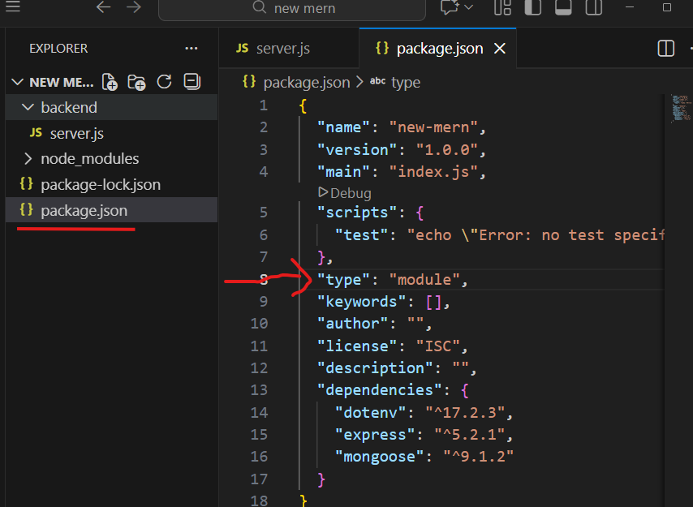
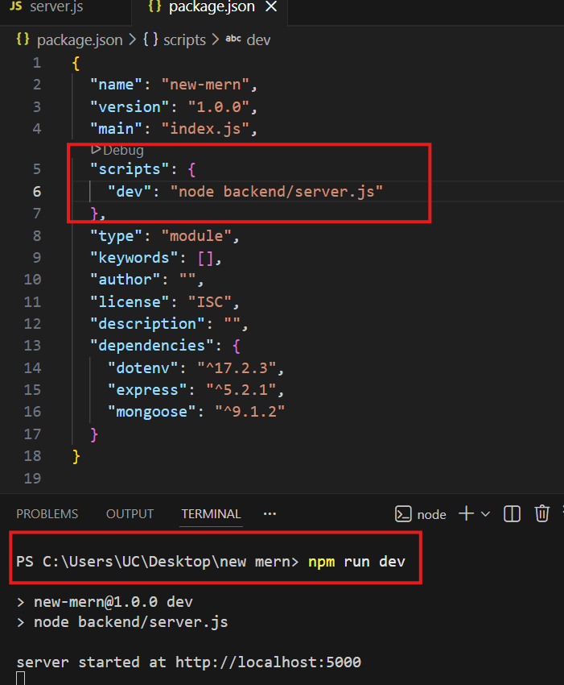
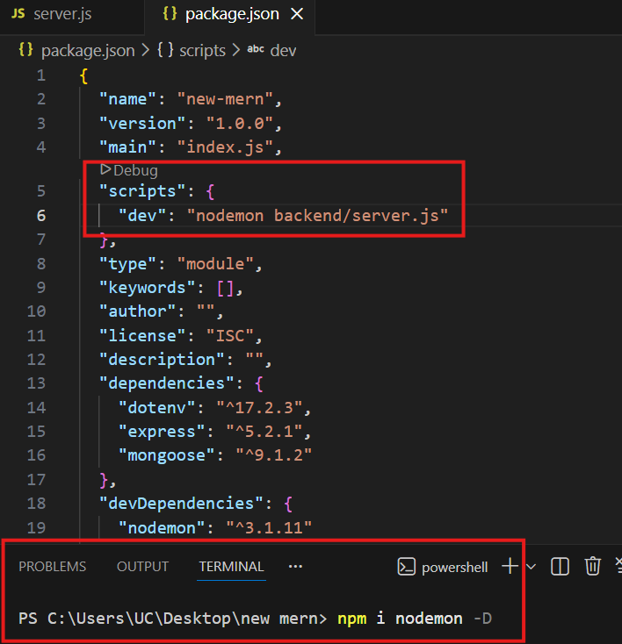

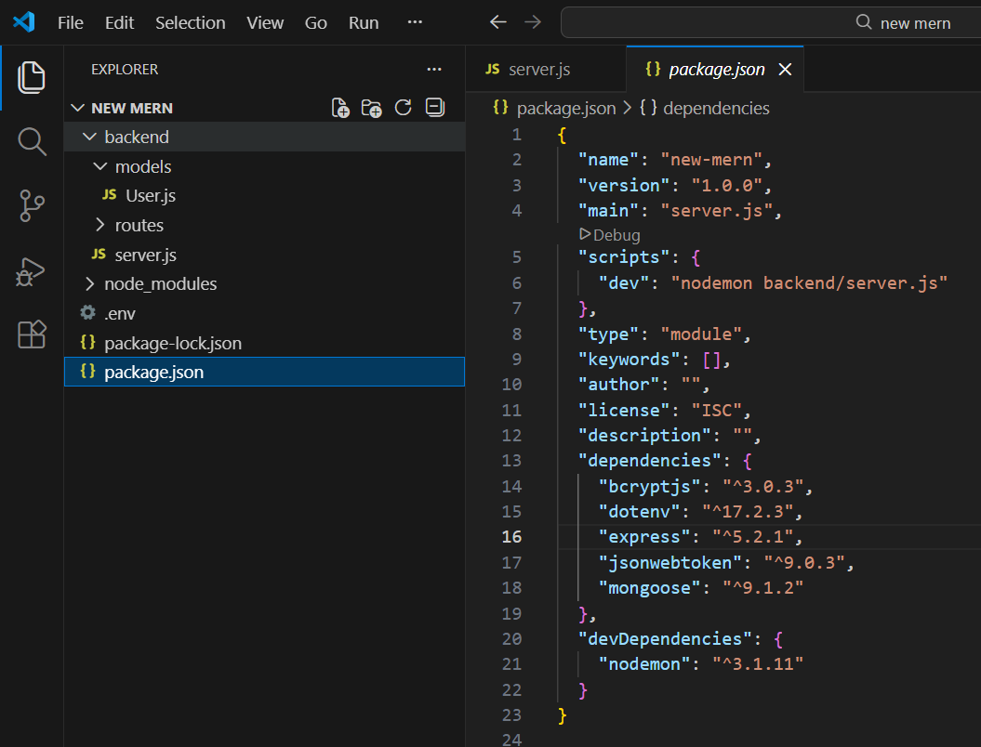

Step 7: Server Setup (server.js)
The server.js file acts as the entry point of the backend application. It: - Initializes Express - Connects to MongoDB - Uses authentication routes - Starts the server

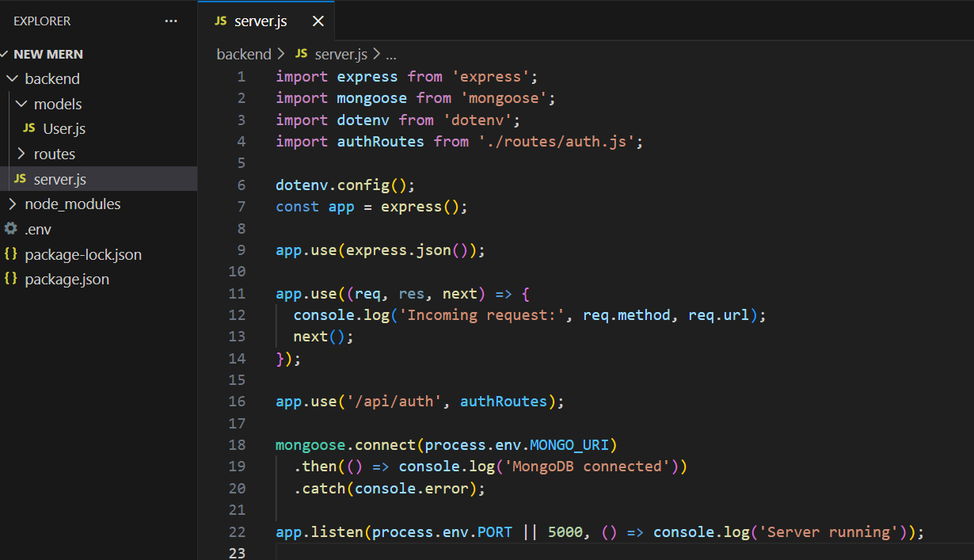

import express from 'express';
import mongoose from 'mongoose';
import dotenv from 'dotenv';
import authRoutes from './routes/auth.js';

dotenv.config();
const app = express();

app.use(express.json());

app.use((req, res, next) => {
console.log('Incoming request:', req.method, req.url);
next();
});

app.use('/api/auth', authRoutes);

mongoose.connect(process.env.MONGO_URI)
.then(() => console.log('MongoDB connected'))
.catch(console.error);

app.listen(process.env.PORT || 5000, () => console.log('Server running'));

Step 7: User Model (models/User.js)
The User model defines the structure of user data stored in MongoDB, including: - Username - Email - Password – Timestamps

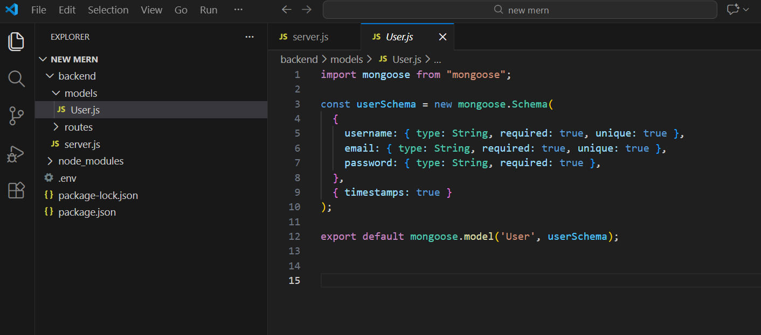

import mongoose from "mongoose";

const userSchema = new mongoose.Schema(
{
username: { type: String, required: true, unique: true },
email: { type: String, required: true, unique: true },
password: { type: String, required: true },
},
{ timestamps: true }
);

export default mongoose.model('User', userSchema);

Step 8: Authentication Routes (routes/auth.js)
The authentication routes provide:

Signup API
- Checks if user already exists
- Hashes password using bcrypt
- Saves user to MongoDB

Login API
- Verifies email and password
- Generates JWT token
- Returns user data and token

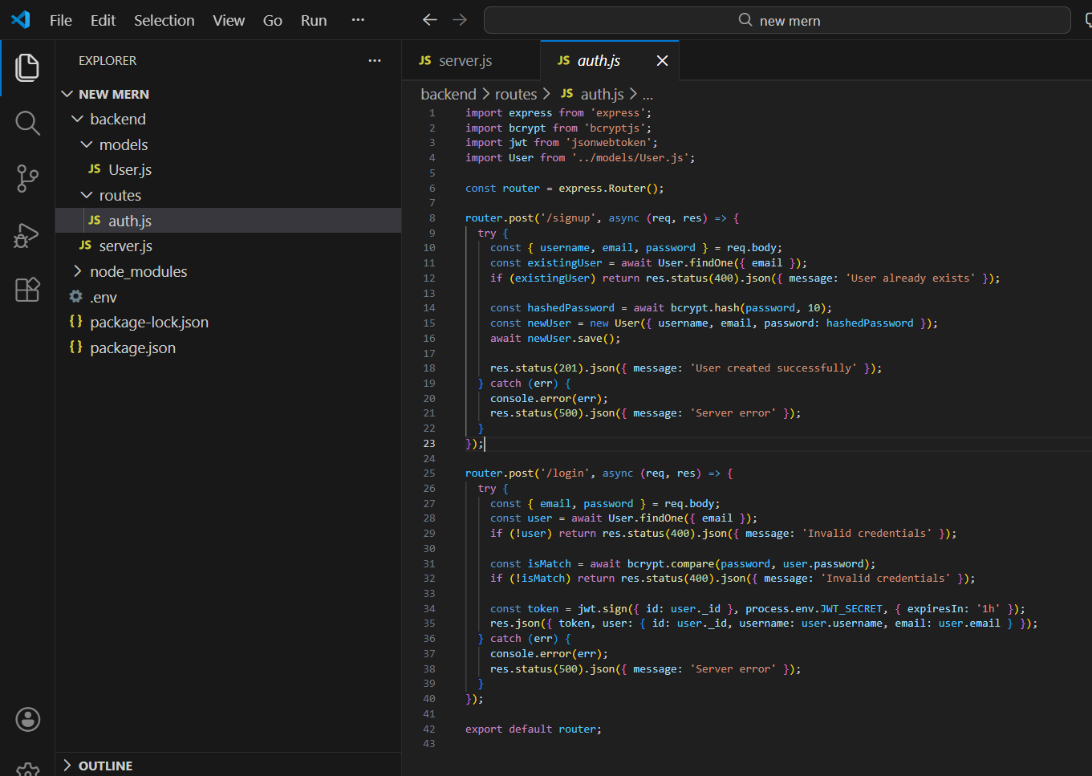

import express from 'express';
import bcrypt from 'bcryptjs';
import jwt from 'jsonwebtoken';
import User from '../models/User.js';

const router = express.Router();

router.post('/signup', async (req, res) => {
try {
const { username, email, password } = req.body;
const existingUser = await User.findOne({ email });
if (existingUser) return res.status(400).json({ message: 'User already exists' });

const hashedPassword = await bcrypt.hash(password, 10);
const newUser = new User({ username, email, password: hashedPassword });
await newUser.save();

res.status(201).json({ message: 'User created successfully' });
} catch (err) {
console.error(err);
res.status(500).json({ message: 'Server error' });
}
});

router.post('/login', async (req, res) => {
try {
const { email, password } = req.body;
const user = await User.findOne({ email });
if (!user) return res.status(400).json({ message: 'Invalid credentials' });

const isMatch = await bcrypt.compare(password, user.password);
if (!isMatch) return res.status(400).json({ message: 'Invalid credentials' });

const token = jwt.sign({ id: user._id }, process.env.JWT_SECRET, { expiresIn: '1h' });
res.json({ token, user: { id: user._id, username: user.username, email: user.email } });
} catch (err) {
console.error(err);
res.status(500).json({ message: 'Server error' });
}
});

export default router;

Step 9: Running the Server
Start the backend server using:
npm run dev
Expected output:
MongoDB connected
Server running

Step 10: Testing with Postman

Signup Endpoint
- Method: POST
- URL: http://localhost:5000/api/auth/signup
- Body (JSON):
{
"username": "testuser",
"email": "test@example.com",
"password": "123456"
}

Login Endpoint
- Method: POST
- URL: http://localhost:5000/api/auth/login
- Body (JSON):
{
"email": "test@example.com",
"password": "123456"
}

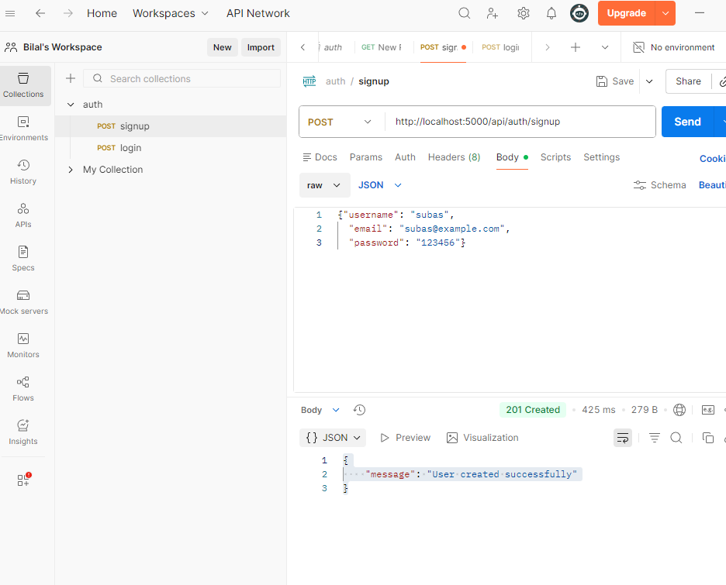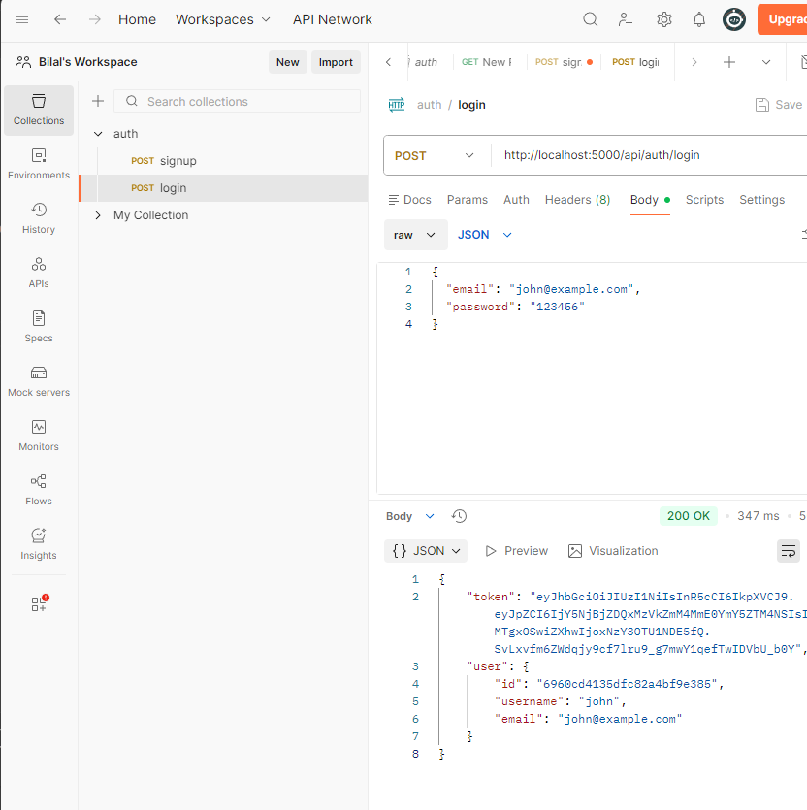

Step 11: MongoDB Verification
- Open MongoDB Atlas
- Navigate to Collections
- Verify that the user data is stored in the database

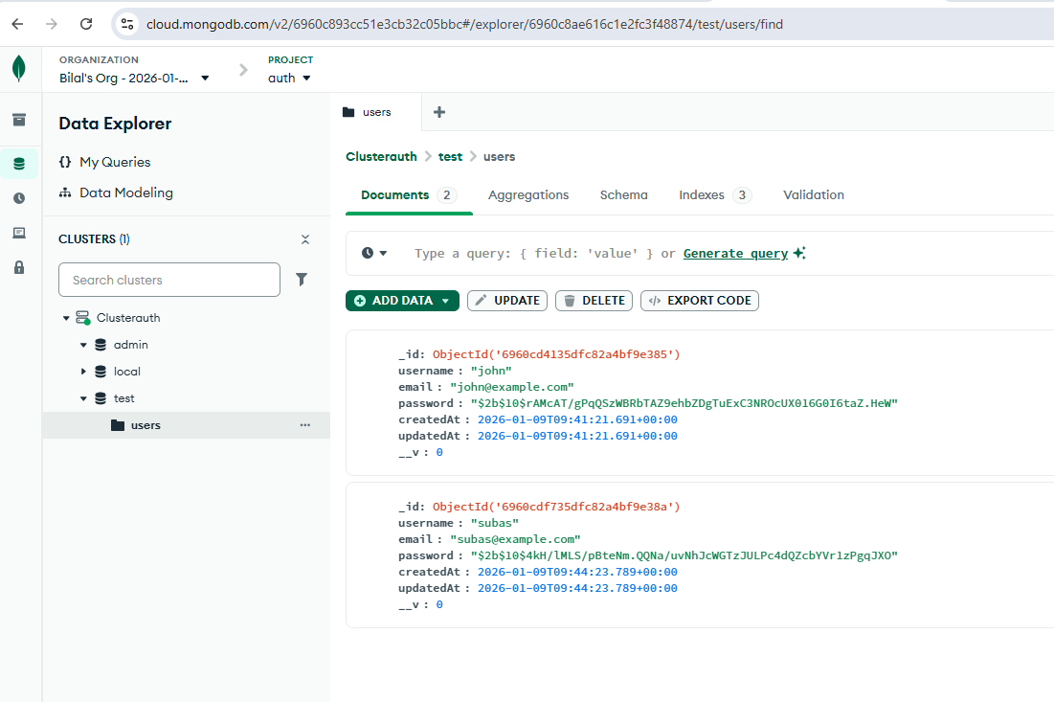

Expected Learning Outcomes
Students will be able to: - Build a secure backend using Node.js and Express - Integrate MongoDB Atlas with Mongoose - Implement authentication using JWT - Test REST APIs using Postman

Lab Submission
- Screenshot of Postman signup and login responses in a pdf
- Screenshot of MongoDB Atlas user collection in a pdf
- Zip file of the backend project

