1. Approach

Student Number: 164776

The machine learning approach used was to process the data, and then fit the data to several different classifiers and compare their accuracy. The program was coded in Python, and as such the classifiers that were implemented are both designed to be used with categorical data. The dataset is a mix of nominal and categorical data and has high dimensionality, and the classifiers chosen (logistic regression [1] and SVM (Support Vector Machine) are best fit for data sets like this. The data set will be dummy encoded (see Methodology for more details), and logistic regression works most effectively with binary data. The specific SVM utilised is scikit-learn’s LinearSVC [2], as it has better scaling to large sample numbers due to its implementation.

Methodology
Data pre-processing for this model was a very complex and delicate task, due to the nature of the data. The data set is a combination of nominal data (number columns such as age) and categorical data (working class, education, etc.). Due to this and the lack of support for non-numerical data types in Python machine learning libraries, several workarounds and compromises had to be made regarding the pre-processing of the data.
The first pre-processing step was to collapse some of the factor levels, specifically most of the categorical data where many were overly specific. The categories were generalized (e.g. combining several low-skill labour jobs into a single category in occupation) to make the data more streamlined. Additionally, some of the data with a ‘?’ in certain columns was considered missing and was changed.
The next issue is to consider whether to impute or remove the missing values. The figure below shows the amount of missing data in the training dataset: 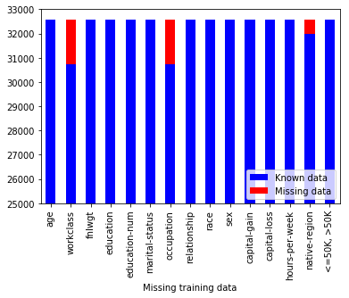
Figure 1: Missing training data by column (labelled red).
As the figure shows, there are over 1000 missing data features in the work-class and occupation sets, and a small number of missing features in the native region set. This is a significant number, but in relation to the entire dataset it’s less than 5%. It won’t massively affect the dataset, but it warrants dealing with properly.
The next point to consider regarding the missing data is whether it’s missing at random or not. The dataset could just be missing some features by happenstance, or there could be correlations in the missing data (e.g. an individual’s occupation is unknown for the same reason their working class is unknown).
To see if there are any correlations in the missing values, the missingno data visualisation suite [3] is used.
This suite can create a dendrogram to check for correlations in the missing data, as shown below: 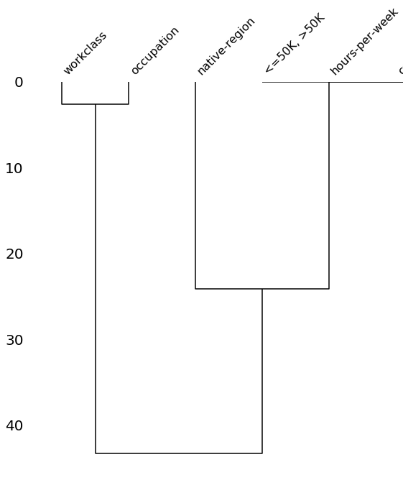
Figure 2: A dendrogram comparing variables by their nullity correlation. The closer their link’s distance to zero, the stronger they predict the other’s presence.

Note that the dendrogram has all of the non-missing categories cropped. The primary point of the graph is the strong correlation between work-class and occupation, meaning that almost all of the time a value is missing from one category, it is missing from the other. This suggests that the data is not missing at random. As such, a smart imputer that can detect these correlations should be the best solution for the missing values.

Unfortunately, this is where compromises in the pre-processing step have to be made. Very few smart imputers coded on Python supported categorical data, and those few that did do not support object data types. Ideally, a random forest imputer such as R’s missForest package would be used to impute the missing values, but no similar package exists on Python that supports the data types being used. Other imputer types such as MICE, kNN and FKM could not be used either, for the same reasons.
Because of this, the best strategy possible was to split the training and test data into two; one set where the missing value rows were dropped, and one where they were imputed with the most frequent values in each column. No other sophisticated imputer exists on Python that could be used in this situation, and dummy encoding has inconsistent results when performed with null values, so the process would be too complicated to impute the values after dummy encoding. Splitting the sets into two was the best option, as the first set with the imputed values may accidentally break correlations, while the second set removes these entirely which is not ideal, but may improve accuracy overall.
After this, the two sets were dummy encoded, and then further split into training and validation sets, ready for the classification models.
The classification models’ performances are assessed in several ways; firstly, their mean accuracy is scored on the respective test set, and then confusion matrices are generated (see code) to score the sensitivity and specificity of each model, to ensure that each model is balanced.
Finally, for the logistic regression models, an ROC curve is generated to test the overall efficiency.

3. Results and Discussion
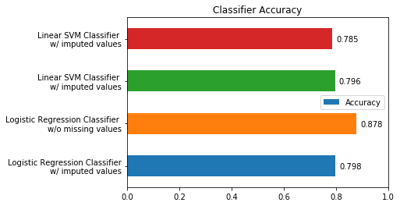
The first results graph is the overall accuracy of each classifier model:
Figure 3: The accuracy of each classifier, between 0.0 and 1.0.

There are two important outcomes to this result; the first is that the difference between the logistic regression and linear SVM classifiers with the missing values imputed is relatively negligible, and the second is that with the missing values removed, the logistic regression classifier is significantly more accurate than any other classifier (by almost 10%) while the linear SVM classifier is slightly less accurate.
The reason the logistic regression classifier with missing values removed is so much more accurate is likely because correlations are completely removed in this set, rather than being misrepresented in the imputed set.
Next, the ROC curves of both the imputed and removed data sets:
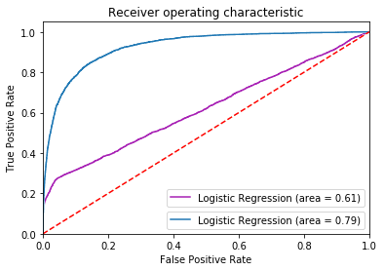
Figure 4: ROC curves of the logistic regression classifiers. The blue line is the model that fitted the data set with the removed missing values, and the purple the model that fitted the imputed data set.

As the curve graph shows, the classifier that ran on the removed missing value data set is significantly more efficient than the classifier with the imputed values.

In conclusion, the logistic regression classifier is relatively effective in classifying the census data, but more could have been done to improve the performance further. If it would have been possible to work on the data without needing to convert it all to a numerical data type, then it could have been imputed more intuitively and other classifiers (e.g. a Random Forest classifier) could have also been implemented for further comparison. (A Random Forest classifier was tested with this build, but it overfitted and claimed 100% accuracy on the dummy encoded values)
This could be possible if either Python’s machine learning libraries are improved, or if the model is written in another language that already has better support, such as MATLAB or R.

References

[1]  [2] | scikit-learn.org, “sklearn.linear_model.LogisticRegression –  scikit-learn 0.19.2 documentation,” [Online]. Available:  http://sckikit-learn.org/stable/modules/generated/  sklearn.linear_model.LogisticRegression.html  scikit-learn.org, "sklearn.svm.LinearSVC — scikit-learn 0.19.2 documentation," [Online]. Available: http://scikit-learn.org  /stable/modules/generated/sklearn.svm.LinearSVC.html.

[3] | Bilogur, (2018). Missingno: a missing data visualization suite.  Journal of Open Source Software, 3(22), 547,  https://doi.org/10.21105/joss.00547

