Home Work 3 Solutions

**6.1.1:** Directed acyclic graph for expression ((x+y) – (x+y)*(x-y)) + ((x+y)*(x-y))

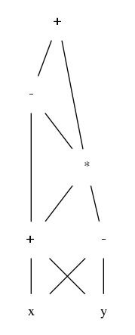

**6.2.1: a)** Syntax tree for a + - (b + c)

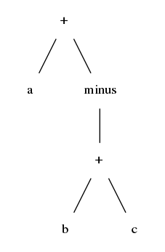

**b)** Quadruples

|  |  |  |  |
| --- | --- | --- | --- |
| op | arg1 | arg2 | result |
| + | b | c | t1 |
| minus | t1 |  | t2 |
| + | a | t2 | t3 |

**c)** Triples

|  |  |  |  |
| --- | --- | --- | --- |
|  | op | arg1 | arg2 |
| 0 | + | b | c |
| 1 | minus | (0) |  |
| 2 | + | a | (1) |

**d)** Indirect triples

|  |  |  |  |
| --- | --- | --- | --- |
|  | op | arg1 | arg2 |
| 0 | + | b | c |
| 1 | minus | (0) |  |
| 2 | + | a | (1) |

|  |  |
| --- | --- |
|  | instruction |
| 34 | (0) |
| 35 | (1) |
| 36 | (2) |

**6.3.2: (a)**

**6.4.3(b)**

t1 = i*w

t2 = j*w

t3 = t1 + t2

t4 = a [t3]

t5 = i*w

t6 = j*w

t7 = t5 + t6

t8 = b [t7]

t9 = t4 + t8

x = t9

**6.4.5: c)**

Address of array[i1][i2][i3]…[ik]

Define $d_{j}= h_{j}- l_{j}+1$

$M_{j}= M_{j+1}* d_{j+1}$

Where $d_{j}$ is the size of the dimension j and $M_{j}$ is the size of base type of dimension j

$Addr=base+ \sum_{j=1}^{k}{\left(i_{j}-l_{j}\right)*M_{j}}$

$Addr=base- \sum_{j=1}^{k}{l_{j}*M_{j}} +\sum_{j=1}^{k}{\left(i_{j}\right)*M_{j}}$

We can store K+1 values $M_{j}$ and $\sum_{j=1}^{k}{l_{j}*M_{j}}$ which are constant for the array in the symbol table and compute the address.

**6.6.2:**

B.false

B.true

|  |  |
| --- | --- |
|  | Goto blabel |
| B.true: | S1.code |
| b_label: | B.code |
| B.false: | … |

S -> while (B) S1

B.true = newlabel()

b_label = newlabel()

B.false = S.next

S1.next = b_label

S.code = gen(‘goto’ b_label)|| label(B.true) || S1.code || label(b_label)|| B.code

**3.3.2: e)**

Even number of a’s and even number of b’s

**3.3.5: h)**

b*(aa*(b|ε))*

**3.7.3: a)**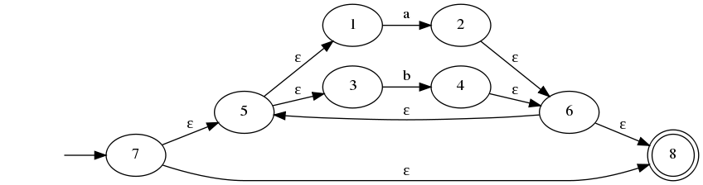

Converting it to DFA, we have the following states and transitions –

|  |  |  |  |
| --- | --- | --- | --- |
| NFA STATE | DFA STATE | a | b |
| {7,5,1,3,8} | A | B | C |
| {2,6,8,5,1,3} | B | B | C |
| {4,6,8,5,1,3} | C | B | C |

