DriverPass System Design Document
Charles Kwena
CS 255 Project Two
October 18, 2026
DriverPass needs one web system for customer accounts, two-hour driving lessons and online training. This design combines the processes and data needed to support those services. It builds on the Project One business requirements and the DriverPass interview. The recommended approach is a cloud-hosted browser application with one central database, managed backups and access based on each user’s role.

Design scope
The diagrams cover the system’s main user goals, booking a driving lesson, taking a practice test, booking messages between components, and the main data relationships. The class model includes a companion view for training content and DMV updates. The presentation uses simpler views of the same design for the client.
Package | Driving sessions | Additional access
One | 3 sessions / 6 hours | Driving instruction
Two | 4 sessions / 8 hours | In-person DMV rules lesson
Three | 6 sessions / 12 hours | In-person lesson, online class and practice tests

Business rules
Every driving session lasts two hours. A reservation must connect one customer, enrollment, driver and vehicle. The system checks customer, driver and vehicle availability and remaining package hours. Pickup and drop-off locations match. Disabling a package blocks new enrollment; the treatment of existing enrollments should be confirmed with the owner.

Source and design assumptions
The interview establishes the required behavior. Database transactions, a hosted payment service and specific recovery targets below are proposed implementation choices. The DMV interface, passing scores, cancellation policy and expected traffic still need client confirmation.

UML Diagrams and UML Use Case Diagram
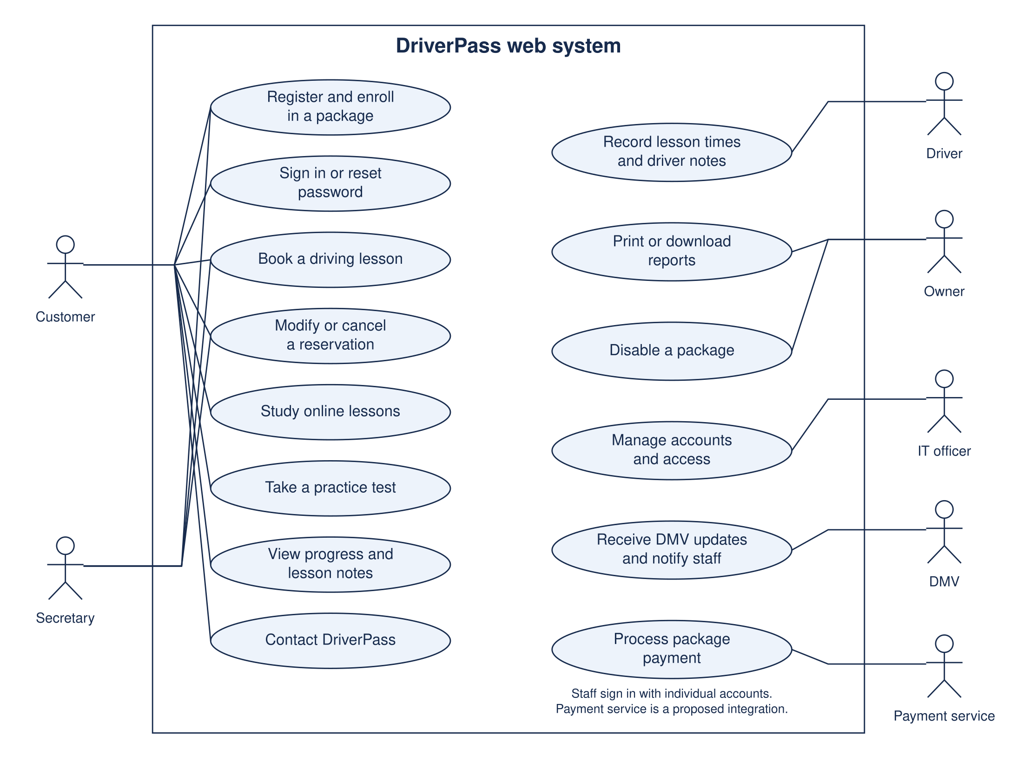
The boundary contains DriverPass functions. Stick figures represent people or external services. Solid lines show participation. Staff authentication applies to all staff tasks; the payment service is a proposed external integration.

Use case responsibilities
User | Responsibilities
Customer | Register, enroll, sign in, reset a password, manage personal reservations, study eligible content, take tests, see progress and contact staff.
Secretary | Register customers and book or change reservations for callers and office visitors. Record the secretary as the acting user.
Driver | See assigned lessons and record actual lesson times and comments.
Owner | Review progress, lesson notes and activity reports; print or download reports; disable packages for new enrollment.
IT officer | Manage account access, reset accounts and block access. Maintain the application and review technical notifications.
DMV | Provide updated rules, policies and sample questions through an agreed connection or import.
Payment service | Process package payments and return a reference and status. This is a recommended implementation choice.

Booking rules and alternatives
Booking requires an authenticated user with permission to act for the selected customer and a valid enrollment with at least two unused, unreserved hours. When the secretary books a lesson, the customer owns the reservation and the secretary remains the recorded actor. At save time, the server rechecks all constraints inside one transaction. It either saves the reservation, reserves the hours and writes the activity entry together, or saves none of them.
A conflicting time returns an explanation without a confirmed booking. A proposed cancellation releases reserved hours and records who canceled it. Rescheduling changes the resource assignment and time together so a failed update keeps the original booking. Client-approved cancellation, refund and no-show rules must be defined before implementation.

Practice test rules
Package Three grants online learning and practice-test access. A test with no attempt appears as not taken. Opening a test creates or resumes an in-progress attempt. Submission records elapsed time and a score, then assigns passed or failed using a configured threshold. The interview does not define that threshold, so the design does not invent a passing percentage. Each attempt refers to a fixed test version to keep historical scores meaningful.

UML Activity Diagrams
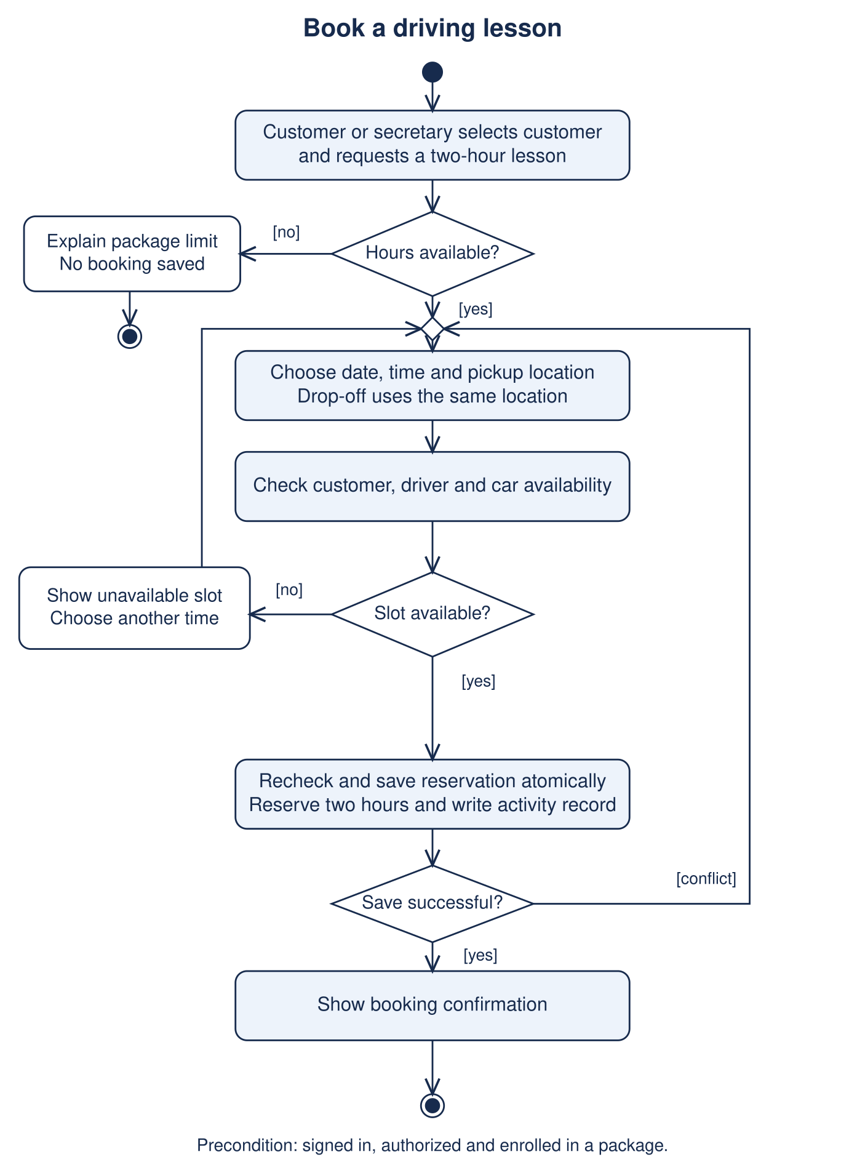
Activity 1. Book a driving lesson. Filled circles start the flow, diamonds select or merge paths, rounded rectangles represent actions, and a bullseye ends the activity. The save-time conflict path returns to choosing a slot.

UML Activity Diagram for Practice Tests
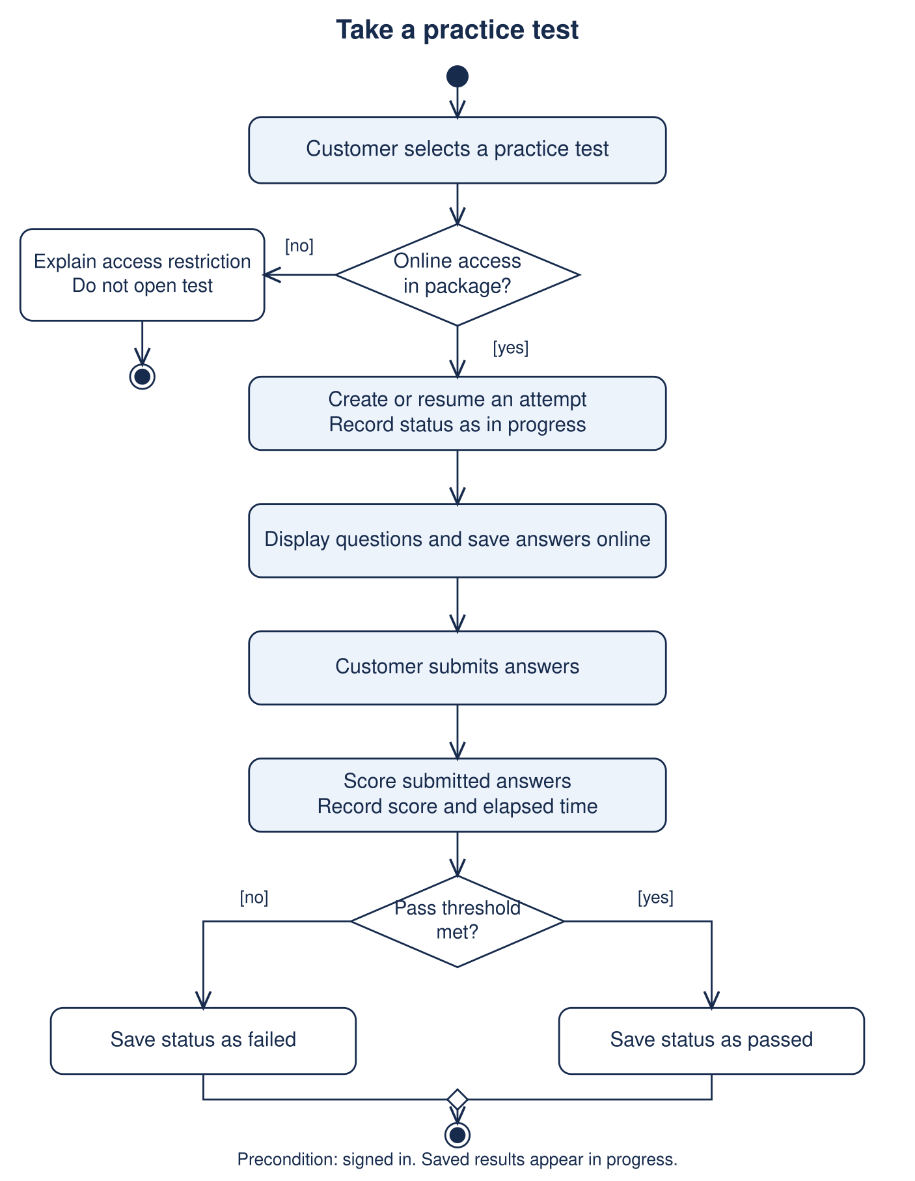
Activity 2. Take a practice test. The system checks package access before opening the test and records the score and status after submission. An interrupted attempt remains in progress until it is submitted or handled under an agreed timeout policy.

UML Sequence Diagram
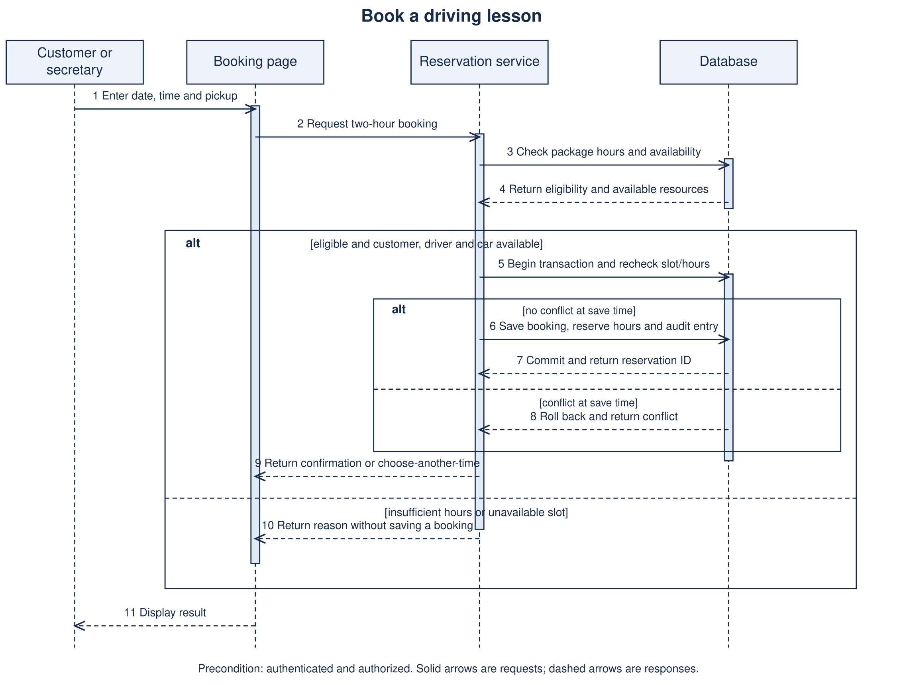
Booking messages follow the same rules as Activity 1. Vertical dashed lines are lifelines, narrow bars indicate execution, and alt frames separate guarded alternatives. A failed save returns a conflict rather than a confirmation.

UML Class Diagram
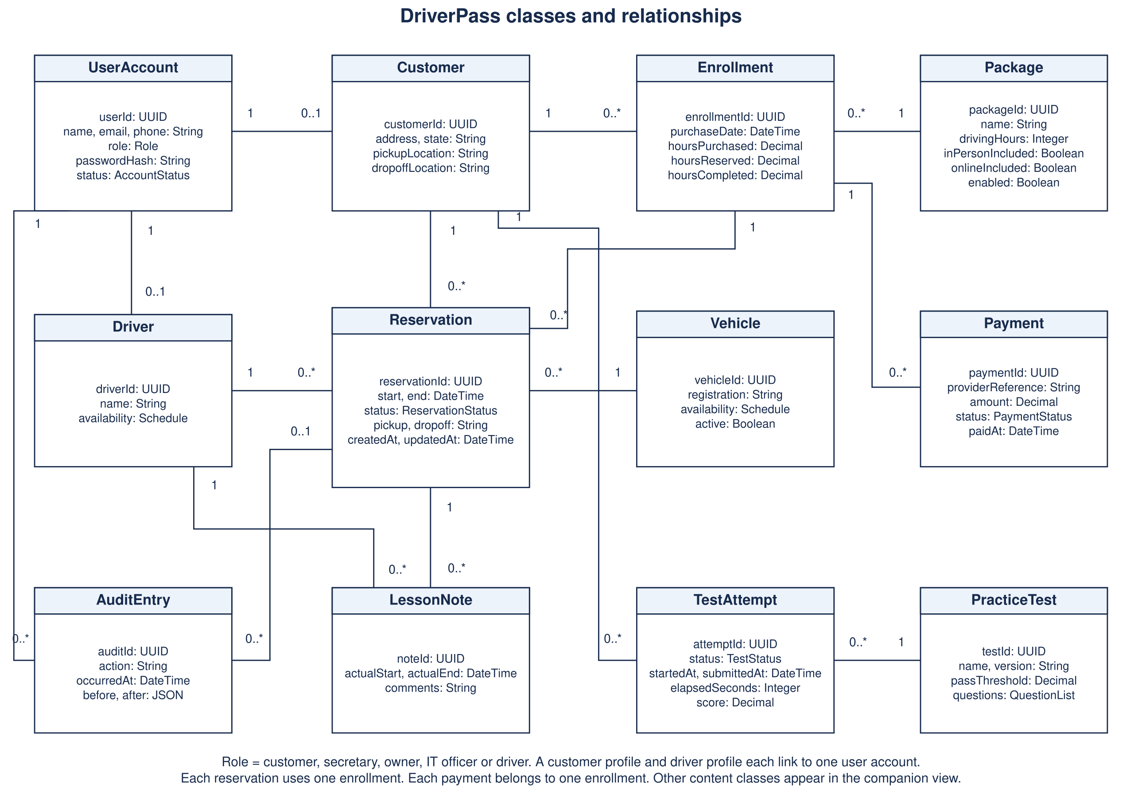

UML Class Diagram for Training Content
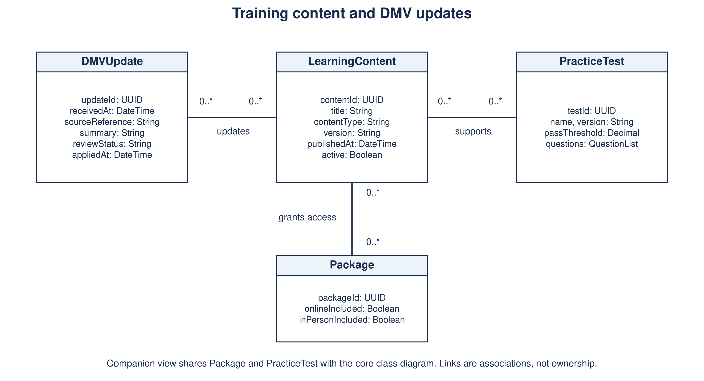
This companion view completes the class model for online classes and DMV changes. Package and PracticeTest are the same classes shown in the core view, not duplicate data.

Class model details
The model uses associations with multiplicities. For example, one customer can have zero or many reservations, but each reservation belongs to exactly one customer. Each reservation uses one enrollment, one driver and one vehicle. A customer can buy multiple enrollments over time. Each enrollment refers to one package and can have payment attempts, while each payment attempt belongs to one enrollment.
UserAccount provides the login identity and role. Customer and Driver contain role-specific information. Staff who do not need a separate profile use UserAccount directly. Each AuditEntry identifies the acting account and can optionally refer to a reservation, allowing the same activity mechanism to cover account and package actions. LessonNote identifies its reservation and authoring driver. A customer can have multiple TestAttempts, each linked to one PracticeTest version.

Data controls
Store timestamps consistently and display them in the business’s local time zone. Calculate remaining hours as purchased hours minus completed and reserved hours. Update these values with the related reservation in a transaction. Apply interval-overlap checks to the customer, driver and vehicle, rather than checking only identical start times. The assigned driver must be qualified and scheduled for the selected car; the assignment policy should reflect DriverPass’s car-and-driver pairing.
Keep audit records append-only for ordinary users and retain canceled reservations for reporting. Protect references with foreign keys. Reservation status can be scheduled, completed or canceled. Account status can be active or blocked. Test status can be in progress, passed or failed; not taken is the display state when no attempt exists. These are proposed implementation details supporting the client’s stated requirements.

Technical Requirements

Hardware and client access
Customers and staff need a supported browser on a computer, tablet or phone with an internet connection. Office workstations need normal keyboard and display access for registration and scheduling, and an optional printer for printed reports. Drivers can use a phone or tablet for assigned lesson details and notes. No dedicated server is required in the DriverPass office. Cloud capacity should be sized after the client confirms expected concurrent users and storage growth.

Software and application structure
Use a responsive HTML, CSS and JavaScript interface, a server-side application and a managed relational database. A Java application service with PostgreSQL is one suitable proposed stack, not a client-mandated choice. The server handles permissions, package rules, scheduling, test scoring, exports and audit events. The browser must not be the only place that enforces these rules. Store learning files in managed object storage and their metadata in the database. Provide CSV or XLSX downloads compatible with Excel and printable reports.

Technical Requirements Continued

Cloud infrastructure and integrations
Host the application behind HTTPS with a managed load balancer or equivalent hosting entry point. Keep the database on a private network and restrict database access to the application and authorized administrators. Separate development, test and production environments. Use managed monitoring, encrypted backups and recovery procedures so DriverPass does not need to operate its own backup servers. Maintain a contact page and a staff-to-student communication function through an approved email provider.
Use a hosted payment service for registration and package purchases. Send card data directly to that provider and retain only its reference, amount and payment status in DriverPass. Do not place full card numbers or security codes in the application database, logs or activity reports. Confirm the DMV’s supported delivery method before promising an automated interface. Receive or import updates, record their source and version, notify staff, and publish reviewed content. An unavailable integration should produce a visible alert rather than silently replacing training material.

Access and protection
Require individual accounts and enforce permissions on every server request. Customers may access only their own records. Drivers may work only with their assigned lessons. The secretary can manage customers and reservations, while the owner can view reports and control package availability. The IT officer can manage accounts and block access. Recommend an additional sign-in verification step for staff, particularly administrative accounts.
Store salted password hashes, protect sessions with secure cookies and inactivity limits, and use expiring, single-use password-reset links. Blocked accounts must lose existing sessions. Encrypt connections, stored sensitive information and backups. Store service credentials in a managed secrets store. Log meaningful changes with the actor, timestamp, record identifier and action, without copying payment secrets into the log. Limit report downloads to authorized users and remind staff that downloaded files contain customer information.

Reliability and performance targets
Proposed targets for client approval are: common pages and searches respond within two seconds under an agreed test load; the service achieves 99.9% monthly availability; and a recovery plan restores service within four hours with no more than one hour of committed data loss. These figures are design targets, not promises made in the interview. Meeting them requires appropriate hosting, transaction-log backups or equivalent recovery, monitoring and scheduled restore exercises. The team must test concurrent booking requests and increase capacity based on measured demand.

Implementation tools and acceptance checks
Use Lucidchart for the final course diagram authoring, Git for source history, an IDE for development, database migration scripts, and separate automated unit and integration tests. Browser testing should cover phone and desktop layouts, keyboard navigation and readable form validation. A deployment pipeline should require tests to pass before releasing a change. Monitor failed logins, scheduling errors, payment failures, backup status and DMV update failures.
Area | Acceptance check
Reservations | Two simultaneous requests cannot confirm overlapping use of the same customer, driver or car. A losing request gets a clear message.
Package hours | Package One supports three two-hour lessons, Package Two four and Package Three six. Reserved and completed hours cannot exceed the purchased amount.
Online training | Packages without online access cannot open tests. Submitted attempts preserve their score, time, status and test version.
Access and history | Blocked users cannot use an existing session. Reservation changes identify both the customer and the acting staff member when applicable.
Reports and recovery | Authorized exports open in Excel. A restore exercise recovers linked accounts, reservations and activity history consistently.
DMV content | Imported changes retain a source/version, generate a staff notification and appear to students only after approval.

Limitations and client decisions
Live updates require internet access. Downloaded reports are snapshots and do not synchronize edits back into DriverPass. The initial release supports the three stated packages and disabling new enrollment; full module changes require development. Scheduling remains limited by available cars and drivers. Confirm cancellation and refund rules, passing thresholds, record retention, actual traffic, downtime expectations and the DMV interface before development.

References
Southern New Hampshire University. (n.d.). CS 255 DriverPass interview transcript. Course material.
Kwena, C. (2026). CS 255 Project One business requirements document.
Southern New Hampshire University. (n.d.). CS 255 Project Two guidelines and rubric. Course material.

