Martha Durrett

Charlie Anderson

Brandon Hagans

Natasha Flowers

Java Project: Rush Hour

The goal of our project is to program Rush Hour. It is a puzzle where the player attempts to maneuver a specific car across a grid that is populated with other “vehicles” of various sizes. Each vehicle is positioned to move either vertically or horizontally, and is only restricted by the edges of the grid and the presence of other vehicles. Typically, there are varying levels of difficulty, which require an increasing number of moves and foresight.

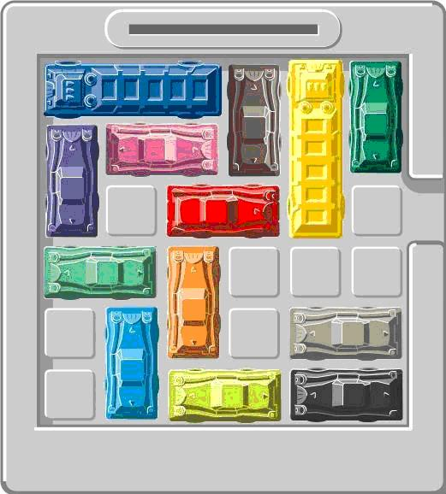

We plan to implement all of the features of the game, but without scoring. There will be three different difficulty levels, each with only one starting configuration. The user will be able to manipulate all vehicles on the grid, moving them back and forth in their original orientation. Vehicles cannot pass through or move other vehicles, nor can they pass through the edges of the grid. Players will move the vehicles by clicking and dragging them. The game will continue until the player either manipulates the red car to the defined exit point or elects to quit the game.

We plan to use model-view-controller as the design pattern.

We’re going to split into two pairs and work on the actual programming of different components separately (ex. One pair works on the model, the other works on the controller). Since we’re not sure exactly how much work the different parts will be, we’ll wait to split up the third component. We’ll start out working all together to write stub code, so that we will have a cohesive project, and then split into pairs to actually implement the methods.

