Project: Predictive Analytics Capstone

Complete each section. When you are ready, save your file as a PDF document and submit it here: <https://coco.udacity.com/nanodegrees/nd008/locale/en-us/versions/1.0.0/parts/7271/project>

## Task 1: Determine Store Formats for Existing Stores

1. What is the optimal number of store formats? How did you arrive at that number?

The optimal number of store formats is 3. See the following analysis result from K-Centroids Diagnostics:

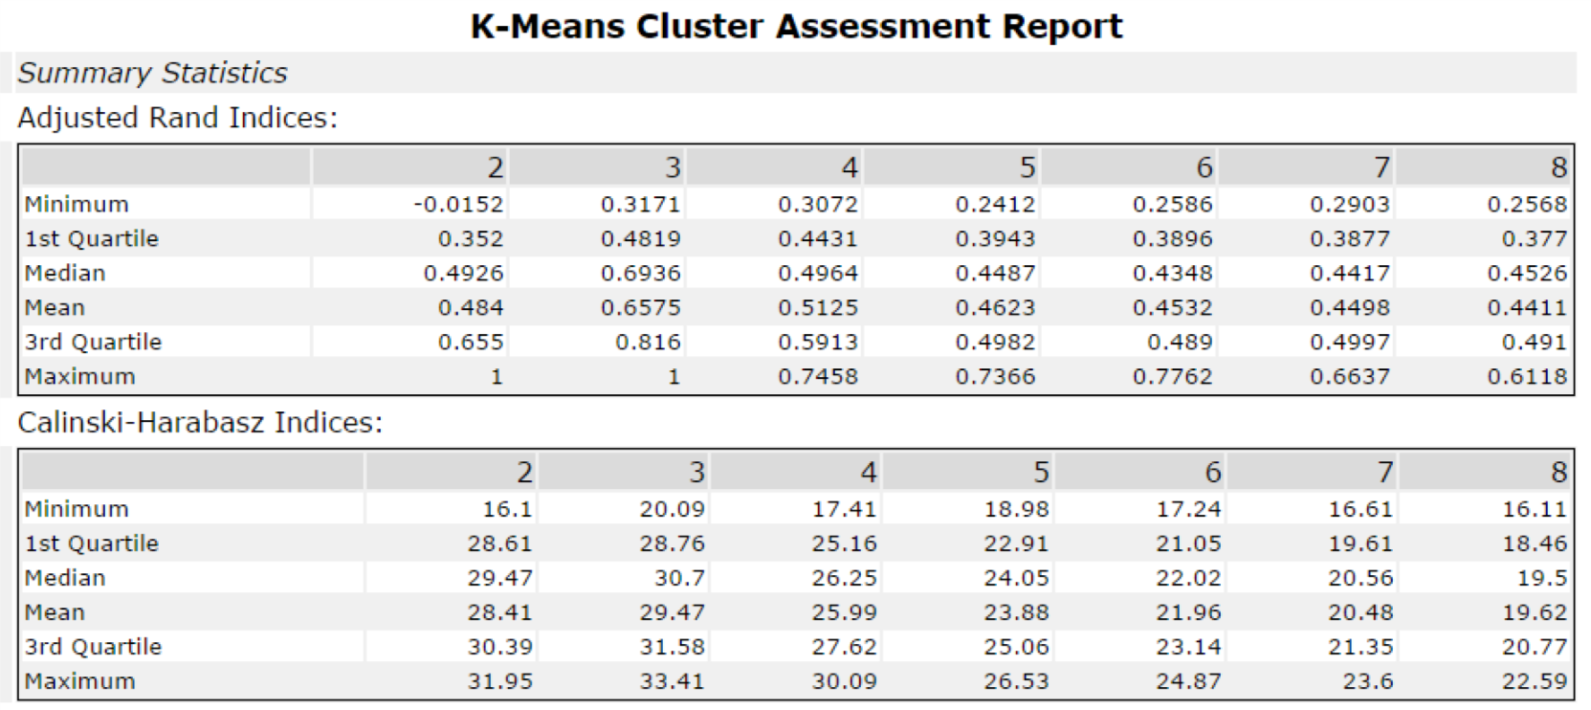

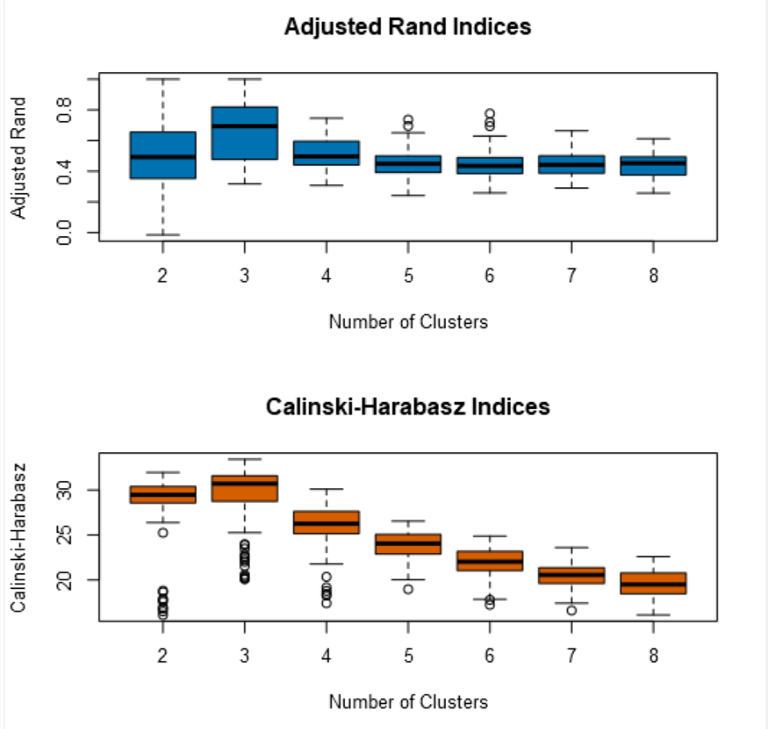

As we can see, 3 clusters has the highest adjusted rand index and Calinski-Harabasz index since the quartiles and the mean are highest among different number of clusters. So we will choose 3 clusters.

1. How many stores fall into each store format?

By choosing 3 clusters, percentages of sales for each category, z-score standardization and K-means, we get the following result:

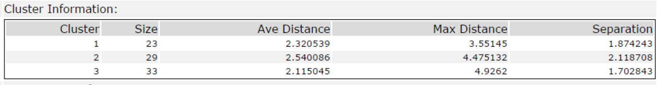

So sizes of the three clusters are 23, 29, and 33.

1. Based on the results of the clustering model, what is one way that the clusters differ from one another?

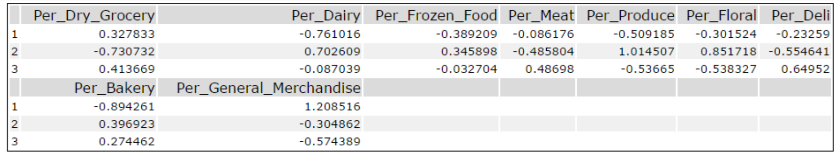

Cluster 1 seems to contain grocery stores by focusing on dry grocery and general merchandise.

Cluster 2 seems to contain fresh markets by focusing on dairy, frozen food, produce, floral and bakery.

Cluster 3 seems to contain Deli stores by focusing on grocery, meat, especially Deli and bakery.

1. Please provide a Tableau visualization (saved as a Tableau Public file) that shows the location of the stores, uses color to show cluster, and size to show total sales.

Tableau Public file link:

<https://public.tableau.com/profile/charlio#!/vizhome/grocery_geo/Sheet1?publish=yes>

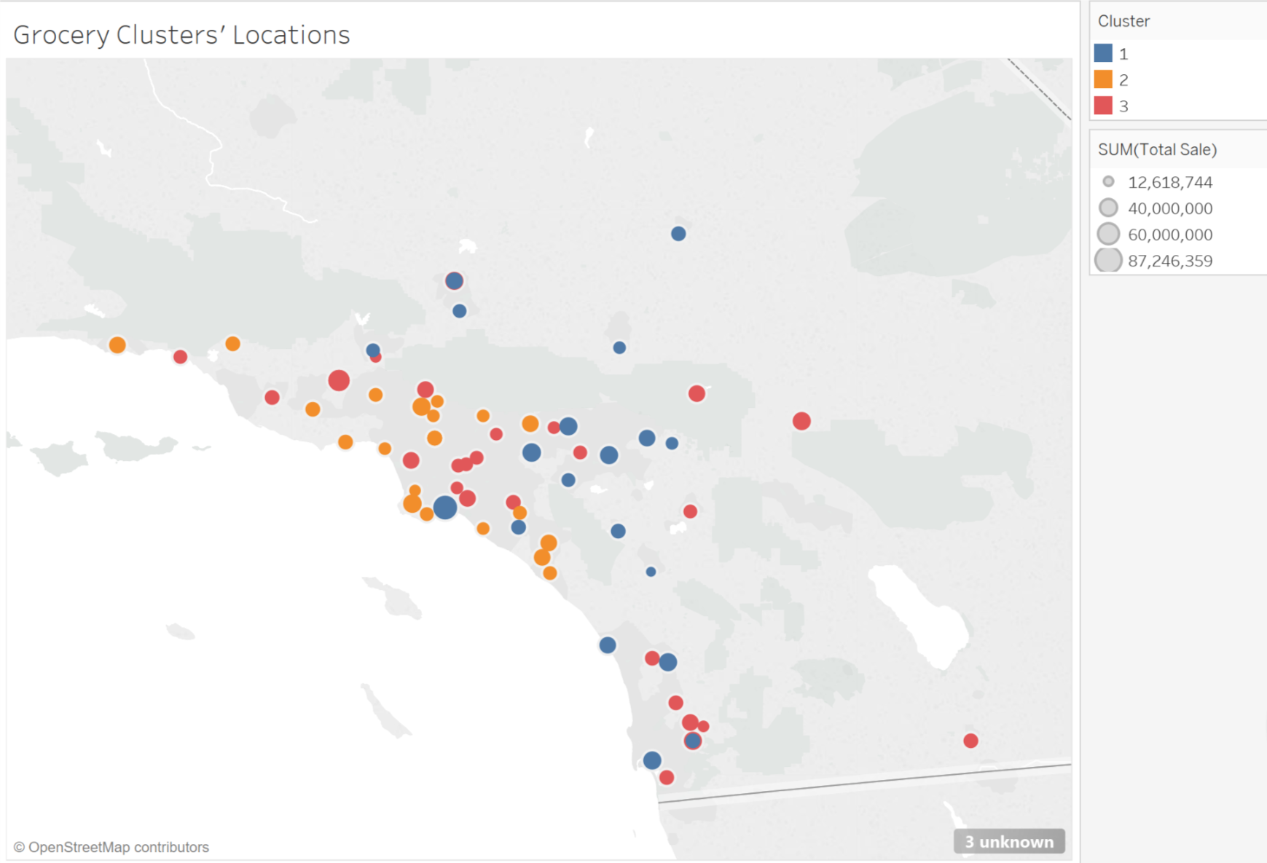

## Task 2: Formats for New Stores

1. What methodology did you use to predict the best store format for the new stores? Why did you choose that methodology? (Remember to Use a 20% validation sample with Random Seed = 3 to test differences in models.)

We need to predict the cluster field for the new stores. Cluster includes 3 values. So this is a non-binary classification problem. Thus we shall use decision tree, forest or boosted models. After running all three models, it turns out boosted model has the highest accuracy and F1 score. So I used the boosted model.

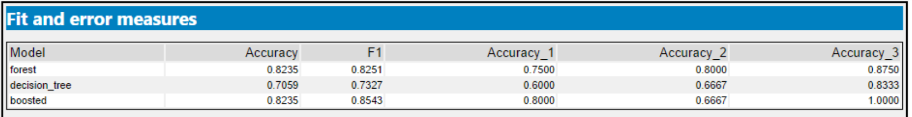

The three most important variables are Age0to9, HVal750KPlus and EdHSGrad.

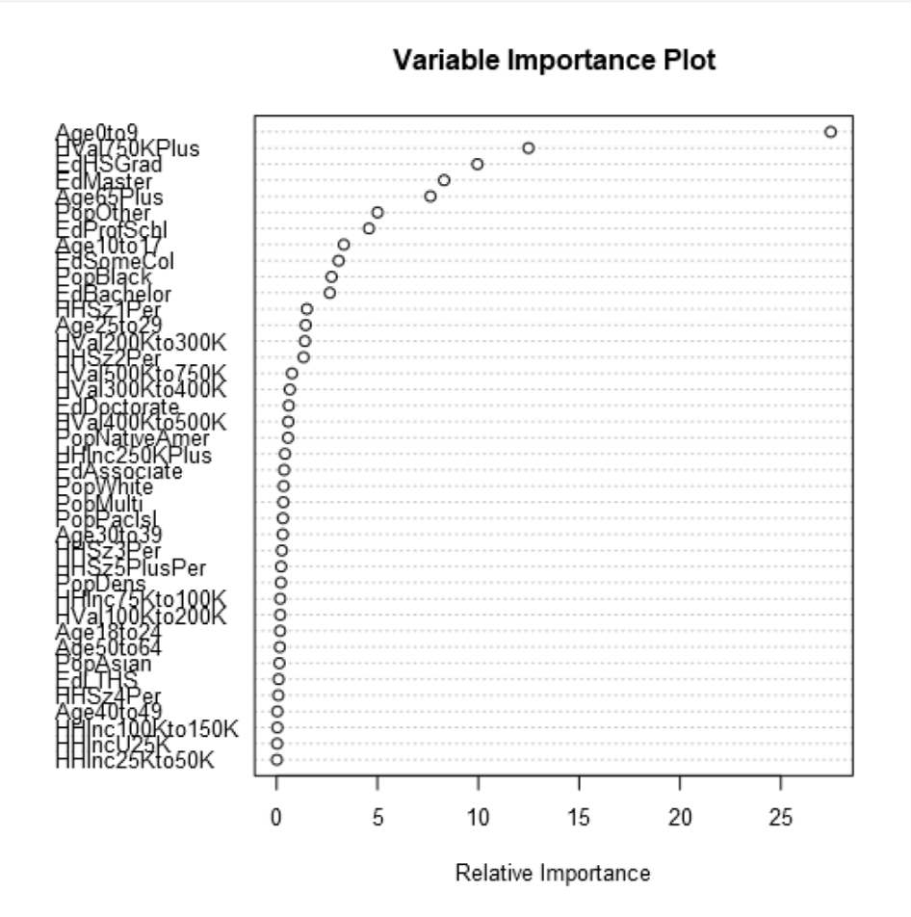

1. What format do each of the 10 new stores fall into? Please fill in the table below.

|  |  |
| --- | --- |
| Store Number | Segment |
| S0086 | 3 |
| S0087 | 2 |
| S0088 | 1 |
| S0089 | 2 |
| S0090 | 2 |
| S0091 | 1 |
| S0092 | 2 |
| S0093 | 1 |
| S0094 | 2 |
| S0095 | 2 |

## Task 3: Predicting Produce Sales

1. What type of ETS or ARIMA model did you use for each forecast? Use ETS(a,m,n) or ARIMA(ar, i, ma) notation. How did you come to that decision?

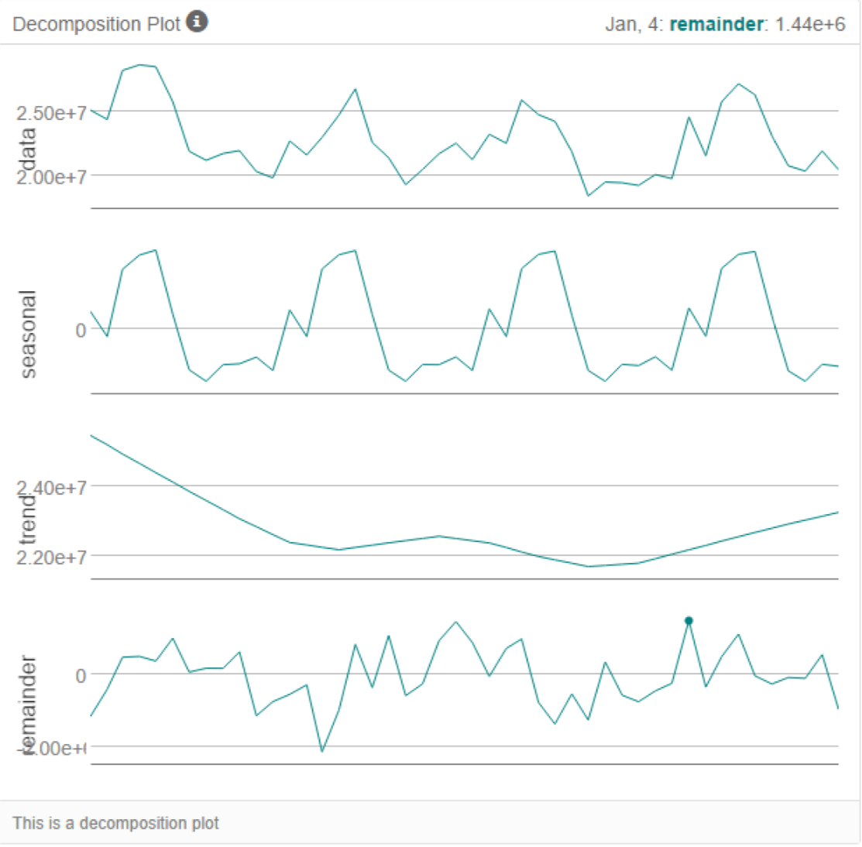

From the above decomposition plot, for ETS model, we shall choose multiplicative error, non trend, and multiplicative seasonality (slightly changing in the above plot),

So ETS(M, N, M)

For ARIMA model, after seasonal differencing, and further first and second order differencing, I finally chose ARIMA(ar=0, i=1, ma=2)(P=0, D=1, Q=2). See the following ACF and PACF plots.

Below is the ACF and PACF for the raw total sales for all existing stores

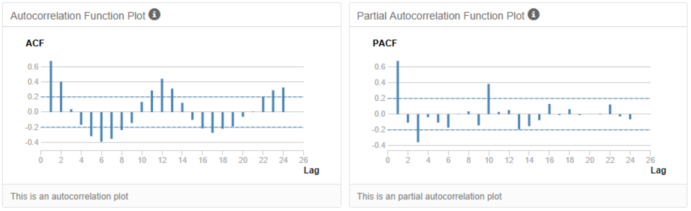

Below is the corresponding seasonal second difference plot:

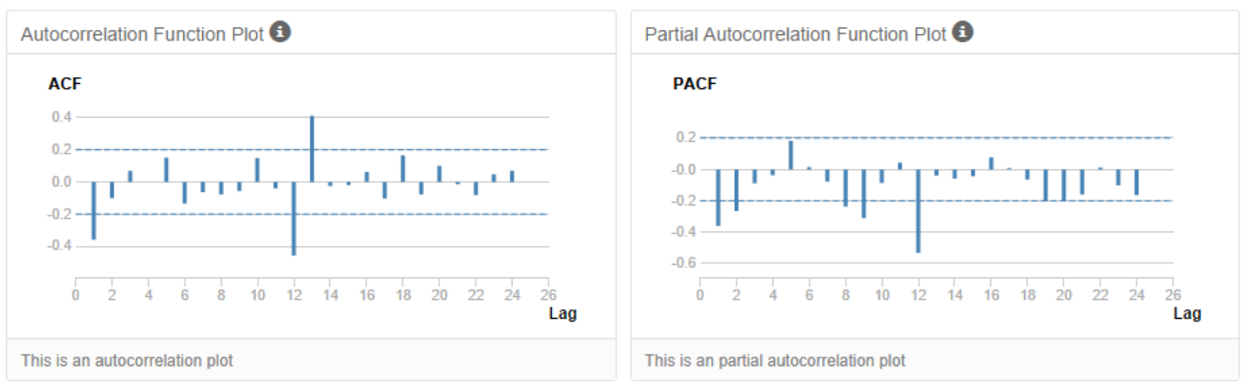

From the following accuracy measures on 12 holdout samples, we can see the ETS model has much smaller errors (RMSE, MASE) than the ARIMA model. So we will use ETS(M, N, M) model for forecasting.

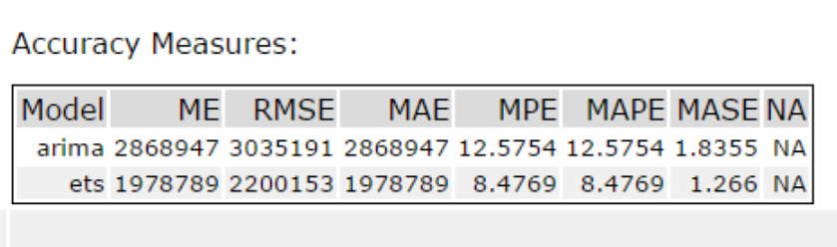

1. Please provide a table of your forecasts for existing and new stores. Also, provide visualization of your forecasts that includes historical data, existing stores forecasts, and new stores forecasts.

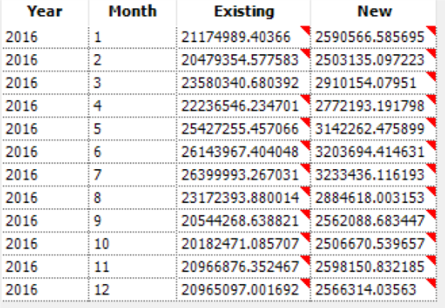

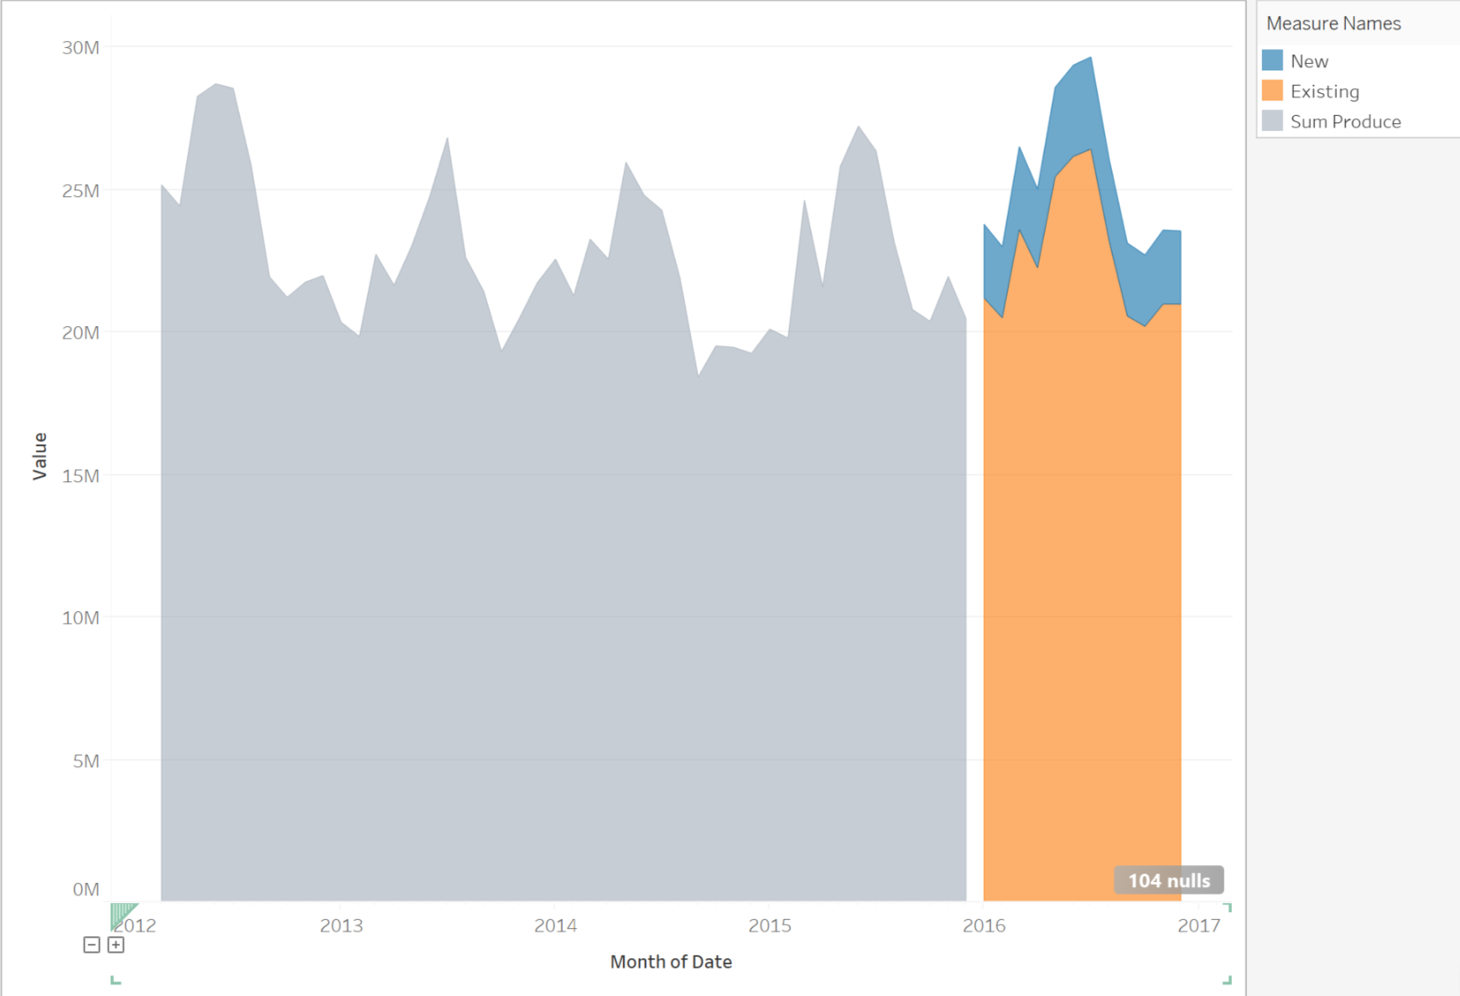

Before you submit

Please check your answers against the requirements of the project dictated by the rubric. Reviewers will use this rubric to grade your project.