1. 等价类设计

|  |  |  |  |  |
| --- | --- | --- | --- | --- |
| 输入及外部条件 | 有效等价类 | 等价类编号 | 无效等价类 | 等价类编号 |
| 前17位输入的类型 | 数字字符 | 1 | 非数字字符 | 8 |
| month | 1<=month<=12 | 2 | month<1 | 9 |
| month>12 | 10 |
| 非闰年的2月 | 1<=day<=28 | 3 | day<1 | 11 |
| day>28 | 12 |
| 闰年的2月 | 1<=day<=29 | 4 | day<1 | 13 |
| day>29 | 14 |
| month∈{1,3,5,7,8,10,12} | 1<=day<=31 | 5 | day<1 | 15 |
| day>31 | 16 |
| month∈{4,6,9,11} | 1<=day<=30 | 6 | day<1 | 17 |
| day>30 | 18 |
| 校验码 | 校验码与加权和模11对应 | 7 | 校验码与加权和模11对应 | 19 |

测试数据：

|  |  |  |  |  |
| --- | --- | --- | --- | --- |
| 有效等价类 | | | | |
| 序号 | 输入数据 | 预期输出 | 覆盖范围 | 测试结果 |
| 1 | 888888200102131233 | TRUE | 1,2,3,7 |  |
| 2 | 88888820000229123X | TRUE | 1,2,4,7 | FALSE |
| 3 | 888888200001311235 | TRUE | 1,2,5,7 | FALSE |
| 4 | 888888200004301235 | TRUE | 1,2,6,7 | FALSE |
| 5 | 888888200001021019 | TRUE | 1,2,5,7 |  |
| 6 | 888888200001021027 | TRUE | 1,2,5,7 |  |
| 7 | 888888200001021035 | TRUE | 1,2,5,7 |  |
| 8 | 888888200001021043 | TRUE | 1,2,5,7 |  |
| 9 | 888888200001021051 | TRUE | 1,2,5,7 |  |
| 10 | 88888820000102106X | TRUE | 1,2,5,7 |  |
| 11 | 888888200001021078 | TRUE | 1,2,5,7 |  |
| 12 | 888888200001021086 | TRUE | 1,2,5,7 |  |
| 13 | 888888200001021094 | TRUE | 1,2,5,7 |  |
| 14 | 888888200001021000 | TRUE | 1,2,5,7 |  |
| 15 | 888888200001021262 | TRUE | 1,2,5,7 |  |
| 16 | 88888820000102106x | TRUE | 1,2,5,7 | FALSE |

|  |  |  |  |  |
| --- | --- | --- | --- | --- |
| 无效等价类 | | | | |
| 序号 | 输入数据 | 预期输出 | 覆盖范围 | 测试结果 |
| 1 | X88888200102131234 | FALSE | 8 |  |
| 2 | 888888200100011238 | FALSE | 9 | TRUE |
| 3 | 888888200113011237 | FALSE | 10 | TRUE |
| 4 | 888888210002001238 | FALSE | 11 |  |
| 5 | 888888210002291239 | FALSE | 12 |  |
| 6 | 888888200402001238 | FALSE | 13 |  |
| 7 | 888888200402301230 | FALSE | 14 |  |
| 8 | 888888200401001236 | FALSE | 15 |  |
| 9 | 88888820040132123X | FALSE | 16 |  |
| 10 | 88888820040300123X | FALSE | 15 |  |
| 11 | 888888200403321233 | FALSE | 16 |  |
| 12 | 888888200405001233 | FALSE | 15 |  |
| 13 | 888888200405321237 | FALSE | 16 |  |
| 14 | 888888200407001237 | FALSE | 15 |  |
| 15 | 888888200407321230 | FALSE | 16 |  |
| 16 | 888888200408001239 | FALSE | 15 |  |
| 17 | 888888200408321232 | FALSE | 16 |  |
| 18 | 888888200410001238 | FALSE | 15 |  |
| 19 | 888888200410321231 | FALSE | 16 |  |
| 20 | 888888200412001231 | FALSE | 15 |  |
| 21 | 888888200412321235 | FALSE | 16 |  |
| 22 | 888888200404001231 | FALSE | 17 |  |
| 23 | 88888820040431123X | FALSE | 18 |  |
| 24 | 888888200406001235 | FALSE | 17 |  |
| 25 | 888888200406311233 | FALSE | 18 |  |
| 26 | 888888200409001230 | FALSE | 17 |  |
| 27 | 888888200409311239 | FALSE | 18 |  |
| 28 | 88888820041100123X | FALSE | 17 |  |
| 29 | 888888200411311238 | FALSE | 18 |  |
| 30 | 888888100001021231 | FALSE | 17 |  |
| 31 | 888888110001021232 | FALSE | 18 |  |
| 32 | 888888200001021011 | FALSE | 19 |  |
| 33 | 888888200001021022 | FALSE | 19 |  |
| 34 | 888888200001021033 | FALSE | 19 |  |
| 35 | 888888200001021044 | FALSE | 19 |  |
| 36 | 888888200001021055 | FALSE | 19 |  |
| 37 | 888888200001021066 | FALSE | 19 |  |
| 38 | 888888200001021077 | FALSE | 19 |  |
| 39 | 888888200001021088 | FALSE | 19 |  |
| 40 | 888888200001021099 | FALSE | 19 |  |
| 41 | 88888820000102100X | FALSE | 19 |  |
| 42 | 888888200001021260 | FALSE | 19 |  |

2、测试样例结果：

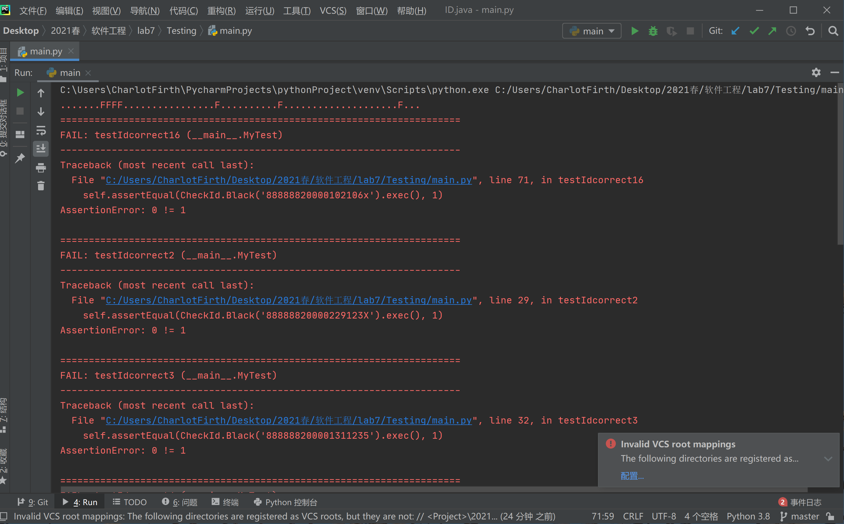

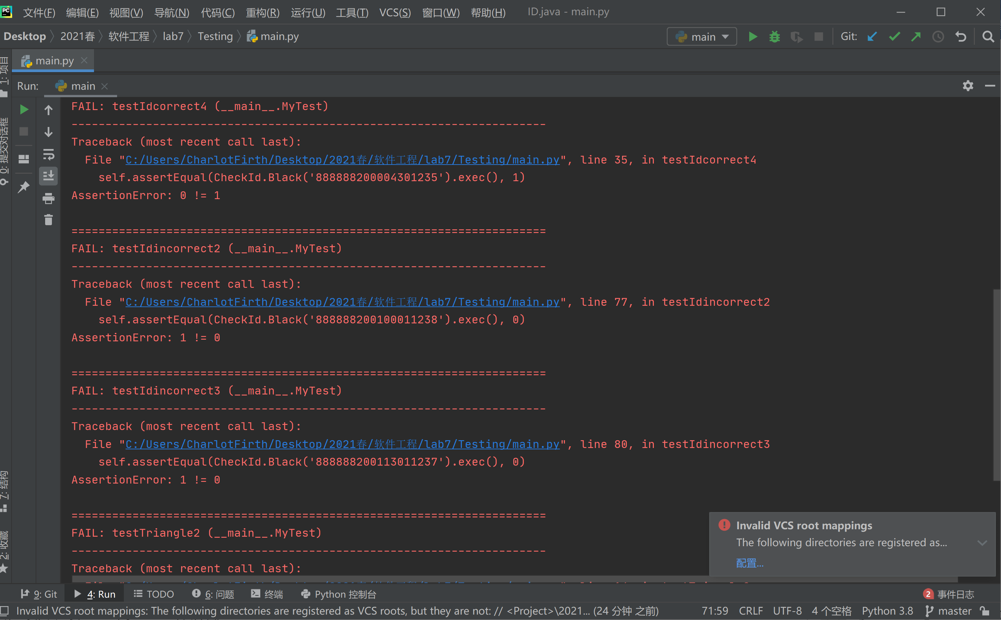

理应输出正确的测试用例中错误的测试数据有：

对闰年2月日期的判断、对大小月日期数的判断、X的大小写的判断

理应输出错误的测试用例中错误的测试数据有：

对月份的判断

3、bug汇总

（1）有些month<1不合法未考虑到

（2）有些month>12不合法未考虑到

（3）未考虑到闰年（年数是400倍数的）2月可以有29天

（4）未考虑到大月（1月）的日期可以有31天

（5）未考虑到小月（4月）的日期可以有30天

（6）检验码为小写x的时候会判断错