HBFC BANK REPORT

-P.CHARLOTTE GIDEON

Contents

1)What percentage of the bank’s customers (according to the data) have availed Personal Loans vs the ones who have not availed it?

2)Generatea table with min, max, median & average for all numeric variables (age, experience, income, family members, CCAvg, Mortgage)

3)Create a new categorical variable for Experience using 4 categories –•0 to 10 years •11 to 20 years •21 to 30 years •30+ years.Plot a bar graph for this new categorical variable[Hint–You may make use of if else/nested if statements to accomplish this task. You can refer how Income_Category has been created in the dataset]

4)Create a scatter plot of the Age and the Experience variable. What do you observe?

5)What are the top 3 areas (ZIPCodes) where the bank’s customers are located?

6)How many customers have a combination of Fixed Deposits and Credit Cards but not Personal Loan?

7)What is the median income of the customers who have availed personal loans and compare it with the median income of those customers who have not availed personal loans? What do you infer?

8)Create 4 separate Pivot Tables. Summarizeyour data by percentagevalues.•Education vs Personal Loan•TD Account Vs Personal Loan•Online vs Personal Loan•Income_Category vs Personal Loan[Hint: Please drag Personal Loan to the Columns area while creating the Pivot Table to get the required values]

9)Analyzethe Pivot tables created in the previous question and state any anomaly that you observe. Which categorical variables appear most important for your further study if you want to analyzewhich customers are most likely to take personal loans and why?

10)In the last campaign, bank reached out to 5000 customers out of which 480 customers accepted the personal loan offer. The bank incurred a huge cost in running a marketing campaign to reach out to so many customers. This is where you as a strategic business consultant step in. You are tasked to optimizethe cost of this campaign by identifying the correct target base (without significant reduction in number of acceptancesof offers). The bank can then send Personal Loan offers to these target customers who have ahigher chance of accepting the offer. Based on your analysis, what strategy would you suggest to the management of HBFC bank?

# 1.What percentage of the bank’s customers (according to the data) have availed Personal Loans vs the ones who have not availed it?

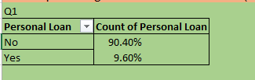

* The table above is obtained by using pivot table on the HBFC data table by dragging personal loan variable into the rows and count of personal loan into the value.
* From the table we can observe that 90.4% of the customers under survey have not availed the personal loan and only 9.6% of them has availed the personal loan

# 2.Generatea table with min, max, median & average for all numeric variables (age, experience, income, family members, CCAvg, Mortgage .

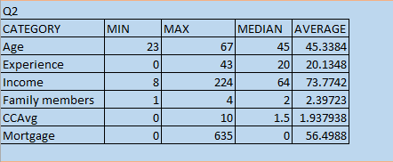

* The table above is obtained by using min, max, median and average functions
* From that we can observe that average and mean/average value does not vary much except for the mortgage

# 3.Create a new categorical variable for Experience using 4 categories –

* •0 to 10 years
* •11 to 20 years
* •21 to 30 years
* •30+ years.
* Plot a bar graph for this new categorical variable

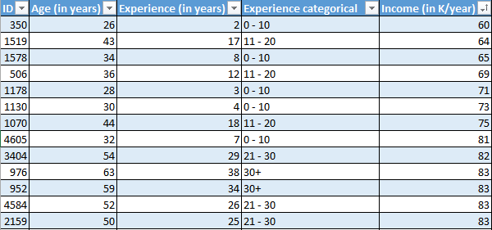

* In this table an extra column “Experience Categorical” is added to categorize the years of professional experience into category range/interval they are—
* 0 to 10
* 11 to 20
* 21 to 30
* 30+
* Which can be used to infer the informations such as count ,average ,sum etc.,within the given ranges .

From the bar chart we can infer that there is more number of customers with the experience category of 21 - 30 years than the others.

# 4.Create a scatter plot of the Age and the Experience variable. What do you observe?

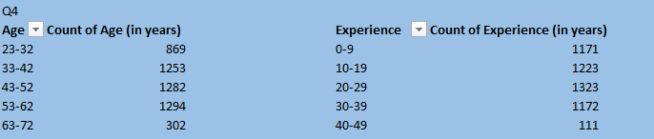

From this we can infer that experience increases as the age increases that is age is directly proportional to experience.

# 5.What are the top 3 areas (ZIPCodes) where the bank’s customers are located?

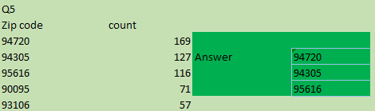

From the given table we can infer that the top three area/zipcodes where the bank’s customers are located are 94720, 94305 ,95616.

# 6.How many customers have a combination of Fixed Deposits and Credit Cards but not Personal Loan?

Count of all the customers having Fixed deposit and credit cards but not personal loan. 147

* It is done by using countif() function
* =COUNTIF(_HBFC[Td and credit],"Yes") and
* =COUNTIFS(Bank1[TD Account],"Yes",Bank1[CreditCard],"Yes",Bank1[Personal Loan],"No")

# 7.What is the median income of the customers who have availed personal loans and compare .

Median of income of Customers who availed personal loans 142.5

Median of income of Customers who have notavailed personal loans 59

From this it can be inferred that the more customers with higher annual income has availed for personal loan than those with lower annual income

* It is obtained by using custom sorting by sorting the personal loan first in a-z order and then by using match function to find the index of yes it will give the index of index of first yes after rows with no or the row reference of the last no value using this refence median for customers who have not availed personal loan is found and the vice versa is done for the customers who availed the personal loan.
* It can also be found by typing the formula/function =MEDIAN(IF(Bank1[Personal Loan]="Yes",Bank1[Income (in K/year)])) and pressing ctrl + shift + enter toget the median of those who have availed personal loan.

# 8.Create 4 separate Pivot Tables. Summarizeyour data by percentagevalues

•Education vs Personal Loan

•TD Account Vs Personal Loan

•Online vs Personal Loan

•Income_Category vs Personal Loan

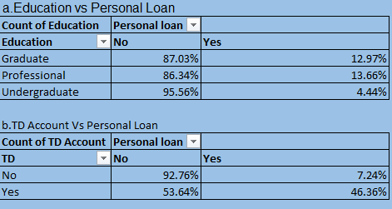

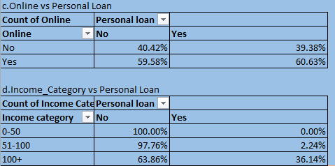

# 9. Analyse the Pivot tables created in the previous question and state any anomaly that you observe. Which categorical variables appear most important for your further study if you want to analyse which customers are most likely to take personal loans and why?

* From the above four pivot tables ,table which contains Income category vs Personal loan and td account vs Personal Loan appeared important for further study as the percentage of the customers who applied for the personal loan is more for the customers with higher income category/annual income.

# **10. In the last campaign, bank reached out to 5000 customers out of which 480 customers accepted the personal loan offer. The bank incurred a huge cost in running a marketing campaign to reach out to so many customers. This is where you as a strategic business consultant step in. You are tasked to optimise the cost of this campaign by identifying the correct target base (without significant reduction in number of acceptance of offers). The bank can then send Personal Loan offers to these target customers who have a higher chance of accepting the offer. Based on your analysis, what strategy would you suggest to the management of HBFC bank?**

* It is done by analyzing the data to identify patterns and characteristics of customers who accepted the personal loan offer. Segmenting customers based on factors such as income levels, age, professional experience, credit score, and other factors or category of a variable which has higher percentage of customers who availed the personal loan.

THANK YOU