group-project.R

HUANG JIANXIN

2021-12-03

setwd("C:/Users/47010/Downloads/New folder")  
data<-read.csv("hotel_bookings.csv")  
model_data<-data[,c(1,2,3,10,11,12,13,15,16,17,18,19,20,23,26,27,28,29)]  
library(ggplot2)

## Warning: package 'ggplot2' was built under R version 4.0.5

library(Rmisc)

## Warning: package 'Rmisc' was built under R version 4.0.5

## Loading required package: lattice

## Warning: package 'lattice' was built under R version 4.0.5

## Loading required package: plyr

## Warning: package 'plyr' was built under R version 4.0.5

p1<-ggplot(model_data,aes(x=hotel,y=days_in_waiting_list))+geom_boxplot()  
p1

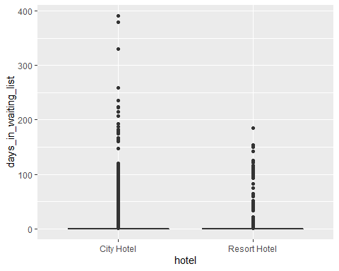

p2<-ggplot(model_data,aes(x=hotel,y=lead_time))+geom_boxplot()  
p2

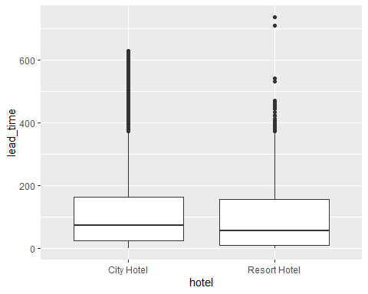

p3<-ggplot(model_data,aes(x=hotel,y=adr))+geom_boxplot()  
p3

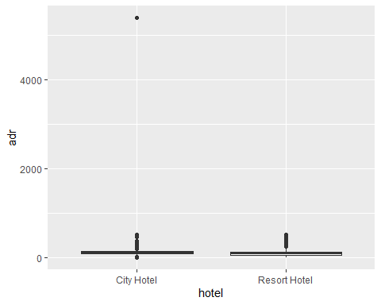

data_remove_adroutlier<-subset(model_data,model_data$adr<4000)  
p4<-ggplot(data_remove_adroutlier,aes(x=hotel,y=adr))+geom_boxplot()  
p4

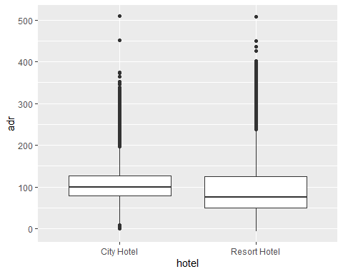

p5<-ggplot(data,aes(x=arrival_date_year,fill=hotel))+  
 geom_bar(position='dodge')+ ylab("Number of customers")  
p5

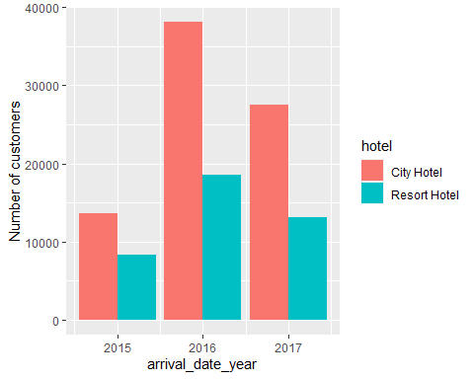

data$arrival_date_month<-factor(data$arrival_date_month,levels=c("January","February","March","April","May","June","July","August","September","October","November","December"),labels=c(1:12))  
p6<-ggplot(data,aes(x=arrival_date_month))+geom_bar()+facet_wrap(~hotel)+ ylab("Number of customers")  
p6

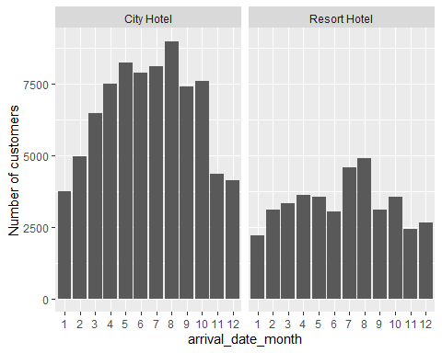

p7<-ggplot(data_remove_adroutlier,aes(hotel,fill=factor(market_segment)))+  
 geom_bar(position="fill")+ylab("percentage of canceled")  
p7

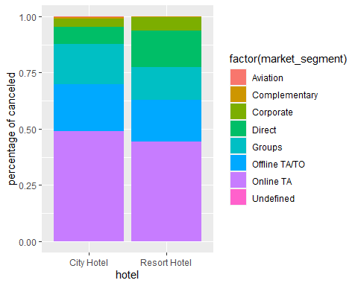

p8<-ggplot(data_remove_adroutlier,aes(hotel,fill=factor(distribution_channel)))+  
 geom_bar(position="fill")+ylab("percentage of canceled")  
p8

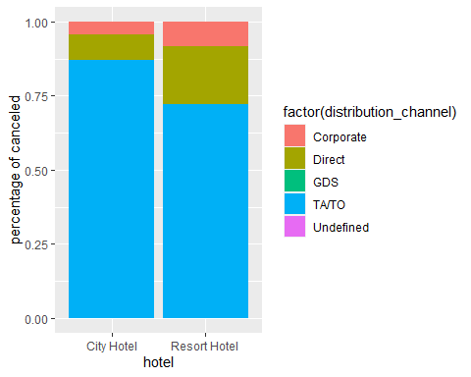

p9<-ggplot(data_remove_adroutlier,aes(hotel,fill=factor(customer_type)))+  
 geom_bar(position="fill")+ylab("percentage of canceled")  
p9

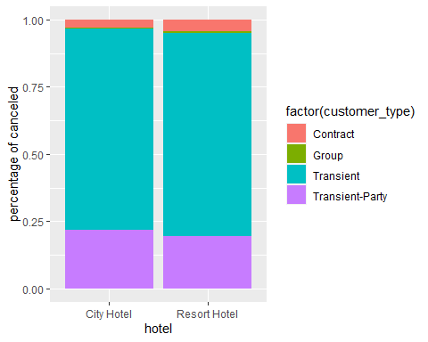

p10<-ggplot(data_remove_adroutlier,aes(hotel,fill=factor(deposit_type)))+  
 geom_bar(position="fill")+ylab("percentage of canceled")  
p10

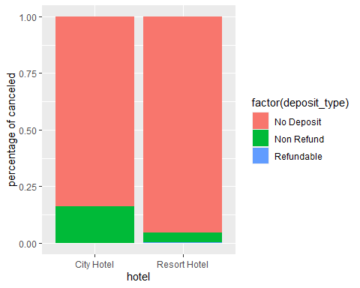

p11<-ggplot(data_remove_adroutlier,aes(hotel,fill=factor(is_canceled)))+  
 geom_bar(position="fill")+ylab("percentage of canceled")  
p11

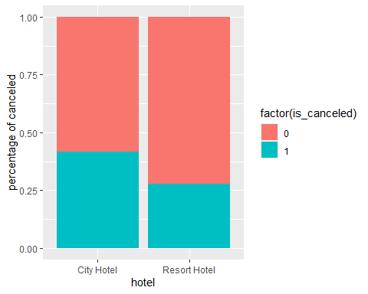

p12<-ggplot(data_remove_adroutlier,aes(hotel,fill=factor(is_repeated_guest)))+  
 geom_bar(position="fill")+ylab("percentage of canceled")  
p12

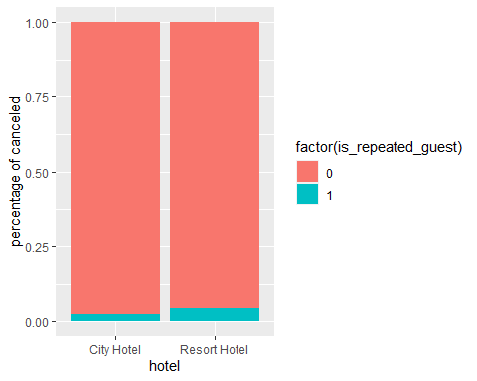

data_repeated_customer<-subset(data_remove_adroutlier,data_remove_adroutlier$is_repeated_guest==1)  
p13<-ggplot(data_remove_adroutlier,aes(previous_cancellations,fill=factor(is_canceled)))+  
 geom_bar(position="fill")+ylab("percentage of canceled")+ggtitle("All Customers")  
p13

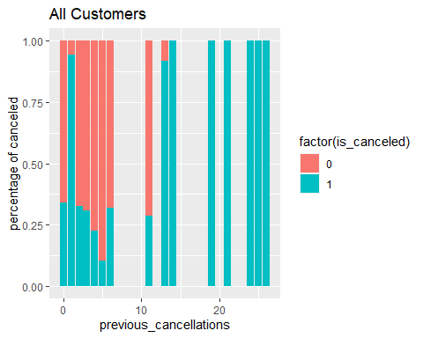

p14<-ggplot(data_repeated_customer,aes(previous_cancellations,fill=factor(is_canceled)))+  
 geom_bar(position="fill")+ylab("percentage of canceled")+ggtitle("Repeated Customers")  
p14

