# Basics of Bioimage analysis

## Course Material:

1. Please download and unzip: [**https://github.com/NEUBIAS/training-resources/archive/master.zip**](https://github.com/NEUBIAS/training-resources/archive/master.zip)

2. Enure you can open the images in the **image_data** folder in Fiji

3. The online resource of the course can be found [**https://neubias.github.io/training-resources/index.html**](https://neubias.github.io/training-resources/index.html)

The course is best rendered with Firefox.

## Follow up material for self study:

Analysis of fluorescence data in ImageJ: <https://petebankhead.gitbooks.io/imagej-intro/content/>

ImageJ Macro: <https://www.youtube.com/watch?v=o8tfkdcd3DA>

Colocalisation: <https://www.youtube.com/watch?v=P2JvFe0hB_M>

Advanced MorpholibJ:<https://www.youtube.com/watch?v=_SiM33C3KcE>

NEUBIAS youtube channel (more specialized topics): <https://www.youtube.com/channel/UC-oy7UpEhRfHQ-5ePCviKFg>

How to ask for help (active and responsive): <https://forum.image.sc/>

**Python:**

* <https://www.youtube.com/watch?v=2KF8vBrp3Zw>
* <https://scikit-image.org/docs/dev/api/skimage.html>

**R:** <https://www.bioconductor.org/packages/release/bioc/html/EBImage.html>

## **Course schedule:**

#### Monday, 25. January 2021, 14:00 – 17:00 CET

* [Basic image properties (pixels)](https://neubias.github.io/training-resources/pixels/index.html)
* [Spatial calibration](https://neubias.github.io/training-resources/spatial_calibration/index.html)
* [Lookup tables](https://neubias.github.io/training-resources/spatial_calibration/index.html)

#### Tuesday, 26. January 2021, 14:00 – 17:00 CET

* [Binarization](https://neubias.github.io/training-resources/binarization/index.html)
* [Connected component labeling](https://neubias.github.io/training-resources/connected_components/index.html)
* [Data types](https://neubias.github.io/training-resources/datatypes/index.html)
* [Object shape measurements](https://neubias.github.io/training-resources/measure_shapes/index.html)
* Optional homework [Workflow - simple 2D object analysis](https://neubias.github.io/training-resources/workflow_segment_2d_nuclei_measure_shape/index.html)
  + The workflow summarizes what we have learned during the first 2 days.
  + We can discuss it on Monday

#### Monday, 1. February 2021, 14:00 – 17:00 CET

1. Please download again and unzip (there are new images) [**https://github.com/NEUBIAS/training-resources/archive/master.zip**](https://github.com/NEUBIAS/training-resources/archive/master.zip)

* [Workflow - simple 2D object analysis](https://neubias.github.io/training-resources/workflow_segment_2d_nuclei_measure_shape/index.html) Discuss if there has been problems
* [Object intensity measurements](https://neubias.github.io/training-resources/measure_intensities/index.html)
* [Global background correction](https://neubias.github.io/training-resources/global_background_correction/index.html)
* [Neighbourhood filters (introduction)](https://neubias.github.io/training-resources/filter_neighbourhood/index.html)

#### Tuesday, 2. February 2021, 14:00 – 17:00 CET

1. Please download again and unzip (there are new images) <https://github.com/NEUBIAS/training-resources/archive/master.zip>

* Self introduction (please paste name in chat)
* Self study recommendations (see above follow up material for self study)
* [Median filter](https://neubias.github.io/training-resources/median_filter/index.html)
* [Local background subtraction](https://neubias.github.io/training-resources/local_background_correction/index.html)
* [Filter objects](https://neubias.github.io/training-resources/filter_objects/index.html)
* [Workflow - 2D segmentation of noisy images with object filtering](https://neubias.github.io/training-resources/workflow_segment_2d_noisy_nuclei_filter_objects_measure_shape/index.html)

## Before the course:

Please, ***before*** the course:

1. Install Fiji

* Download and install Fiji on your computer<https://fiji.sc/>

2. Install the MorpholibJ Fiji update site

* Install the Fiji update site for MorpholibJ.
* In Fiji: [Help > Update > Manage update sites], scroll down the list and check **IJPB-plugins**.
  + For general information on how to install update sites see [Update Sites](https://imagej.net/Update_Sites)
* Restart Fiji
* Make sure you now find **MorpholibJ** in the Fiji Plugins menu: [Plugins > MorpholibJ > …]

3. Test your installation

* Start Fiji.
* Open a sample image [File > Open Sample > Dot Blot]
* Apply a MorphoLibJ filter to this image.
* [Plugins > MorpholibJ > Morphological Filters]
* 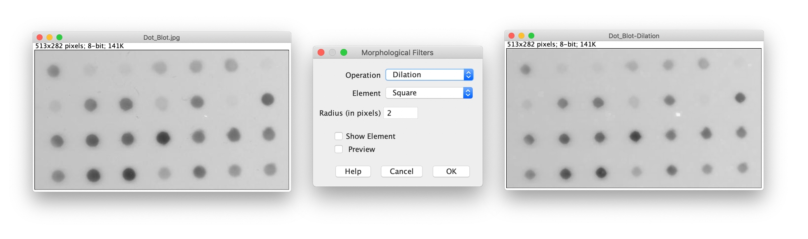
* You do *not* need to understand what happened; you will learn this *during* the course :-)

Please

1. Write your name (you also may paste a (small) funny photo of yourself, if you want)  
2. Did the above installation work? Do you need help?  
3. What do you expect from this course?