Source Code Visualization

Team Irma

Nathan Wheeler
Samuel Matloob
Charlotte Morrison
Ahmed Moussa
Jeremy Futral

Software Requirements Specification

Document

Version: (1.1) Date: (10/11/2017)

Table of Contents

1. Introduction 4
1.1 Purpose 4
1.2 Scope 4
1.3 Definitions, Acronyms, and Abbreviations. 4
1.4 References 4
1.5 Overview 4
2. The Overall Description 5
2.1 Product Perspective 5
2.1.1 System Interfaces 5
2.1.2 Interfaces 5
2.1.3 Hardware Interfaces 6
2.1.4 Software Interfaces 6
2.1.5 Communications Interfaces 7
2.1.6 Memory Constraints 7
2.1.7 Operations 7
2.1.8 Site Adaptation Requirements 7
2.2 Product Functions 8
2.3 User Characteristics 8
2.4 Constraints 9
2.5 Assumptions and Dependencies 9
2.6 Apportioning of Requirements. 9
3. Specific Requirements 10
3.1 External Interfaces 10
3.2 Functions 12
3.3 Performance Requirements 12
3.4 Logical Database Requirements 12
3.5 Design Constraints 12
3.5.1 Standards Compliance 12
3.6 Software System Attributes 13
3.6.1 Reliability 13
3.6.2 Availability 13
3.6.3 Security 13
3.6.4 Maintainability 13
3.6.5 Portability 13
3.7 Organizing the Specific Requirements 13
3.8 Additional Comments 13
4. Change Management Process 13
5. Document Approvals 14
6. Supporting Information 15
Definitions: 15
Acronyms: 15
Abbreviations: 15
System Models: 15
Activity Diagram for IRMA 15
Use Case Diagram for IRMA 15
Sequence Diagram for IRMA 15
Class Diagram for IRMA 15
References: 15

1. Introduction

1.1 Purpose

The purpose of this SRS document is ultimately to provide a detailed overview of our Source Code Visualization program. This specification will act as the contract between our intended audiences, which include ourselves as contractors and Dr. Reddivari as our customer.

1.2 Scope

The software product being produced will be named “IRMA Source Code Visualization Tool” or IRMA for short. IRMA will take a text file input which includes a list of all source files. The tool will then produce a visualization of the source code files with a GUI, giving more information about each of the source code files on click.

The tool will allow users to more easily understand the source code in their programs by having the ability to see the source code in an easily understandable visual format. The driving goal of our project is to allow programmers to see their source code visually. This visualization will provide a better understand their source code by seeing it from a different perspective.

1.3 Definitions, Acronyms, and Abbreviations.

Please see the sections labeled “Definitions”, “Acryonyms” and “Abbreviations” respectively in section 6, Supporting Information.

1.4 References

Please see the section labeled “References” in section 6, Supporting Information for all references.

1.5 Overview

The rest of the SRS document contains all the information necessary for our clients to understand IRMA at a high level. In addition, this SRS contains enough information for developers and contractors to be able to implement the IRMA system.

Customers and Users will want to review section 2, “The Overall Description” and Developers and contractors will be interested in section 3, “Specific Requirements”.

2. The Overall Description

2.1 Product Perspective

Our product, IRMA, is a source code visualization tool. This means that it allows you to visually view the connections between your code files, as well as different attributes about those code files in a user-friendly and visual way. Other such products on the market now include the following: open source solutions like “CodeFlower Source code visualization” [11] and proprietary solutions like “CodeSonar” by GrammaTech [12]. In addition, references 1-10 in the references section all either describe different source code visualization software or include some aspect of Source Code visualization that our team referenced while researching the subject of Source Code visualization.

2.1.1 System Interfaces

IRMA will be a stand-alone application which doesn’t interface with external software applications. We will be using core Java as well the JavaFX platform to develop our graphical user interface.

2.1.2 Interfaces

We will be building an interface which users will leverage to input their list of source code files. Logically, the interface will be import file button interface which is easily utilized by business and technical users alike.

In addition, there will be a graphical user interface component which will display, in a visual format, each of the source code files which was input, their connections with other source code files, and the lines of code contained within each source code file individually. Each source code file will be identified with a circle with differing size and color based on how many connections the file has to other files as well as to which files that file is connected.

This GUI must take into consideration color blind and visually impaired users, so the colors of connecting files must have a high enough contrast to accommodate these users. In addition, any text shown on the screen must be of size and quality standards which meet ADA guidelines.

Finally, users will be able to hover your mouse over a given source code file to view additional details about the file, including the name of the file and the number of lines of code which the file contains. This information will be presented in a user-friendly format to appeal to business users who have zero technical knowledge, but would like to visualize code at a high level just like a technical individual would.

2.1.3 Hardware Interfaces

The only hardware interfaces required to run IRMA would be a computer monitor, a computer with a graphics card able to process JavaFX applications and sufficient memory and disk space.

2.1.4 Software Interfaces

Interface:

Name: Java Development Kit
Mnemonic: JDK
Specification number: 7
Version number: 7u6 or above (Includes JavaFx)
Source: http://www.oracle.com/technetwork/java/javase/downloads/jdk8-downloads-2133151.html

This interface not only allows developers to develop applications in Java and allows developers to run their applications in the Java Runtime Environment, but also provides the JavaFX library which is needed to build our Graphical user interface. In addition, any user which wants to run our program, IRMA, must have Java Virtual Machine installed, which comes with the JDK outlined above. The message content and format will be consistent with the functions provided in the JDK.

Interface:

Name: Microsoft Windows
Mnemonic: Windows
Specification Number: Vista Service Pack 2, Windows 7 Service Pack 1, Windows 8.
Version number: Vista, 7 or 8
Source: In-store purchase or digital download

We would suggest that users run their application on Microsoft Windows, with a version such as 7. JavaFX and the Java JDK have been tested and proven to work with stable results on these Operating Systems specifically. We will not be using this interface to pass program content per se, but the operating system will be required to run program as JavaFX has its own operating system requirements. Communication with the operating system will be handled by the Java Virtual Machine, which comes with the JDK outlined in the interface above.

2.1.5 Communications Interfaces

This section was skipped as there are no external Communications Interfaces implemented in the program as outlined in this SRS.

2.1.6 Memory Constraints

A minimum of 2.5 GB of RAM is required to run IRMA on Windows 8. This is due to the 2 GB minimum to run the operating system itself. JavaFx requires 512MB of RAM. 4 GB is recommended to allow ample room for both the Windows Operating System as well as the program itself to run very effectively. Our target audience of developers and business users who wish to visualize source code should fit well within this RAM limit.

2.1.7 Operations

Users of IRMA will have the ability to import a text file filled with source code files via a user-friendly, file import button interface. The user will then be given a visual graphical user interface with which they are able to interact. The interactions include viewing the different source code files in a visual format and hovering over those source code files to get additional details on those files. As described, this is the normal operation of the IRMA system. There are no options which require special maneuvers or user input.

During periods of unattended operation, IRMA will stay on the screen which the user has last left off on, with no change to the overall user interface. There will be no additional data processing support functions which are required by the customer. There will be no backup or recovery option available for IRMA. However, the easy-to-use file import button interface will allow the user to quickly import their source code files once again to return to the GUI on which they left off.

2.1.8 Site Adaptation Requirements

Users of the IRMA system will require a computer with a visual output device such as a computer monitor. In addition, the user’s machine must meet the following requirements:

- Intel Pentium 4, Intel Centrino, Intel Xeon, or Intel Core Duo (or compatible) 1.8 GHz minimum (2.6 GHz Intel Pentium 4 or equivalent recommended)
- Java Standard Edition version 7 or above.
- Window Vista Service Pack 2, Windows 7 Service Pack 1 or Windows 8.
- One of the following graphics cards:

NVIDIA | Mobile GPUs: GeForce 8M and 100M series or higher, NVS 2100M series or higher, and Mobility Quadro FX 300M series or higher  Desktop GPUs: GeForce 8 and 100 series or higher  Workstation GPUs: Quadro FX 300 series or higher
ATI | Mobile GPUs: Mobility Radeon HD 3000, 4000, and 5000 series  Desktop GPUs: Radeon HD 2400, 3000, 4000, 5000, and 6000 series
Intel | Mobile GPUs: GMA 4500MHD and GMA HD  Desktop GPUs: GMA 4500 and GMA HD

Source: http://docs.oracle.com/javafx/2/system_requirements_2-2/jfxpub-system_requirements_2-2.htm

2.2 Product Functions

- Function: File Import with checking

Description: IRMA gives users the ability to import a file containing a list of source code files, listed in a text document, into the IRMA program. This function then checks for validity and feeds into the next function, which is Source Code Analysis.

Input: Text file input that contains source code.

Output: The results will be an array of Strings that will be fed as the input to the Souce Code Analysis.

Precondition: File must exist.

Post-condition: File must be in a valid format.

- Function: Source Code Analysis

Description: This function crawls through the source code files, finding all links between the files in text input file. The information obtained in this function is then passed into the final function, which is the core focus of the IRMA system, Source Code Visualization.

Input: The output results from the file Import with checking function.
Output: The results will be a graph that will be fed as the input to the Source Code Visualization.

Precondition: Valid results from the File input with checking function..

Post-condition: Full dependency graph of the source code input is produced.

- Function: Source Code Visualization, using a graphical user interface.

Description: IRMA will display each source code file which was listed in the text input file in a visual way. Each source code file will be represented as a circle with a different size depending on the amount of connections it has with the other files within the text input file. In addition, the circles will have different colors which will allow users a friendly bird’s eye view into the whole of the input code files.

Input: The output results as a graph from the Source Code Analysis function.

Output: Output will be a source code visualization displayed on the screen to the user.

Precondition: Valid graph from the Source Code Analysis function.

Post-condition: Full dependency graph of the source code visually represented on the GUI with color.

2.3 User Characteristics

Intended users: Both Technical and Non-technical individuals who are interested in gaining a high-level bird’s eye view into a software system.

There is no set education level or experience necessary. However, users must be able to understand what source code is and have the expertise to create a text file which contains the names of all the pieces of source code which the user wants to visualize.

Due to the general nature of our intended audience, we have decided that the Americans with Disabilities Act should play a key role in making our application more accessible. This is the reasoning that drove us to adopt high-contrast colors in the UI portion of the SRS.

2.4 Constraints

- Americans with Disabilities Act guidelines for creating accessible applications.
- Site Adaptation Requirements as listed in section 2.1.8.
- Java programming language must be used to develop the application.

2.5 Assumptions and Dependencies

Assumptions:

- Site Adaptation Requirements as listed in section 2.1.8 will be accounted for on the user’s computer system.
- The user will interface with the system using either a mouse, or a keyboard in the case of a keyboard only user.

Dependencies:

- Site Adaptation Requirements as listed in section 2.1.8 must be accounted for on the user’s computer system.
- The user must interface with the system using either a mouse or a keyboard.

2.6 Apportioning of Requirements.

- Text file input- This function is part of the minimum viable product and must be delivered with the initial version of the software.
- Source code Analysis- This function is part of the minimum viable product and must be delivered with the initial version of the software.
- Source code Visualization- This function is part of the minimum viable product and must be delivered with the initial version of the software.
- ADA accessibility requirements- In the case of having to delay requirements until future versions of the system, the accessibility requirements of the IRMA system, including the high contrast color requirements as well as the keyboard interfacing ability of the system, will have to be re-prioritized into a later version of the system.

3. Specific Requirements

3.1 External Interfaces

Name of item:
File Upload Interface

Description of purpose:
The purpose of this interface is to give users the ability to upload a text document with a list of source code files.

Source of input or destination of output:
The source of input is to be a text document provided by the end-user.

Valid range, accuracy and/or tolerance:
The program will read line by line, so the input files must be separated by line breaks. IRMA will be able to handle any input up to the maximum allowable input for a file is 1MB.

Units of measure:
The text input file size will be measured in Bytes, but the program will recognize the input file by the number of lines of code as well.

Timing:
Files uploaded should take no longer than 10 seconds to fully upload.

Relationships to other inputs/outputs
The text input is input into the source code analyzer function which crawls the source code for additional file references.

Screen formats/organization
The file upload interface button will be present on the left side of the screen at the top.

Window formats/organization
This interface will be anchored to the window.

Data formats
The data will be textual data imported from a .txt file.

Command formats
There are no commands associated with this interface.

End messages
There are no end messages associated with this interface.
Name of item
Data Visualization Graphical User Interface

Description of purpose
The purpose of this interface is to visualize the textual data which was input from the interface listed above.

Source of input or destination of output
The source input comes from the File Upload Interface after the data has passed through the source code analyzer algorithm.

Valid range, accuracy and/or tolerance
The interface can accept any textual data that is produced by the source code analysis algorithm, which receives its input from the file upload interface.

Units of measure
The units used to measure the visualizations are pixels as used in the JavaFx toolkit.

Timing
The visualization will be produced in less than 10 seconds after the text file is uploaded.

Relationships to other inputs/outputs
The graphical user interface takes data from the source code analysis algorithm, which gets its input from the .txt file which is uploaded by the user.

Screen formats/organization
. The screen is segmented into 2 different segments. The segment on the left includes the file upload interface, and the segment on the right includes a screen section on which the graphical representations will be produced

Window formats/organization
The window will be resizable as per the Windows Operating System business as usual functionality.

Data formats
The data will be visually represented by circles, which are bigger or smaller depending on the amount of dependencies.

Command formats
There are no command formats included in this interface.

End messages
There are no end messages included in this interface.

3.2 Functions

The submit button shall be activated once the text file has been selected.
The application shall parse the text file to collect information.
The application shall do format and correctness checking.
If the validation fails, the application shall show an error message and start the process over.
The system shall analyze the source code documents and produce a network of dependencies.
The system shall create a graphical visualization of the dependency network.

3.3 Performance Requirements

Since the application will be a standalone application, the application will only be used by one user per time in any computer session.
The system may cope with data files of up to 1 MB in order to ensure good performance.
The system should not take more than 10 seconds to upload and analyze the source code documents from the .txt file.
The system shall not take more than 10 seconds for the graphical output to be processed and displayed.

3.4 Logical Database Requirements

This section will be skipped as there are no Database Requirements for this project.

3.5 Design Constraints

3.5.1 Standards Compliance

The Americans with Disabilities Act shall be upheld, which means ensuring adequate text sizes and formats as well as the proper contrast for the graphical output.

3.6 Software System Attributes

3.6.1 Reliability

The software will be standalone workstation application software, so it will be 99% reliable, notwithstanding underlying workstation reliability. Typical usage is about an hour, so MTBF will be approximately the same at one hour.

3.6.2 Availability

The application will be available on-demand. All changes that user makes are auto-saved every 30 seconds. If the application crashes, then the user will be presented with an option to restore the most recent iteration that had been saved within the last 30 seconds.

3.6.3 Security

Security will be maintained locally on the user’s workstation. All changes will be logged in a central log for analysis which will be secured with administrator credentials.

3.6.4 Maintainability

Code shall be written in java and will be modular. Classes will be patterned after the Model-Controller-View design pattern for ease of development. Interfaces will be exploited and well documented where applicable.

3.6.5 Portability

Code shall be written as such to be portable. It will be written in the Java language and rely upon the JavaFx toolkit. This will ensure that the program in its entirety will be portable to any windowing operating system.

Java is inherently portable because it runs on the Java Virtual Machine.

3.7 Organizing the Specific Requirements

Skipped as 3.7 is not technically a section.

3.8 Additional Comments

Skipped as 3.8 is purely for informational purposes.

Change Management Process

Changes to the SRS will be handled as follows:

1. Gather customer feedback at bi-weekly customer checkpoints.

2. If the customer is happy with the results as they are progressing, no changes to the SRS will be made.

3. If the customer requires a specific feature or requirement that was not captured in the SRS, this will be noted outside the SRS, but only implemented if time and resources permit and all 5 team members of team Irma agree unanimously.

4. If, as we are progressing, the customer comes to realize that our progress is not meeting their needs as they believe their needs to be expressed in this SRS, we will one of the following:
a. Append the newly agreed upon requirement to the SRS and accommodate the change in the current release.
b. If there is not enough time to accommodate changes, the change will be implemented in the next iteration.

Changes can be requested formally in writing or informally through bi-weekly customer touchpoints.

Document Approvals

Nathan Wheeler
Signature: Nathan Wheeler
Date:11/04/2017

Samuel Matloob
Signature: Sam Matloob
Date:11/04/2017

Charlotte Morrison
Signature: Charlotte Morrison
Date:11/04/2017

Ahmed Moussa
Signature: Ahmed Moussa
Date:11/04/2017

Jeremy Futral
Signature: Jeremy Futral
Date:11/04/2017

Sandeep Reddivari
Signature:
Date:

Supporting Information

Definitions

Skipped as no concepts discussed warrant a definition.

Acronyms

1. JVM – Java Virtual Machine
2. JRE – Java Runtime Environment
3. GUI – Graphical User Interface
4. ADA – Americans with Disabilities Act
5. JDK – Java Development Kit
6. RAM – Random Access Memory
7. GPU – Graphical Processing Unit

Abbreviations

Skipped as no abbreviations were used throughout this SRS.

System Models

Activity Diagram for IRMA
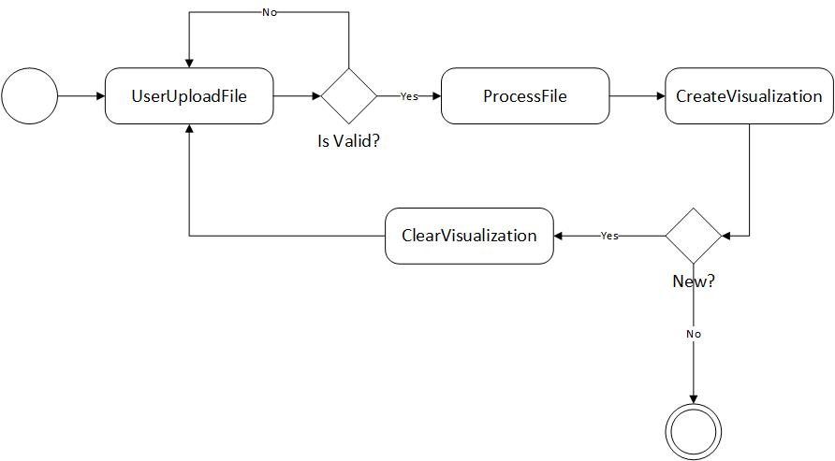

Use Case Diagram for IRMA
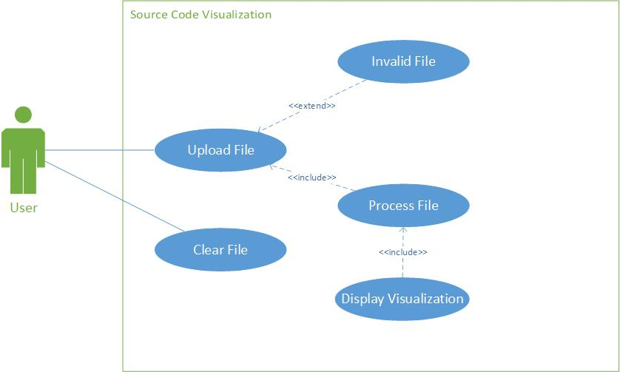

Sequence Diagram for IRMA
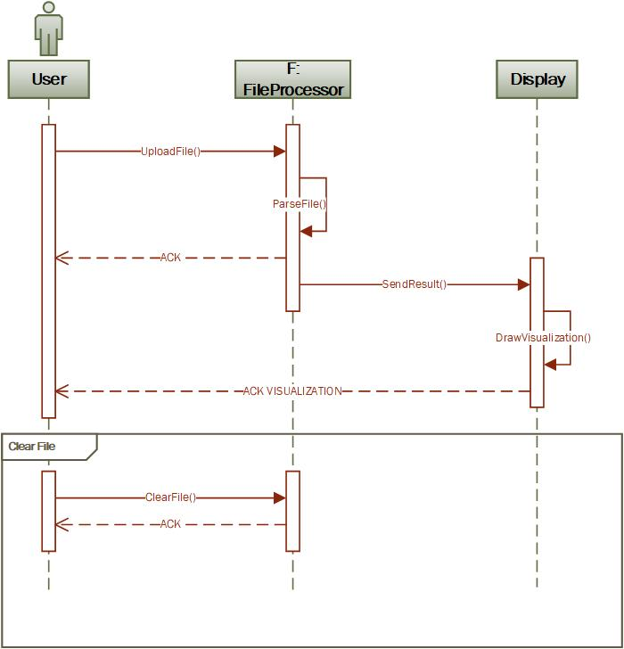

Class Diagram for IRMA
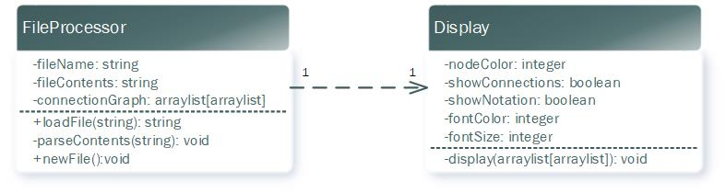

References

1. Bae, M., Ji, J., & Woo, G. (2008). A visualization system of source codes using FOL. 2008 8th IEEE International Conference on Computer and Information Technology. doi:10.1109/cit.2008.4594785

2. Cheon, J., Jo, K., & Woo, G. (2014). VizMe: An Automatic Visualization Tool for Source Codes. 2014 IEEE International Conference on Computer and Information Technology. doi:10.1109/cit.2014.33

3. Park, Y., & Jensen, C. (2009). Beyond pretty pictures: Examining the benefits of code visualization for Open Source newcomers. 2009 5th IEEE International Workshop on Visualizing Software for Understanding and Analysis. doi:10.1109/vissof.2009.5336433

4. Bohnet, J., & Dollner, J. (2007). Facilitating Exploration of Unfamiliar Source Code by Providing 21/2D Visualizations of Dynamic Call Graphs. 2007 4th IEEE International Workshop on Visualizing Software for Understanding and Analysis. doi:10.1109/vissof.2007.4290701

5. ROCAT on KATARIBE: Code Visualization for Communities
Tomohiro Ichinose-Kyohei Uemura-Daiki Tanaka-Hideaki Hata-Hajimu Iida-Kenichi Matsumoto - 2016 4th Intl Conf on Applied Computing and Information Technology/3rd Intl Conf on Computational Science/Intelligence and Applied Informatics/1st Intl Conf on Big Data, Cloud Computing, Data Science & Engineering (ACIT-CSII-BCD) – 2016

6. Bae, M., Ji, J., & Woo, G. (2010). Show my code in the web. Proceedings of the 21st ACM conference on Hypertext and hypermedia - HT 10. doi:10.1145/1810617.1810690

7. Gao, M., & Liu, C. (2015). TeamWATCH demonstration: a web-based 3d software source code visualization for education. Proceedings of the 1st International Workshop on Code Hunt Workshop on Educational Software Engineering - CHESE 2015. doi:10.1145/2792404.2792408

8. Jakobsen, M. R., & Hornbæk, K. (2009). Fisheyes in the field. Proceedings of the 27th international conference on Human factors in computing systems - CHI 09. doi:10.1145/1518701.1518943

9. Jelinek, J., & Slavik, P. (2004). GUI generation from annotated source code. Proceedings of the 3rd annual conference on Task models and diagrams - TAMODIA 04. doi:10.1145/1045446.1045470

10. Koch, J., Bohra, S., Goel, R., Pagade, S., & Cooper, K. (2011). AODVis. Proceeding of the 1st workshop on Developing tools as plug-ins - TOPI 11. doi:10.1145/1984708.1984716

11. CodeFlower Source code visualization. (n.d.). Retrieved October 12, 2017, from http://www.redotheweb.com/CodeFlower/

12. R. (2015, December 30). Code Visualization. Retrieved October 12, 2017, from https://www.grammatech.com/products/code-visualization

