**STARTING THE GAME**

The first thing the game will do is ask the players for their names. This will appear as shown below:

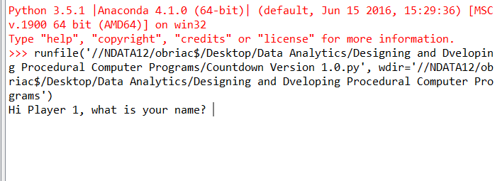

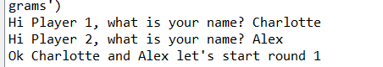Player 1 should enter their name on the same line as the question. This will repeat for Player 2 as shown to the right:

**ROUND ONE – LETTERS ROUND**

As soon as the players have inputted their names, Round 1 will start; this is a letters round in which the computer will randomly generate a sample of letters containing 6 consonants and 3 vowels. The aim of this round is to try and create a word that is as long as possible. Points are awarded based on the amount of letters in the word entered (at the conversion rate of 1 point = 1 letter, e.g cat = 3 points).

The letters will appear as shown to the right:

As soon as the letters appear the computer will then set a 30 second timer whilst the players try to find words from the letters.

When the 30 seconds is up, the computer will ask the players what is the longest word they have come up with as shown below:

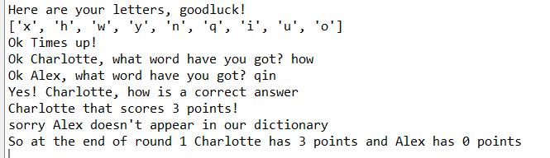

As you can see in this example, Charlotte has entered the word ‘how’. This word will then be checked against the dictionary to check that it is a legitimate word, and then it is also checked against the letters that were given in the random sample to check that the word entered has used the given letters. ‘how’ has then been awarded 3 points. Alex’s word ‘qin’ was not found in the dictionary and therefore will receive zero points for this round.

**ROUND TWO – LETTERS ROUND**

As the same as Round 1, Round 2 will start; this is a letters round in which again the computer will randomly generate a sample of letters containing 6 consonants and 3 vowels. The aim of this round is to try and create a word that is as long as possible. Points are awarded based on the amount of letters in the word entered (at the conversion rate of 1 point = 1 letter, e.g cat = 3 points).

The letters will appear as shown to the right:

As soon as the letters appear the computer will then set a 30 second timer whilst the players try to find words from the letters.

When the 30 seconds is up, the computer will ask the players what is the longest word they have come up with as shown below:

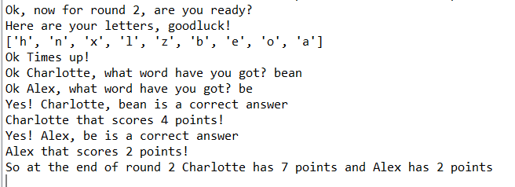

As you can see in this example, Charlotte has entered the word ‘bean’. This word will then be checked against the dictionary to check that it is a legitimate word, and then it is also checked against the letters that were given in the random sample to check that the word entered has used the given letters. ‘bean’ has then been awarded 4 points, bringing Charlotte’s total to 7 points. Alex’s word ‘be’ was also accepted and Alex now has a total of 2 points at the end of Round 2.

**ROUND THREE – NUMBERS ROUND**

Round 3 is slightly different to the previous letters rounds, this is a numbers round in which again the computer will randomly generate a sample of letters containing 6 numbers. In Round 3, **Player 1** is given the choice of how many ‘big ones’ they would like to use. ‘big ones’ are the following numbers: 25, 50, 75, and 100. ‘small ones’ are then the numbers under 10 (1-9). Player 1 should choose a number smaller than 6. The system will then randomly generate a number between 100 and 1000.

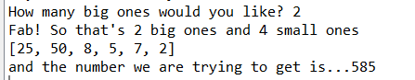The aim of this round is to try and use the numbers in the random sample to get to the number given at the start of the round using only basic mathematical symbols (e.g +, -, *, and /). 10 points are awarded to the player that gets closest to the target number. The numbers round is displayed below:

At the end of the 30 seconds, the system will ask each player what number they have managed to achieve. Whoever is the closest to the target number will then get the chance to say how they got to that number. If their workings are correct, 10 points will be awarded, as shown below:

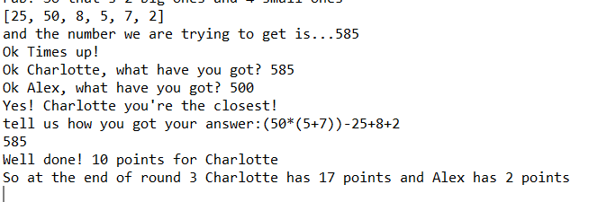

In the above example, Charlotte has achieved the target number and the workings out she has provided are correct so 10 points are awarded. If Charlotte’s workings out where incorrect, it would then go to the other player, if the other player can get to the number they have submitted then the points will then be awarded to them.

**ROUND FOUR – NUMBERS ROUND**

Round 4 is exactly the same as the previous numbers round, again this is a numbers round in which again the computer will randomly generate a sample of letters containing 6 numbers. In Round 3, **Player 2** is now given the choice of how many ‘big ones’ they would like to use. ‘big ones’ are the following numbers: 25, 50, 75, and 100. ‘small ones’ are then the numbers under 10 (1-9). Player 1 should choose a number smaller than 6. The system will then randomly generate a number between 100 and 1000.

The aim of this round is to try and use the numbers in the random sample to get to the number given at the start of the round using only basic mathematical symbols (e.g +, -, *, and /). 10 points are awarded to the player that gets closest to the target number. The numbers round is displayed below:

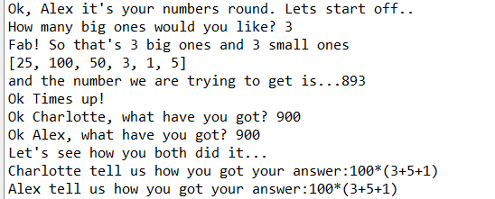At the end of the 30 seconds, the system will ask each player what number they have managed to achieve. Whoever is the closest to the target number will then get the chance to say how they got to that number. If their workings are correct, 10 points will be awarded, as shown below:

In the above example, Charlotte and Alex have both got the same number. In this instance as long as they can both prove how they got to this number 10 points will be awarded to each.

**ROUND FIVE – LETTERS ROUND**

The final round is back to a letters round. This is the same as previous letters rounds in which again the computer will randomly generate a sample of letters containing 6 consonants and 3 vowels. The aim of this round is to try and create a word that is as long as possible. Points are awarded based on the amount of letters in the word entered (at the conversion rate of 1 point = 1 letter, e.g cat = 3 points).

The letters will appear as shown to the right:

As soon as the letters appear the computer will then set a 30 second timer whilst the players try to find words from the letters.

At the end of this round the person with the highest amount of points will be awarded the winner.

**LINE MANAGER FEEDBACK**

|  |
| --- |
|  |

**LINE MANAGER SIGN OFF**

|  |  |  |  |  |
| --- | --- | --- | --- | --- |
| Learner |  |  | Date Signed |  |
| Line Manager |  |  | Date Signed |  |