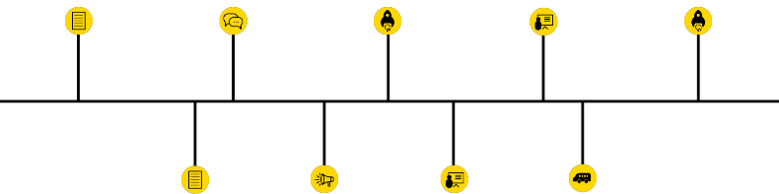

*Timeline showing (historic) volcano eruptions*

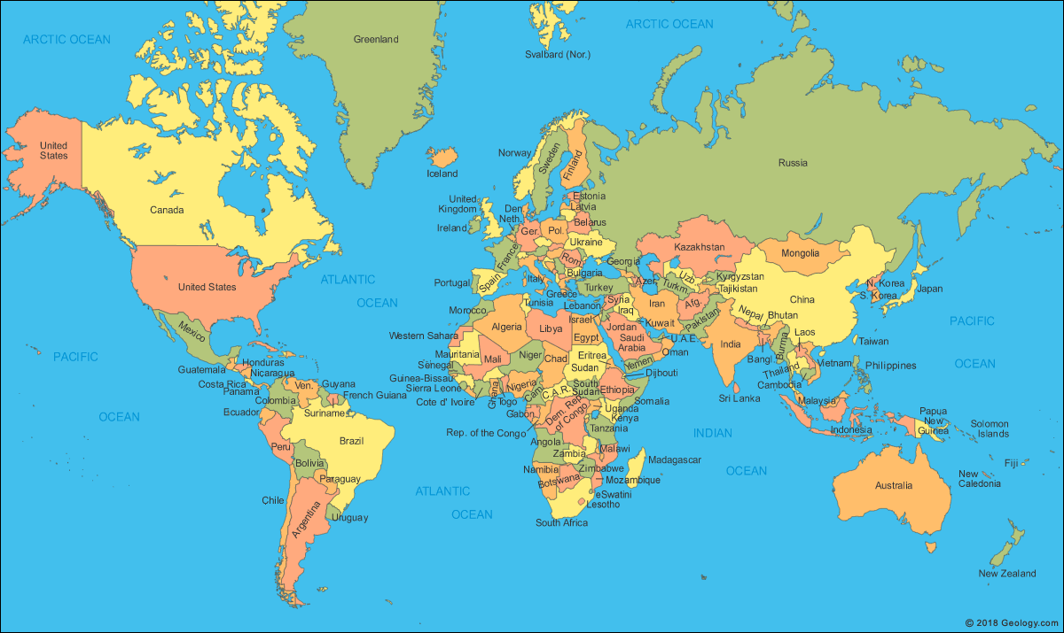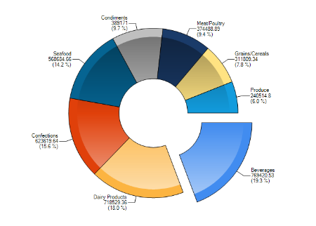

Hover: show name of country and list of volconoes (last eruption, elevation)

*Map shows countries which contain volcanoes Donut chart shows all different types of volcanoes which exist in the world*

On click: appear

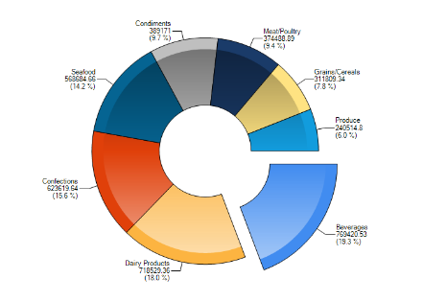

On click: appear

*This donut chart shows all types of volcanoes*

*which exist in specific country*

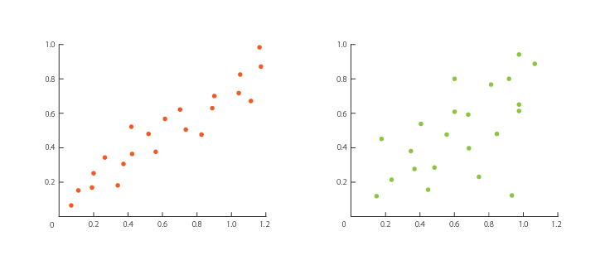

Drop  
down

*These scatterplots shows number of eruptions or number of deaths per type of volcano*