

# Digital Style Guide

Updated October 9th, 2018

Hello.

The TikTok visual identity was built around the ideas of entertainment and social enjoyment. Through the vibrant colors and bold elements, the identity forms a symbol of fun musical moments. This visual guide was created to help the identity communicate these values, and ensure the system maintains its best form across many environments.

Digital Style Guide 2

Contents

A. Logo

1. Clear Spacing
2. Minimum Sizes
3. Lockups
4. Alignment
5. Incorrect Usage
6. Image Use
7. Color / Image
8. Do’s and Don’ts
9. Typography
10. Advertising Guidelines
11. Loading Screen Guides
12. Partnership Usage
13. Digital Assets

B. Colors

1. Color Palette
2. Color Usage

18. Typography 25. App Store Icons

E. Graphics

20. Brand Shapes

Digital Style Guide 3

Logo

Digital Style Guide 4

Logotype

Primary Mark Lockup



Logo Mark

Digital Style Guide 5

Center

## Clear Spacing



2x

2x

1x

1x

2x

2x

A minimum area of space must always surrand the TikTok mark/logotype lockups. This area of isolation allows the identity to stand out by ensuring that other visual element are kept clear from the mark.

This clear space is based on the spacing of one arm on the letter k.

## 0.4in = 1x

Digital Style Guide 6

## Minimum Sizes



A clean and legible mark requires a minimum reproduction size.

Two sizes of the logo have been created to optimize the mark/logotype for small printing sizes and digital displays at small sizes.

Use this logo when printing less than 1/2 inch tall.

Comparison Between Original Version

Mark: Smaller Use TikTok_Logo_Small_RGB.ai

The glitch version was reduced to increase visual clarity when displayed at small sizes.

.5in 1.5 in



Digital Style Guide 7

## Lockups

The primary lockup will be in a vertical orientation to ensure that it stands at the utmost strongest form possible.

However if the format does not allow for this, an alternative approach of using the mark and logotype individually.

Lastly as a third solution and least desireable is the horizontal lockup. Please use as the last resort if needed.

Pimary Lockup



(Discouraged Use)



Secondary Single (preferred)



Secondary Single (preferred)

Digital Style Guide 8

.5x



## Alignment

The center of the mark should align with the Tiktok logotype.

The spacing between the mark and the logotype is the height of the top arm of the K seen on (page 6)



Please note that this relationship and lockup is critical for balance and visual clarity.

1x

Digital Style Guide 9

## Incorrect Usage



This style guide is developed to ensure that the TikTok logo is used in a way that allows the logo to standout from other elements and retain its integrity, along with the design intent across environments.

While new uses not covered may arise, please do not distort the logo, add to it or use it in any way that hinders legibility. A few examples have been provided.



1. Do not add drop-shadows or effects to the mark/logotype.
2. Do not add any type of gradient or color changes to the mark/logotype.
3. Do not stretch or warp the mark/logotype.
4. Do not use the logo on colors that are too similar to the logo colors.

Digital Style Guide 10

Color

Digital Style Guide 11

## Color Palette

The TikTok logo consists of colors that are designed to standout across the competitive landscape.

The mark/logotype should not appear in colors other than shown here or on the (Color Usage Page 13)

COLOR: BLACK RGB: 0/0/0 HEX: #000000

CMYK: 75/68/67/90

While new colors may arise that are not covered, we should be resepectful of the brand guides and goals.

|  |  |
| --- | --- |
| COLOR: TANGY BLUE | COLOR: TANGY PINK |
| RGB: 0/247/239 | RGB: 255/0/79 |
| HEX: #00F7EF | HEX: #FF004F |
| PANTONE: PANTONE 297C | PANTONE: 7416 U |
| CMYK: 54/0/15/0 | CMYK: 0/99/59/0 |

PRIMARY COLORS

|  |  |
| --- | --- |
| COLOR: DARK GRAY | COLOR: MEDIUM GRAY |
| RGB: 102/102/102 | RGB: 153/153/153 |
| HEX: #666666 | HEX: #999999 |
| CMYK: 60/51/51/20 | CMYK: 43/35/35/1 |

NEUTRAL GRAYSCALE

COLOR: GRAY RGB: 204/204/204 HEX: #CCCCCC CMYK: 19/15/16/0

NON COLOR

COLOR: WHITE RGB: 255/255/255 HEX: #FEFEFE CMYK: 0/0/0/0

Digital Style Guide 12

## Color Usage



The colors in the logo

should stay consistent at all times, however, some

situations call for adjustments.



In situations where color



arises the reduced versions, black or white should be

used. These were created for visual clarity.



Digital Style Guide 13

Image Use

Digital Style Guide 14

## Color Usage: Image

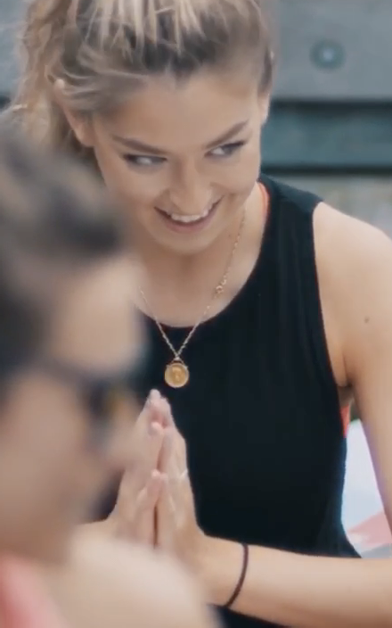

In certain uses, such as busy

photography or color fields that are too close to the

mark/logotype, the TikTok logo might not stand out against the background it is placed on.

In these cases, changing the logo color will be necessary.

On photos where the mark will not stand out the logo can be

reversed to white so enough contrast occurs between the

image and the mark/logotype.

On color fields that do not

compliment the logo color. the

mark/logotype can be reversed to white to allow contrast.

Digital Style Guide 15

## Image Use: Do’s and Don’ts

The brands position is under the notion that social is fun, authentic and approachable. TikTok is raw with user-generated content, and we want to convey that across all environments.

We will absolutely not use over poduced videos or photos that provide a sense of “perfection” or “highly curated”.

## Key Values

Fun Raw

Approachable Real Life

UGC (User Generated Content)





Do Not Use Use

Digital Style Guide 16

Typography

Digital Style Guide 17

1. Typography

## Typography

The TikTok logotype is based of a modified version of Sofia Pro by Typekit.com type foundry.

To maintain that typographic vernacular throughout the communications materials, we recommend using several version of the Sofia Pro headlines and subheads.

Sofia Pro is a strong purposeful supporting san-serif typeface. The Sofia Pro Regular Family should be used for body copy and

TikTok

ABCDEFGHIJKLMNOPQRSTUVWXYZ

abcdefghijklmnopqrstuvwxyz 1234567890!@#$%^&*()?

Sofia Pro Bold

Primary Typeface (headlines,large typography, etc.)

https://typekit.com/fonts/sofia

captions throughout all applications.

Sofia Pro should be purchased from https://typekit.com

## ABCDEFGHIJKLMNOPQRSTUVWXYZ

## abcdefghijklmnopqrstuvwxyz 1234567890!@#$%^&*()?

Sofia Pro Medium

Primary Typeface (Subheads, call-outs)

https://typekit.com/fonts/sofia

## ABCDEFGHIJKLMNOPQRSTUVWXYZ

## abcdefghijklmnopqrstuvwxyz 1234567890!@#$%^&*()?

Sofia Pro Regular

Primary Typeface ( Paragraphs, Captions, Body)

https://typekit.com/fonts/sofia

Digital Style Guide 18

Graphics

Digital Style Guide 19

1. Graphics

## Brand Shapes

As an extension of the logo, the alternative graphic elements can support the brand when appropriate.

Each graphical element is created by disecting the angles and shapes of the logomark.

Colors will be chosen based on the brand color palette (on page 12.)

Digital Style Guide 20

Advertising Guidelines

Digital Style Guide 21

## Loading Screen

TikTok will be presenting ads upon opening. These templates are made to help adhere to the needed standards based on the TikTok experience. They are phone and OS specific.

Skip Ad

Safe Area

Skip Ad

Safe Area

Templates

https://drive.google.com/ope n?id=18fVYA-gDdwslTX1vnHM lc3-5mCoSEwD9https://drive. google.com/file/d/1wlLOyRg e32dPYHJr3FuRaGdJU8wqz- Gk/view?usp=sharing

We currently only have iOS

Digital Style Guide 22

## Parnership Usage

When TikTok is present with another brand we want to make sure there is a clear distinction between one brand and another.

Option 1

Simple background with not much color will use the “Glitch” primary llogo ockup.

Option 2

When presented on the partners brand, it’s best to respect their brand and use our reduced version to provide visual clarity and cleanliness.

 +

Mcdonalds Option 1



+

Mcdonalds Option 2

Digital Style Guide 23

Digital Assets

Digital Style Guide 24

G. Digital Assets

## Badges

Always defer to the App Store Google Play guidelines that have been provided by Apple and Google.



App Store Guides https://developer.apple.com/app- store/marketing/guidelines/

Google Play Guides

https://play.google.com/intl/en_us



/badges/

Digital Style Guide 25