

《Java 程序设计》上机报告



姓 名 | 杨雨澄 | 学 号 | 170405207
班 级 | 计算机1702班 | 提交日期 | 2019年11月21日
内 容 | Java GUI与异常
评语
成 绩
评阅教师 | 常燕 | 评阅日期
- 目标与内容
目标 掌握GUI编程中的接口监听实现方法 掌握Java的异常处理方法
内容，完成下列类设计内容
设计一个GUI的绘图程序，要求实现
（1）绘制：圆形、矩形、三角形、扇形
（2）修改图形属性：颜色、位置、不同图形的不同属性
（3）图形的参数使用图形用户界面接收输入，注意：接口实现，接收数据的类型转换等
2.已实现的功能设计说明
1.根据按钮绘画出三角形，圆形，扇形，矩形
2.输入属性值来选择想要的图形的大小
3.能够对已经建立的图形，修改属性值，是否填充等。
4.点击图形能对其进行象征性的增大或者缩小，或者旋转
- 主要源码
package gui;
import gui.geoMoving;
import gui.geotransformation;
import java.awt.Color;
import java.awt.Graphics;
public abstract class geo implements geotransformation, geoMoving{
Color color = new Color(0,0,0);
protected Color fillcolor=new Color(0,0,0);
protected int x; //private cannot be used in the subclass directly
protected int y;
protected String isfill="N";//protected can be used in the subclass directly
public geo() {}
public geo(Color c) {
color = c;
}
public geo(int x, int y, Color c) {
color = c; this.x = x; this.y = y;
}
public abstract void draw(Graphics g);
public void setlocation(int a,int b)
{
x=a;
y=b;
}
@Override
public void toRight(int x) {
this.x += x;
}
@Override
public void toLeft(int x) {
this.x -= x;
}
@Override
public void toUp(int y) {
this.y -= y;
}
@Override
public void toDown(int y) {
this.y += y;
}
public int[] setcolor(String str)
{
int[] a=new int[3];
switch(str)
{
case "red": a[0]=255;a[1]=0;a[2]=0;break;
case "orange":a[0]=255;a[1]=200;a[2]=0;break;
case "yellow":a[0]=255;a[1]=255;a[2]=0;break;
case "green":a[0]=0;a[1]=255;a[2]=0;break;
case "blue":a[0]=0;a[1]=0;a[2]=255;break;
case "purple":a[0]=128;a[1]=0;a[2]=128;break;
case "black":a[0]=0;a[1]=0;a[2]=0;break;
case "white":a[0]=255;a[1]=255;a[2]=255;break;
case "gray":a[0]=128;a[1]=128;a[2]=128;break;
default:a[0]=0;a[1]=0;a[2]=0;break;
}
return a;
}
}
}
package gui;

public interface geoMoving{
void toRight(int x);
void toLeft(int x);
void toUp(int y);
void toDown(int y);
package gui;

public interface geotransformation {
void rotate();
void scale(double xScale, double yScale);
}

}
package gui;

import java.awt.Color;
import java.awt.Graphics;

public class circle extends geo{
int radius;
public circle(Color c, int r) {
super(c);
radius = r;
}
public circle(int x, int y, Color c, int r) {
super(x, y, c);
radius = r;
}
public void setParams(int x,int y, int z,int radius,int r,int s,int t,String str)
{
this.color=new Color(x,y,z);
this.radius=radius;
this.fillcolor=new Color(r,s,t);
this.isfill=str;
}
@Override
public void draw(Graphics g) {
g.setColor(this.color);
g.drawOval(this.x-radius, this.y-radius, 2*radius, 2*radius);
if(isfill.equals("Y"))
{
g.setColor(this.fillcolor);
g.fillOval(this.x-radius, this.y-radius, 2*radius, 2*radius);
}
}

@Override
public void rotate() {

}
@Override
public void scale(double xScale, double yScale) {//yScale means nothing to a circle.
this.radius = (int)(this.radius * xScale);
}
}
package gui;

import java.awt.Color;
import java.awt.Graphics;

public class rectangle extends geo{
//int x1,y1,x2,y2;
int width;
int height;
public rectangle(int x, int y, Color color, int w, int h) {
super(x,y,color);
width = w; height = h;
}
@Override
public void rotate() {
int t=this.height;
this.height=this.width;
this.width=t;
}

@Override
public void scale(double xScale, double yScale) {
this.width = (int) (this.width * xScale);
this.height = (int) (this.height * yScale);
}

@Override
public void draw(Graphics g) {
g.setColor(this.color);
g.drawRect(x-width/2,y-height/2,width,height);
if(isfill.equals("Y"))
{
g.setColor(this.fillcolor);
g.fillRect(x-width/2,y-height/2,width,height);
}
}
public void setParams(int x,int y, int z,int w, int h,int r,int s,int t,String str) {
this.color=new Color(x,y,z);
this.width = w;
this.height = h;
this.fillcolor=new Color(r,s,t);
this.isfill=str;
}
}
package gui;

import java.awt.Color;
import java.awt.Graphics;

public class triangle extends geo{
int[] xpoints=new int[3];
int[] ypoints=new int[3];
public triangle(int x, int y, Color color, int x1, int y1, int x2, int y2, int x3, int y3)
{
super(x,y,color);
xpoints[0]=x1;
xpoints[1]=x2;
xpoints[2]=x3;
ypoints[0]=y1;
ypoints[1]=y2;
ypoints[2]=y3;
}
@Override
public void rotate() {
int a,b,c,d,e,f,g,h,k,l,n,m;
a=(xpoints[0]+xpoints[1]+xpoints[2])/3;
b=(ypoints[0]+ypoints[1]+ypoints[2])/3;
c=xpoints[0]-a;
d=b-ypoints[0];
xpoints[0]=a+d;
ypoints[0]=b+c;
e=xpoints[1]-a;
f=b-ypoints[1];
xpoints[1]=a+f;
ypoints[1]=b+e;
g=xpoints[2]-a;
h=b-ypoints[2];
xpoints[2]=a+h;
ypoints[2]=b+g;
}

@Override
public void scale(double xScale, double yScale) {
/*int A1=2*(xpoints[1]-xpoints[0]);
int B1=2*(ypoints[1]-ypoints[0]);
int C1=xpoints[1]^2+ypoints[1]^2-xpoints[0]^2-ypoints[0]^2;
int A2=2*(xpoints[2]-xpoints[1]);
int B2=2*(ypoints[2]-ypoints[1]);
int C2=xpoints[2]^2+ypoints[2]^2-xpoints[1]^2-ypoints[1]^2;
int x=(int)((C1*B2)-(C2*B1))/((A1*B2)-(A2*B1));
int y=(int)((A1*C2)-(A2*C1))/((A1*B2)-(A2*B1));
int d1=(int)Math.sqrt((x-xpoints[0])^2+(y-ypoints[0])^2);
xpoints[0]=x-((int)(d1+10*xScale)*(x-xpoints[0])/d1);
ypoints[0]=x-((int)(d1+10*xScale)*(y-ypoints[0])/d1);
int d2=(int)Math.sqrt((x-xpoints[1])^2+(y-ypoints[1])^2);
xpoints[1]=x-((int)(d2+10*xScale)*(x-xpoints[1])/d2);
ypoints[1]=x-((int)(d2+10*xScale)*(y-ypoints[1])/d2);
int d3=(int)Math.sqrt((x-xpoints[2])^2+(y-ypoints[2])^2);
xpoints[2]=x-((int)(d3+10*xScale)*(x-xpoints[2])/d3);
ypoints[2]=x-((int)(d3+10*xScale)*(y-ypoints[2])/d3);*/
}

@Override
public void draw(Graphics g) {
g.setColor(this.color);
g.drawPolygon(this.xpoints,this.ypoints,3);
if(isfill.equals("Y"))
{
g.setColor(this.fillcolor);
g.fillPolygon(this.xpoints,this.ypoints,3);
}

}
public void setParams( int x,int y, int z,int x1, int y1, int x2, int y2, int x3, int y3,int r,int s,int t,String str) {
this.color=new Color(x,y,z);
xpoints[0]=x1;
xpoints[1]=x2;
xpoints[2]=x3;
ypoints[0]=y1;
ypoints[1]=y2;
ypoints[2]=y3;
this.fillcolor=new Color(r,s,t);
this.isfill=str;
}
@Override
public void toRight(int x) {
this.xpoints[0]+= x;
this.xpoints[1]+= x;
this.xpoints[2]+= x;
}
@Override
public void toLeft(int x) {
this.xpoints[0]-= x;
this.xpoints[1]-= x;
this.xpoints[2]-= x;
}
@Override
public void toUp(int y) {
this.ypoints[0]-= y;
this.ypoints[1]-= y;
this.ypoints[2]-= y;
}
@Override
public void toDown(int y) {
this.ypoints[0]+= y;
this.ypoints[1]+= y;
this.ypoints[2]+= y;
}
}
package gui;
import java.awt.Color;
import java.awt.Graphics;

public class sector extends geo
{
int startangle;
int endtangle;
int h;
public sector(int x, int y, Color c, int h, int startangle, int endangle)
{
super(x,y,c);
this.startangle=startangle;
this.endtangle=endangle;
this.h=h;
}
@Override
public void rotate() {
this.startangle-=90;
}

@Override
public void scale(double xScale, double yScale) {
this.h = (int) (this.h * xScale);
}

@Override
public void draw(Graphics g)
{
g.setColor(this.color);
g.drawArc(this.x,this.y,this.h,this.h,this.startangle,this.endtangle);
g.fillArc(this.x,this.y,this.h,this.h,this.startangle,this.endtangle);
}
public void setParams(int x,int y, int z,int h,int n,int m)
{
this.color=new Color(x,y,z);
this.h = h;
this.startangle = n;
this.endtangle=m-n;
}
}
package gui;

import java.awt.*;
import java.awt.event.ActionEvent;
import java.awt.event.ActionListener;
import java.awt.Color;
import java.awt.Graphics;
import javax.swing.JButton;
import javax.swing.JDialog;
import javax.swing.JLabel;
import javax.swing.JTextField;

public class dlgaddcircle extends JDialog{
private geo o;
int a;
private int[] b=new int[3];
private int[] q=new int[3];
JLabel[] labels = new JLabel[] {new JLabel("radius: "),new JLabel("Color: "),new JLabel("Site X: "),new JLabel("Site Y: "),new JLabel("IS Fill:(Y/N)"),new JLabel("FillColor: ")};
JTextField[] txtFields = new JTextField[] {new JTextField(),new JTextField(),new JTextField(),new JTextField(),new JTextField(),new JTextField()};
JButton btnOk = new JButton("OK");
public dlgaddcircle(drawingpanel pa, geo o) {
super(pa,"Add Circle",true);
Container container=getContentPane();
container.setBackground(Color.white);
this.o = o;
if(pa.Flag==0) {
a = 2;
container.setLayout(new GridLayout(3, 2, 5, 5));
}
else {
a = 6;
container.setLayout(new GridLayout(7, 2, 5, 5));
}
for(int i=0; i< a; i++) {
container.add(labels[i]);
container.add(txtFields[i]);
labels[i].setFont(new Font("", Font.BOLD, 22)); //设置字体大小
labels[i].setForeground(Color.BLUE);//设置字体颜色
labels[i].setHorizontalAlignment(JLabel.CENTER);
txtFields[i].setFont(new Font("", Font.BOLD, 22)); //设置字体大小
txtFields[i].setForeground(Color.BLACK);//设置字体颜色
txtFields[i].setHorizontalAlignment(JLabel.CENTER);
}
container.add(btnOk);
btnOk.addActionListener(new ActionListener() {
public void actionPerformed(ActionEvent e) {
/*int w = Integer.parseInt(txtFields[0].getText());*/
/*double w1=Double.parseDouble(txtFields[0].getText());*/
int w=(int)Double.parseDouble(txtFields[0].getText());
String getcolor=txtFields[1].getText();
String getfill="";
String getcolor1="";
if(pa.Flag==1) {
int m=(int)Double.parseDouble(txtFields[2].getText());
int n=(int)Double.parseDouble(txtFields[3].getText());
getfill = txtFields[4].getText();
getcolor1 = txtFields[5].getText();
q=o.setcolor(getcolor1);
((circle)o).setlocation(m,n);
}
b = o.setcolor(getcolor);
((circle) o).setParams(b[0], b[1], b[2], w, q[0], q[1], q[2], getfill);
pa.Flag = 1;
dispose();
}
});
this.setSize(350,400);
centreWindow(this);
this.setVisible(true);
}
public static void centreWindow(Window frame) {
Dimension dimension = Toolkit.getDefaultToolkit().getScreenSize();
int x = (int) ((dimension.getWidth() - frame.getWidth()) / 2);
int y = (int) ((dimension.getHeight() - frame.getHeight()) / 2);
frame.setLocation(x, y);
}
}
package gui;

import java.awt.*;
import java.awt.event.ActionEvent;
import java.awt.event.ActionListener;
import javax.swing.JButton;
import javax.swing.JDialog;
import javax.swing.JLabel;
import javax.swing.JTextField;

public class dlgaddrect extends JDialog{
geo o;
int a;
private int[] b=new int[3];
private int[] q=new int[3];
JLabel[] labels = new JLabel[] {new JLabel("width: "),new JLabel("height: "),new JLabel("color: "),new JLabel("Site X: "),new JLabel("Site Y: "),new JLabel("IS Fill:(Y/N) "),new JLabel("FillColor: ")};
JTextField[] txtFields = new JTextField[] {new JTextField(),new JTextField(),new JTextField(),new JTextField(),new JTextField(),new JTextField(),new JTextField()};
JButton btnOk = new JButton("OK");
public dlgaddrect(drawingpanel pa, geo o) {
super(pa,"Add Rectangle",true);
Container container=getContentPane();
container.setBackground(Color.white);
this.o = o;
if(pa.Flag==0) {
a = 3;
container.setLayout(new GridLayout(4, 2, 5, 5));
}
else {
a = 7;
container.setLayout(new GridLayout(8, 2, 5, 5));
}
for(int i=0; i< a; i++) {
container.add(labels[i]);
container.add(txtFields[i]);
labels[i].setFont(new Font("", Font.BOLD, 22)); //设置字体大小
labels[i].setForeground(Color.BLUE);//设置字体颜色
labels[i].setHorizontalAlignment(JLabel.CENTER);
txtFields[i].setFont(new Font("", Font.BOLD, 22)); //设置字体大小
txtFields[i].setForeground(Color.BLACK);//设置字体颜色
txtFields[i].setHorizontalAlignment(JLabel.CENTER);
}
container.add(btnOk);
btnOk.addActionListener(new ActionListener() {
public void actionPerformed(ActionEvent arg0) {
int w=(int)Double.parseDouble(txtFields[0].getText());
int h=(int)Double.parseDouble(txtFields[1].getText());
String getcolor=txtFields[2].getText();
String getfill="";
String getcolor1="";
if(pa.Flag==1) {
int m=(int)Double.parseDouble(txtFields[3].getText());
int n=(int)Double.parseDouble(txtFields[4].getText());
getfill = txtFields[5].getText();
getcolor1 = txtFields[6].getText();
q=o.setcolor(getcolor1);
((rectangle)o).setlocation(m,n);
}
b=o.setcolor(getcolor);
((rectangle)o).setParams(b[0],b[1],b[2],w,h,q[0],q[1],q[2],getfill);
pa.Flag=1;
dispose();
}
});
this.setSize(350,650);
centreWindow(this);
this.setVisible(true);
}
public static void centreWindow(Window frame) {
Dimension dimension = Toolkit.getDefaultToolkit().getScreenSize();
int x = (int) ((dimension.getWidth() - frame.getWidth()) / 2);
int y = (int) ((dimension.getHeight() - frame.getHeight()) / 2);
frame.setLocation(x, y);
}
}

package gui;

import java.awt.Color;
import java.awt.Container;
import java.awt.Dimension;
import java.awt.GridLayout;
import java.awt.Toolkit;
import java.awt.Window;
import java.awt.event.ActionEvent;
import java.awt.event.ActionListener;
import java.awt.Font;
import javax.swing.JButton;
import javax.swing.JDialog;
import javax.swing.JLabel;
import javax.swing.JTextField;

public class dlgaddtrian extends JDialog{
geo o;
int a;
private int[] b=new int[3];
private int[] q=new int[3];
JLabel[] labels = new JLabel[] {new JLabel("x1: "),new JLabel("y1: "),new JLabel("x2: "),new JLabel("y2: "),new JLabel("x3: "),new JLabel("y3: "),new JLabel("color: "),new JLabel("IS Fill:(Y/N) "),new JLabel("FillColor: ")};
JTextField[] txtFields = new JTextField[] {new JTextField(),new JTextField(),new JTextField(),new JTextField(),new JTextField(),new JTextField(),new JTextField(),new JTextField(),new JTextField()};
JButton btnOk = new JButton("OK");
public dlgaddtrian(drawingpanel pa, geo o) {
super(pa,"Add Triangle",true);
Container container=getContentPane();
container.setBackground(Color.white);
this.o = o;
if(pa.Flag==0) {
a = 7;
container.setLayout(new GridLayout(8, 2, 5, 5));
}
else {
a = 9;
container.setLayout(new GridLayout(10, 2, 5, 5));
}
for(int i=0; i<a; i++) {
container.add(labels[i]);
container.add(txtFields[i]);
labels[i].setFont(new Font("", Font.BOLD, 22)); //设置字体大小
labels[i].setForeground(Color.BLUE);//设置字体颜色
labels[i].setHorizontalAlignment(JLabel.CENTER);
txtFields[i].setFont(new Font("", Font.BOLD, 22)); //设置字体大小
txtFields[i].setForeground(Color.BLACK);//设置字体颜色
txtFields[i].setHorizontalAlignment(JLabel.CENTER);
}
container.add(btnOk);
btnOk.addActionListener(new ActionListener() {
public void actionPerformed(ActionEvent arg0) {
int x1=(int)Double.parseDouble(txtFields[0].getText());
int y1=(int)Double.parseDouble(txtFields[1].getText());
int x2=(int)Double.parseDouble(txtFields[2].getText());
int y2=(int)Double.parseDouble(txtFields[3].getText());
int x3=(int)Double.parseDouble(txtFields[4].getText());
int y3=(int)Double.parseDouble(txtFields[5].getText());
String getcolor=txtFields[6].getText();
String getfill="";
String getcolor1="";
if(pa.Flag==1) {
getfill = txtFields[7].getText();
getcolor1 = txtFields[8].getText();
q=o.setcolor(getcolor1);
}
b=o.setcolor(getcolor);
((triangle)o).setParams( b[0],b[1],b[2],x1, y1, x2, y2, x3, y3,q[0],q[1],q[2],getfill);
pa.Flag=1;
dispose();
}
});
this.setSize(350,550);
centreWindow(this);
this.setVisible(true);
}
public static void centreWindow(Window frame) {
Dimension dimension = Toolkit.getDefaultToolkit().getScreenSize();
int x = (int) ((dimension.getWidth() - frame.getWidth()) / 2);
int y = (int) ((dimension.getHeight() - frame.getHeight()) / 2);
frame.setLocation(x, y);
}
}
package gui;

import java.awt.*;
import java.awt.event.ActionEvent;
import java.awt.event.ActionListener;
import javax.swing.JButton;
import javax.swing.JDialog;
import javax.swing.JLabel;
import javax.swing.JTextField;

public class dlgaddsector extends JDialog{
private geo o;
int a;
private int[] b=new int[3];
JLabel[] labels = new JLabel[] {new JLabel("radius: "),new JLabel("startangle: "),new JLabel("endangle: "),new JLabel("color: "),new JLabel("Site X: "),new JLabel("Site Y: ")};
JTextField[] txtFields = new JTextField[] {new JTextField(),new JTextField(),new JTextField(),new JTextField(),new JTextField(),new JTextField()};
JButton btnOk = new JButton("OK");
public dlgaddsector(drawingpanel pa, geo o) {
super(pa,"Add Sector",true);
Container container=getContentPane();
container.setBackground(Color.white);
this.o = o;
if(pa.Flag==0) {
a = 4;
container.setLayout(new GridLayout(5, 2, 5, 5));
}
else {
a = 6;
container.setLayout(new GridLayout(7, 2, 5, 5));
}
for(int i=0; i<a; i++) {
container.add(labels[i]);
container.add(txtFields[i]);
labels[i].setFont(new Font("", Font.BOLD, 22)); //设置字体大小
labels[i].setForeground(Color.BLUE);//设置字体颜色
labels[i].setHorizontalAlignment(JLabel.CENTER);
txtFields[i].setFont(new Font("", Font.BOLD, 22)); //设置字体大小
txtFields[i].setForeground(Color.BLACK);//设置字体颜色
txtFields[i].setHorizontalAlignment(JLabel.CENTER);
}
container.add(btnOk);
btnOk.addActionListener(new ActionListener() {
public void actionPerformed(ActionEvent e) {
int w=(int)Double.parseDouble(txtFields[0].getText());
int h=(int)Double.parseDouble(txtFields[1].getText());
int n=(int)Double.parseDouble(txtFields[2].getText());
String getcolor=txtFields[3].getText();
if(pa.Flag==1) {
int m=(int)Double.parseDouble(txtFields[4].getText());
int k=(int)Double.parseDouble(txtFields[5].getText());
((sector)o).setlocation(m,k);
}
b=o.setcolor(getcolor);
((sector)o).setParams(b[0],b[1],b[2],w,h,n);
pa.Flag=1;
dispose();
}
});
this.setSize(300,400);
centreWindow(this);
this.setVisible(true);
}
public static void centreWindow(Window frame) {
Dimension dimension = Toolkit.getDefaultToolkit().getScreenSize();
int x = (int) ((dimension.getWidth() - frame.getWidth()) / 2);
int y = (int) ((dimension.getHeight() - frame.getHeight()) / 2);
frame.setLocation(x, y);
}
}
package gui;

import java.awt.Graphics;

public class geometrics1{
public static final int MAX = 100;
public static int count = 0;
public int a;
public geo[] geometrics = new geo[MAX];
public geo add(geo o) {
if(count<MAX) {
geometrics[count++] = o;
a=count-1;
return geometrics[count-1];
}else{
return null;
}
}
public void draw(Graphics g) {
for(geo o: geometrics) {
if(o != null) {
o.draw(g);
}
}
}
}
package gui;

import java.awt.Color;
import java.awt.Graphics;
import java.awt.event.ActionEvent;
import java.awt.event.ActionListener;
import java.awt.event.MouseWheelEvent;
import java.awt.event.MouseWheelListener;
import java.util.Random;
import javax.swing.JButton;
import javax.swing.JFrame;
import javax.swing.JOptionPane;
import javax.swing.JPanel;

public class drawingpanel extends JFrame {
public static final int d = 10;
private geometrics1 obj = new geometrics1(); //图形管理类
private geo currentGeo; //当前操作图形，目前为新增的图形
private int flag=0;
public int Flag=0;
public int flag1=0;
JButton btnCircle = new JButton("Circle");
JButton btnRect = new JButton("Rectangle");
JButton btnTrian = new JButton("Triangle");
JButton btnSector = new JButton("Sector");
JButton[] btnMove = new JButton[] { new JButton("Right"),new JButton("Left"),new JButton("Up"), new JButton("Down")};
JButton rotate = new JButton("Rotate");
JButton modify = new JButton("Modify");
JButton clear=new JButton("Clear All");
JButton Clear=new JButton("Clear The");
/*class MyPanel extends JPanel{
@Override
public void paint(Graphics g) {
super.paint(g);
obj.draw(g);
}
}
}
MyPanel p1=new MyPanel();*/
JPanel p1 = new JPanel() { //定义匿名内部类，实现与MyPanel一样，可替代MyPanel
@Override
public void paint(Graphics g) {
super.paint(g);
obj.draw(g);
}
};
public drawingpanel() {
super("DrawingPane");
initComponents(); //初始化p1
this.setSize(1600,1200);
this.setLocationRelativeTo(null); // Center the frame
this.setDefaultCloseOperation(JFrame.EXIT_ON_CLOSE);
this.setVisible(true);
}
private void initComponents() {
btnCircle.addActionListener(new ActionListener() {
public void actionPerformed(ActionEvent e) {
btnCircleClicked(e);
}
});
p1.add(btnCircle);

btnRect.addActionListener(new ActionListener() {
public void actionPerformed(ActionEvent e) {
btnRectClicked(e);
}
});
p1.add(btnRect);

btnTrian.addActionListener(new ActionListener() {
public void actionPerformed(ActionEvent e) {
btnTrianClicked(e);
}
});
p1.add(btnTrian);

btnSector.addActionListener(new ActionListener() {
public void actionPerformed(ActionEvent e) {
btnSectorClicked(e);
}
});
p1.add(btnSector);

p1.add(modify);
modify.addActionListener(new ActionListener() {
@Override
public void actionPerformed(ActionEvent e) {
switch(flag1)
{
case 1: modifycircleClicked(e);break;
case 2: modifyRectClicked(e);break;
case 3: modifyTrianClicked(e);break;
case 4: modifySectorClicked(e);break;
}
}
});

p1.add(clear);
clear.addActionListener(new ActionListener() {
@Override
public void actionPerformed(ActionEvent e) {
for(int i=0;i<20;i++)
obj.geometrics[i]=null;
p1.repaint();
}
});
p1.add(Clear);
Clear.addActionListener(new ActionListener() {
@Override
public void actionPerformed(ActionEvent e) {
obj.geometrics[obj.a]=null;
p1.repaint();
}
});
for(int i=0; i<btnMove.length; i++) {
btnMove[i].addActionListener(new ActionListener() {
@Override
public void actionPerformed(ActionEvent e) {
switch(e.getActionCommand()) {
case "Right":
if (flag != 0)
((triangle)currentGeo).toRight(d);
else
currentGeo.toRight(d);
break; //currentGeo.x += 5;break;
case "Left":
if (flag != 0)
((triangle)currentGeo).toLeft(d);
else
currentGeo.toLeft(d);
break; //currentGeo.x += 5;break;
case "Up":
if (flag != 0)
((triangle)currentGeo).toUp(d);
else
currentGeo.toUp(d);
break; //currentGeo.x += 5;break;
case "Down":
if (flag != 0)
((triangle)currentGeo).toDown(d);
else
currentGeo.toDown(d);
break; //currentGeo.x += 5;break;
}
p1.repaint();
}
});
p1.add(btnMove[i]);
}
rotate.addActionListener(new ActionListener() {
@Override
public void actionPerformed(ActionEvent e) {
rotateClicked(e);
}
});
p1.add(rotate);
p1.setBackground(new Color(255,255,255));
p1.addMouseWheelListener(new MouseWheelListener() {
@Override
public void mouseWheelMoved(MouseWheelEvent e) {
if(currentGeo != null) {
if(e.getWheelRotation() < 0) //==-1
currentGeo.scale(2, 2);
else //==1
currentGeo.scale(0.5, 0.5);
}
p1.repaint();
}
});
this.add(p1);
}
protected void btnCircleClicked(ActionEvent e) {
flag=0;
Flag=0;
flag1=1;
JOptionPane.showMessageDialog(p1, "To add a new Circle!","Information",JOptionPane.INFORMATION_MESSAGE);
Random r = new Random();
currentGeo = obj.add(new circle(
r.nextInt(425 - 80 + 1) + 80, r.nextInt(700 - 100 + 1) + 100,
new Color(r.nextInt(255), r.nextInt(255), r.nextInt(255)), 0));
new dlgaddcircle(this, currentGeo);
if(currentGeo == null) {
JOptionPane.showMessageDialog(p1, "No space for it!","Error",JOptionPane.ERROR_MESSAGE);
}
p1.repaint();
}
protected void btnRectClicked(ActionEvent e) {
flag=0;
Flag=0;
flag1=2;
JOptionPane.showMessageDialog(p1, "To add a new Rectangle!","Information",JOptionPane.INFORMATION_MESSAGE);
Random r = new Random();
currentGeo = obj.add(new rectangle(r.nextInt(900-500+1)+500, r.nextInt(700-100+1)+ 100,new Color(r.nextInt(255),r.nextInt(255),r.nextInt(255)), 0,0));
new dlgaddrect(this, currentGeo);//set width and height
if(currentGeo == null) {
JOptionPane.showMessageDialog(p1, "No space for it!","Error",JOptionPane.ERROR_MESSAGE);
}
p1.repaint();
}
public void btnTrianClicked(ActionEvent e)
{
Flag=0;
flag1=3;
JOptionPane.showMessageDialog(p1, "To add a new Triangle!","Information",JOptionPane.INFORMATION_MESSAGE);
Random r = new Random();
currentGeo = obj.add(new triangle(0,0,new Color(r.nextInt(255),r.nextInt(255),r.nextInt(255)), 0,0,0,0,0,0));
new dlgaddtrian(this, currentGeo);//set width and height
if(currentGeo == null) {
JOptionPane.showMessageDialog(p1, "No space for it!","Error",JOptionPane.ERROR_MESSAGE);
}
flag=1;
p1.repaint();
}
public void btnSectorClicked(ActionEvent e)
{
flag=0;
Flag=0;
flag1=4;
JOptionPane.showMessageDialog(p1, "To add a new Sector!","Information",JOptionPane.INFORMATION_MESSAGE);
Random r = new Random();
currentGeo = obj.add(new sector(r.nextInt(1400-950+1)+950, r.nextInt(700-100+1)+ 100,new Color(r.nextInt(255),r.nextInt(255),r.nextInt(255)), 0,0,0));
new dlgaddsector(this, currentGeo);//set width and height
if(currentGeo == null) {
JOptionPane.showMessageDialog(p1, "No space for it!","Error",JOptionPane.ERROR_MESSAGE);
}
p1.repaint();
}
protected void modifycircleClicked(ActionEvent e) {
JOptionPane.showMessageDialog(p1, "To modify the Circle!","Information",JOptionPane.INFORMATION_MESSAGE);
new dlgaddcircle(this, currentGeo);
p1.repaint();
}
protected void modifyRectClicked(ActionEvent e) {
JOptionPane.showMessageDialog(p1, "To modify the Rectangle!","Information",JOptionPane.INFORMATION_MESSAGE);
new dlgaddrect(this, currentGeo);
p1.repaint();
}
protected void modifyTrianClicked(ActionEvent e) {
JOptionPane.showMessageDialog(p1, "To modify the Triangle!","Information",JOptionPane.INFORMATION_MESSAGE);
new dlgaddtrian(this, currentGeo);
p1.repaint();
}
protected void modifySectorClicked(ActionEvent e) {
JOptionPane.showMessageDialog(p1, "To modify the Sector!","Information",JOptionPane.INFORMATION_MESSAGE);
new dlgaddsector(this, currentGeo);
p1.repaint();
}
protected void rotateClicked(ActionEvent e) {
currentGeo.rotate();
p1.repaint();
}

}
package gui;

public class main {

public static void main(String[] args) {
new drawingpanel();
}

}
- 开发中遇到的问题与解决方法
- 对监听接口的使用还存在一些问题
- 建立的形状有的是随机值，因为不知道为什么将自己写好的程序运行进去就是不好使
- 图形管理类，不太会是从网上学习过来的
- 目前存在的问题与改进方案
将写好的程序与监听器使用在一起，需要后续的具体调试
- 运行效果图
绘制一个圆形，如下图所示
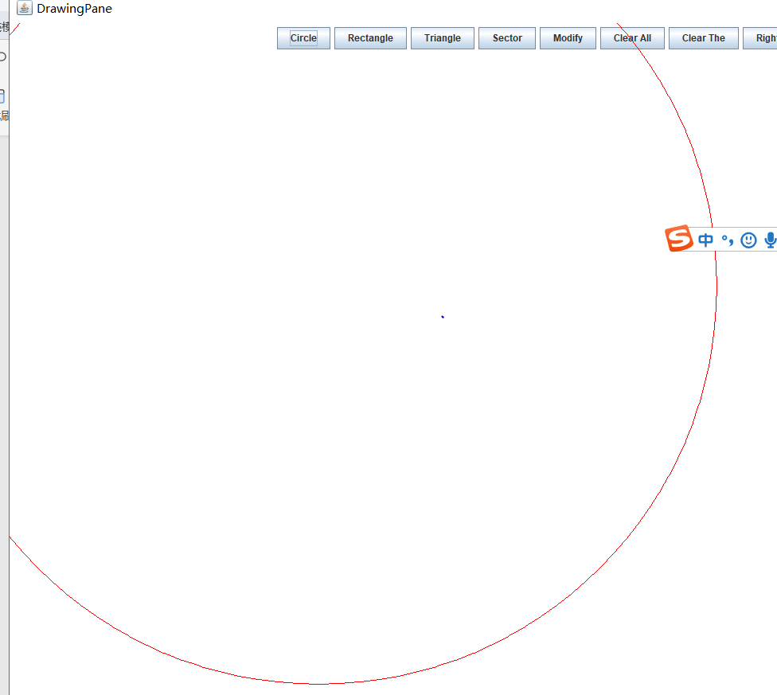
添加一个矩形，效果如下图所示
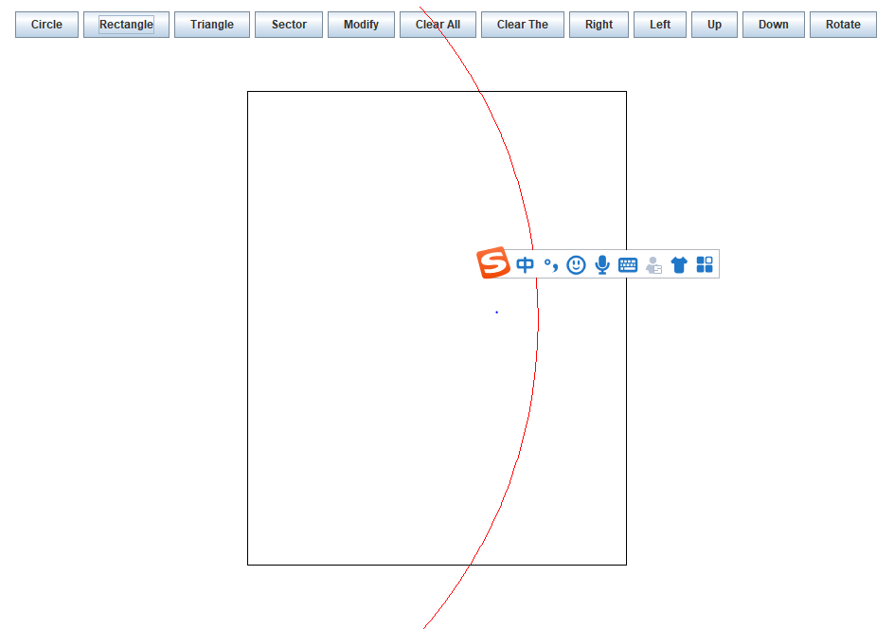

添加一个三角形，效果如下图所示
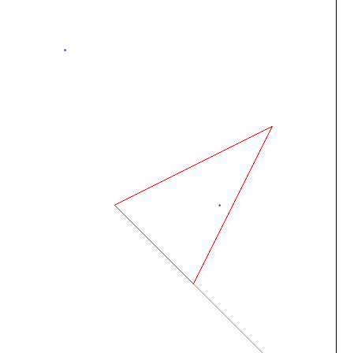

添加一个扇形，效果图，如下所示

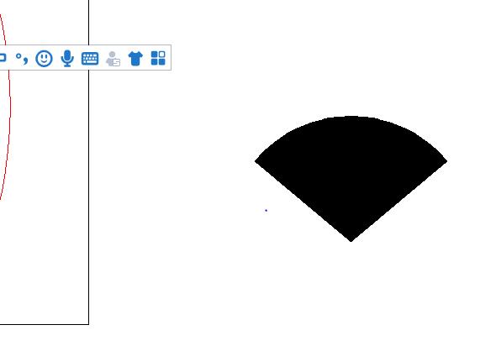
修改矩形效果，如下图所示

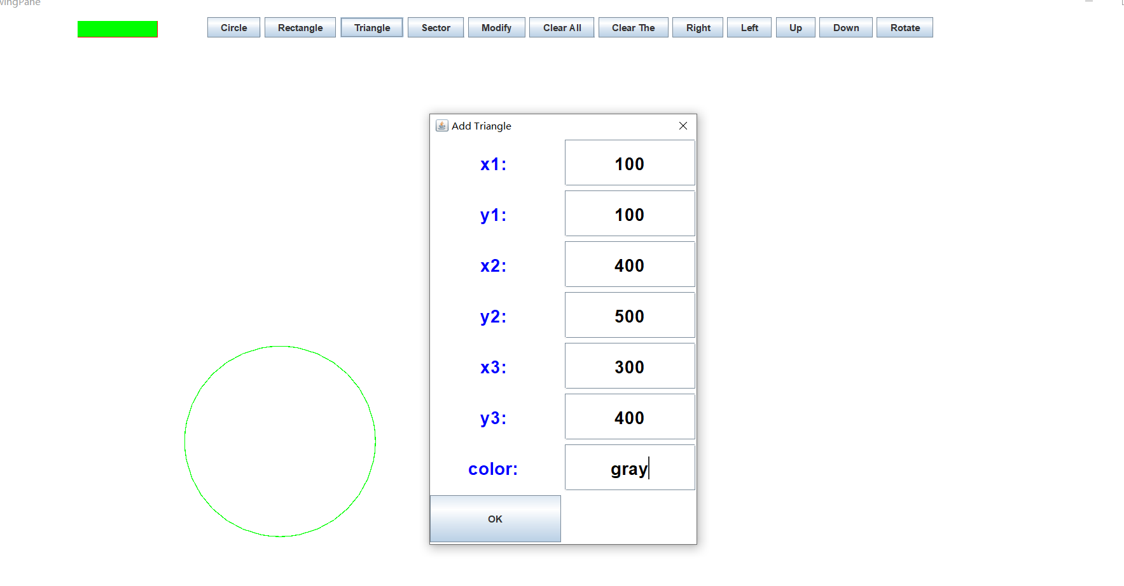
修改图形的颜色，位置大小，如下图所示
