1.About Parking Buddy
How the Project Was Acquired:
Our software company was contacted by the University of Houston to help with parking because of the growing student population. They wanted our company to create a parking app that could help students, staff, and campus police. After looking at the problem, we decided to create Parking Buddy.
Company Introduction:
Our company, Lucky Vision Tech, creates mobile and web apps. Our goal is to create simple systems that are easy for both customers and businesses to use.

2. Competitive Comparison
Before planning Parking Buddy, I looked at parking apps and management systems that are already being used. Most of them focus more on either the driver or the parking operator. Parking Buddy is meant to bring both sides together in one platform.
1.SpotHero
Focus: Reserving parking in garages and lots.
Strength: Easy to search for and reserve parking.
Weakness: Availability depends on the garage keeping its information accurate.
2.ParkWhiz
Focus: Prepaid parking for garages, events, and airports.
Strength: Helpful for planning parking before a trip or event.
Weakness: Focuses more on reservations than managing the garage itself.
3.ParkMobile
Focus: Paying for metered and zone-based parking.
Strength: Makes it easy to pay and add more parking time.
Weakness: Paying does not always guarantee that a parking space is available.
4.PayByPhone
Focus: Mobile payments for street and city parking.
Strength: Easy payments and reminders when parking time is running out.
Weakness: Focuses more on payment than reserving a parking space.

What Parking Buddy Does Differently
Parking Buddy is created to help make parking easier for both drivers and parking operators. Drivers can find parking, reserve a space, pay and get directions all in one place. Operators will be able to have their own dashboard to update prices, availability and garage information.

3.Project Overview
Parking Buddy is a smart platform for both Mobile app and Web app. It will help drivers find nearby garages, check the available parking space, reserve a space, pay through the app and get directions. Parking operators will use a dashboard to manage spaces, prices, reservations, and reports. The main goal is to make finding and managing parking faster and easier.
Project Goals
Make it easier for drivers to find available parking.
Reduce the time drivers spend searching for a garage.
Give drivers clear parking prices before they pay.
Give parking operators a simple way to manage availability and reservations.
Keep reservations, payments, and parking information in one system.

4. Scope
In scope: Drivers accounts, searching for parking, maps, live parking availability, garage information, reservations, payments, receipts, notifications, directions, and a dashboard for garage operators.
Out of scope: Street parking meters, parking tickets, towing, valet parking, EV charging, and advanced pricing features.

5. Stakeholders
Drivers and vehicle owners
Parking facility operators
City transportation departments
System administrators
Finance and billing personnel
Mobile application users
Third-party payment providers

6. Use Cases
- Create an account
Actor: Driver
The driver creates an account by entering their information.
- Sign in
Actor: Driver / Operator / Admin
The user logs in and is taken to the correct part of the system.
- Search for parking
Actor: Driver
The driver enters a location and time to find nearby garages.
- View parking on a map
Actor: Driver
The driver sees nearby garages, prices, and open spaces on a map.
- View garage details
Actor: Driver
The driver can see the garage price, hours, location, and available spaces.
- Reserve parking
Actor: Driver
The driver chooses a garage and reserves a parking space.
- Pay for parking
Actor: Driver / Payment Provider
The driver chooses a payment method and pays for the reservation.
- Get confirmation
Actor: Driver
The driver receives the reservation details after booking.
- Cancel a reservation
Actor: Driver
The driver cancels a reservation and checks if they will get a refund.
- Extend parking time
Actor: Driver
The driver adds more time if space is still available.
- View past reservations and receipts
Actor: Driver
The driver can look at previous reservations and receipts.
- Get directions
Actor: Driver / Mapping Service
The driver can open directions to the selected garage.
- Manage garage information
Actor: Parking Operator
The operator updates garage details, prices, and available spaces.
- View reports
Actor: Parking Operator
The operator can see basic information about parking usage and reservations.
- Manage accounts
Actor: Administrator
The administrator can create, update, or disable user accounts.

7. Work Breakdown Structure (WBS)
The work breakdown structure splits Parking Buddy into smaller pieces of work. Level 1 is the whole project, Level 2 is the nine main phases, and Level 3 is the deliverables inside each phase. The development phases follow the 15 use cases in Section 6. This is a draft, so it will be expanded as the project moves forward.
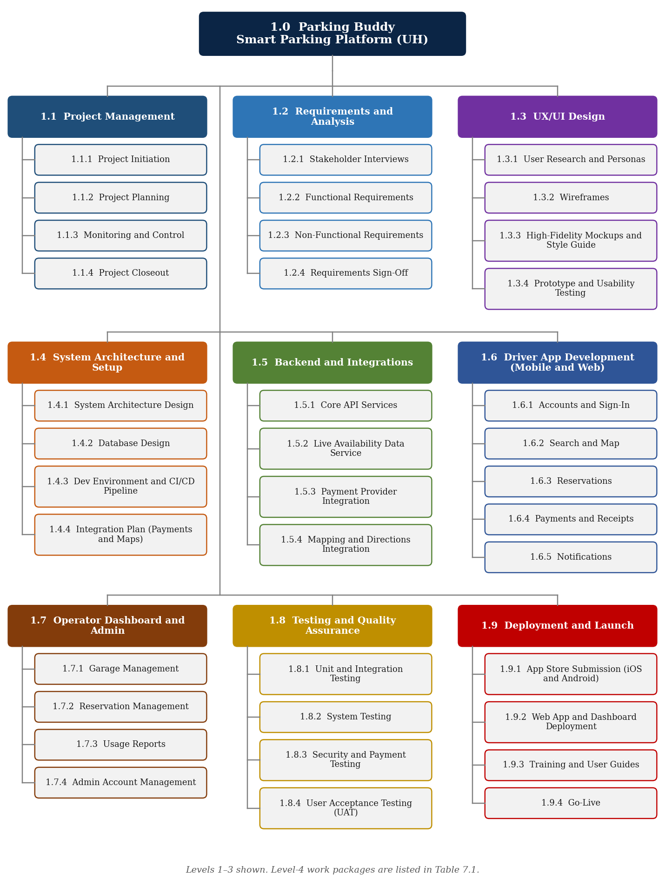
WBS Deliverables
WBS | Deliverable | Owner
1.0 | Parking Buddy (Smart Parking Platform) | Project Manager
1.1 | Project Management | Project Manager
1.1.1 | Project Initiation | Project Manager
1.1.2 | Project Planning | Project Manager
1.1.3 | Monitoring and Control | Project Manager
1.1.4 | Project Closeout | Project Manager
1.2 | Requirements and Analysis | Project Manager
1.2.1 | Stakeholder Interviews | Business Analyst
1.2.2 | Functional Requirements | Business Analyst
1.2.3 | Non-Functional Requirements | Solutions Architect
1.2.4 | Requirements Sign-Off | Project Manager
1.3 | UX/UI Design | Project Manager
1.3.1 | User Research and Personas | UX Designer
1.3.2 | Wireframes | UX Designer
1.3.3 | High-Fidelity Mockups and Style Guide | UX Designer
1.3.4 | Prototype and Usability Testing | UX Designer
1.4 | System Architecture and Setup | Project Manager
1.4.1 | System Architecture Design | Solutions Architect
1.4.2 | Database Design | Backend Developer
1.4.3 | Dev Environment and CI/CD Pipeline | DevOps Engineer
1.4.4 | Integration Plan (Payments and Maps) | Solutions Architect
1.5 | Backend and Integrations | Project Manager
1.5.1 | Core API Services | Backend Developer
1.5.2 | Live Availability Data Service | Backend Developer
1.5.3 | Payment Provider Integration | Backend Developer
1.5.4 | Mapping and Directions Integration | Backend Developer
1.6 | Driver App Development (Mobile and Web) | Project Manager
1.6.1 | Accounts and Sign-In | Mobile / Web Developer
1.6.2 | Search and Map | Mobile / Web Developer
1.6.3 | Reservations | Mobile / Web Developer
1.6.4 | Payments and Receipts | Mobile / Web Developer
1.6.5 | Notifications | Mobile / Web Developer
1.7 | Operator Dashboard and Admin | Project Manager
1.7.1 | Garage Management | Web Developer
1.7.2 | Reservation Management | Web Developer
1.7.3 | Usage Reports | Web Developer
1.7.4 | Admin Account Management | Web Developer
1.8 | Testing and Quality Assurance | Project Manager
1.8.1 | Unit and Integration Testing | QA Engineer
1.8.2 | System Testing | QA Engineer
1.8.3 | Security and Payment Testing | QA Engineer
1.8.4 | User Acceptance Testing (UAT) | UH Stakeholders
1.9 | Deployment and Launch | Project Manager
1.9.1 | App Store Submission (iOS and Android) | DevOps Engineer
1.9.2 | Web App and Dashboard Deployment | DevOps Engineer
1.9.3 | Training and User Guides | Business Analyst
1.9.4 | Go-Live | Project Manager
8. Draft Project Timeline
Parking Buddy is planned to run for 20 weeks, from Monday, August 3, 2026 to Friday, December 18, 2026 (97 working days). Planning and requirements come first, then design and architecture, then the backend and the two apps are built at the same time. Testing runs during development and finishes with user acceptance testing before launch. These dates are a first draft and will be adjusted as the team learns more.
Assumptions
Work week: Monday to Friday. Durations are counted in working days.
Holidays: September 7 (Labor Day) and November 26–27, 2026 (Thanksgiving break) are not work days.
Team: One project manager, one business analyst, one designer, one solutions architect, three developers, one tester, and one DevOps engineer.
Key Milestones
Table 8.1 – Key Milestones
Milestone | Target Date
Project kickoff | August 3, 2026
Requirements signed off | September 4, 2026
Design approved | October 16, 2026
Features complete | November 25, 2026
Go-live | December 17, 2026

Phase Schedule
Table 8.2 – Draft Schedule by Phase
WBS | Phase | Start | End | Work Days
1.1 | Project Management | Aug 3 | Dec 18 | 97
1.2 | Requirements and Analysis | Aug 10 | Sep 4 | 20
1.3 | UX/UI Design | Sep 8 | Oct 16 | 29
1.4 | System Architecture and Setup | Sep 8 | Sep 25 | 14
1.5 | Backend and Integrations | Sep 28 | Nov 6 | 30
1.6 | Driver App Development (Mobile and Web) | Oct 19 | Nov 25 | 28
1.7 | Operator Dashboard and Admin | Oct 19 | Nov 25 | 28
1.8 | Testing and Quality Assurance | Oct 19 | Dec 11 | 38
1.9 | Deployment and Launch | Dec 7 | Dec 17 | 9
 | Full project | Aug 3 | Dec 18 | 97
Dates are in 2026.
Gantt Chart
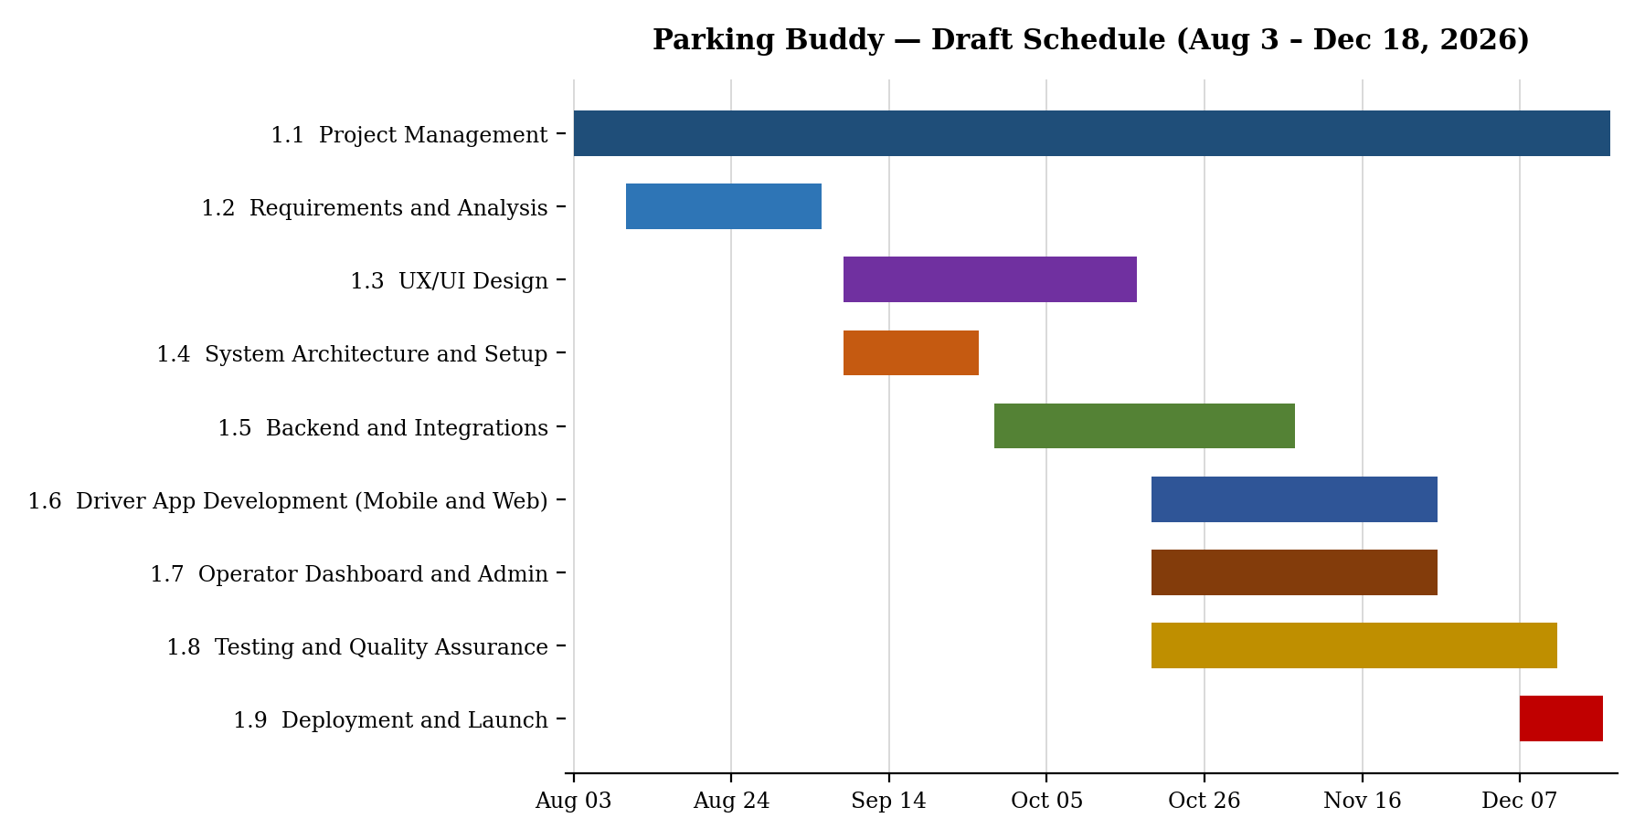
Figure 8.1 – Draft Gantt chart by phase
9. Product Backlog and Sprint 1 Plan
The Parking Buddy backlog is kept on a Trello board. Each card is one item the team needs to build, based on the use cases in Section 6. This is a first draft and will get more detail later in the project.
Table 9.1 – Backlog Summary
Category | Items | Examples
Login | 5 | Create an account, sign in, reset password, sign out
UI (driver and operator) | 15 | Home map, garage details, reserve a space, payment, operator dashboard
Backend processes | 15 | Database, garage search, live availability, reservations, payments
Reporting | 10 | Past reservations, receipts, occupancy report, revenue report
Total | 45

Sprint 1 Plan
Dates: September 28 to October 9, 2026 (2 weeks)
Goal: Users can create an account and sign in, and the database and API are ready for the rest of the app.
Why: Every other feature depends on users being able to sign in, so this comes first.
Table 9.2 – Sprint 1 Backlog
ID | Backlog Item | For
L-01 | Create an account | Driver
L-02 | Sign in | All
L-05 | Open the right screen for each role after sign-in | All
B-01 | Set up the database | All
B-02 | User accounts API | All
B-03 | Sign-in security and user roles | All

Trello Board
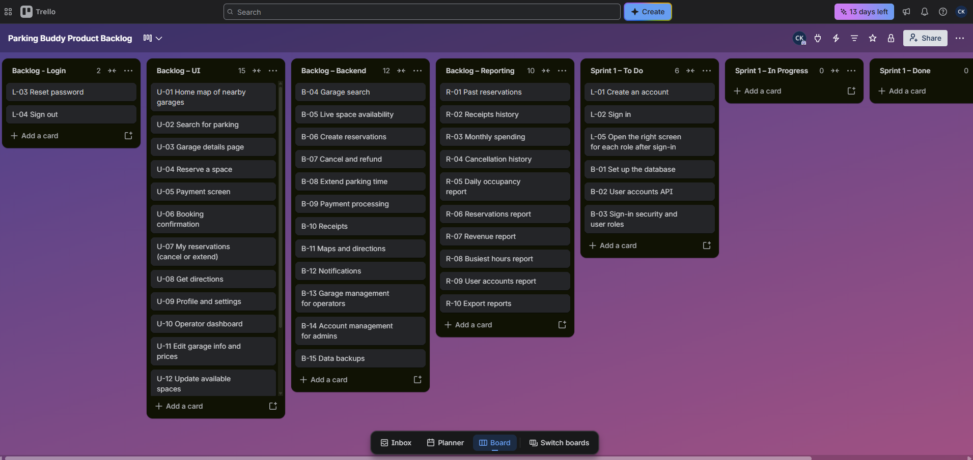
Trello board link: Parking Buddy Product Backlog

