1.About Parking Buddy
How the Project Was Acquired:
The University of Houston contacted our company because parking has become harder as the student population grows. They wanted an app that could help students, staff, and campus police. After looking at the problem, we decided to create Parking Buddy.
Company Introduction:
Lucky Vision Tech creates mobile and web apps. Our goal is to build simple tools that are easy for people and businesses to use.

2. Competitive Comparison
Before planning Parking Buddy, I looked at parking apps that are already being used. Most of them focus on either the driver or the parking operator. Parking Buddy is designed to help both in one app.
1.SpotHero
Focus: Reserving parking in garages and lots.
Strength: Easy to search for and reserve parking.
Weakness: Availability depends on the garage keeping its information accurate.
2.ParkWhiz
Focus: Prepaid parking for garages, events, and airports.
Strength: Helpful for planning parking before a trip or event.
Weakness: Focuses more on reservations than managing the garage itself.
3.ParkMobile
Focus: Paying for metered and zone-based parking.
Strength: Makes it easy to pay and add more parking time.
Weakness: Paying does not always guarantee that a parking space is available.
4.PayByPhone
Focus: Mobile payments for street and city parking.
Strength: Easy payments and reminders when parking time is running out.
Weakness: Focuses more on payment than reserving a parking space.

What Parking Buddy Does Differently
Parking Buddy is created to help make parking easier for both drivers and parking operators. Drivers can find parking, reserve a space, pay and get directions all in one place. Operators will be able to have their own dashboard to update prices, availability and garage information.

3.Project Overview
Parking Buddy is a mobile and web app that helps drivers find nearby garages, check open spaces, reserve parking, pay, and get directions. Parking operators can use a dashboard to manage spaces, prices, reservations, and reports. The goal is to make parking easier for drivers and easier to manage for operators.
Project Goals
Make it easier for drivers to find available parking.
Reduce the time drivers spend searching for a garage.
Give drivers clear parking prices before they pay.
Give parking operators a simple way to manage availability and reservations.
Keep reservations, payments, and parking information in one system.

4. Scope
In scope: Drivers accounts, searching for parking, maps, live parking availability, garage information, reservations, payments, receipts, notifications, directions, and a dashboard for garage operators.
Out of scope: Street parking meters, parking tickets, towing, valet parking, EV charging, and advanced pricing features.

5. Stakeholders
Drivers and vehicle owners
Parking facility operators
City transportation departments
System administrators
Finance and billing personnel
Mobile application users
Third-party payment providers

6. Use Cases
- Create an account
Actor: Driver
The driver creates an account by entering their information.
- Sign in
Actor: Driver / Operator / Admin
The user logs in and is taken to the correct part of the system.
- Search for parking
Actor: Driver
The driver enters a location and time to find nearby garages.
- View parking on a map
Actor: Driver
The driver sees nearby garages, prices, and open spaces on a map.
- View garage details
Actor: Driver
The driver can see the garage price, hours, location, and available spaces.
- Reserve parking
Actor: Driver
The driver chooses a garage and reserves a parking space.
- Pay for parking
Actor: Driver / Payment Provider
The driver chooses a payment method and pays for the reservation.
- Get confirmation
Actor: Driver
The driver receives the reservation details after booking.
- Cancel a reservation
Actor: Driver
The driver cancels a reservation and checks if they will get a refund.
- Extend parking time
Actor: Driver
The driver adds more time if space is still available.
- View past reservations and receipts
Actor: Driver
The driver can look at previous reservations and receipts.
- Get directions
Actor: Driver / Mapping Service
The driver can open directions to the selected garage.
- Manage garage information
Actor: Parking Operator
The operator updates garage details, prices, and available spaces.
- View reports
Actor: Parking Operator
The operator can see basic information about parking usage and reservations.
- Manage accounts
Actor: Administrator
The administrator can create, update, or disable user accounts.

7. Work Breakdown Structure (WBS)
The WBS breaks Parking Buddy into smaller parts. Level 1 is the full project, Level 2 shows the nine main phases, and Level 3 shows the work inside each phase. The development phases follow the 15 use cases in Section 6. This is a draft and can be updated as the project moves forward.
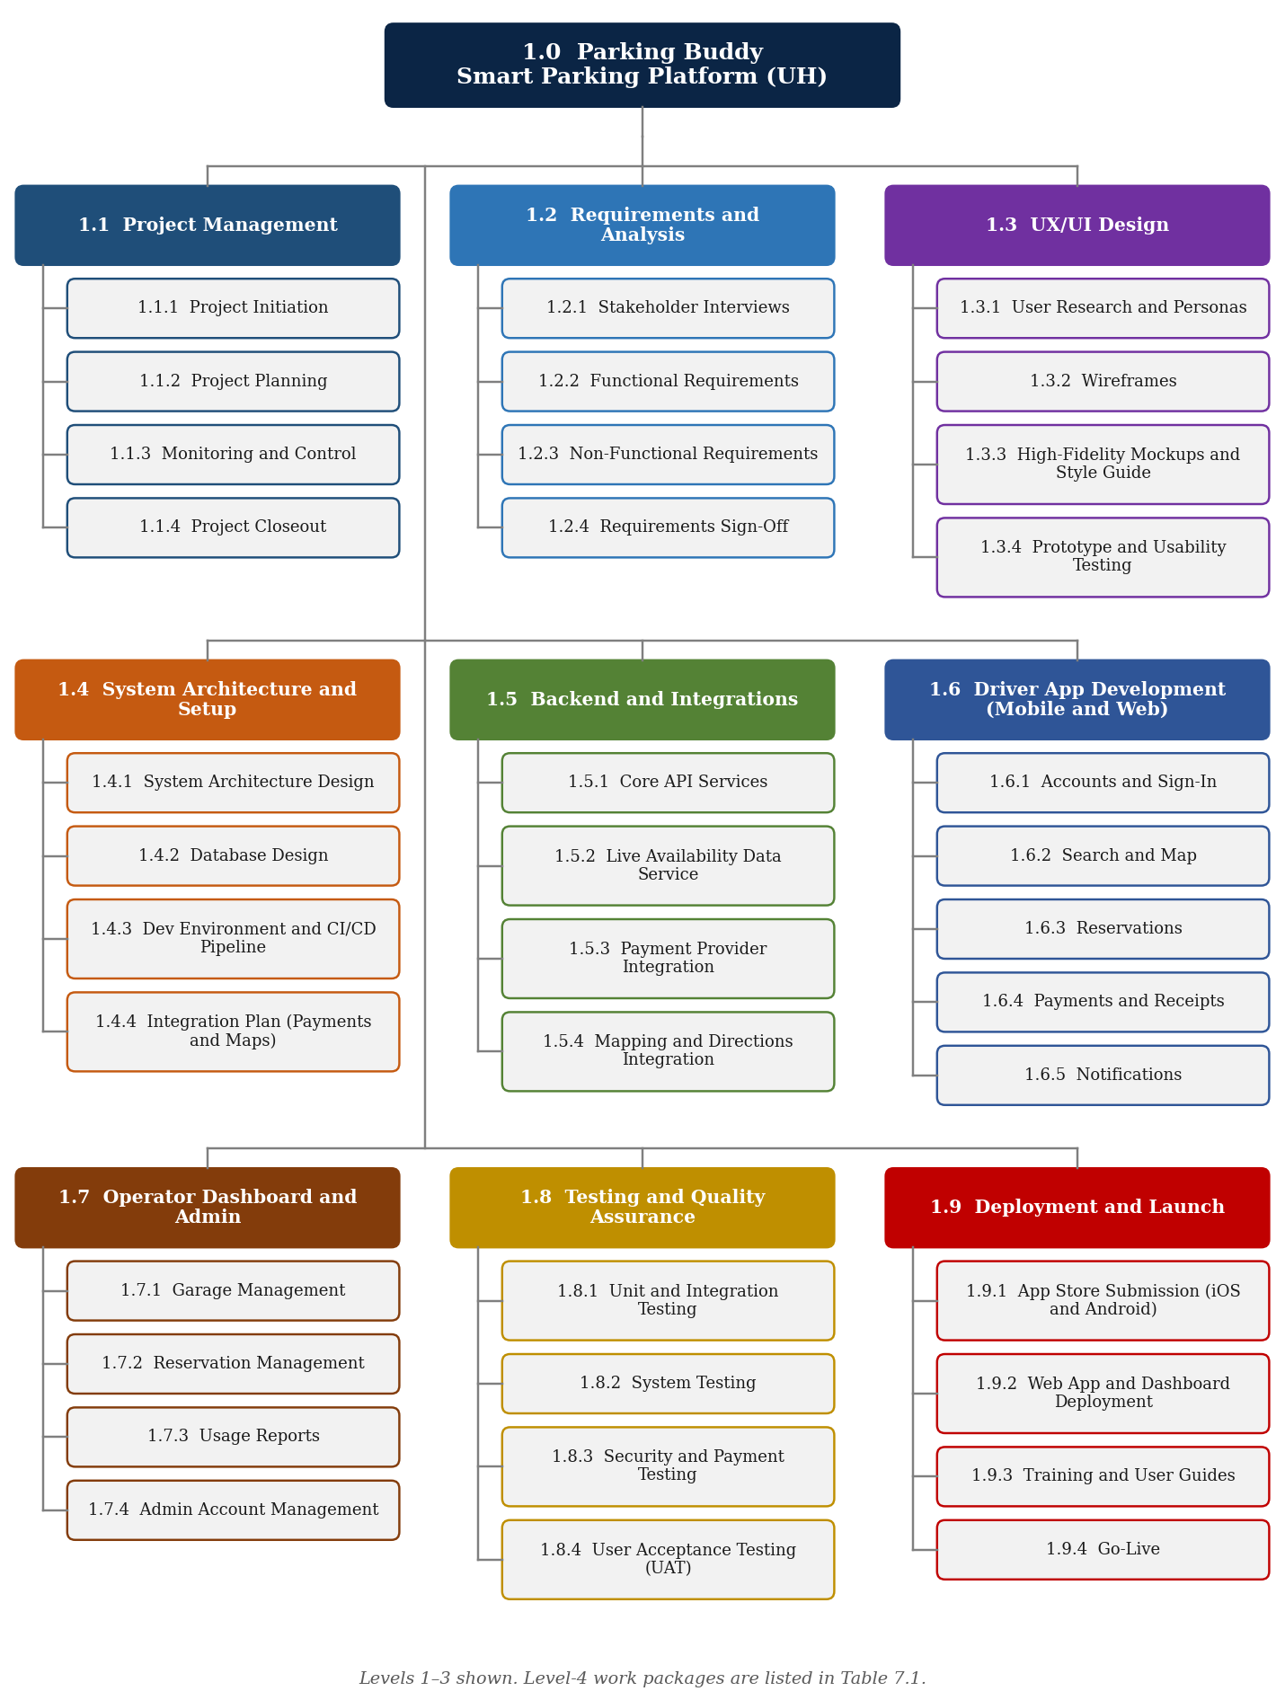
WBS Deliverables
WBS | Deliverable | Owner
1.0 | Parking Buddy (Smart Parking Platform) | Project Manager
1.1 | Project Management | Project Manager
1.1.1 | Project Initiation | Project Manager
1.1.2 | Project Planning | Project Manager
1.1.3 | Monitoring and Control | Project Manager
1.1.4 | Project Closeout | Project Manager
1.2 | Requirements and Analysis | Project Manager
1.2.1 | Stakeholder Interviews | Business Analyst
1.2.2 | Functional Requirements | Business Analyst
1.2.3 | Non-Functional Requirements | Solutions Architect
1.2.4 | Requirements Sign-Off | Project Manager
1.3 | UX/UI Design | Project Manager
1.3.1 | User Research and Personas | UX Designer
1.3.2 | Wireframes | UX Designer
1.3.3 | High-Fidelity Mockups and Style Guide | UX Designer
1.3.4 | Prototype and Usability Testing | UX Designer
1.4 | System Architecture and Setup | Project Manager
1.4.1 | System Architecture Design | Solutions Architect
1.4.2 | Database Design | Backend Developer
1.4.3 | Dev Environment and CI/CD Pipeline | DevOps Engineer
1.4.4 | Integration Plan (Payments and Maps) | Solutions Architect
1.5 | Backend and Integrations | Project Manager
1.5.1 | Core API Services | Backend Developer
1.5.2 | Live Availability Data Service | Backend Developer
1.5.3 | Payment Provider Integration | Backend Developer
1.5.4 | Mapping and Directions Integration | Backend Developer
1.6 | Driver App Development (Mobile and Web) | Project Manager
1.6.1 | Accounts and Sign-In | Mobile / Web Developer
1.6.2 | Search and Map | Mobile / Web Developer
1.6.3 | Reservations | Mobile / Web Developer
1.6.4 | Payments and Receipts | Mobile / Web Developer
1.6.5 | Notifications | Mobile / Web Developer
1.7 | Operator Dashboard and Admin | Project Manager
1.7.1 | Garage Management | Web Developer
1.7.2 | Reservation Management | Web Developer
1.7.3 | Usage Reports | Web Developer
1.7.4 | Admin Account Management | Web Developer
1.8 | Testing and Quality Assurance | Project Manager
1.8.1 | Unit and Integration Testing | QA Engineer
1.8.2 | System Testing | QA Engineer
1.8.3 | Security and Payment Testing | QA Engineer
1.8.4 | User Acceptance Testing (UAT) | UH Stakeholders
1.9 | Deployment and Launch | Project Manager
1.9.1 | App Store Submission (iOS and Android) | DevOps Engineer
1.9.2 | Web App and Dashboard Deployment | DevOps Engineer
1.9.3 | Training and User Guides | Business Analyst
1.9.4 | Go-Live | Project Manager
8. Draft Project Timeline
Parking Buddy is planned to run for 20 weeks, from August 3 to December 18, 2026, for a total of 97 working days. Planning and requirements come first, followed by design and system setup. The backend, driver app, and operator dashboard are then built. Testing happens during development and ends with user testing before launch. These dates are a draft and may change as the project moves forward.
Assumptions
Work week: Monday to Friday. Durations are counted in working days.
Holidays: September 7 (Labor Day) and November 26–27, 2026 (Thanksgiving break) are not work days.
Team: One project manager, one business analyst, one designer, one solutions architect, three developers, one tester, and one DevOps engineer.
Key Milestones
Table 8.1 – Key Milestones
Milestone | Target Date
Project kickoff | August 3, 2026
Requirements signed off | September 4, 2026
Design approved | October 16, 2026
Features complete | November 25, 2026
Go-live | December 17, 2026

Phase Schedule
Table 8.2 – Draft Schedule by Phase
WBS | Phase | Start | End | Work Days
1.1 | Project Management | Aug 3 | Dec 18 | 97
1.2 | Requirements and Analysis | Aug 10 | Sep 4 | 20
1.3 | UX/UI Design | Sep 8 | Oct 16 | 29
1.4 | System Architecture and Setup | Sep 8 | Sep 25 | 14
1.5 | Backend and Integrations | Sep 28 | Nov 6 | 30
1.6 | Driver App Development (Mobile and Web) | Oct 19 | Nov 25 | 28
1.7 | Operator Dashboard and Admin | Oct 19 | Nov 25 | 28
1.8 | Testing and Quality Assurance | Oct 19 | Dec 11 | 38
1.9 | Deployment and Launch | Dec 7 | Dec 17 | 9
 | Full project | Aug 3 | Dec 18 | 97
Dates are in 2026.
Gantt Chart
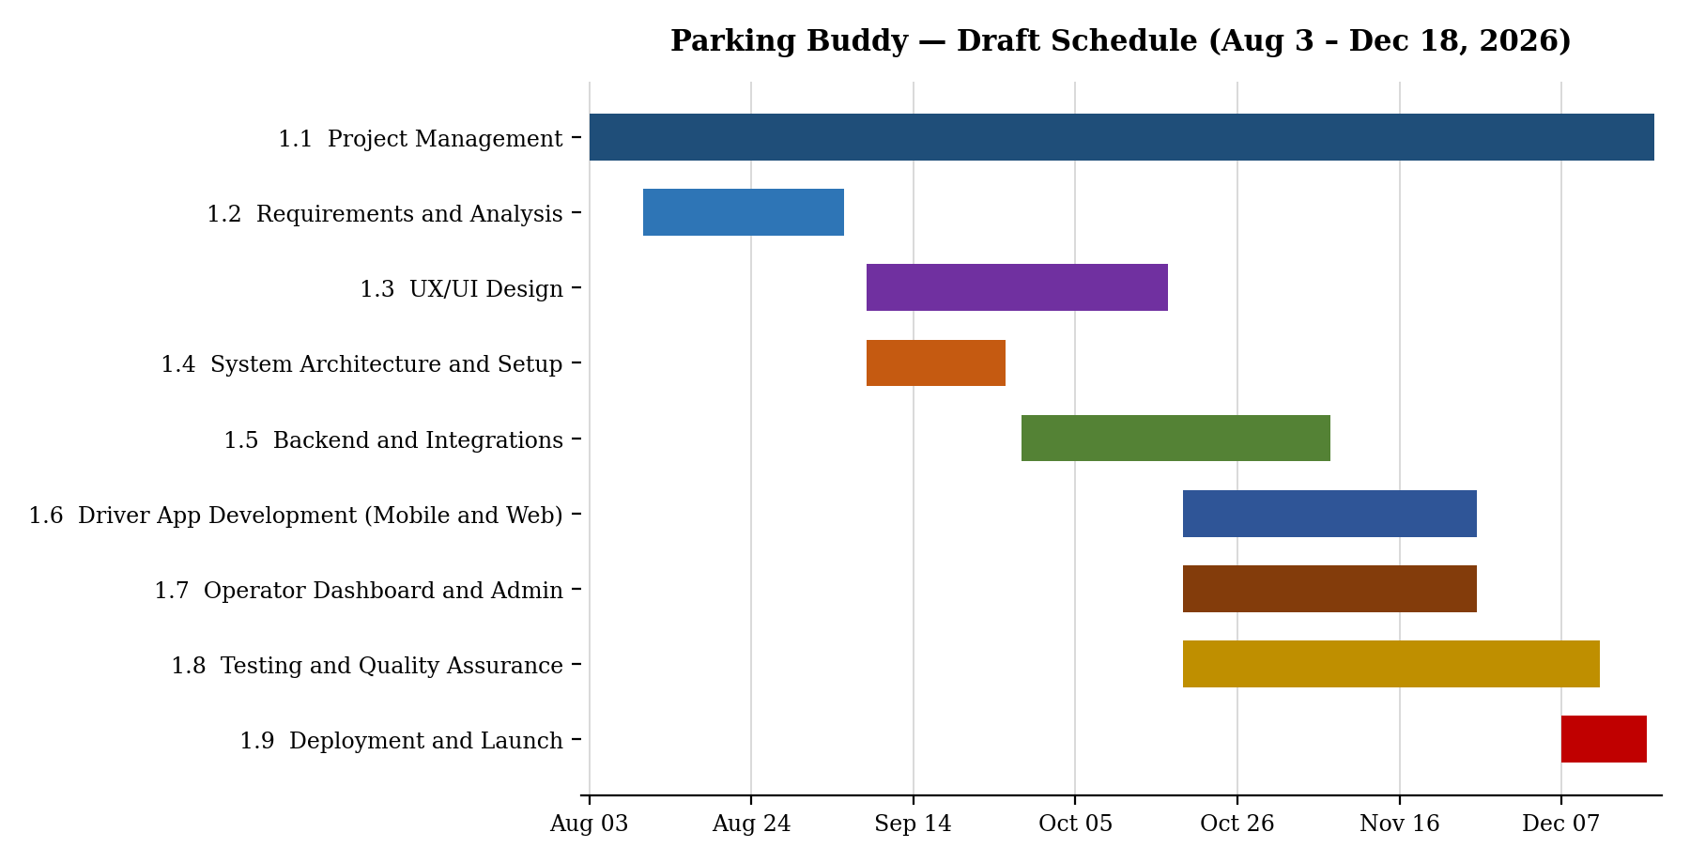
Figure 8.1 – Draft Gantt chart by phase
9. Product Backlog and Sprint 1 Plan
The Parking Buddy backlog is kept on a Trello board. Each card shows one thing the team needs to build based on the use cases in Section 6. This is the first version and more details can be added later.
Table 9.1 – Backlog Summary
Category | Items | Examples
Login | 5 | Create an account, sign in, reset password, sign out
UI (driver and operator) | 15 | Home map, garage details, reserve a space, payment, operator dashboard
Backend processes | 15 | Database, garage search, live availability, reservations, payments
Reporting | 10 | Past reservations, receipts, occupancy report, revenue report
Total | 45

Sprint 1 Plan
Dates: September 28 to October 9, 2026 (2 weeks)
Goal: Users can create an account and sign in, while the database and API are set up for the rest of the app.
Why: Most other features need users to sign in first, so this needs to be done early.
Table 9.2 – Sprint 1 Backlog
ID | Backlog Item | For
L-01 | Create an account | Driver
L-02 | Sign in | All
L-05 | Open the right screen for each role after sign-in | All
B-01 | Set up the database | All
B-02 | User accounts API | All
B-03 | Sign-in security and user roles | All

Trello Board
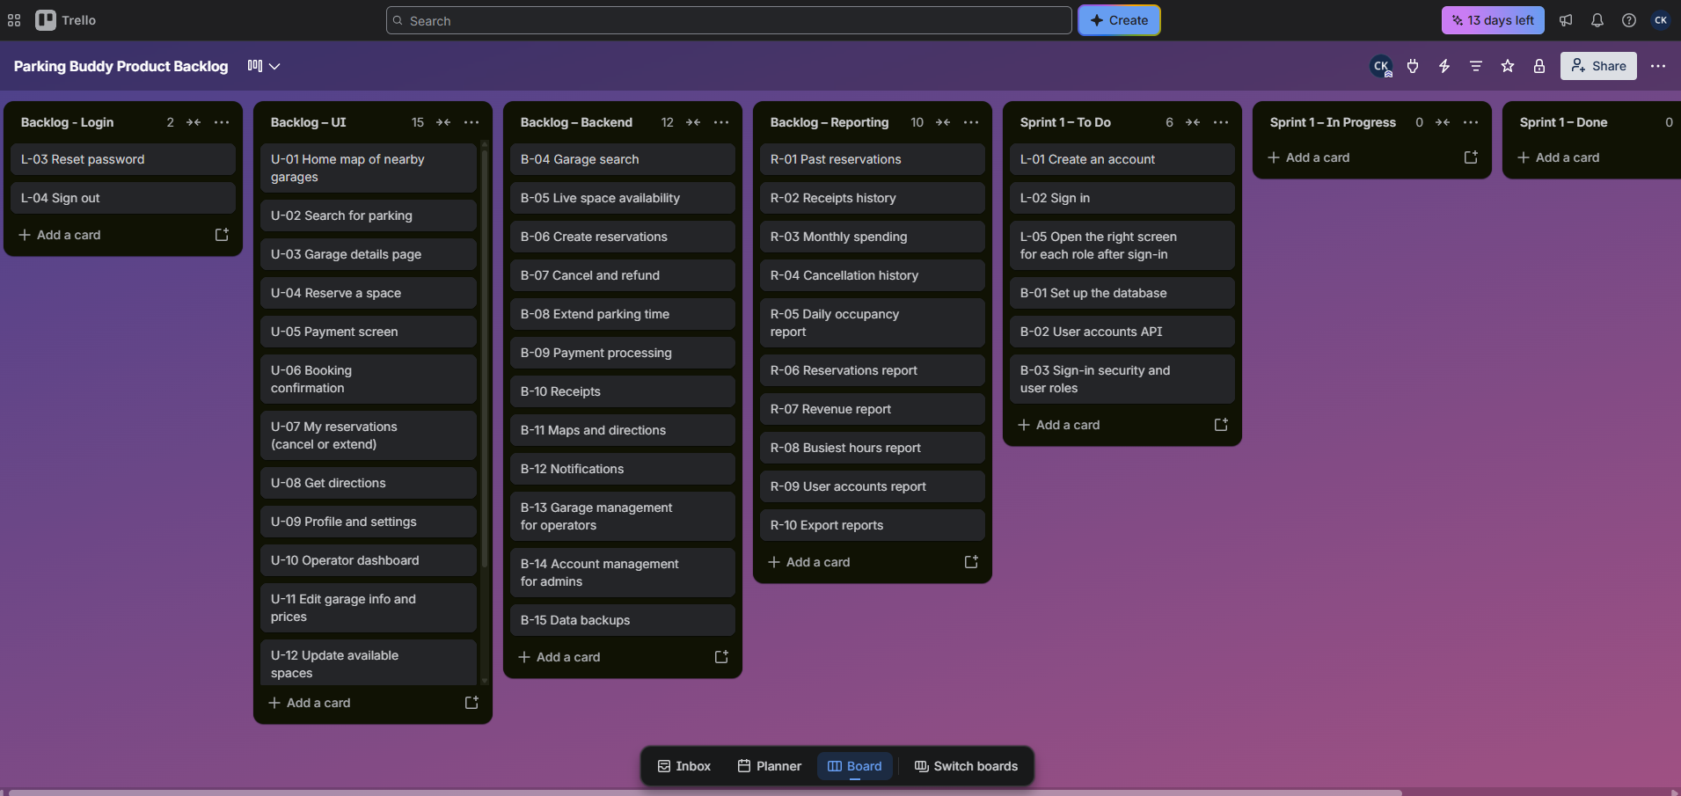
Trello board link: Parking Buddy Product Backlog
10. Risk Management
This section shows the main risks for Parking Buddy and what the team will do about them.
Risks by Category
Table 10.1 – Risks by Category
Category | Risks
Technical | (1) Live parking availability is wrong or late; (2) Payment integration fails or charges drivers twice; (3) A security problem exposes user or payment data; (4) The app slows down when many students use it at the same time.
Schedule | (1) UH asks for new features after sign-off (scope creep); (2) Backend delays hold up the driver app and dashboard; (3) App store review delays the December 17 go-live; (4) UH is not available for testing during Thanksgiving and finals.
Financial | (1) Development takes longer than planned; (2) Map, payment, and hosting costs are higher than expected; (3) UH cuts or delays project funding; (4) Garages need extra sensors to report live availability.
People | (1) A key developer leaves the team; (2) The team lacks skills in payment security or app releases; (3) Only one tester creates a bottleneck; (4) UH staff take too long to answer questions or approve designs.

Risk Register
P means probability and I means impact. Both are scored from 1 to 5, and the final rating comes from the class risk matrix.
Table 10.2 – Risk Register
ID | Risk | Category | P | I | Rating | Owner | Response Strategy | Status
R-01 | Live availability is wrong or delayed | Technical | 4 | 4 | High | Backend Dev | Reduce risk: show a 'last updated' time and test with real UH data early. | Open
R-02 | Payment integration fails | Technical | 3 | 4 | High | Backend Dev | Use a trusted payment provider to handle card data. | Open
R-03 | Security issue exposes user data | Technical | 2 | 5 | High | Architect | Reduce risk: add sign-in security in Sprint 1 and test it. | In progress
R-04 | App slows down at peak times | Technical | 3 | 4 | High | DevOps | Reduce risk: test heavy traffic before launch and use hosting that can handle more users. | Open
R-05 | Scope creep from UH | Schedule | 4 | 3 | High | Project Manager | Avoid: send new requests through the change request process. | Monitoring
R-06 | Backend delays block the apps | Schedule | 3 | 4 | High | Project Manager | Reduce risk: give front-end developers a mock API to use. | Open
R-07 | UH not available for UAT | Schedule | 3 | 3 | Medium | Business Analyst | Avoid: schedule UAT sessions before Thanksgiving. | Open
R-08 | Project goes over budget | Financial | 3 | 3 | Medium | Project Manager | Reduce risk: track hours each week and keep a 10% reserve. | Open
R-09 | Key developer leaves | People | 2 | 4 | Medium | Project Manager | Reduce risk: use code reviews and keep clear documentation. | Open
R-10 | Single tester bottleneck | People | 4 | 3 | High | QA Engineer | Reduce risk: developers write unit tests and run tests automatically. | Open

11. Communication Plan
The team has 9 people, which creates 36 possible communication paths (9 × 8 ÷ 2). Regular meetings and updates help everyone stay on the same page.
Meeting Cadence
Table 11.1 – Meeting Cadence
Meeting | Who | How Often | Purpose
Daily stand-up | Development team | Every weekday, 15 min | Progress and blockers
Sprint planning and review | Whole team | Every 2 weeks, 1 hour | Plan the sprint, demo finished work
Weekly progress meeting | Project manager and team leads | Weekly, 30 min | Schedule, budget, and risks
Monthly stakeholder meeting | Project manager and UH Parking | Monthly, 1 hour | Big-picture progress and decisions

Reporting Methods
Trello board: daily task and bug tracking for the team.
Weekly status report: a short email to UH showing what was finished, what is next, and the main risks.
Sprint demo: a live demo every two weeks to show the new features.
Monthly dashboard: simple slides for UH leadership showing progress, budget, and risks.

