Parking Buddy – Project Management Plan
Lucky Vision Tech · Client: University of Houston
Version 6 · Updated October 14, 2026
Revision History
Version | Date | What Changed
1 | Sep 10, 2026 | Project kickoff: about the project, competitors, overview, scope, stakeholders, use cases
2 | Sep 17, 2026 | Added WBS and draft timeline with Gantt chart
3 | Sep 24, 2026 | Added product backlog and Sprint 1 plan (Trello)
4 | Oct 1, 2026 | Added risk register and communication plan
5 | Oct 8, 2026 | Added roles and resources, cost plan, cashflow, and RACI matrix
6 | Oct 14, 2026 | Project update: added functional and non-functional requirements and user stories; fixed stakeholders; aligned WBS owners with RACI; updated timeline and Gantt after Sprint 1; added Sprint 1 review, Sprint 2 plan and sprint roadmap; expanded risk register to 16 risks; added stakeholder matrix, escalation path and tools; added role responsibilities and budget status; expanded RACI
1. About Parking Buddy
How the Project Was Acquired:
The University of Houston contacted our company because parking has become harder as the student population grows. They wanted an app that could help students, staff, and campus police. After looking at the problem, we decided to create Parking Buddy.
Company Introduction:
Lucky Vision Tech creates mobile and web apps. Our goal is to build simple tools that are easy for people and businesses to use.

2. Competitive Comparison
Before planning Parking Buddy, I looked at parking apps that are already being used. Most of them focus on either the driver or the parking operator. Parking Buddy is designed to help both in one app.
1. SpotHero
Focus: Reserving parking in garages and lots.
Strength: Easy to search for and reserve parking.
Weakness: Availability depends on the garage keeping its information accurate.
2. ParkWhiz
Focus: Prepaid parking for garages, events, and airports.
Strength: Helpful for planning parking before a trip or event.
Weakness: Focuses more on reservations than managing the garage itself.
3. ParkMobile
Focus: Paying for metered and zone-based parking.
Strength: Makes it easy to pay and add more parking time.
Weakness: Paying does not always guarantee that a parking space is available.
4. PayByPhone
Focus: Mobile payments for street and city parking.
Strength: Easy payments and reminders when parking time is running out.
Weakness: Focuses more on payment than reserving a parking space.

What Parking Buddy Does Differently
Parking Buddy is created to help make parking easier for both drivers and parking operators. Drivers can find parking, reserve a space, pay and get directions all in one place. Operators will be able to have their own dashboard to update prices, availability and garage information.

3. Project Overview
Parking Buddy is a mobile and web app that helps drivers find nearby garages, check open spaces, reserve parking, pay, and get directions. Parking operators can use a dashboard to manage spaces, prices, reservations, and reports. The goal is to make parking easier for drivers and easier to manage for operators.
Project Goals
Make it easier for drivers to find available parking.
Reduce the time drivers spend searching for a garage.
Give drivers clear parking prices before they pay.
Give parking operators a simple way to manage availability and reservations.
Keep reservations, payments, and parking information in one system.

4. Scope
In scope: Driver accounts, searching for parking, maps, live parking availability, garage information, reservations, payments, receipts, notifications, directions, and a dashboard for garage operators.
Out of scope: Street parking meters, parking tickets, towing, valet parking, EV charging, and advanced pricing features.

5. Stakeholders
Drivers and vehicle owners
Parking facility operators
UH Parking and Transportation Services (client)
System administrators
UH finance and billing staff
UH Police Department (campus parking enforcement)
Third-party payment providers

6. Use Cases and Requirements (SRS)
- Create an account
Actor: Driver
The driver creates an account by entering their information.
- Sign in
Actor: Driver / Operator / Admin
The user logs in and is taken to the correct part of the system.
- Search for parking
Actor: Driver
The driver enters a location and time to find nearby garages.
- View parking on a map
Actor: Driver
The driver sees nearby garages, prices, and open spaces on a map.
- View garage details
Actor: Driver
The driver can see the garage price, hours, location, and available spaces.
- Reserve parking
Actor: Driver
The driver chooses a garage and reserves a parking space.
- Pay for parking
Actor: Driver / Payment Provider
The driver chooses a payment method and pays for the reservation.
- Get confirmation
Actor: Driver
The driver receives the reservation details after booking.
- Cancel a reservation
Actor: Driver
The driver cancels a reservation and checks if they will get a refund.
- Extend parking time
Actor: Driver
The driver adds more time if space is still available.
- View past reservations and receipts
Actor: Driver
The driver can look at previous reservations and receipts.
- Get directions
Actor: Driver / Mapping Service
The driver can open directions to the selected garage.
- Manage garage information
Actor: Parking Operator
The operator updates garage details, prices, and available spaces.
- View reports
Actor: Parking Operator
The operator can see basic information about parking usage and reservations.
- Manage accounts
Actor: Administrator
The administrator can create, update, or disable user accounts.

Functional Requirements
Functional requirements describe what the system must do. Each one links back to a use case above. Priority uses MoSCoW (Must, Should, Could).
Table 6.1 – Functional Requirements
ID | Requirement | Use Case | Priority
FR-01 | The system shall let a driver create an account with name, UH email, phone, and vehicle plate. | UC 1 | Must
FR-02 | The system shall sign users in and send them to the driver app, operator dashboard, or admin page based on their role. | UC 2 | Must
FR-03 | The system shall let users reset their password by email and sign out. | UC 2 | Must
FR-04 | The system shall let drivers search for garages by location, date, and time. | UC 3 | Must
FR-05 | The system shall show garages on a map with price and number of open spaces. | UC 4 | Must
FR-06 | The system shall show garage details: price, hours, address, open spaces, and a "last updated" time. | UC 5 | Must
FR-07 | The system shall let drivers reserve a space and hold it for 10 minutes while they pay. | UC 6 | Must
FR-08 | The system shall take card and mobile wallet payments through a third-party payment provider. | UC 7 | Must
FR-09 | The system shall send a confirmation with a reservation code by in-app message and email. | UC 8 | Must
FR-10 | The system shall let drivers cancel a reservation and apply the refund rules set by UH. | UC 9 | Should
FR-11 | The system shall let drivers extend parking time if a space is still open. | UC 10 | Should
FR-12 | The system shall show past reservations and receipts. | UC 11 | Should
FR-13 | The system shall open turn-by-turn directions to the selected garage. | UC 12 | Must
FR-14 | The system shall let operators update garage details, prices, and open spaces. | UC 13 | Must
FR-15 | The system shall show operators occupancy, reservation, and revenue reports. | UC 14 | Should
FR-16 | The system shall let admins create, update, and disable user accounts. | UC 15 | Must
FR-17 | The system shall remind drivers 15 minutes before their reservation ends. | UC 10 | Could
FR-18 | The system shall let drivers edit their profile, saved vehicles, and notification settings. | UC 1 | Should
Non-Functional Requirements
Non-functional requirements describe how well the system must work. Each one has a target the QA engineer can test.
Table 6.2 – Non-Functional Requirements
ID | Category | Requirement | How We Test It
NFR-01 | Performance | Search results and the map load in under 3 seconds. | Load test with 2,000 users at the same time
NFR-02 | Data freshness | Open space counts are no more than 60 seconds old. | Compare app counts with garage gate data
NFR-03 | Availability | The app is up 99.5% of the time during the semester. | Hosting uptime monitoring
NFR-04 | Security | Passwords are encrypted, all traffic uses HTTPS, and users only see what their role allows. | Security review and role tests
NFR-05 | Payments | Card data is never stored by Parking Buddy; the payment provider handles it (PCI compliant). | Payment testing in sandbox mode
NFR-06 | Usability | A new driver can reserve and pay for a space in under 2 minutes. | Usability testing with UH students
NFR-07 | Accessibility | Screens meet WCAG 2.1 AA (contrast, screen readers, text size). | Accessibility checker and manual review
NFR-08 | Compatibility | Works on iOS 16+, Android 12+, and current Chrome, Safari, and Edge. | Device and browser test list
NFR-09 | Scalability | Handles peak class-change traffic without slowing down. | Load test before launch (risk R-04)
NFR-10 | Privacy | User data is only used for parking and follows UH data policies. | Review with UH IT before launch
NFR-11 | Reliability | Data is backed up every day and can be restored within 4 hours. | Restore test before launch (B-15)
User Stories
User stories describe each feature from the user’s point of view. Every functional requirement is covered by at least one story. Each story lists its Trello cards, has acceptance criteria that define “done,” and an estimate in story points (1 = very small, 8 = large).
Table 6.3 – User Stories
ID | User Story | Acceptance Criteria | Priority | Pts | Sprint
US-01 | As a driver, I want to create an account so that I can reserve parking. (L-01) | Account saved with UH email and plate; duplicate emails blocked; welcome email sent. | Must | 3 | S1 ✓
US-02 | As a user, I want to sign in and land on the right screen for my role. (L-02, L-05) | Driver, operator, and admin each open their own home screen; wrong password shows an error. | Must | 5 | S1 ✓
US-03 | As a user, I want my account protected so that no one else can use it. (B-03) | Passwords encrypted; account locks after 5 failed tries; each role only sees its own pages. | Must | 5 | S1 → S2
US-04 | As a driver, I want to reset my password and sign out. (L-03, L-04) | Reset link expires in 30 minutes; sign out ends the session on that device. | Must | 3 | S2
US-05 | As a driver, I want to search for parking near a building so I can find a garage fast. (U-02, B-04) | Search by building or address and time; results sorted by distance. | Must | 5 | S2
US-06 | As a driver, I want to see garages and open spaces on a map. (U-01, B-05) | Map pins show price and open spaces; counts refresh every 60 seconds. | Must | 5 | S2
US-07 | As a driver, I want to view garage details before I choose. (U-03) | Shows price, hours, address, open spaces, and last updated time. | Must | 2 | S2
US-08 | As a driver, I want to reserve a space so it is saved for me. (U-04, B-06) | Space held for 10 minutes during checkout; open space count goes down by one. | Must | 5 | S3
US-09 | As a driver, I want to pay in the app and get a receipt. (U-05, U-06, B-09, B-10) | Card and mobile wallet work; no double charges; receipt and reservation code sent. | Must | 8 | S3
US-10 | As a driver, I want directions to my garage. (U-08, B-11) | One tap opens directions in the phone’s map app. | Must | 3 | S3
US-11 | As a driver, I want to cancel or extend my reservation. (U-07, B-07, B-08) | Refund follows UH rules; extension only allowed if a space is open. | Should | 5 | S4
US-12 | As a driver, I want a reminder before my time runs out. (B-12) | Push notification 15 minutes before end time. | Could | 3 | S4
US-13 | As an operator, I want to update garage info, prices, and spaces. (U-10, U-11, U-12, B-13) | Changes show in the driver app within 60 seconds; changes are logged. | Must | 8 | S4
US-14 | As an admin, I want to manage user accounts. (B-14) | Admin can create, edit, and disable accounts; disabled users cannot sign in. | Must | 3 | S4
US-15 | As an operator, I want occupancy and revenue reports. (R-05, R-06, R-07) | Reports filter by date and garage and can be exported. | Should | 5 | S5
US-16 | As a driver, I want to see my past reservations and receipts. (R-01, R-02) | List shows the last 12 months with downloadable receipts. | Should | 3 | S5
US-17 | As a driver, I want to manage my profile and vehicles. (U-09) | Driver can edit name, phone, plates, and notification settings. | Should | 2 | S4
US-18 | As a driver, I want to see my monthly spending and cancellations. (R-03, R-04) | Totals by month; cancelled bookings show refund amount. | Could | 3 | S5
US-19 | As an operator, I want busiest-hours and account reports I can export. (R-08, R-09, R-10) | Charts by hour and day; export to CSV and PDF. | Could | 5 | S5
US-20 | As UH, I want parking data backed up so nothing is lost. (B-15) | Daily backups; a restore test passes before launch. | Must | 3 | S6
✓ = finished. S1 → S2 = started in Sprint 1 and carried into Sprint 2.
7. Work Breakdown Structure (WBS)
The WBS breaks Parking Buddy into smaller parts. Level 1 is the full project, Level 2 shows the nine main phases, and Level 3 shows the work inside each phase. The development phases follow the 15 use cases in Section 6. This is a draft and can be updated as the project moves forward.
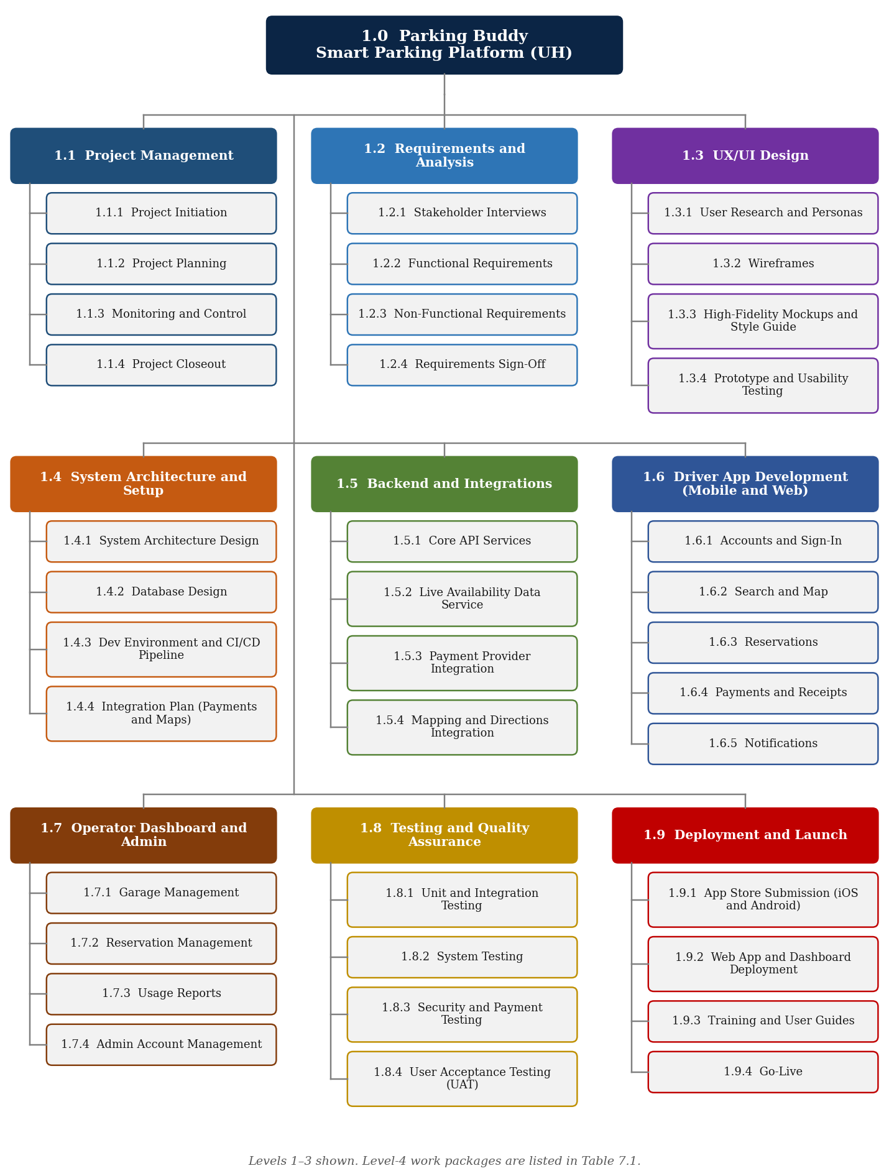
WBS Deliverables
WBS | Deliverable | Owner
1.0 | Parking Buddy (Smart Parking Platform) | Project Manager
1.1 | Project Management | Project Manager
1.1.1 | Project Initiation | Project Manager
1.1.2 | Project Planning | Project Manager
1.1.3 | Monitoring and Control | Project Manager
1.1.4 | Project Closeout | Project Manager
1.2 | Requirements and Analysis | Project Manager
1.2.1 | Stakeholder Interviews | Business Analyst
1.2.2 | Functional Requirements | Business Analyst
1.2.3 | Non-Functional Requirements | Solutions Architect
1.2.4 | Requirements Sign-Off | Project Manager
1.3 | UX/UI Design | Project Manager
1.3.1 | User Research and Personas | UX Designer
1.3.2 | Wireframes | UX Designer
1.3.3 | High-Fidelity Mockups and Style Guide | UX Designer
1.3.4 | Prototype and Usability Testing | UX Designer
1.4 | System Architecture and Setup | Solutions Architect
1.4.1 | System Architecture Design | Solutions Architect
1.4.2 | Database Design | Backend Developer
1.4.3 | Dev Environment and CI/CD Pipeline | DevOps Engineer
1.4.4 | Integration Plan (Payments and Maps) | Solutions Architect
1.5 | Backend and Integrations | Solutions Architect
1.5.1 | Core API Services | Backend Developer
1.5.2 | Live Availability Data Service | Backend Developer
1.5.3 | Payment Provider Integration | Backend Developer
1.5.4 | Mapping and Directions Integration | Backend Developer
1.6 | Driver App Development (Mobile and Web) | Project Manager
1.6.1 | Accounts and Sign-In | Mobile / Web Developer
1.6.2 | Search and Map | Mobile / Web Developer
1.6.3 | Reservations | Mobile / Web Developer
1.6.4 | Payments and Receipts | Mobile / Web Developer
1.6.5 | Notifications | Mobile / Web Developer
1.7 | Operator Dashboard and Admin | Project Manager
1.7.1 | Garage Management | Web Developer
1.7.2 | Reservation Management | Web Developer
1.7.3 | Usage Reports | Web Developer
1.7.4 | Admin Account Management | Web Developer
1.8 | Testing and Quality Assurance | QA Engineer
1.8.1 | Unit and Integration Testing | QA Engineer
1.8.2 | System Testing | QA Engineer
1.8.3 | Security and Payment Testing | QA Engineer
1.8.4 | User Acceptance Testing (UAT) | UH Stakeholders
1.9 | Deployment and Launch | Project Manager
1.9.1 | App Store Submission (iOS and Android) | DevOps Engineer
1.9.2 | Web App and Dashboard Deployment | DevOps Engineer
1.9.3 | Training and User Guides | Business Analyst
1.9.4 | Go-Live | Project Manager
Update (Oct 14): The owners of 1.4, 1.5, and 1.8 were changed from the Project Manager to the Solutions Architect and QA Engineer so the WBS matches who is Accountable in the RACI matrix (Section 14).
8. Project Timeline
Parking Buddy is planned to run for 20 weeks, from August 3 to December 18, 2026, for a total of 97 working days. Planning and requirements come first, followed by design and system setup. The backend, driver app, and operator dashboard are then built. Testing happens during development and ends with user testing before launch. Updated October 14, 2026: Sprint 1 ended on October 9 and Sprint 2 is in progress. Two phases were adjusted after Sprint 1 (see the note under Table 8.2).
Assumptions
Work week: Monday to Friday. Durations are counted in working days.
Holidays: September 7 (Labor Day) and November 26–27, 2026 (Thanksgiving break) are not work days.
Team: One project manager, one business analyst, one designer, one solutions architect, three developers, one tester, and one DevOps engineer.
Key Milestones
Table 8.1 – Key Milestones and Status
Milestone | Target Date | Status
Project kickoff | August 3, 2026 | Complete
Requirements signed off | September 4, 2026 | Complete
Architecture and dev environment ready | September 25, 2026 | Complete
Sprint 1 review | October 9, 2026 | Complete (1 item carried over)
Design approved | October 16, 2026 | On track (final review with UH)
Payments working end to end | November 6, 2026 | Not started
Features complete (Must-have) | November 25, 2026 | Not started
UAT sign-off | December 11, 2026 | Not started
Go-live | December 17, 2026 | Not started

Phase Schedule
Table 8.2 – Schedule by Phase (Updated Oct 14)
WBS | Phase | Start | End | Work Days | % Done
1.1 | Project Management | Aug 3 | Dec 18 | 97 | 52%
1.2 | Requirements and Analysis | Aug 10 | Sep 4 | 20 | 100%
1.3 | UX/UI Design | Sep 8 | Oct 16 | 29 | 93%
1.4 | System Architecture and Setup | Sep 8 | Sep 25 | 14 | 100%
1.5 | Backend and Integrations | Sep 28 | Nov 20 * | 40 | 30%
1.6 | Driver App Development (Mobile and Web) | Sep 28 * | Nov 25 | 43 | 25%
1.7 | Operator Dashboard and Admin | Oct 19 | Nov 25 | 28 | 0%
1.8 | Testing and Quality Assurance | Oct 19 | Dec 11 | 38 | 0%
1.9 | Deployment and Launch | Dec 7 | Dec 17 | 9 | 0%
 | Full project | Aug 3 | Dec 18 | 97
Dates are in 2026.
* Changed after Sprint 1: (1) 1.6 now starts Sep 28 instead of Oct 19, because Sprint 1 already built the sign-in and account screens (part of 1.6.1). (2) 1.5 now ends Nov 20 instead of Nov 6, because the operator and admin APIs (B-13, B-14) are planned for Sprint 4. Go-live stays December 17.
Gantt Chart
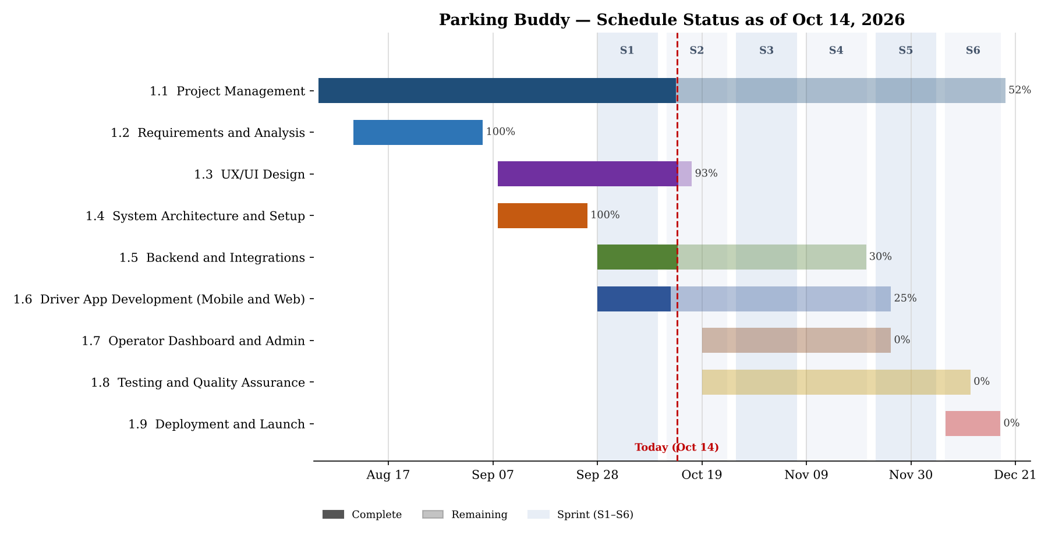
Figure 8.1 – Gantt chart by phase with sprints and progress as of October 14, 2026
9. Product Backlog and Sprint Plan
The Parking Buddy backlog is kept on a Trello board. Each card shows one thing the team needs to build based on the use cases in Section 6. This is the first version and more details can be added later.
Table 9.1 – Backlog Summary (as of Oct 14)
Category | Items | Done | Sprint 2 | To Do | Examples
Login (L) | 5 | 3 | 2 | 0 | Create an account, sign in, reset password, sign out
UI (U) | 15 | 0 | 3 | 12 | Home map, garage details, reserve a space, payment, operator dashboard
Backend (B) | 15 | 2 | 3 | 10 | Database, garage search, live availability, reservations, payments
Reporting (R) | 10 | 0 | 0 | 10 | Past reservations, receipts, occupancy report, revenue report
Total | 45 | 5 | 8 | 32

Sprint 1 Review (September 28 – October 9, 2026)
Goal: Users can create an account and sign in, while the database and API are set up for the rest of the app.
Result: 5 of 6 items finished (16 of 21 story points). Velocity = 16 points.
Table 9.2 – Sprint 1 Results
ID | Backlog Item | For | Pts | Status
L-01 | Create an account | Driver | 3 | Done
L-02 | Sign in | All | 3 | Done
L-05 | Open the right screen for each role after sign-in | All | 2 | Done
B-01 | Set up the database | All | 5 | Done
B-02 | User accounts API | All | 3 | Done
B-03 | Sign-in security and user roles | All | 5 | Carried over to Sprint 2
Why B-03 was carried over: Password security was finished, but UH had not confirmed what operators and admins are allowed to see. The team did not want to guess, so the role permissions moved to Sprint 2. This became risk R-16 in the register.
What we changed: UH now has a 2-business-day response target for open questions, and the weekly status email lists every decision we are waiting on.
Sprint 2 Plan (October 12 – October 23, 2026)
Goal: Drivers can search for parking and see garages with live open spaces on a map.
Capacity: 21 points, close to Sprint 1 velocity (16) plus the 3 points left on B-03. UI screens use the approved wireframes; final colors and polish follow the Oct 16 design approval.
Table 9.3 – Sprint 2 Backlog
ID | Backlog Item | For | Pts | Status (Oct 14)
B-03 | Sign-in security and user roles (role permissions) | All | 3 | In progress
L-03 | Reset password | All | 2 | In progress
L-04 | Sign out | All | 1 | To do
B-04 | Garage search | Driver | 3 | In progress
B-05 | Live space availability | Driver | 5 | To do
U-01 | Home map of nearby garages | Driver | 3 | To do
U-02 | Search for parking | Driver | 2 | To do
U-03 | Garage details page | Driver | 2 | To do
 | Total |  | 21
Sprint Roadmap
The rest of the backlog is planned across Sprints 3 to 6. Must-have items come first, so that if time runs short, only Should- and Could-have items move after launch.
Table 9.4 – Sprint Roadmap
Sprint | Dates | Goal | Main Backlog Items
S1 | Sep 28 – Oct 9 | Accounts, sign-in, database (done) | L-01, L-02, L-05, B-01, B-02
S2 | Oct 12 – Oct 23 | Search and live map | B-03, L-03, L-04, B-04, B-05, U-01, U-02, U-03
S3 | Oct 26 – Nov 6 | Reserve, pay, and get directions | U-04, U-05, U-06, U-08, B-06, B-09, B-10, B-11
S4 | Nov 9 – Nov 20 | Manage reservations, operator dashboard, admin | U-07, U-09–U-12, B-07, B-08, B-12, B-13, B-14
S5 | Nov 23 – Dec 4 | Reports and UAT fixes (short week: Thanksgiving) | U-13–U-15, R-01–R-10 (Must/Should first)
S6 | Dec 7 – Dec 17 | Hardening and launch | B-15, bug fixes, app store release, go-live
How Work Is Tracked
Trello has one list per backlog category plus To Do, In Progress, and Done lists for the current sprint. Each card shows its story points and links to its user story.
Code is stored on GitHub. Developers work on feature branches (for example feature/B-04-garage-search), and every pull request names its Trello card, such as “Add garage search API (B-04).” A teammate reviews each pull request, and automated tests run before it can be merged into main. This lets the project manager see which code finished which task.

Trello Board (after Sprint 1 review)
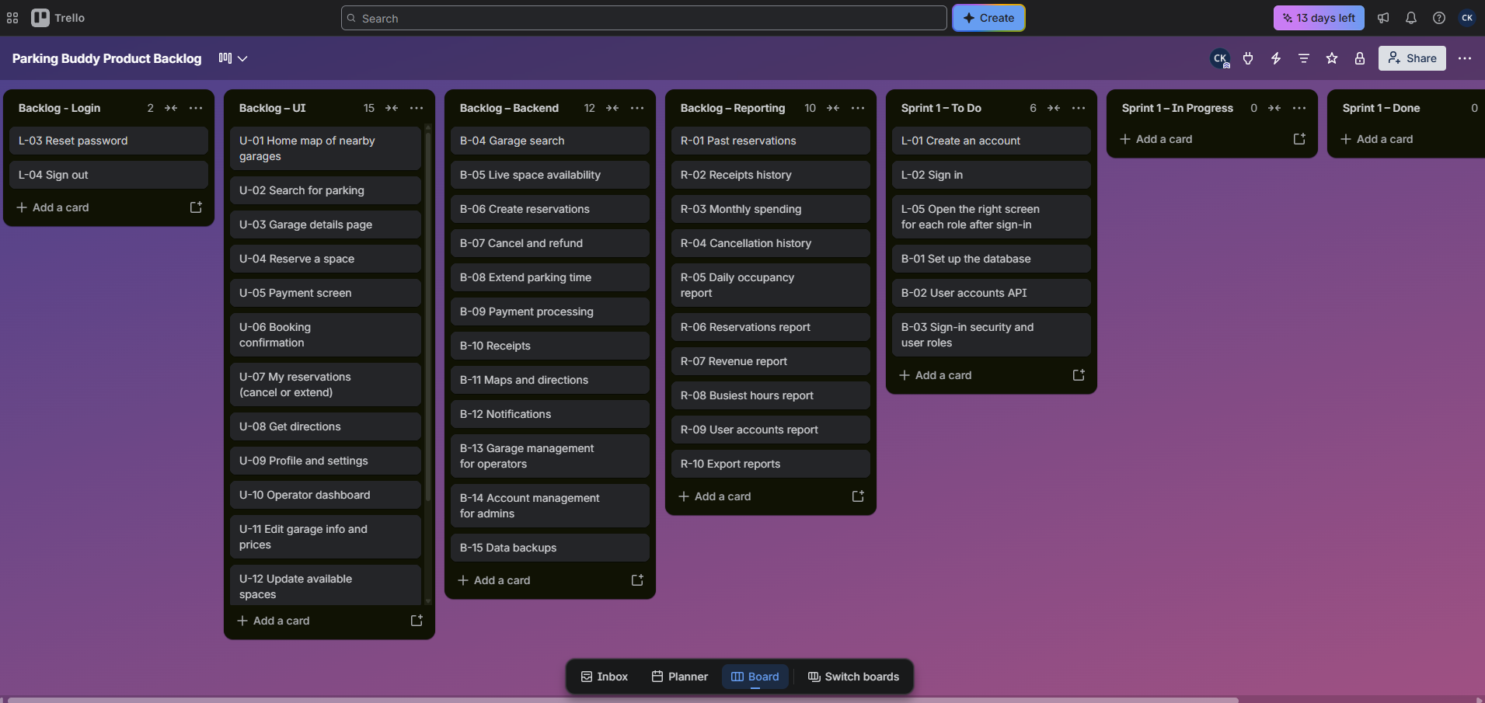
Trello board link: Parking Buddy Product Backlog
10. Risk Management
This section shows the main risks for Parking Buddy and what the team will do about them.
Risks by Category
Table 10.1 – Risks by Category
Category | Risks
Technical | (1) Live parking availability is wrong or late; (2) Payment integration fails or charges drivers twice; (3) A security problem exposes user or payment data; (4) The app slows down when many students use it at the same time.
Schedule | (1) UH asks for new features after sign-off (scope creep); (2) Backend delays hold up the driver app and dashboard; (3) App store review delays the December 17 go-live; (4) UH is not available for testing during Thanksgiving and finals.
Financial | (1) Development takes longer than planned; (2) Map, payment, and hosting costs are higher than expected; (3) UH cuts or delays project funding; (4) Garages need extra sensors to report live availability.
People | (1) A key developer leaves the team; (2) The team lacks skills in payment security or app releases; (3) Only one tester creates a bottleneck; (4) UH staff take too long to answer questions or approve designs.

Risk Register
P means probability and I means impact. Both are scored from 1 to 5. Score = P × I: 10 or more is High, 5 to 9 is Medium, and 4 or less is Low. Updated Oct 14: R-11 to R-16 were added so every risk in Table 10.1 is now in the register, and statuses were updated after Sprint 1.
Table 10.2 – Risk Register (Updated Oct 14)
ID | Risk | Category | P | I | Rating | Owner | Response Strategy | Status
R-01 | Live availability is wrong or delayed | Technical | 4 | 4 | High | Backend Dev | Reduce: show a “last updated” time and test with real UH gate data in Sprint 2. | In progress
R-02 | Payment integration fails or double-charges | Technical | 3 | 4 | High | Backend Dev | Transfer: use a trusted payment provider to handle card data; test in sandbox mode first. | Open
R-03 | Security issue exposes user data | Technical | 2 | 5 | High | Architect | Reduce: password security done in Sprint 1; role permissions finish in Sprint 2. | In progress
R-04 | App slows down at peak times | Technical | 3 | 4 | High | DevOps | Reduce: load test 2,000 users (NFR-01) before launch; use hosting that scales. | Open
R-05 | Scope creep from UH | Schedule | 4 | 3 | High | Project Manager | Avoid: send new requests through the change request process. | Monitoring
R-06 | Backend delays block the apps | Schedule | 3 | 4 | High | Project Manager | Reduce: front-end developers use a mock API until the real one is ready. | In progress
R-07 | UH not available for UAT | Schedule | 3 | 3 | Medium | Business Analyst | Avoid: UAT sessions booked for Nov 30 – Dec 4. | Open
R-08 | Project goes over budget | Financial | 3 | 3 | Medium | Project Manager | Reduce: track hours weekly; keep 10% reserve. September ran $1,095 over (see Table 13.3). | Monitoring
R-09 | Key developer leaves | People | 2 | 4 | Medium | Project Manager | Reduce: code reviews on every pull request and clear documentation. | Open
R-10 | Single tester bottleneck | People | 4 | 3 | High | QA Engineer | Reduce: developers write unit tests that run automatically on each pull request. | Open
R-11 | App store review delays go-live | Schedule | 3 | 4 | High | DevOps | Reduce: submit to the app stores by Dec 4; web app can launch first as a backup. | Open
R-12 | Map, payment, or hosting costs higher than planned | Financial | 2 | 2 | Low | Project Manager | Accept: covered by contingency; set usage alerts on each service. | Monitoring
R-13 | UH cuts or delays funding | Financial | 2 | 5 | High | Project Manager | Reduce: bill by milestone and review the budget at each monthly meeting. | Monitoring
R-14 | Garages need extra sensors for live data | Financial | 2 | 4 | Medium | Architect | Avoid: use UH gate entry and exit counts for version 1 instead of sensors. | Open
R-15 | Team lacks payment security or app release skills | People | 2 | 3 | Medium | Architect | Reduce: outside security review ($2,000 in cost plan); DevOps leads the release checklist. | Open
R-16 | UH staff slow to answer questions or approve work | People | 4 | 3 | High | Business Analyst | Reduce: 2-business-day response target; open decisions listed in the weekly status email. | Occurred (Sprint 1)

11. Communication Plan
The team has 9 people, which creates 36 possible communication paths (9 × 8 ÷ 2). Regular meetings and updates help everyone stay on the same page.
Meeting Cadence
Table 11.1 – Meeting Cadence
Meeting | Who | How Often | Purpose
Daily stand-up | Development team | Every weekday, 15 min | Progress and blockers
Sprint planning and review | Whole team | Every 2 weeks, 1 hour | Plan the sprint, demo finished work
Weekly progress meeting | Project manager and team leads | Weekly, 30 min | Schedule, budget, and risks
Monthly stakeholder meeting | Project manager and UH Parking | Monthly, 1 hour | Big-picture progress and decisions

Reporting Methods
Trello board: daily task and bug tracking for the team.
Weekly status report: a short email to UH showing what was finished, what is next, and the main risks.
Sprint demo: a live demo every two weeks to show the new features.
Monthly dashboard: simple slides for UH leadership showing progress, budget, and risks.
Stakeholder Communication Matrix
Table 11.2 – Stakeholder Communication Matrix
Stakeholder | What They Need | How | How Often | Owner
UH Parking and Transportation Services | Progress, budget, risks, decisions needed | Status email, monthly meeting, sprint demo | Weekly / monthly | Project Manager
UH Police Department | How the app affects parking enforcement | Meeting and email | At design approval and before launch | Business Analyst
Students, faculty, and staff (drivers) | Feedback on designs; launch info | Usability tests, UAT, launch emails | Design and UAT phases | UX Designer
Garage operators | Dashboard training and changes | Training session, user guide | Before launch | Business Analyst
Payment provider | Integration setup and testing | Email and support portal | As needed (Sprint 3) | Backend Developer
Project team | Tasks, blockers, decisions | Stand-up, Trello, team chat | Daily | Project Manager
Escalation Path
Level 1: Team member raises a blocker at stand-up or in team chat. Goal: solved within 1 day.
Level 2: Project Manager steps in if it is not solved in 1 day, or if it affects the sprint goal.
Level 3: Project Manager takes it to the UH Parking director if it affects scope, budget, or the go-live date. Goal: decision within 2 business days.
Tools
Trello: backlog, sprint boards, and bug tracking.
GitHub: source code, pull requests, code reviews, and automated tests.
Microsoft Teams: team chat, stand-ups, and meetings with UH.
Email: weekly status reports and formal approvals from UH.
Figma: designs shared with UH for comments and approval.
12. Roles and Resources
This table lists the Parking Buddy team. Names are fictional. FTE % is the average share of a full-time schedule each person spends on the project over the 20 weeks (776 full-time hours). Some roles are busier in certain phases, so their hours change by month.
Table 12.1 – Resource Plan
Role | Name | Skill Level | FTE % | Hours | Rate | Cost
Project Manager | Maya Thompson | Senior | 50% | 388 | $60 | $23,280
Business Analyst | Jordan Lee | Mid-level | 40% | 314 | $45 | $14,130
UX Designer | Ana Rivera | Mid-level | 43% | 330 | $45 | $14,850
Solutions Architect | David Chen | Senior | 29% | 227 | $70 | $15,890
Backend Developer | Marcus Green | Senior | 55% | 426 | $55 | $23,430
Mobile/Web Developer | Priya Patel | Mid-level | 36% | 278 | $45 | $12,510
Web Developer | Tyler Brooks | Junior | 36% | 278 | $35 | $9,730
QA Engineer | Sofia Martinez | Mid-level | 45% | 352 | $40 | $14,080
DevOps Engineer | Kevin Nguyen | Mid-level | 34% | 261 | $50 | $13,050
TOTAL |  |  |  | 2,854 |  | $140,950

Role Responsibilities
Table 12.2 – Role Responsibilities
Role | Main Responsibilities | Owns (WBS)
Project Manager | Runs sprint planning and reviews, tracks schedule, budget, and risks, manages change requests, and is the main contact for UH. | 1.1, 1.2, 1.3, 1.6, 1.7, 1.9
Business Analyst | Gathers requirements, writes user stories and acceptance criteria, keeps the backlog organized, and runs UAT and training with UH. | 1.2.1, 1.2.2, 1.9.3
UX Designer | Creates personas, wireframes, mockups, and prototypes, and runs usability tests with students. | 1.3.1 – 1.3.4
Solutions Architect | Designs the system, sets technical standards, approves integrations, and reviews security. | 1.4, 1.5
Backend Developer | Builds the database, APIs, live availability service, and payment and map integrations. | 1.4.2, 1.5.1 – 1.5.4
Mobile/Web Developer | Builds the driver app screens for iOS, Android, and web. | 1.6.1 – 1.6.5
Web Developer | Builds the operator dashboard and admin pages. | 1.7.1 – 1.7.4
QA Engineer | Writes test plans, runs system, security, and payment tests, and tracks bugs. | 1.8
DevOps Engineer | Manages hosting, GitHub, automated tests and deployments, and app store releases. | 1.4.3, 1.9.1, 1.9.2
13. Resource and Cost Plan
The budget uses a bottom-up estimate. Labor comes from the hours in Table 12.1, and the other costs are the tools and services the app needs. A 10% contingency covers surprises like extra API usage or rework.
Table 13.1 – Bottom-Up Cost Plan
Item | Category | Qty | Unit Cost | Months | Total | Notes
Team labor | Labor | 2,854 hours | $35–$70/hour | 5 | $140,950 | See Table 12.1
Cloud hosting | Infrastructure | 5 months | $300/month | 5 | $1,500 | Servers, database, backups
Maps and directions API | Third-party API | 3 months | $200/month | 3 | $600 | Starts when app development begins
Design and team tools | Licenses & Tools | 5 months | $150/month | 5 | $750 | Figma, GitHub, Trello
App store accounts | Licenses & Tools | one-time | $124 | N/A | $124 | Apple ($99) and Google Play ($25)
Security and payment testing | Testing | one-time | $2,000 | N/A | $2,000 | Outside security review
Contingency | Reserve | 10% | of subtotal | N/A | $14,593 | Matches risk R-08
TOTAL |  |  |  |  | $160,517

Monthly Cashflow
Table 13.2 – Budgeted Monthly Cashflow
Month | Labor | Cloud & APIs | Licenses | Testing | Contingency | Total
Aug 2026 | $13,650 | $300 | $150 | $0 | $1,410 | $15,510
Sep 2026 | $30,945 | $300 | $150 | $0 | $3,140 | $34,535
Oct 2026 | $36,425 | $500 | $150 | $0 | $3,708 | $40,783
Nov 2026 | $36,410 | $500 | $150 | $2,000 | $3,906 | $42,966
Dec 2026 | $23,520 | $500 | $274 | $0 | $2,429 | $26,723
TOTAL | $140,950 | $2,100 | $874 | $2,000 | $14,593 | $160,517

Spending peaks in October and November, when the developers, tester, and designer are all working at the same time.
Budget Status (as of September 30, 2026)
Actual costs are compared to the budget each month. August and September are closed; October will be added at the end of the month.
Table 13.3 – Budget vs. Actual
Month | Budget | Actual | Variance | Reason
Aug 2026 | $15,510 | $15,180 | +$330 | Requirements finished slightly under hours
Sep 2026 | $34,535 | $35,960 | –$1,425 | Extra BA and architect hours on user roles and the payment integration plan
Total to date | $50,045 | $51,140 | –$1,095 | 2.2% over; covered by contingency
Contingency used: $1,095 of $14,593. Remaining contingency: $13,498. The total budget of $160,517 does not change.
14. RACI Matrix
The RACI matrix shows who does what for each main phase of the WBS and for ongoing project activities. Each row has exactly one person who is Accountable. Updated Oct 14: added rows for sprint planning, code reviews, UAT, risk management, and change requests; UAT was split from testing because UH staff do the UAT.
R = Responsible: does the work.
A = Accountable: approves the work and owns the result.
C = Consulted: gives input before decisions are made.
I = Informed: is kept up to date.
Table 14.1 – RACI Matrix
Activity | PM | BA | UX | Arch. | Devs | QA | DevOps | UH
Project management | A/R | C | I | I | I | I | I | C
Requirements and user stories | A | R | C | C | I | C | I | C
UX/UI design | A | C | R | C | C | I | I | C
Architecture and setup | C | I | I | A | C | I | R | I
Backend and integrations | I | I | I | A | R | C | C | I
Driver app and dashboard | A | C | C | C | R | C | I | I
Sprint planning and backlog | A/R | R | C | C | C | C | C | I
Code reviews and pull requests | I | I | I | A | R | C | C | –
Testing and QA | I | C | I | I | C | A/R | I | I
User acceptance testing (UAT) | C | R | C | I | C | A | I | R
Risk management | A/R | C | C | C | C | C | C | I
Change requests | A | R | C | C | C | I | I | C
Deployment and launch | A | C | I | C | C | C | R | I

UH = UH Parking and Transportation Services. PM = Project Manager, BA = Business Analyst, Arch. = Solutions Architect, Devs = Developers.

