**MONITORING AND MAPPING URBAN AIR**

**POLLUTION LEVELS using IoT Sensors and GIS**

A Capstone Project Proposal

Presented to the Faculty of the

College of Computer Studies and Information Technology,

Southern Leyte State University-Tomas Oppus Campus

In Partial Fulfillment of the Requirement

For the Degree of Bachelor of Science in Information Technology

By:

Abegail Jamel

October 2023

**APPROVAL SHEET**

This Research/Capstone Project Study entitled “___________________________________” prepared and submitted by ____________, _____________, and ____________ has been examined and is recommended for approval and acceptance.

**APPROVED** by the Committee on Oral Examination with a grade of ____________ on ________________.

**JOSE C. AGOYLO JR., MSIT** **MARK RJ MARTE**

ADVISER IT EXPERT

**DORRIS S. LINTAO, MSTCS**  **ENGR. EFREN I. BALABA, PhD.TM**

MEMBER PANEL CHAIR

**__________** and **______________** in partial fulfillment of the requirements in Bachelor of Science in Information Technology.

**ENGR. EFREN I. BALABA, PhD.TM**

Department Head, BSIT

Date: ___________________

**Table of Contents**

**Page**

Title Page i

Table of Contents ii

List of Figures……………………………………………………………………………………………………...iii

**Chapter I: Introduction**

Project Context……………………………………………………………………………………….1

Purpose and Description of the Project…………………………………………………….1

Objectives of the Project 2

Scope and Limitations of the Project 2

**Chapter II: Review of Related Literature**

Review of Related Literature and Studies………………………………………………..3

**Chapter III: Technical Background**

1. The Technicality of the Project……………………………………………………………..6
2. System Requirements……………………………………………………………………..7
3. Proposed Project Plan……………………………………………………………………..8
4. Architectural Layout……………………………………………………………………….12

**REFERENCES**………………………………………………………………………………………………..13

**Chapter I**

**Introduction**

**Project Context**

Urban air pollution is a growing concern in many cities around the world. As urban populations continue to increase, so does the demand for transportation, industrial activities, and energy consumption. These factors contribute to the release of pollutants into the atmosphere, which can have detrimental effects on public health and the environment. Monitoring and addressing urban air pollution has become a priority for governments and environmental organizations.

This project aims to address the issue of urban air pollution by utilizing IoT (Internet of Things) sensors and Geographic Information Systems (GIS) technology. IoT sensors will be strategically deployed in urban areas to collect real-time data on various air pollutants, while GIS technology will be used to map and analyze this data. By doing so, we can gain a deeper understanding of air pollution patterns, sources, and its spatial distribution within urban areas. This information can be invaluable for designing effective pollution control strategies and promoting a healthier urban environment.

**Purpose and Description of the Project**

The primary objective of this study is to design and implement a comprehensive system aimed at the continuous monitoring and spatial mapping of urban air pollution levels through the utilization of Internet of Things (IoT) sensors and Geographic Information Systems (GIS).

The central focus of this research is to furnish real-time, location-specific data concerning a range of air pollutants. By achieving this goal, our study aims to contribute significantly to the enhancement of urban air quality assessment, thereby facilitating better-informed decision-making processes for the benefit of public health and overall quality of life in urban environments.

This study represents a comprehensive effort to create a practical and data-driven solution for monitoring and addressing urban air pollution issues. It is anticipated that the outcomes of this research will provide essential insights for policymakers, environmental agencies, and the general public, ultimately contributing to a healthier and more sustainable urban environment.

**Objectives of the Project**

The main objectives of the proposed system are as follows:

1. To gather data of various air pollutants in urban areas using IoT sensors for the monitoring, thereby establishing a robust data collection system.
2. To utilize GIS technology to analyze and spatially map the collected air pollution data, identifying pollution hotspots, sources, and patterns within urban areas.
3. To utilize the research findings and data to inform evidence-based policy recommendations for mitigating urban air pollution and to design public awareness campaigns that educate the community about air quality and its implications for health and well-being.

**Scope and Limitations of the Project**

The scope of this research project focuses on the comprehensive monitoring and spatial mapping of urban air pollution levels in the context of increasing urbanization and its associated demand for transportation, industrial activities, and energy consumption. The study employs a multi-faceted approach, integrating Internet of Things (IoT) sensors for real-time data collection and Geographic Information Systems (GIS) technology for spatial analysis.

While this research project holds the potential for significant contributions to the understanding and management of urban air pollution, it is essential to acknowledge its inherent limitations. The project is limited to the specific urban areas, its findings may not be universally applicable to all urban settings, and is also limited to the data availability and its accuracy. It is also limited to the budget and resource constraints that may affect the scale and scope of the project.

**Chapter II**

**Review of Related Literature**

Urban air pollution poses a major public health threat globally. Real-time air quality monitoring and control systems are critical to formulate evidence-based pollution mitigation policies. This project aims to develop an IoT-enabled system for real-time air pollution mapping and alerting. The key objectives are to: 1) Design a sensor network architecture; 2) Develop an integrated platform with geospatial analytics; 3) Assess system performance for decision support.

This literature review focuses on IoT and geospatial technologies for air quality monitoring. It will inform the system design, methodology and expected benefits aligned with the project scope.

Akbari et al. (2015) implemented an OGC standards-based system integrating sensor data for real-time air quality monitoring and alerting in Tehran. Interoperable data collection and visualization capabilities offered decision support. This demonstrates the value of geospatial standards for integrated monitoring.

Liang et al. (2019) proposed an AI model fusing ground sensor, satellite and LiDAR data for high-resolution PM2.5 concentration modeling. Predictive performance testing highlighted the utility of multi-source data fusion and machine learning for enhanced pollution mapping.

Anitha and Kumar developed an IoT prototype with gas/PM sensors and filters for pollution monitoring and control. Effective PM removal down to 0.3 microns was achieved. Cloud connectivity enabled real-time data access. This illustrates the potential of IoT architectures for air quality management.

The reviewed studies establish the feasibility of IoT and geospatial techniques for air quality monitoring, analysis and control. Key expected benefits include: real-time pollution data collection; integrated modeling for hotspot identification; localized alerts for public health protection; evidence support for pollution control policies. The current project aims to develop an IoT-enabled system tailored to the urban context using state-of-the-art methods for field deployment and performance assessment.

**Chapter III**

**Technical Background**

1. **The Technicality of the Project**

The foundation of this project is an extensive network of IoT sensors strategically placed in urban areas. The selection of sensors is crucial to gather accurate and comprehensive data on various air pollutants. Sensors capable of measuring parameters such as particulate matter (PM2.5 and PM10), volatile organic compounds (VOCs), nitrogen dioxide (NO2), sulfur dioxide (SO2), carbon monoxide (CO), and ozone (O3) will be chosen. These sensors will be strategically deployed in areas with high pollution potential, including busy traffic intersections, industrial zones, and residential areas.

The sensors will continuously collect real-time data on air quality, sending this information to a central data repository through secure IoT communication protocols. These data streams will include information on pollutant concentrations, temperature, humidity, and GPS coordinates. The data transmission and storage will be designed to ensure data integrity, security, and redundancy to minimize data loss.

The GIS component of the project plays a pivotal role in spatially mapping and analyzing the collected air quality data. The data from IoT sensors will be integrated with existing geographical information, such as road networks, land use, and meteorological data. Spatial analysis techniques will be applied to understand the correlation between air pollution and various urban factors.

Through GIS, the project will identify pollution hotspots and pollution sources within urban areas. By correlating sensor data with geographical features, potential emission sources, and meteorological conditions, the system will help pinpoint areas with high pollution levels and their contributing factors.

To ensure the real-time functionality of the system, an integrated platform will be developed to provide alerts and visualizations. Public health alerts will be generated for high pollution events, and these alerts will be displayed on user-friendly interfaces, including mobile applications and websites.

The project's findings will contribute to evidence-based policy recommendations for mitigating urban air pollution. These recommendations will consider factors such as traffic management, industrial regulations, and green infrastructure development to reduce pollution and improve overall urban air quality.

To validate the system's performance, the IoT sensor network will undergo field deployment in selected urban areas. This phase will test the reliability of sensor data, data transmission, and system functionality in a real-world context.

Data validation processes will be implemented to ensure the accuracy and reliability of the sensor data. This includes cross-referencing IoT sensor measurements with reference air quality monitoring stations.

The technicality of this project involves the seamless integration of IoT sensors, GIS technology, machine learning, and AI models to create a sophisticated system for urban air pollution monitoring and mapping. The project aims to provide real-time, location-specific data for decision support, public health protection, and evidence-based policy recommendations to combat urban air pollution and enhance the quality of life in urban environments.

1. **System Requirements**

**IoT Sensors:**

Networked devices that measure environmental parameters like air quality, temperature, humidity etc. Examples are PM2.5, CO, Ozone sensors.

**IoT Gateway:**

An intermediary device that connects sensors to the cloud. It aggregates, processes and transmits sensor data. Provides functionality like device connectivity, security, data filtering.

**Cloud Platform:**

Backbone for collecting, storing and processing IoT data at scale. Provides services like device management, data streaming, storage, analytics. Examples are AWS IoT, Microsoft Azure IoT.

**Time Series Database:** Optimized database for storing and analyzing time-series sensor data efficiently. Examples are InfluxDB, TimescaleDB. Provides metrics storage, queries.

**Data Processing:** Modules to process and analyze sensor data to derive insights. Can involve statistical analysis, ML models, rules engine, complex event processing.

**GIS (Geographic Information System):** Software to visualize, analyze and interpret geospatial data. Allows mapping pollution data with location. Examples are ArcGIS, QGIS.

**Dashboard**: Frontend application providing visual charts, reports for pollution data. Lets users analyze trends and patterns easily. Built using frameworks like React, Angular.

**Mobile App**: App to showcase air quality index, maps and alerts to citizens. Built natively for iOS and Android or using cross-platform frameworks like React Native, Flutter.

1. **Proposed Project Plan**

**Phase 1: Project Initiation (Month 1)**

* Define project objectives, scope, and deliverables.
* Establish a project team and assign roles.
* Create a detailed project plan with milestones and deadlines.
* Procure necessary hardware and software.

**Phase 2: Sensor Network Setup (Months 2-4)**

* Select and procure IoT sensors for air quality monitoring.
* Develop and test IoT sensor prototypes.
* Establish secure communication protocols for data transmission.
* Deploy IoT sensors at strategically selected locations in the urban area.

**Phase 3: Data Collection and Transmission (Months 5-6)**

* Set up a central data repository on a cloud platform (e.g., AWS IoT or Azure IoT).
* Configure IoT gateways for data aggregation, processing, and transmission.
* Ensure data integrity, security, and redundancy to minimize data loss.

**Phase 4: GIS Integration and Analysis (Months 7-8)**

* Integrate IoT data with GIS technology (e.g., ArcGIS or QGIS).
* Develop spatial analysis techniques to correlate air pollution data with geographical features.
* Identify pollution hotspots and sources within urban areas.

**Phase 5: Geospatial Analytics and Dashboard Development (Months 9-10)**

* Implement machine learning and AI models for enhanced pollution mapping.
* Develop a user-friendly dashboard for real-time data visualization.
* Create an interactive web application for data analysis.

**Phase 6: Mobile App Development (Months 10-11)**

* Develop native mobile applications for iOS and Android.
* Implement features such as air quality index, maps, and real-time alerts.
* Ensure cross-platform compatibility for broader accessibility.

**Phase 7: Field Deployment and Testing (Month 11)**

* Deploy the IoT sensor network in selected urban areas for real-world testing.
* Validate the reliability and accuracy of sensor data.
* Gather feedback from test users and address any issues.

**Phase 8: Data Validation and Fine-tuning (Month 12)**

* Implement data validation processes, including cross-referencing IoT sensor measurements with reference air quality monitoring stations.
* Fine-tune the system based on feedback and performance data.
* Prepare a comprehensive project report and documentation.

**Phase 9: Project Conclusion and Handover (Month 12)**

* Conduct a final project review and assessment.
* Hand over the project deliverables to relevant stakeholders.
* Prepare training materials for system maintenance and operation.

**Project Deliverables:**

* IoT sensor network infrastructure.
* Central data repository on a cloud platform.
* Integrated GIS system for air quality mapping.
* Real-time data visualization dashboard.
* Native mobile applications for iOS and Android.
* Comprehensive project report and documentation.

**Project Budget:**

* The budget will be allocated for hardware procurement, cloud service subscriptions, software development, and personnel costs.

**Project Risks:**

* Potential risks include sensor malfunction, data security breaches, and unforeseen technical challenges. Risk mitigation plans will be in place to address these issues.

**Project Success Criteria:**

* The project will be considered successful if it achieves real-time air quality monitoring and mapping, delivers accurate and reliable data, and facilitates evidence-based decision-making for pollution control.

**Project Stakeholders:**

* Government agencies responsible for air quality management.
* Environmental organizations.
* The general public in urban areas.
* Project team members and investors.

1. **Architectural Layout**

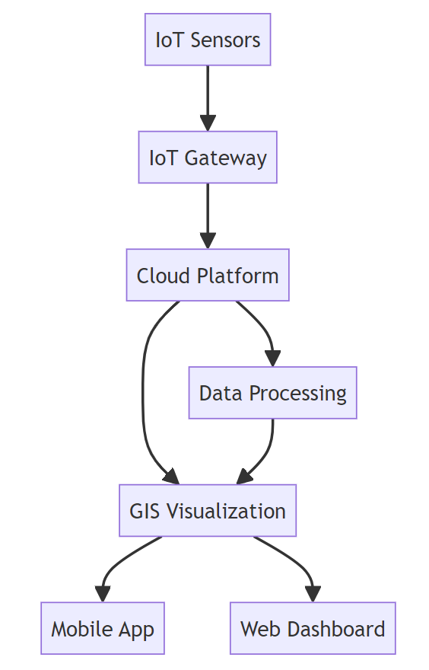

**References**

Akbari, M., Zahmatkesh, H., & Eftekhari, M. (2021). A GIS-Based System for Real-Time Air Pollution Monitoring and Alerting Based on OGC Sensors Web Enablement Standards. *Pollution*, *7*(1), 25-41.

Liang, L., Daniels, J., Bailey, C., Hu, L., Phillips, R., & South, J. (2023). Integrating low-cost sensor monitoring, satellite mapping, and geospatial artificial intelligence for intra-urban air pollution predictions. *Environmental Pollution*, *331*, 121832

Kumar, R., Mukherjee, A. and Singh, V.P. (2017). Traffic noise mapping of Indian roads through smartphone user community participation. Environ. Monit. Assess., 189(1), 17.

Gryech, I., Ben-Aboud, Y., Guermah, B., Sbihi, N., Ghogho, M., & Kobbane, A. (2020). MoreAir: a low-cost urban air pollution monitoring system. *Sensors*, *20*(4), 998.

|  |
| --- |
|  |
| Shah, H. N., Khan, Z., Merchant, A. A., Moghal, M., Shaikh, A., & Rane, P. (2018). IOT based air pollution monitoring system. *International Journal of Scientific & Engineering Research*, *9*(2), 62-66.  Kalia, P., & Ansari, M. A. (2020). IOT based air quality and particulate matter concentration monitoring system. *Materials Today: Proceedings*, *32*, 468-475.  Aashiq, M. N. M., Kurera, W. T. C. C., Thilekaratne, M. G. S. P., Saja, A. M. A., Rouzin, M. R. M., Neranjan, N., & Yassin, H. (2023). An IoT-based handheld environmental and air quality monitoring station. *Acta IMEKO*, *12*(3), 1-9. |
| Chicago |  |