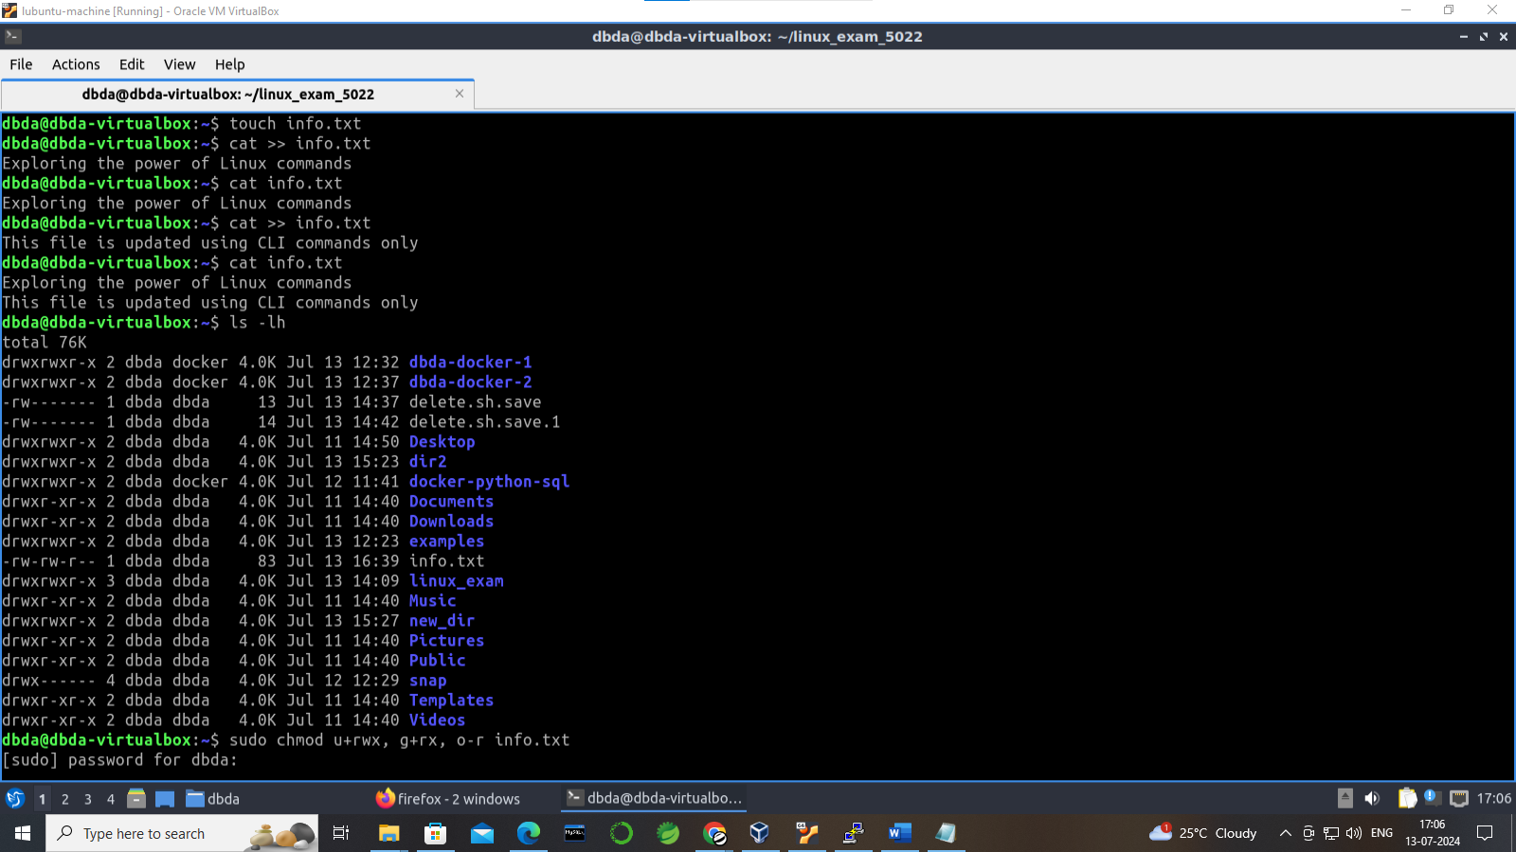

OUTPUT:

