PROGRAMMING IN JAVA
CSA0915
ASSIGNMENT 1 – CO1
CAMPUS SMART-PARKING SYSTEM
Name: S.Charmi
Register Number: 192324034
Course Code: CO1 – Programming in Java
Submission Date: 7/11/26

Scope and Design Assumptions
The campus has multiple parking floors, each with a fixed but potentially different number of slots. Vehicles include two-wheelers, cars and electric vehicles. The system allocates a suitable slot, issues a unique ticket, records entry time, computes the fee at exit and releases the slot. Students and staff with valid monthly passes park free; visitors pay the applicable fee.
- Each slot holds at most one vehicle; null denotes an empty slot.
- Registration numbers are unique among currently parked vehicles.
- Ticket identifiers increase monotonically and are not reused during a system run.
- Every started hour is billed as a full hour; zero minutes costs zero.
- A jagged array is used because floors may have unequal capacities.
- Rates in examples are illustrative because the assignment does not prescribe a tariff. The FeeDemo rates are selected to reproduce its required output.
- The examples assume a single process. A real multi-user deployment needs database transactions and concurrency control.
The report is based on the supplied 20-page Java Assignment 1 – CO1 PDF. The student must still execute the programs, capture screenshots, fill actual test results, add personal details and submit the required GitHub repository.

TASK 1 – Understand the Problem and Identify the Objects

1.1 Candidate classes and responsibilities
Class | Responsibility | Justification
ParkingFacility | Stores floors/slots; allocates and releases spaces. | Centralises occupancy and prevents double allocation.
ParkingSlot | Represents floor, slot number, compatibility and occupancy. | Protects slot state and enables EV charging-slot rules.
Vehicle (abstract) | Common registration data and fee template. | Avoids repeated fields and supports polymorphism.
TwoWheeler, Car, ElectricCar | Vehicle-specific rates and capabilities. | Allows categories to be extended independently.
ParkingTicket | Ticket ID, vehicle, slot, entry time and pass reference. | Contains information needed at exit.
ParkingUser / ParkingPass | Student, staff, visitor and pass validity. | Separates user eligibility from vehicle type.
FeePolicy | Computes price using time, category and pass rules. | Keeps changing pricing rules in one place.
ParkingService | Coordinates entry, exit, allocation and ticket lifecycle. | Separates application workflow from data objects.

1.2 Business rules
- A slot cannot hold two vehicles.
- A vehicle can use only a compatible slot; an EV requiring charging must use a charging-enabled slot.
- A ticket ID is unique and never reused within the system lifetime.
- A registration number cannot have two active tickets simultaneously.
- Exit is permitted only for an active ticket.
- The slot recorded in the ticket is released only after successful fee calculation/exit processing.
- A valid monthly pass for a student or staff member waives the fee; a visitor pays unless holding a valid one-day pass.
- Negative durations, invalid slot indexes, blank registration numbers and invalid rates must be rejected.

1.3 Assumptions
The initial tariff is assumed to charge Rs 30 per started hour for a two-wheeler, Rs 90 for a car and Rs 150 for an electric car, plus a separate energy charge. These values are illustrative. Pass validity is checked at exit. A production billing implementation should use BigDecimal rather than double for currency.

1.4 Alternative: vehicle objects versus parallel arrays
An object groups registration number, category, entry time and behaviour. A linear search by registration number is O(n) in an array/list; a HashMap improves average lookup to O(1). Adding a field means updating the relevant class. Parallel arrays regNo[], type[] and entryTime[] use matching indexes. Search is also O(n), but every insertion, deletion and sort must preserve alignment. Adding an attribute requires another array and coordinated changes.
Representation | Search | Space per vehicle | Adding an attribute
Vehicle objects | O(n), or O(1) average with HashMap | Object header, fields and references | Add field/accessor/validation in class
Parallel arrays | O(n) | Several array elements/references | Add a parallel array and keep indexes aligned
The object model is selected because it groups state and behaviour, supports validation and polymorphism, and avoids parallel-index errors.

TASK 2 – Choose the Data Representation
Data | Type | Reason
Floor/slot index | int | Whole-number indexes.
Registration number | String | Contains letters and digits.
Entry/exit time | LocalDateTime or Instant | Accurate date-time representation.
Duration | long minutes | Avoids fractional-minute ambiguity.
Ticket number | long | Large monotonically increasing identifier.
Rate/fee | double in coursework; BigDecimal in production | BigDecimal avoids binary floating-point currency errors.
Pass validity | boolean plus expiry date/time | Represents current eligibility.

2.1 Jagged array
String[][] slots is appropriate because each floor may have a different capacity. The outer array represents floors and each inner array represents that floor's slots. A null cell means free.
String[][] slots = new String[slotsPerFloor.length][];
for (int f = 0; f < slotsPerFloor.length; f++) {
slots[f] = new String[slotsPerFloor[f]];
}

2.2 Input method
Scanner is appropriate for interactive console input such as registration, category and user choice. Command-line arguments are better for scripts and repeatable automated runs. Input collection should remain in main(); core classes should receive validated values through method parameters.

2.3 Integer division and casting risk
For a 90-minute stay, 90 / 60 using integer division gives 1. This is wrong when every started hour is charged. The correct ceiling expression for non-negative minutes is (minutes + 59) / 60, which gives 2. Casting a fractional fee such as 90.75 to int loses the decimal portion. Keep the fee in a floating-point/decimal type.
int billableHours = (minutes + 59) / 60; // minutes >= 0
double fee = billableHours * hourlyRate;

2.4 Alternative array structures
A flat one-dimensional array can use floor * slotsPerFloor + slot only when every floor has equal capacity. Unequal capacities require a prefix-offset array, where offset[f] is the total capacity of all preceding floors and index = offset[f] + slot. ArrayList<String[]> supports dynamic row addition but retains row-based indexing.
Structure | Known floor/slot access | Find first free slot | Space
Jagged array | O(1) | O(N) scan | O(N) references plus row arrays
Flat, equal capacity | O(1) formula | O(N) scan | O(N)
Flat + offsets | O(1) with offset | O(N) scan | O(N+F)
ArrayList of rows | O(1) average row/cell | O(N) scan | O(N+F) plus list overhead
Jagged arrays are selected because they directly represent unequal floor capacities.

TASK 3 – Design the Control Logic

3.1 Allocation pseudocode
ALGORITHM Allocate(vehicleNo)
IF vehicleNo is null OR blank THEN RETURN INVALID
FOR floor ← 0 TO numberOfFloors - 1
FOR slot ← 0 TO slots[floor].length - 1
IF slots[floor][slot] IS null THEN
slots[floor][slot] ← vehicleNo
RETURN (floor, slot)
END IF
END FOR
END FOR
RETURN null
END ALGORITHM
The search scans floors and slots in ascending order. It stops immediately after the first free slot is assigned. If no free slot exists after the final iteration, it returns null.

3.2 Fee pseudocode
ALGORITHM CalculateFee(vehicle, minutes, user, energy)
IF minutes < 0 THEN RETURN INVALID
IF user has valid monthly or one-day pass THEN RETURN 0
IF minutes = 0 THEN hours ← 0
ELSE hours ← (minutes + 59) DIV 60
fee ← hours × vehicle.ratePerHour
IF daily cap is configured THEN fee ← MIN(fee, daily cap)
IF vehicle supports charging THEN fee ← fee + chargingFee(energy)
RETURN fee
END ALGORITHM
The example uses if–else for duration and pass checks. A switch is suitable when selecting among a small fixed set of fee categories. A configurable policy object is more maintainable when new pricing rules are expected.
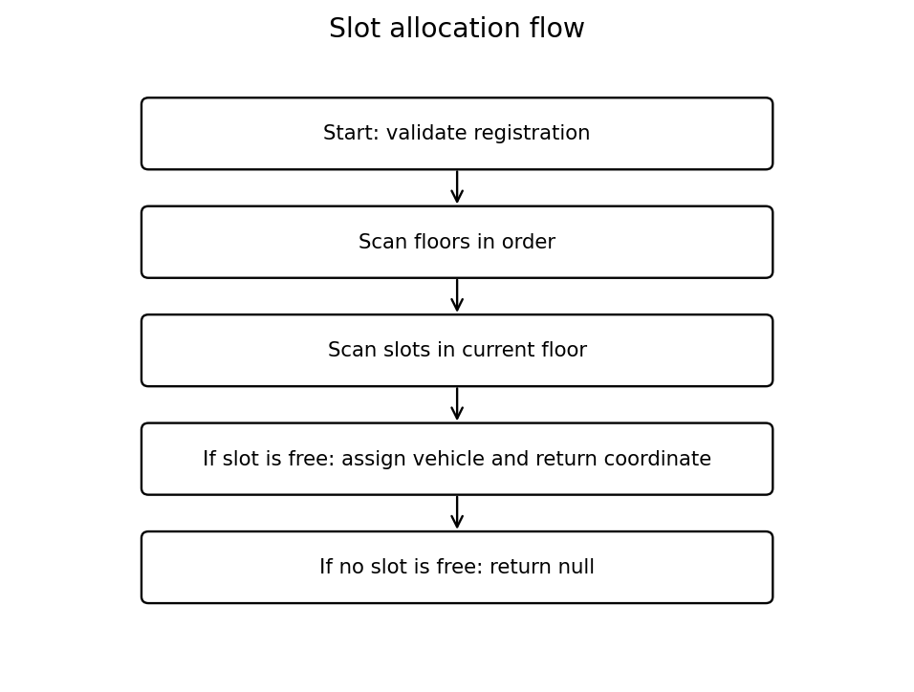
Figure 1. Flowchart for finding and allocating the first free slot.
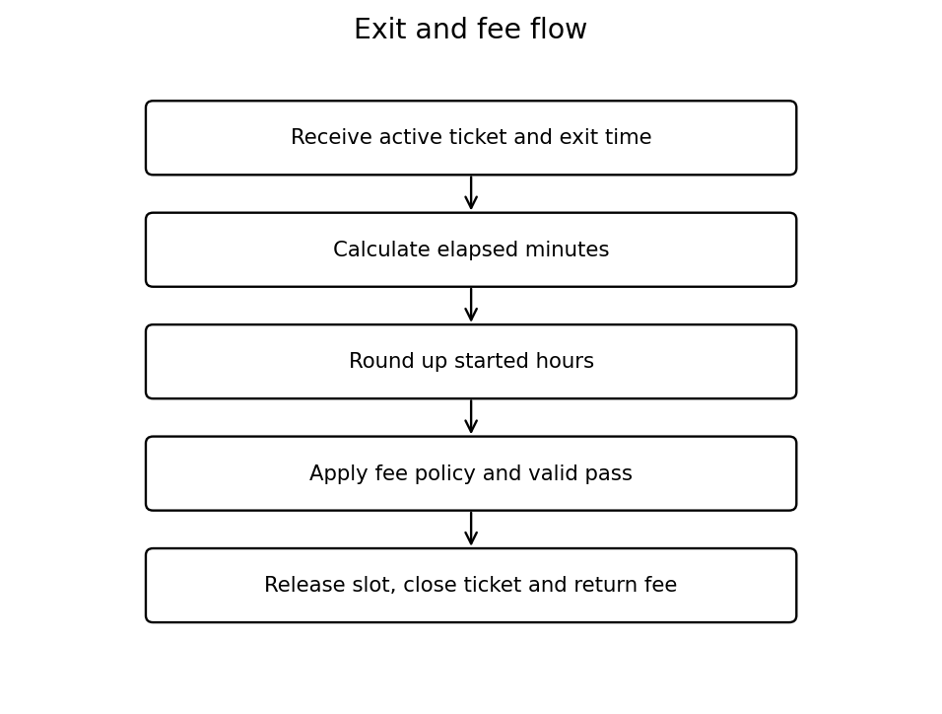
Figure 2. Flowchart for exit and fee computation.

3.3 Completed Code – ParkingFacility
import java.util.Arrays;

public class ParkingFacility {
private final String[][] slots; // null means free

public ParkingFacility(int[] slotsPerFloor) {
if (slotsPerFloor == null || slotsPerFloor.length == 0)
throw new IllegalArgumentException("At least one floor required");
slots = new String[slotsPerFloor.length][];
for (int f = 0; f < slotsPerFloor.length; f++) {
if (slotsPerFloor[f] < 0)
throw new IllegalArgumentException("Negative capacity");
slots[f] = new String[slotsPerFloor[f]];
}
}

public int[] allocate(String vehicleNo) {
if (vehicleNo == null || vehicleNo.isBlank())
throw new IllegalArgumentException("Registration required");
for (int f = 0; f < slots.length; f++) {
for (int s = 0; s < slots[f].length; s++) {
if (slots[f][s] == null) {
slots[f][s] = vehicleNo;
return new int[] {f, s};
}
}
}
return null;
}

public boolean release(int floor, int slot) {
if (floor < 0 || floor >= slots.length) return false;
if (slot < 0 || slot >= slots[floor].length) return false;
if (slots[floor][slot] == null) return false;
slots[floor][slot] = null;
return true;
}

public static void main(String[] args) {
ParkingFacility p = new ParkingFacility(new int[] {2, 1});
System.out.println(Arrays.toString(p.allocate("TN01AA1111")));
System.out.println(Arrays.toString(p.allocate("TN02BB2222")));
System.out.println(Arrays.toString(p.allocate("TN03CC3333")));
System.out.println(p.allocate("TN04DD4444"));
System.out.println(p.release(0, 1) + " " + p.release(0, 1)
+ " " + p.release(5, 0));
System.out.println(Arrays.toString(p.allocate("TN04GH4444")));
}
}
Expected output:
[0, 0]
[0, 1]
[1, 0]
null
true false false
[0, 1]

3.4 Alternative: free-slot stacks
A stack of free coordinates per floor allows allocation by popping a coordinate and release by pushing it back. A non-empty-floor index avoids scanning empty stacks. Both operations can then be O(1) amortized, with O(N) extra coordinate storage. A free count alone cannot identify which slot is free; it must be combined with a stack, queue or bitset.
Approach | Allocate | Release | Extra space
Nested scan | O(N) worst case | O(1) given coordinate | Slot array O(N)
Per-floor stack + non-empty index | O(1) amortized | O(1) amortized | O(N) coordinates + O(F) metadata
Free count only | May still scan slots | O(1) counter update | O(F), but no direct slot locator

TASK 4 – Design Classes, Objects and Constructors
A class is a blueprint and an object is a runtime instance. ParkingTicket represents one parking session. It should be constructed only when all required values are available and valid.

4.1 Constructor overloading and chaining
import java.time.LocalDateTime;

public class ParkingTicket {
private final long ticketId;
private final String registrationNo;
private final int floor, slot;
private final LocalDateTime entryTime;

public ParkingTicket(long id, String regNo, int floor, int slot) {
this(id, regNo, floor, slot, LocalDateTime.now());
}

public ParkingTicket(long id, String regNo, int floor, int slot,
LocalDateTime entryTime) {
if (id <= 0 || regNo == null || regNo.isBlank()
|| floor < 0 || slot < 0 || entryTime == null)
throw new IllegalArgumentException("Invalid ticket");
this.ticketId = id;
this.registrationNo = regNo;
this.floor = floor;
this.slot = slot;
this.entryTime = entryTime;
}

public long getTicketId() { return ticketId; }
public String getRegistrationNo() { return registrationNo; }
public int getFloor() { return floor; }
public int getSlot() { return slot; }
public LocalDateTime getEntryTime() { return entryTime; }
}
The shorter constructor delegates to the full constructor using this(...). Validation and initialization are written once. final fields make ticket identity and entry details immutable.

4.2 Alternative creation approaches
- Default constructor followed by setters: flexible, but the object can exist temporarily in an incomplete state. Every setter must validate, and callers can forget a required field.
- Overloaded constructors with chaining: validate all required data during construction, so the object is valid immediately.
- Static factory methods: methods such as ParkingTicket.create(...) give descriptive creation names and can centralise validation or return specialised implementations.
All approaches allocate n objects and use O(n) total storage for n retained tickets. Their asymptotic creation time is O(n). Constructor/factory calls add only constant-time overhead. The major difference is correctness and maintainability, not asymptotic complexity.

TASK 5 – Apply Static Members and the Object Life Cycle
A ticket counter belongs to the class, not an individual ticket. If every ticket had its own counter, each could start at the same value. Total occupancy may also be static when one facility is represented by the whole process, although a facility instance field is preferable if several facilities can exist.
public final class TicketIdGenerator {
private static long nextId = 1;
private TicketIdGenerator() { }
public static synchronized long nextId() {
return nextId++;
}
}
- Static variable: nextId, shared by all ticket instances.
- Static method: nextId(), because generation does not depend on a particular ticket object.
- Static block: appropriate for one-time initialization of fixed configuration or lookup tables, not lengthy application work.
A ticket is created at entry and remains reachable through the active-ticket collection. At exit it is closed and removed from that collection. When no live reference points to it, it becomes eligible for garbage collection. Java does not guarantee exactly when collection occurs.
Java passes object references by value. A method can mutate the referenced object, but reassigning its local reference does not replace the caller's reference. Entry may return a ParkingTicket; exit may accept one and return a fee/receipt.
Static counter access is O(1) time and O(1) shared space. n tickets require O(n) storage. Removing from an array may require O(n) shifting; HashMap removal is O(1) average.

TASK 6 – Design the Inheritance Hierarchy
Vehicle is an abstract superclass containing registration number and common behaviour. TwoWheeler, Car, ElectricCar and DeliveryVan are subclasses. This is hierarchical inheritance. Each subclass inherits the common registration getter and fee template, and supplies its rate or additional capability.
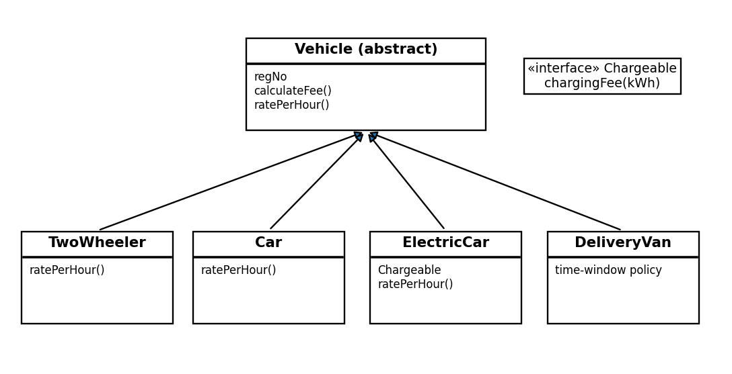
Figure 3. UML-style vehicle inheritance hierarchy and Chargeable capability.

6.1 super and constructor execution
abstract class Vehicle {
private final String regNo;
protected Vehicle(String regNo) {
if (regNo == null || regNo.isBlank())
throw new IllegalArgumentException("Registration required");
this.regNo = regNo;
}
public String getRegNo() { return regNo; }
}
class Car extends Vehicle {
private final int seats;
public Car(String regNo, int seats) {
super(regNo); // Vehicle constructor runs first
this.seats = seats;
}
}
When an ElectricCar is created, memory for the complete object is allocated; its constructor begins; super(regNo) invokes Vehicle's constructor; the superclass validates and assigns the registration; control returns to ElectricCar; subclass fields are initialized; and the object becomes ready.

6.2 Composition alternative
Instead of Car is-a Vehicle, one Vehicle could have-a VehicleType or RatePolicy object. Composition is more flexible when the difference is mainly a configurable rate or pricing rule. Inheritance is appropriate for genuine vehicle categories and shared substitutability. Composition permits runtime policy changes but requires delegation and policy objects.

TASK 7 – Apply Method Overriding and Object-Class Methods
Each subclass overrides ratePerHour(). The common calculateFee() method calls it, and runtime dispatch selects the subclass version.
class TwoWheeler extends Vehicle {
TwoWheeler(String regNo) { super(regNo); }
@Override protected double ratePerHour() { return 10.0; }
}
class Car extends Vehicle {
Car(String regNo) { super(regNo); }
@Override protected double ratePerHour() { return 30.0; }
}
- @Override asks the compiler to verify that a method actually overrides an inherited method.
- The signature must match; return type must be identical or covariant; access cannot be made more restrictive.
- Static methods are hidden rather than overridden; private methods are not overridden.
- final fields protect identity values; a final method protects critical invariants; a final class prevents subclassing and should not be used for the extensible Vehicle base.

7.1 Object methods
@Override public String toString() {
return getClass().getSimpleName() + "[regNo=" + regNo + "]";
}
@Override public boolean equals(Object obj) {
if (this == obj) return true;
if (!(obj instanceof Vehicle)) return false;
Vehicle other = (Vehicle) obj;
return regNo.equals(other.regNo);
}
@Override public int hashCode() { return regNo.hashCode(); }
The FeeDemo prints true for a Car and ElectricCar with the same registration because equals() compares only registration numbers. If registration identifies the physical vehicle, this is acceptable. The system must still prevent both objects from being parked simultaneously. If vehicle category is part of identity, equals() must also compare category.
A switch-based calculateFee() would test a type field centrally. A switch over k fixed types is commonly O(1) with a compiled switch, while a sequential if–else chain may take O(k). Dynamic dispatch is also effectively O(1). The major advantage of overriding is maintenance: a new subclass supplies its own method without editing a central switch.

TASK 8 – Apply Polymorphism
Compile-time polymorphism is method overloading. For example, enter(Vehicle), enter(Vehicle, ParkingUser) and enter(Vehicle, ParkingUser, boolean) are selected by the compiler according to arguments.
class ParkingService {
void enter(Vehicle v) { /* default entry */ }
void enter(Vehicle v, ParkingUser u) { /* normal entry */ }
void enter(Vehicle v, ParkingUser u, boolean priority) {
/* priority entry */
}
}
Runtime polymorphism occurs when a superclass reference refers to a subclass object. Example: Vehicle v = new Car("TN02B2"); v.calculateFee(130). The declared type is Vehicle, actual type is Car, and the call to ratePerHour() executes Car.ratePerHour().
Trace item | Value
Declared type | Vehicle
Actual object | Car
Call | v.calculateFee(130)
Overridden method | Car.ratePerHour()
Billable hours | (130 + 59) / 60 = 3
Fee in FeeDemo | 3 × Rs 30 = Rs 90
Polymorphism avoids long if–else chains because the runtime object selects its implementation. Using instanceof checks and casts can require up to k checks for k categories, increases central code size and requires editing the central method whenever a category is added.

TASK 9 – Apply Abstract Classes and Interfaces
Vehicle is an abstract class because vehicles share instance state (registration), a constructor and implemented behaviour. Chargeable is an interface because charging is an optional capability. ElectricCar extends Vehicle and implements Chargeable. A class can implement multiple interfaces, for example Chargeable, Insurable and Trackable.
interface Chargeable {
double chargingFee(int kWh);
default boolean supportsFastCharging() { return false; }
static boolean validEnergy(int kWh) { return kWh >= 0; }
}
abstract class Vehicle {
private final String regNo;
protected Vehicle(String regNo) { this.regNo = regNo; }
public String getRegNo() { return regNo; }
protected abstract double ratePerHour();
public double calculateFee(int minutes) {
if (minutes < 0) throw new IllegalArgumentException();
int hours = (minutes + 59) / 60;
return hours * ratePerHour();
}
}
class ElectricCar extends Vehicle implements Chargeable {
ElectricCar(String regNo) { super(regNo); }
@Override protected double ratePerHour() { return 20.0; }
@Override public double chargingFee(int kWh) {
if (!Chargeable.validEnergy(kWh)) throw new IllegalArgumentException();
return kWh * 15.0;
}
@Override public boolean supportsFastCharging() { return true; }
}
A default interface method supplies optional behaviour. A static interface method supplies a utility called through the interface name. If Vehicle became an interface, it could not have an ordinary constructor or per-instance fields; each class would need to duplicate registration storage and validation. If Chargeable became an abstract class, ElectricCar could not extend both Vehicle and Chargeable because Java has single class inheritance. Interface dispatch and abstract-class virtual calls are both constant-time in the usual model; the important distinction is state/constructor support versus multiple capability contracts.

9.1 Completed Code – FeeDemo
This standalone program reproduces the exact expected output in the assignment. Rates are deliberately chosen to produce the stated values: two-wheeler Rs 10/hour, car Rs 30/hour, electric car Rs 20/hour plus Rs 15 per kWh.
interface Chargeable { double chargingFee(int kWh); }

abstract class Vehicle {
private final String regNo;
protected Vehicle(String regNo) { this.regNo = regNo; }
public String getRegNo() { return regNo; }
protected abstract double ratePerHour();

public double calculateFee(int minutes) {
if (minutes < 0) throw new IllegalArgumentException("Negative time");
int hours = (minutes + 59) / 60;
return hours * ratePerHour();
}
@Override public boolean equals(Object o) {
return o instanceof Vehicle
&& regNo.equals(((Vehicle) o).regNo);
}
@Override public int hashCode() { return regNo.hashCode(); }
}
class TwoWheeler extends Vehicle {
TwoWheeler(String r) { super(r); }
@Override protected double ratePerHour() { return 10.0; }
}
class Car extends Vehicle {
Car(String r) { super(r); }
@Override protected double ratePerHour() { return 30.0; }
}
class ElectricCar extends Vehicle implements Chargeable {
ElectricCar(String r) { super(r); }
@Override protected double ratePerHour() { return 20.0; }
@Override public double chargingFee(int kWh) { return kWh * 15.0; }
}
public class FeeDemo {
public static void main(String[] args) {
Vehicle[] vehicles = {
new TwoWheeler("TN01A1"),
new Car("TN02B2"),
new ElectricCar("TN03C3")
};
for (Vehicle v : vehicles) {
double fee = v.calculateFee(130);
if (v instanceof Chargeable c) fee += c.chargingFee(10);
System.out.println(v.getClass().getSimpleName() + " "
+ v.getRegNo() + " -> Rs " + fee);
}
System.out.println(new Car("TN02B2")
.equals(new ElectricCar("TN02B2")));
}
}
Expected output:
TwoWheeler TN01A1 -> Rs 30.0
Car TN02B2 -> Rs 90.0
ElectricCar TN03C3 -> Rs 210.0
true
The last line is true because equals() compares registration numbers only. This is consistent with registration number being the physical vehicle identity, while active-ticket validation prevents duplicates.

TASK 10 – Enforce Encapsulation through Packages and Access Modifiers
src/
campus/parking/model/
Vehicle.java, Car.java, ElectricCar.java
ParkingTicket.java, ParkingSlot.java
campus/parking/service/
ParkingService.java, FeePolicy.java
campus/parking/app/
Main.java
campus/parking/util/
TicketIdGenerator.java
Modifier | Visibility | Appropriate use
private | Declaring class | Fields such as registration, ticket ID and slot state.
package-private | Same package | Internal helpers not exposed as public API.
protected | Package and subclasses | Subclass extension method such as ratePerHour().
public | All packages | Selected service methods and getters.
Keep fields private. Expose required values through getters. Omit setters for immutable ticket identity. Validate mutable values inside setters or domain methods such as occupy() and release().

10.1 Wrapper classes and autoboxing
Integer, Long and Double are wrapper classes used when primitives must be stored in generic collections, such as ArrayList<Integer>. Autoboxing converts int to Integer and unboxing converts Integer to int. Comparing Integer objects with == checks reference identity, not numeric value; use equals(). Unboxing null causes NullPointerException.
Integer a = 1000, b = 1000;
System.out.println(a == b); // reference comparison; usually false
System.out.println(a.equals(b)); // value comparison; true

10.2 Public fields alternative
Public fields allow callers to assign negative fees, invalid slot indexes or inconsistent occupancy. Every caller must repeat validation. If there are m call sites, a changed rule may require edits at up to m locations. Encapsulation centralises validation. A simple scalar validation is O(1) per update; its key benefit is consistent state and lower maintenance cost.

TASK 11 – Implement, Test and Defend the Design
Testing must include normal entry/exit, boundaries and invalid input. The following table lists expected outcomes; execute the programs and replace the final column with actual observations.
Test | Input / condition | Expected result | Actual result
Two-wheeler entry | Free compatible slot | Ticket created and slot occupied | Fill after run
Car exit | 130 minutes; Rs 30/hour | 3 hours; Rs 90 | Fill after run
EV exit | 10 kWh charging | Parking plus charging fee | Fill after run
Last free slot | One slot remains | That slot is allocated | Fill after run
Facility full | All slots occupied | Allocation returns null | Fill after run
Zero-minute stay | 0 minutes | Rs 0 | Fill after run
Exact boundary | 60 minutes | 1 billable hour | Fill after run
Over boundary | 61 minutes | 2 billable hours | Fill after run
Unknown type | Unsupported category | Reject; no slot allocated | Fill after run
Duplicate registration | Already active | Reject second ticket | Fill after run
Invalid slot | Negative/out-of-range coordinate | release() returns false | Fill after run
Negative duration | -1 minute | Reject input | Fill after run

11.1 Active-ticket storage
class ActiveTickets {
private final java.util.Map<String, ParkingTicket> active =
new java.util.HashMap<>();

public void add(String regNo, ParkingTicket ticket) {
if (active.containsKey(regNo))
throw new IllegalArgumentException("Duplicate active vehicle");
active.put(regNo, ticket);
}
public ParkingTicket find(String regNo) {
return active.get(regNo);
}
public ParkingTicket remove(String regNo) {
return active.remove(regNo);
}
}
Structure | Find ticket | Exit processing | Space
Array | O(n) | O(n) scan | O(n)
ArrayList<ParkingTicket> | O(n) | O(n) search; removal may shift | O(n)
HashMap<String, ParkingTicket> | O(1) average; O(n) worst | O(1) average lookup/removal | O(n)
HashMap is recommended for active tickets because exit commonly starts with registration number. In a complete system, slot allocation and ticket creation should be treated as one transaction; if ticket creation fails, the slot allocation must be rolled back.

TASK 12 – Re-evaluate and Adapt the Design

12.1 A. Impact analysis
The new requirements add e-bikes with a flat fee, delivery vans charged at twice the car rate during 9 AM–5 PM, one-day visitor passes, and five floors with different slot capacities. Unequal floor capacities reinforce the jagged-array choice. A rectangular array would waste space or require special handling.
- E-bike: add an E-Bike subclass or a flat-fee pricing policy.
- Delivery van: add DeliveryVan and a time-window policy that identifies the overlap with 09:00–17:00.
- One-day visitor pass: generalise the pass model to a start and end validity time.
- Five floors: update capacity configuration; do not hard-code three floors or equal capacity.
- Likely modifications: FeePolicy, pass validation and configuration. Allocation can remain unchanged if it already uses jagged arrays.

12.2 B. Evaluation of original design
Change | Original design assessment | Response
E-bike flat fee | Hourly-only rate method is not sufficient. | Add FlatFeePolicy.
Delivery van time window | Single ratePerHour cannot express time overlap. | Add time-aware policy.
One-day pass | Monthly-only assumption is too narrow. | Generalise ParkingPass validity interval.
Unequal five floors | Jagged array already supports it. | Change capacity configuration only.
New categories can be represented by subclasses, but hourly-only pricing is not sufficiently flexible for flat fees and time-dependent tariffs. Pricing conditions should not be scattered through each vehicle subclass or a central switch.

12.3 C. Adaptation / redesign decision
Decision: MODIFY the original design. Retain Vehicle, Chargeable, ParkingTicket, jagged-array ParkingFacility and HashMap active-ticket storage. Modify pricing to use a FeePolicy strategy and generalise passes. This protects already-tested allocation and ticket logic while allowing new pricing rules to be added independently.
interface FeePolicy {
double calculate(Vehicle vehicle, long minutes,
java.time.LocalDateTime entry,
java.time.LocalDateTime exit);
}
class HourlyFeePolicy implements FeePolicy {
private final double rate;
HourlyFeePolicy(double rate) { this.rate = rate; }
public double calculate(Vehicle v, long minutes,
java.time.LocalDateTime entry, java.time.LocalDateTime exit) {
if (minutes <= 0) return 0;
long hours = (minutes + 59) / 60;
return hours * rate;
}
}
class FlatFeePolicy implements FeePolicy {
private final double amount;
FlatFeePolicy(double amount) { this.amount = amount; }
public double calculate(Vehicle v, long minutes,
java.time.LocalDateTime entry, java.time.LocalDateTime exit) {
return amount;
}
}
For delivery vans, a production policy should split the stay into time intervals and calculate the exact overlap with each daily window [09:00, 17:00). The overlap minutes are charged at twice the car rate; remaining minutes are charged at the normal rate. The assignment does not specify how partial hours should be rounded separately across the two periods, so that tariff detail must be confirmed rather than assumed.

12.4 One-day pass model
import java.time.LocalDateTime;
class ParkingPass {
private final String passId, registrationNo;
private final LocalDateTime validFrom, validUntil;

ParkingPass(String id, String reg, LocalDateTime from,
LocalDateTime until) {
if (id == null || reg == null || from == null || until == null
|| until.isBefore(from))
throw new IllegalArgumentException("Invalid pass");
passId = id; registrationNo = reg;
validFrom = from; validUntil = until;
}
public boolean isValidAt(String reg, LocalDateTime time) {
return registrationNo.equals(reg)
&& !time.isBefore(validFrom)
&& !time.isAfter(validUntil);
}
}

12.5 New-category tests
Test | Expected result
E-bike, 1 minute | Configured flat fee is charged once.
E-bike, 8 hours | Same per-visit flat fee if tariff defines it that way.
Van, 10:00–12:00 | Double car rate for peak-period duration.
Van, 08:00–10:00 | Normal rate 08:00–09:00; double rate 09:00–10:00.
Van, 16:00–18:00 | Double rate 16:00–17:00; normal rate 17:00–18:00.
Visitor with valid one-day pass | Fee waived during validity.
Visitor with expired pass | Normal fee applies.
Five floors [20,35,40,25,50] | 170 slots can be allocated and released.

12.6 Trade-offs and final decision
The modified design adds policy classes and configuration, increasing the number of components. In return, new pricing rules do not require rewriting the allocation algorithm or ticket model. Each policy can be unit-tested independently. The jagged array remains appropriate. MODIFY is therefore the best-supported decision.

Complexity Summary
Operation | Time | Space
Nested slot allocation | O(N) worst case | O(N) slots
Release using known coordinate | O(1) | O(1) extra
Free-slot stack | O(1) amortized | O(N) coordinates
Array/list ticket search | O(n) | O(n)
HashMap ticket lookup | O(1) average; O(n) worst | O(n)
Hourly fee calculation | O(1) | O(1)
Time-window policy across d days | O(d) | O(1)

Conclusion
The campus smart-parking system is best represented using Java objects because vehicles, tickets, slots, users and passes have distinct state and responsibilities. Jagged arrays support unequal floor capacities. Encapsulation protects system invariants, constructors create valid objects, static members support shared ticket numbering, and inheritance with polymorphism supports vehicle-specific behaviour. Chargeable models an optional capability. HashMap improves active-ticket lookup. For the new requirements, modifying the design with FeePolicy and a generalised ParkingPass preserves stable components while making pricing extensible.

References and Submission Checklist
Primary source: Java Assignment 1 – CO1, Campus Smart-Parking System, supplied PDF (20 pages). Task descriptions, scenario, expected outputs and Day-4 requirements are derived from that document.
- Replace name, register number and GitHub link placeholders.
- Save ParkingFacility code as ParkingFacility.java and FeeDemo code as FeeDemo.java in separate folders/files.
- Compile with javac ParkingFacility.java and javac FeeDemo.java; run with java ParkingFacility and java FeeDemo.
- Execute every code sample and capture actual console screenshots.
- Complete the Actual Result column from your own execution.
- Create CSA09-<RegisterNumber>-Assignment1 with one folder per task and a README.md.
- Commit progressively, at least one commit per task, and share the working repository link with faculty.
Suggested environment: Java 17 or later. The report provides expected results and code; screenshots and measured actual results must come from the student's own execution.

