Prg_01 | '''Open the hello_world.py file you just created. Make a typo somewhere in the line and run the program again. Can you make a typo that generates an error? Can you make sense of the error message? Can you make a typo that doesn’t generate an error? Why do you think it didn’t make an error?’’’
CODE:- | print("**CHARMI**")  print("Hello World")
OUTPUT:- | 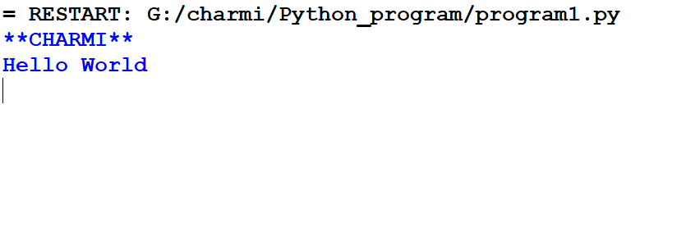
Prg_02 | Simple Message: ‘store a message in a variable ,and print the message'''
CODE:- | print("CHARMI")  name = "charmi"  age = 21  print("Name:",name)  print("Name:",age)
OUTPUT:- | 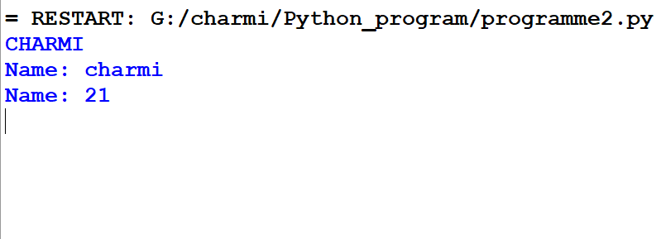
Prg_03 | Simple Message:'''store a message in a variable, and print the message. Then change the value of your variable in a new message, print the new message'''
Code:- | print("CHARMI")  p = "GM"  print("stmt1:",p)  p = "GOOD MOARNING"  print("stmt2:",p)
OUTPUT:- | 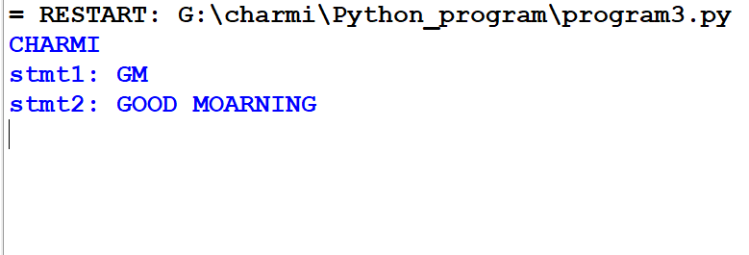
Prg_04 | Personal Message: ‘store a person's name in a variable and print a message to that person your message should be simple such as "hello student", would you like to learn some python today'''
Code:- | print("CHARMI")  name = "charmi"  age = 21  print("Name:",name)  print("Name:",age)
OUTPUT:- | 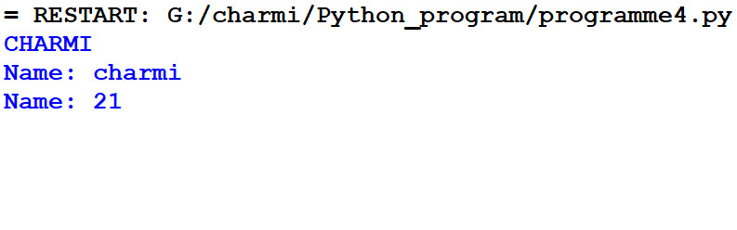
Prg_05 | Name cause: ‘store a person's name in variable and print that person's name in lowercase, uppercase and title case'''
Code:- | print("CHARMI")  x=input("ENTER A NAME:-")  print(x.lower())  print(x.upper())  print(x.title())
OUTPUT:- | 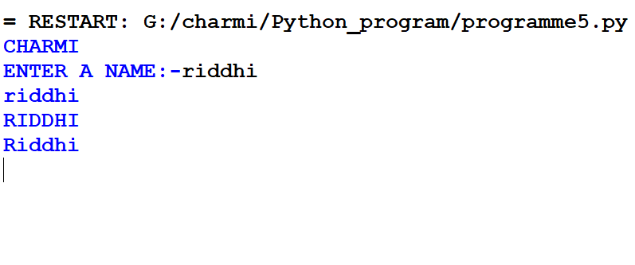
Prg_06 | Famous Quote: Find a quote from person you admire. Print the quote and the name of its author. Your output look the following, including the question marks:  Hellen Keller once said” A person who never made a mistake never tried anything new,”
Code: - | print("CHARMI")  print('Heller Keller once said”A person who never made a\n mistake never tried anything new.”')
OUTPUT:- | 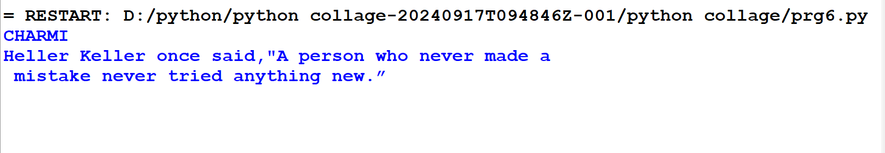
Prg_07 | Famous Quote 2: ‘Repeat a previous program ,but this time store the person’s name in a variable called famous_person.Then  compose your message and store it in a new variable called message. Print your message'''
Code:- | print("CHARMI")  a="Abdul kalam"  print(a)  print("The best brains of the nation may be found on the last benches of the classroom")
OUTPUT:- | 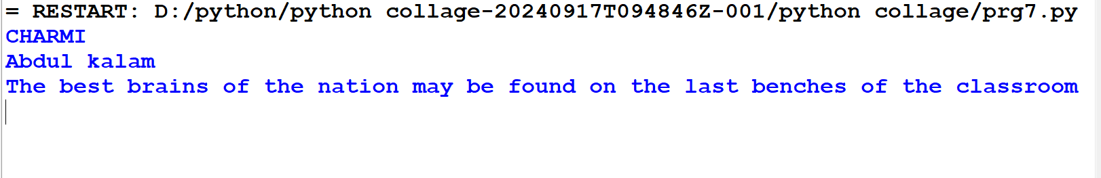
Prg_08 | Stripping names:'''Store a person's name,and include some whitespaces character at beginning and end of the name.make  sure you use each character combinbation,"\t" and "\n",at least once.print the name once, so the whitespace around the  Name is displayed. Then the name using each of the three stripping function, strip (), strip (), and strip ().'''
Code:- | print("CHARMI")  name=' charmi"\t" monani"\n"'  print(name)  print(name.lstrip())  print(name.rstrip())  print(name.strip())
OUTPUT:- | 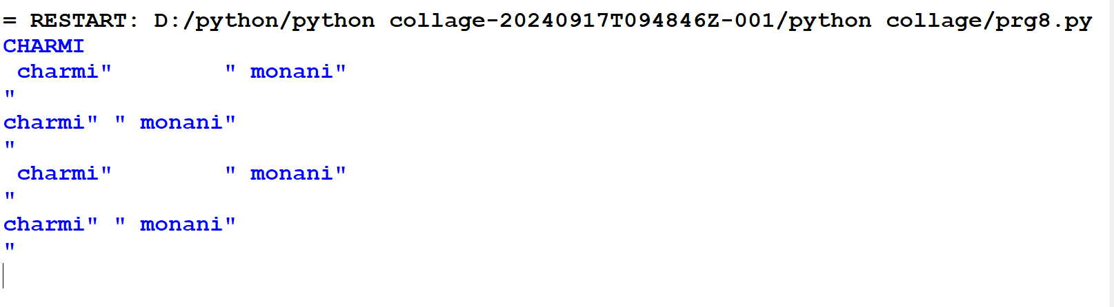
Prg_09 | Number eight:'''Write addition,subtraction,multiplication and division operation each result in the number 8.be sure to enclose your operation in print statments to see the results.you  should create four line look like this:print(5+3)your output should be four line the number 8 apperauing once  each line'''
Code:- | print("CHARMI")  print(6+2)  print(10-2)  print(2*4)  print(16/2)
Output:- | 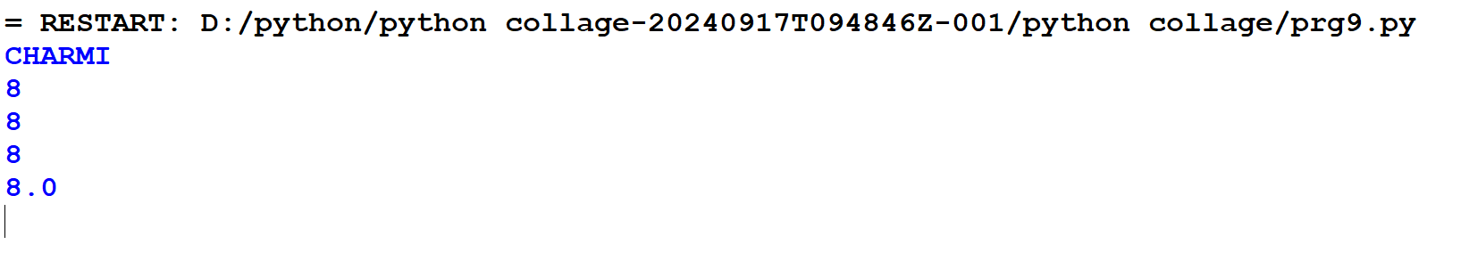
Prg_10 | Favorite Number: ‘store your favorite number in a variable .then using that variable ,create a message that reveals your favourite  number.print the message'''
Code:- | print("CHARMI")  c=168203  msg=("Have A Nice Day!!!")  print("MY FAVORITE NUMBER IS:",c)  print(msg)
OUTPUT:- | 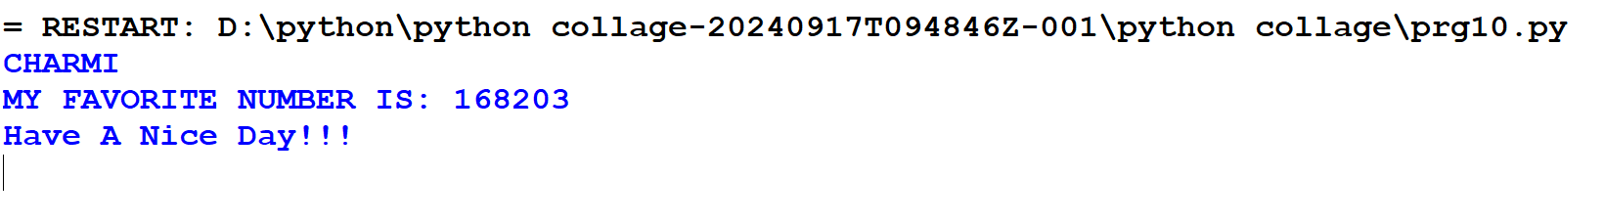
Prg_11 | Adding comnments:'''choose two of the program's you've written ,and add at least one commment to each.if  you don't have anything specific to write because your program are simple at this point,just add your name and date '''
Code:- | print("CHARMI")  print('Date:-11/09/2024')  '''perform task'''  quote=("Mahatma Gandhi quote said Where there is love there is life.")  print("Quote of the day",quote)
OUTPUT:- | 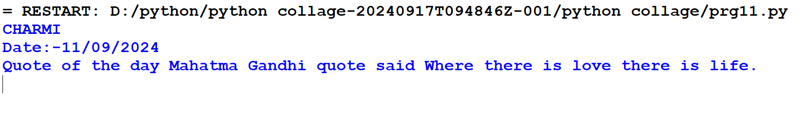
Prg_12 | '''(1)Write A program to use python string'''
Code:- | print("CHARMI")  str='hello world!'  print(str)#prints complete string  print(str[0])#print first character of the string  print(str[2:5])#prints string starting 3rd to 5th  print(str[2:])#print element starting from 3rd character  print(str*2)#print string two times  print(str+"Test")#print concatenated string
OUTPUT:- | 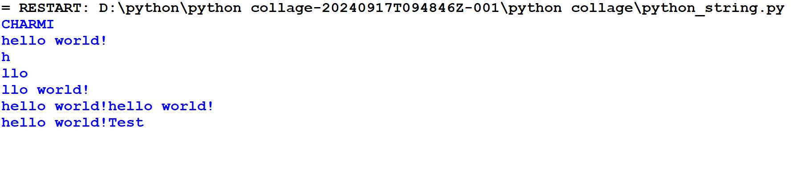
 | '''(2)Write A program to use python list'''
Code:- | print("CHARMI")  list=['abcd',786,2.23,'John',70.2]  tinylist=[123,'john']  print(list)#print complete list  print(list[0])#print first element of the list  print(list[1:3])#print element starting from 2nd till 3rd  print(list[2:])#print element starting from 3rd  print(tinylist*2)#print list two times  print(list+tinylist)#print concatenated lists
OUTPUT:- | 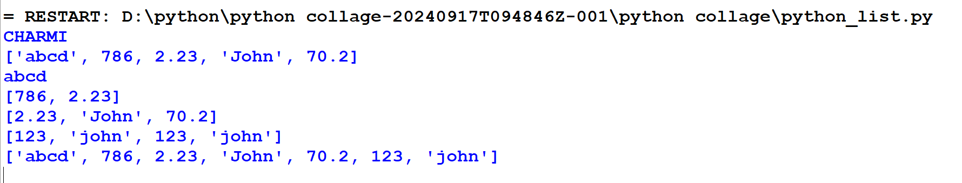
 | '''(3)Write A program to use python tuple'''
Code:- | print("CHARMI")  tuple=['abcd',786,2.23,'John',70.2]  tinytuple=[123,'john']  print(tuple)#print complete tuple  print(tuple[0])#print first element of the tuple  print(tuple[1:3])#print element starting from 2nd till 3rd  print(tuple[2:])#print element starting from 3rd  print(tinytuple*2)#print tuple two times  print(tuple+tinytuple)#print concatenated tuple
OUTPUT:- | 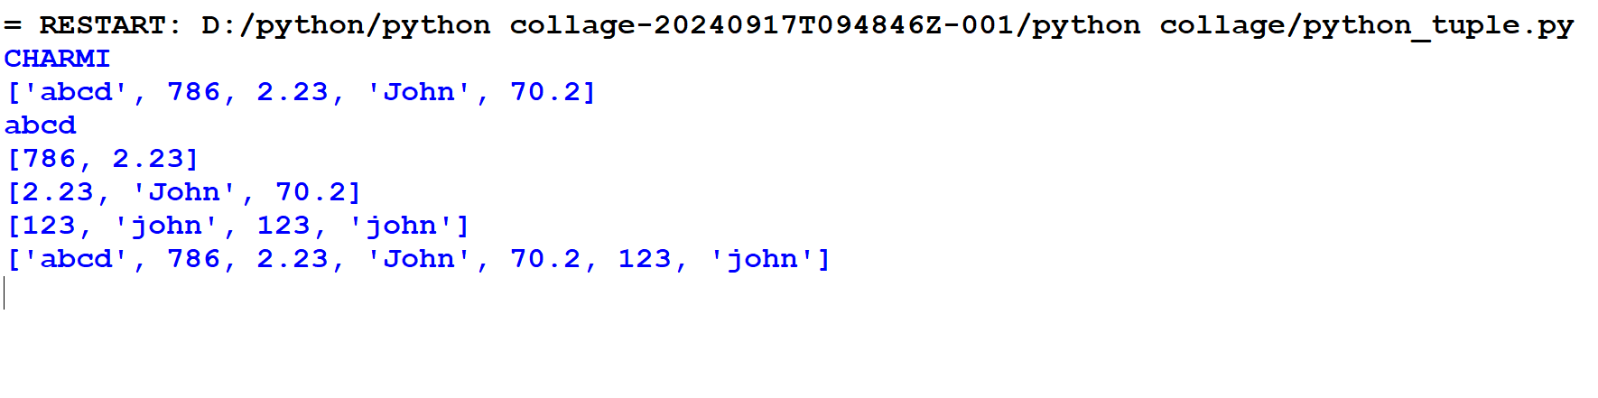
 | '''(4)write a program to use python dictionary'''
Code:- | print("CHARMI")  dict={}  dict['one']="This is one"  dict[2]="This is two"  tinydict={'name':'john','code':6734,'dept':'sales'}  print(dict['one'])#prints value for 'one'key  print(dict[2])#prints value for 2 key  print(tinydict)#prints complete dictionary  print(tinydict.keys())#prints all key the keys  print(tinydict.values())#prints all the values
OUTPUT:- | 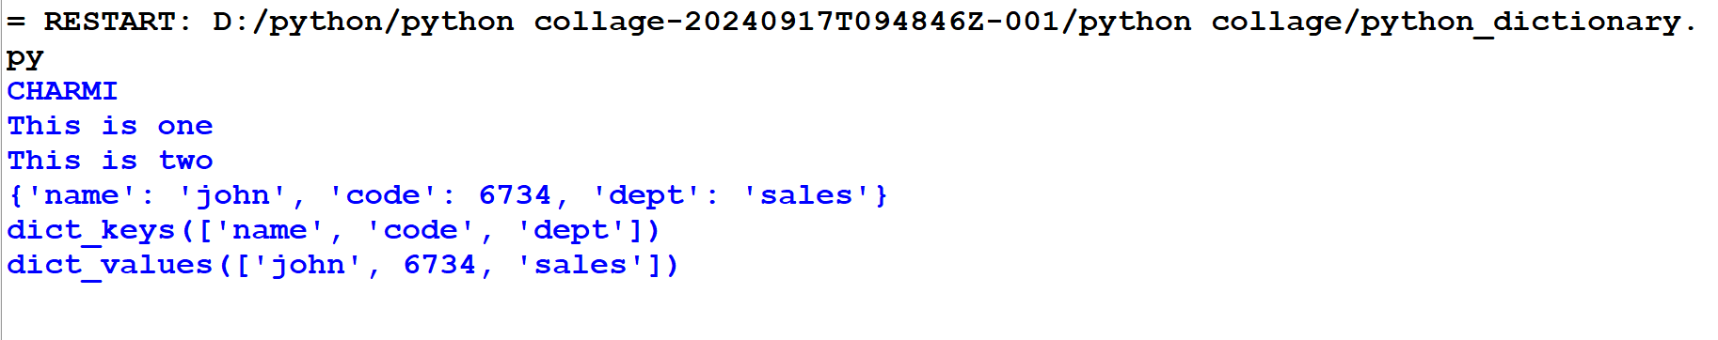
Prg_13 | (1)'''stores the name of a few of yours friends in a list called names. Print each person's name by accessing  each element in the list, one at a time.'''
Code:- | print("CHARMI")  name=["Kruti","Preeti","Harsh","Pinki","radhu"]  print (name[0])  print(name [1])  print (name[2])  print (name[3])  print (name[4])  print (name[-2])  print (name[-4])
OUTPUT:- | 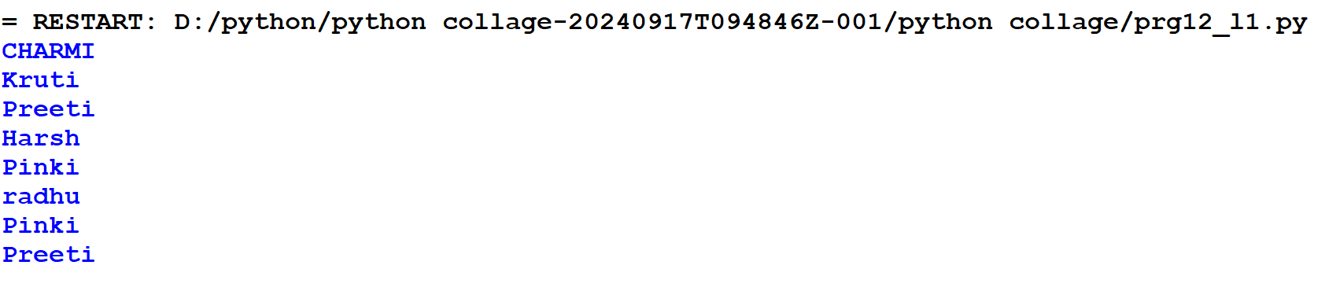
(2)'''Start with the list you used in exercise 3.1, but instead of just printing each person's name, print a message to
them. The next of each message should be the same,but each message should be personalized with the person's name'''
Code:- | print("CHARMI")  names=["Kriti","Geeta","Meeta"]  for names in names:  print("You look like a princess "+names)
OUTPUT:- | 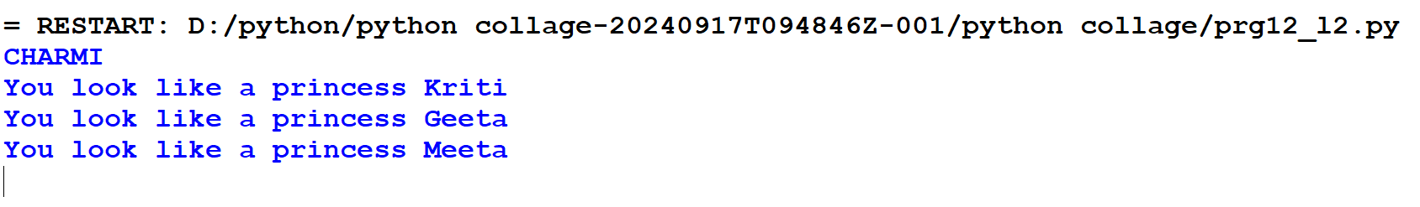
 | (3)
Prg_14 | '''Write a program to use Python Arithmetic Operators'''
Code:- | print("CHARMI")  a=21  b=10  c=0  c=a+b  print("Line 1-value of c is",c)  c=a-b  print("Line 2-value of c is",c)  c=a*b  print("Line 3-value of c is",c)  c=a/b  print("Line 4-value of c is",c)  c=a%b  print("Line 5-value of c is",c)  a=2  b=3  c=a**b  print("Line 6-value of c is",c)  a=10  b=5  c=a//b  print("Line 7-value of c is",c)
OUTPUT:-
 | '''Write a program to use python logical operator'''
Code:- | print("CHARMI")  a=10  b=20  list=[1,2,3,4,5]  if(a in list):  print("Line-1 is available in the given list")  else:  print("Line-1 is not available in the given list")  if(b not in list):  print("Line-2 is not available in the given list")  else:  print("Line-2 is available in the given list")  c=a/b  if(c in list):  print("Line-3 is available in the given list")  else:  print("Line-3is not available in the given list")
OUTPUT:- | 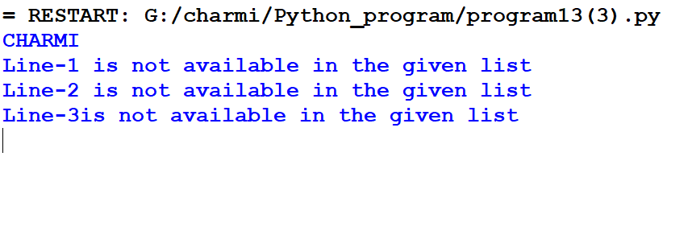
 | ‘’’write a python program to assignment operator’’’
(15) | '''Write a python program - discount is calculated on the input amount.Rate of discount is 5%,if the ampunt is less than 1000,and 10% if it is above 10000'''
Code:- | print("CHARMI")  amount=int(input("Enter Amount:"))  if amount<1000:  discount=amount*0.05  print("Discount",discount)  else:  discount=amount*0.10  print("Discount",discount)  print("Net payable:",amount-discount)
OUTPUT:- | 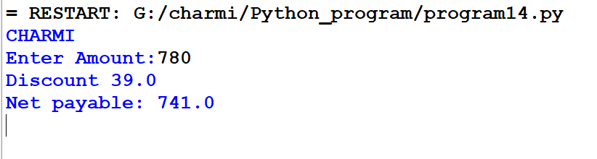
(16) | '''Write a python same program with the help of if...elif..else.'''
Code:- | print("CHARMI")  amount=int(input("Enter Amount:"))  if amount<1000:  discount=amount*0.05  print("Discount",discount)  elif amount<5000:  print("Discount",discount)  else:  discount=amount*0.15  print("Discount",discount)  print("Net payable:",amount-discount)
OUTPUT:- | 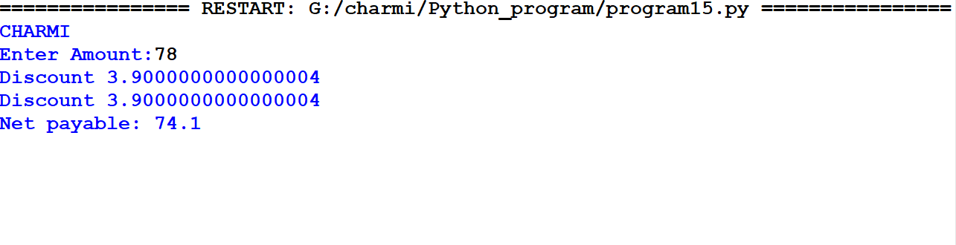
(17) | '''Write a python program for use of nested if'''
Code:- | print("CHARMI")  num=int(input("Enter Number:--"))  if num%2==0:  if num%3==0:  print("Divisible by 3 and 2")  else:  print("Divisible by 2 not divisible by 3")  else:  if num%3==0:  print("Divisible by 3 not divisible by 2")  else:  print("not divisible by 3 not divisible by 2")
OUTPUT:- | 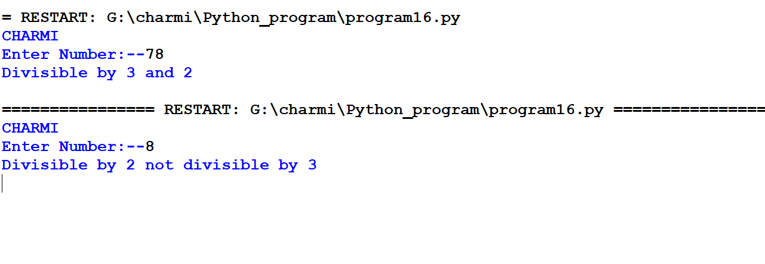
(18) | '''Write a python program to use python while loop'''
Code:- | print("CHARMI")  count=0  while(count<9):  print("The Count is:",count)  count=count+1  print ("Good Bye!")
OUTPUT:- | 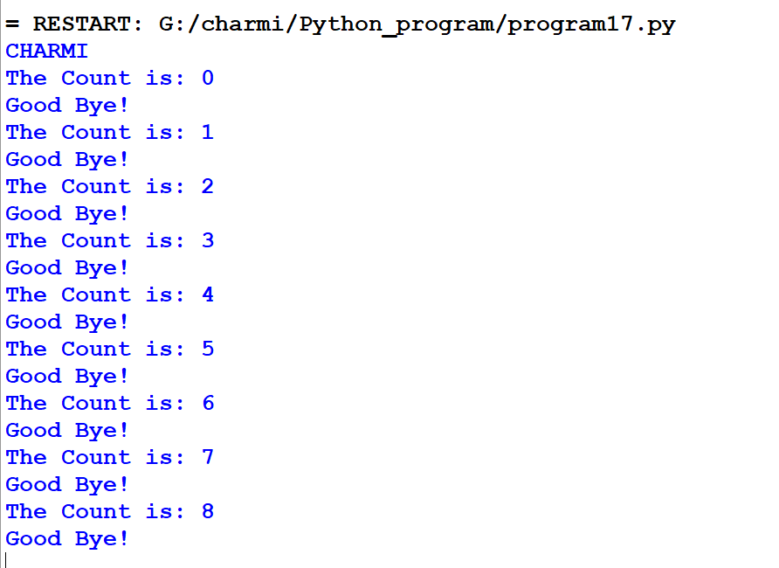
(19) | '''Write a python program to use using else statment with loop'''
Code:- | print("CHARMI")  count=0  while count<5:  print(count,"is less than 5")  count=count+1  else:  print(count,"is not less than 5")
OUTPUT:- | 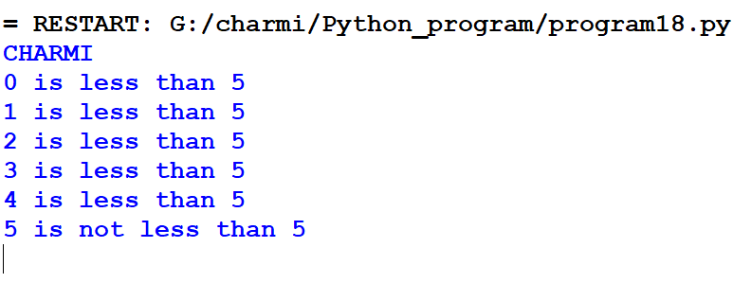
(20) | '''Write a python program to use for loop'''
Code:- | print("CHARMI")  for var in list(range(5)):  print(var)
OUTPUT:-
(21) | #write a python program use of break statement
Code:- | for letter in 'Python':  if letter == 'h':  break  print("Current letter:",letter)  var=10#Second example  while var>0:  print("Current variable name",var)  var=var-1  if var==5:  break  print("Good Bye!")
OUTPUT:- | 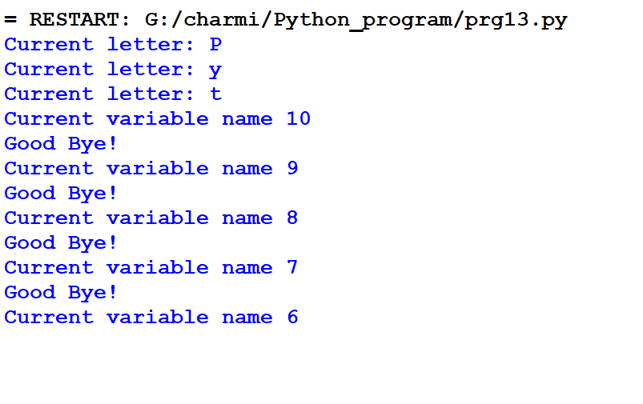
(22) | #write a python program use of continue statment
Code:- | print("CHARMI")  for letter in 'Python':#first Example  if letter == 'h':  continue  print("Current letter:",letter)  var=10#Second example  while var>0:  var=var-1  if var==5:  continue  print("Current letter:",var)  print("Good Bye!")
OUTPUT:- | 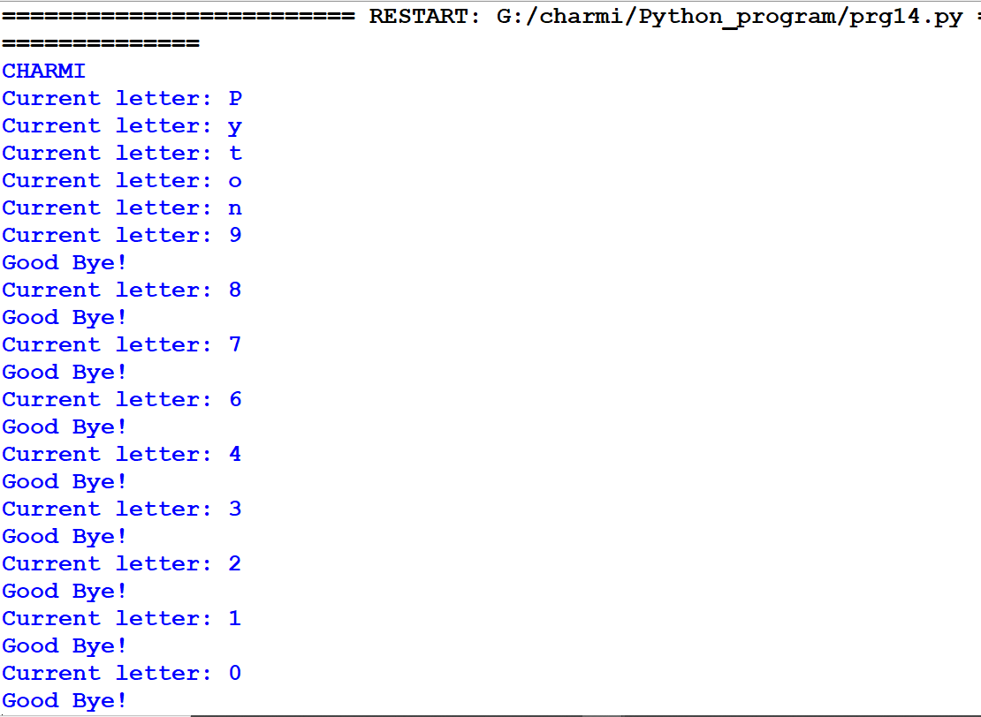
(23) | #write a python program use of pass statment
Code:- | print("CHARMI")  for letter in 'Python':#first Example  if letter == 'h':  pass  print("This is a pass block")  print("Current letter:",letter)  print("Good Bye!")
OUTPUT:- | 