
PainterApp

Try it now
Go to PainterApp to start Painting.
Documentation
Shortcuts
You can almost do anything with shortcuts. Click on the menu you can see the shortcuts all of them with menus.
Rectangles
Choose Rectangle and click click click instead of drag. You can fill it with any color you want with resizing it.
Layers
You can easily create more than one Layer by adding new canvas which is transparent like Photoshop. You can move by click on tree and also change the order of the layer
Multiple Documents
You can create multiple document at a time. You can edit it, save it and open it meanwhile…..So, the application supported multiple document.

Translating
To translate PainterApp into other languages, by selecting languages at the first stage of application

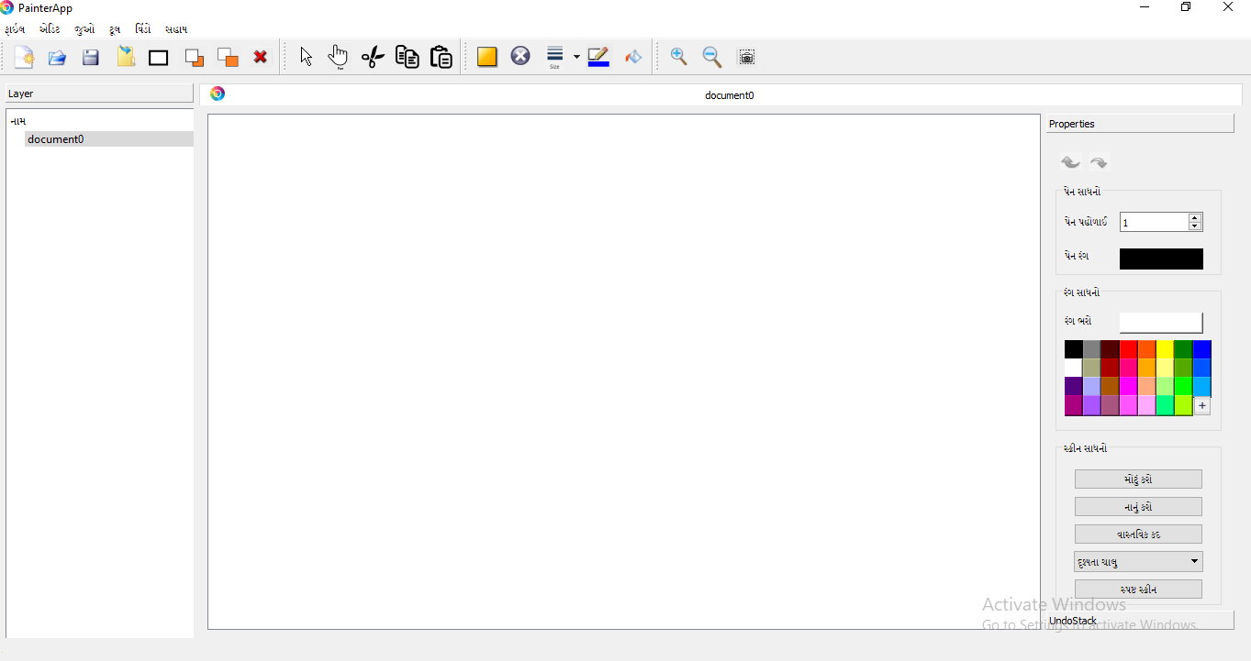
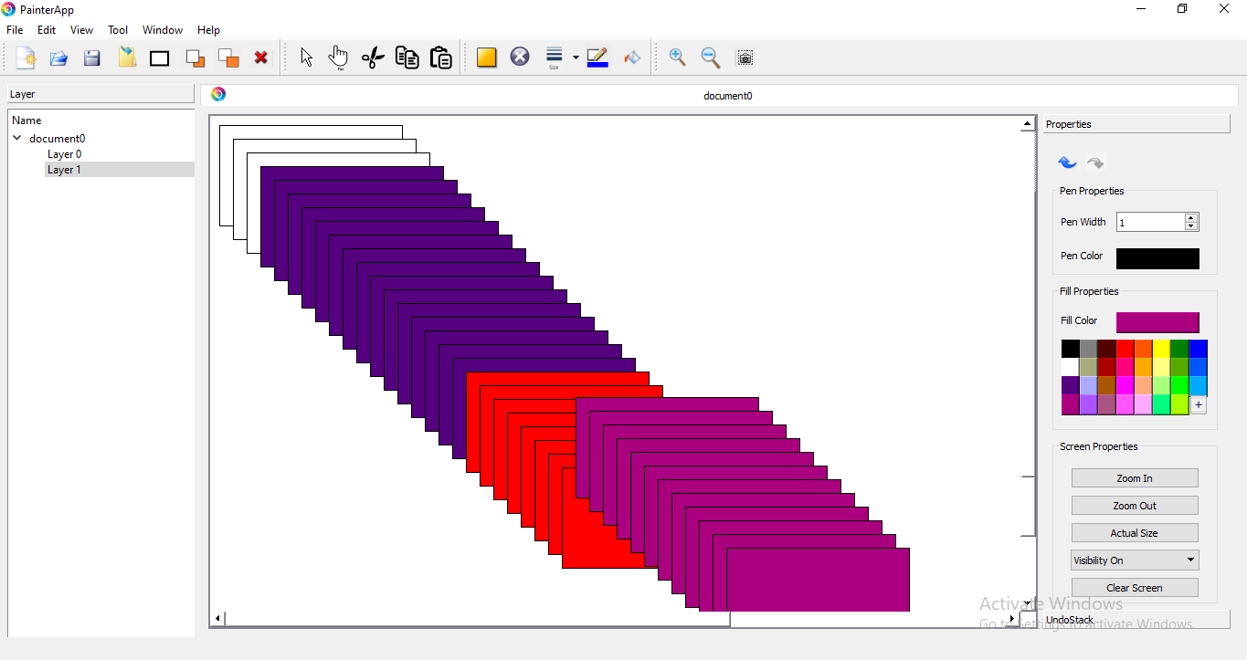
Developement
Code Sandbox
- Go to https://github.com/Charmi215/PainterApplication
  - You may need to sign in with Github and reload the page
- You can start coding instantly, and even send PRs from there!
Local Installation
These instructions will get you a PainterAppInstaller. You can install it via downloading installer.
Contributing
Pull requests are welcome. For major changes, please open an issue first to discuss what you would like to change.

