|  |
| --- |
| Experiment No.2 |
| Selection Sort |
| Date of Performance: |
| Date of Submission: |

**Experiment No. 2**

**Title**: Selection Sort

**Aim**: To implement Selection Comparative analysis for large values of ‘n’

**Objective:** To introduce the methods of designing and analyzing algorithms

**Theory**:

Selection sort is a sorting algorithm, specifically an in-place comparison sort. Selection sort is noted for its simplicity, and it has performance advantages over more complicated algorithms in certain situations, particularly where auxiliary memory is limited.

The algorithm divides the input list into two parts: the sub list of items already sorted, which is built up from left to right at the front (left) of the list, and the sub list of items remaining to be sorted that occupy the rest of the list. Initially, the sorted sub list is empty and the unsorted sub list is the entire input list. The algorithm proceeds by finding the smallest (or largest, depending on sorting order) element in the unsorted sub list, exchanging it with the leftmost unsorted element (putting it in sorted order), and moving the sublist boundaries one element to the right.

**Example**:

arr[] = 64 25 12 22 11

// Find the minimum element in arr[0...4] // and place it at beginning

**11** 25 12 22 64

// Find the minimum element in arr[1...4] // and place it at beginning of arr[1...4]

11 12 25 22 64

// Find the minimum element in arr[2...4] // and place it at beginning of arr[2...4]

11 12 **22** 25 64

// Find the minimum element in arr[3...4] // and place it at beginning of arr[3...4]

11 12 22 **25** 64

**Algorithm and Complexity**:

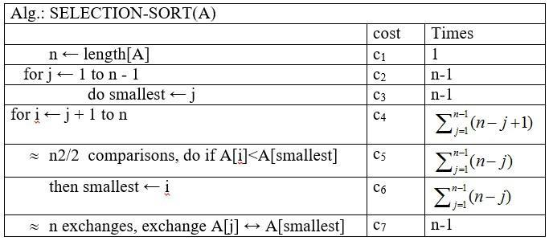

**Implementation:**

#include <stdio.h>

#include <conio.h>

void selection(int arr[], int n)

{

int i, j, small;

for (i = 0; i < n-1; i++) // One by one move boundary of unsorted subarray

{

small = i; //minimum element in unsorted array

for (j = i+1; j < n; j++)

if (arr[j] < arr[small])

small = j;

// Swap the minimum element with the first element

int temp = arr[small];

arr[small] = arr[i];

arr[i] = temp;

}

}

void printArr(int a[], int n) /* function to print the array */

{

int i;

for (i = 0; i < n; i++)

printf("%d ", a[i]);

}

int main()

{

int a[] = { 12, 31, 25, 8, 32, 17 };

int n = sizeof(a) / sizeof(a[0]);

clrscr();

printf("Before sorting array elements are - \n");

printArr(a, n);

selection(a, n);

printf("\nAfter sorting array elements are - \n");

printArr(a, n);

return 0;

}

**Output:**

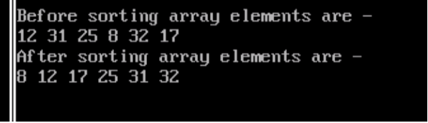

**Conclusion:** The implementation of selection sort demonstrated its effectiveness in sorting elements by repeatedly selecting the minimum element from the unsorted portion and placing it at the beginning. This experiment underscores selection sort's simplicity and efficiency for small datasets, offering insights into its practical application in sorting algorithms.