|  |
| --- |
| Experiment No. 4 |
| Binary Search Algorithm |
| Date of Performance: |
| Date of Submission: |

**Experiment No. 4**

**Title:** Binary Search Algorithm

**Aim:** To study and implement Binary Search Algorithm

**Objective:** To introduce Divide and Conquer based algorithms

**Theory:**

Search a sorted array by repeatedly dividing the search interval in half. Begin with an interval covering the whole array. If the value of the search key is less than the item in the middle of the interval, narrow the interval to the lower half. Otherwise, narrow it to the upper half. Repeatedly check until the value is found or the interval is empty

* Binary search is efficient than linear search. For binary search, the array must be sorted, which is not required in case of linear search.
* It is divide and conquer based search technique.
* In each step the algorithms divides the list into two halves and check if the element to be searched is on upper or lower half the array
* If the element is found, algorithm returns.

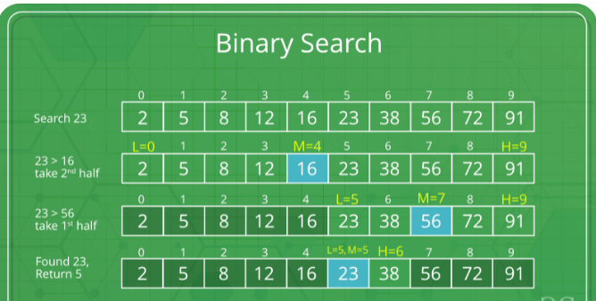

The idea of binary search is to use the information that the array is sorted and reduce the time complexity to O(Log n).

* Compare x with the middle element.
* If x matches with the middle element, we return the mid index.
* Else If x is greater than the mid element, then x can only lie in the right half subarray after the mid element. So we recur for the right half.
* Else (x is smaller) recur for the left half.
* Binary Search reduces search space by half in every iterations. In a linear search, search space was reduced by one only.
* n=elements in the array
* Binary Search would hit the bottom very quickly.

|  |  |  |
| --- | --- | --- |
|  | **Linear Search** | **Binary Search** |
| 2nd iteration | n-1 | n/2 |
| 3rd iteration | n-2 | n/4 |

**Example:**

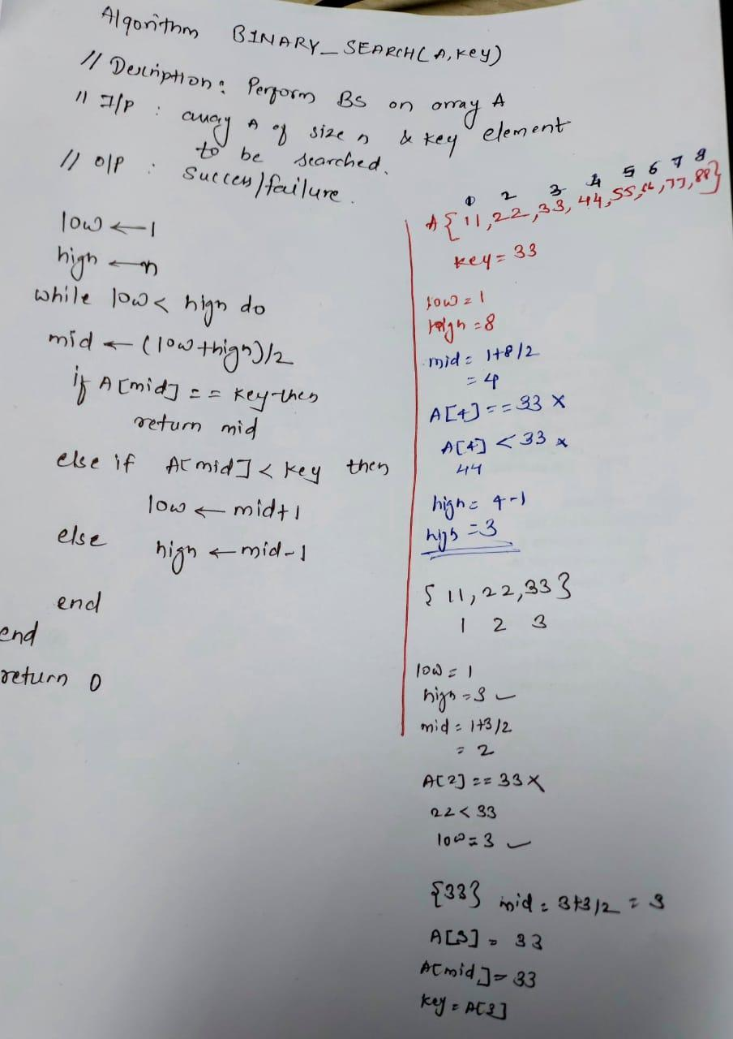

**Algorithm and Complexity:**

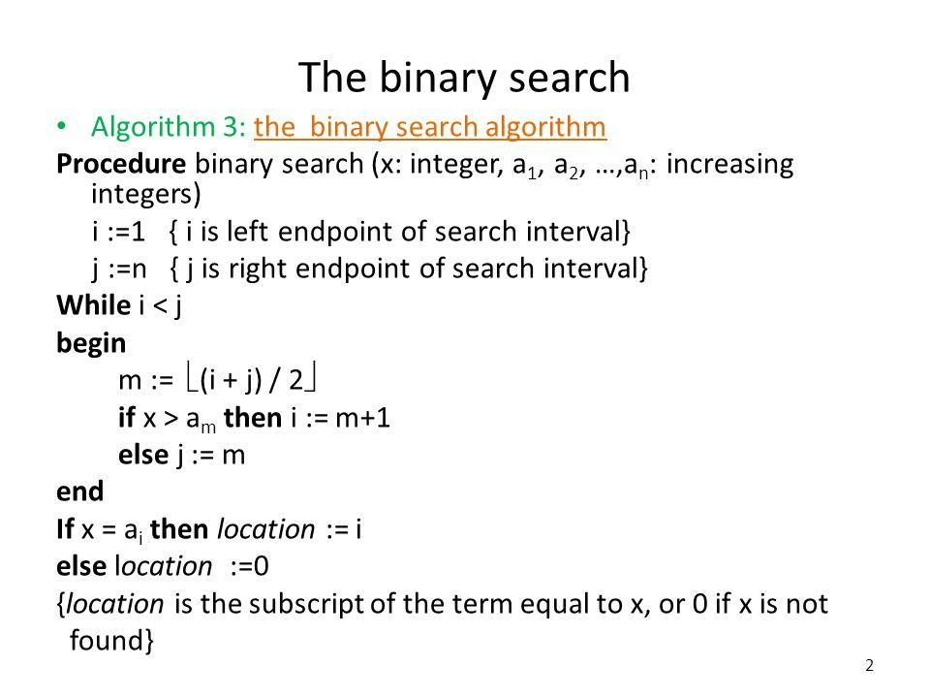

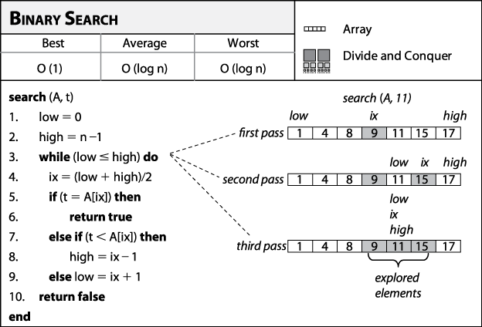

**Best Case:**

Key is first compared with the middle element of the array.

The key is in the middle position of the array, the algorithm does only one comparison, irrespective of the size of the array.

T(n)=1

**Worst Case:**

In each iteration search space of BS is reduced by half, Maximum log n(base 2) array divisions are possible.

Recurrence relation is

T(n)=T(n/2) +1

Running Time is O(logn).

**Average Case:**

Key element neither is in the middle nor at the leaf level of the search tree.

It does half of the log n(base 2).

Base case=O(1)

Average and worst case=O(logn)

**Implementation:**

#include <stdlib.h>

#include <conio.h>

#include <stdio.h>

int main(){

int key, low, high, mid, n, i, A[100];

clrscr();

printf("Enter the size of array ;");

scanf("%d",&n);

printf("\nEnter the array elements : \n");

for(i=0;i<n;i++){

scanf("%d",&A[i]);

}

printf("\nEnter the key : ");

scanf("%d",&key);

low=1;

high=n;

while(low<=high){

mid=(low+high)/2;

if(A[mid]==key){

printf("\nKey found at: %d ",mid);

break;

}

else if(A[mid]<key){

low=mid+1;

}

else{

high=mid-1;

}

}

return 0;

}

**Output:**

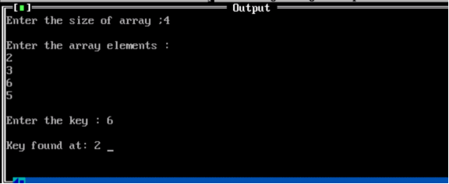

**Conclusion:** the experimental deployment of binary search has validated its prowess in swiftly locating target elements within sorted arrays. Leveraging its logarithmic time complexity, binary search stands as a formidable algorithm, offering optimal performance and scalability in diverse computational contexts. This empirical confirmation underscores its indispensable role in efficient data retrieval and underscores its status as a cornerstone technique in algorithmic design and analysis.