|  |
| --- |
| Experiment No. 6 |
| Prim’s Algorithm |
| Date of Performance: |
| Date of Submission: |

**Title:** Prim’s Algorithm.

**Aim:** To study and implement Prim’s Minimum Cost Spanning Tree Algorithm.

**Objective:** To introduce Greedy based algorithms

**Theory:**

Prim's algorithm is a greedy algorithm that finds a minimum spanning tree for a weighted undirected graph. This means it finds a subset of the edges that forms a tree that includes every vertex, where the total weight of all the edges in the tree is minimized. The algorithm operates by building this tree one vertex at a time, from an arbitrary starting vertex, at each step adding the cheapest possible connection from the tree to another vertex.

**Example:**

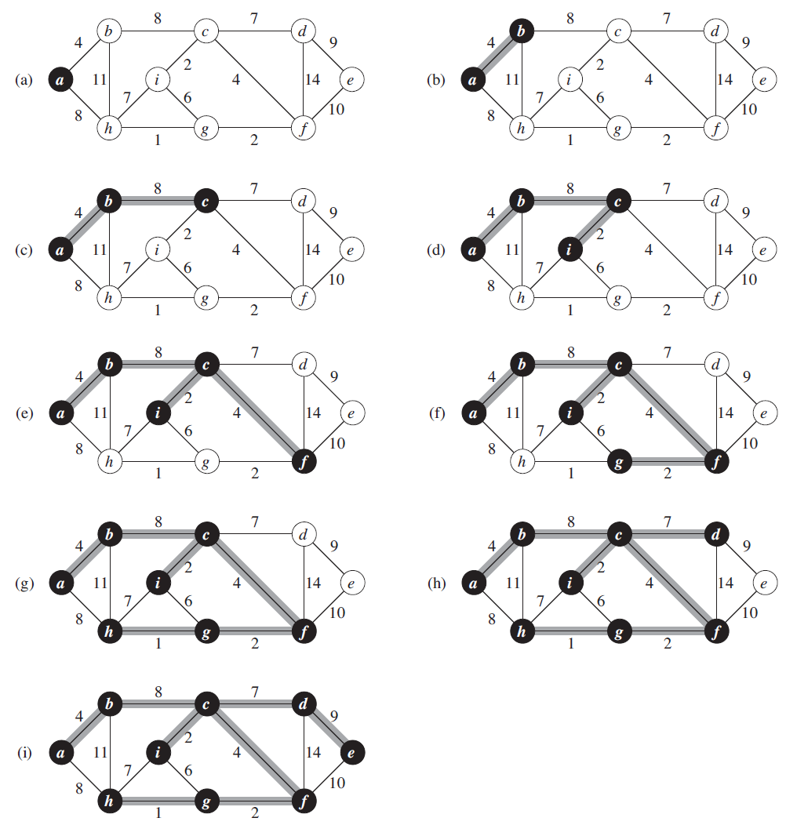

**Algorithm and Complexity:**

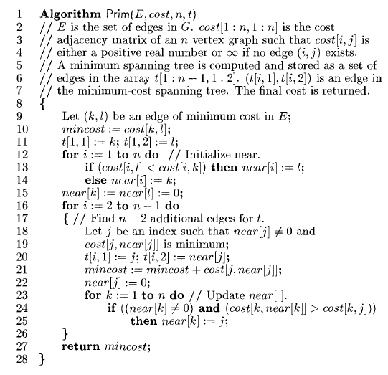

Time Complexity is O( n2 ), Where, n = number of vertices **Theory:**

**Implemenation:**

#include<stdio.h>

#include<conio.h>

int a,b,u,v,n,i,j,ne=1;

int visited[10]={0},min,mincost=0,cost[10][10];

void main()

{

clrscr();

printf("Enter the number of nodes:");

scanf("%d",&n);

printf("Enter the adjacency matrix:\n");

for(i=1;i<=n;i++)

for(j=1;j<=n;j++)

{

scanf("\t%d",&cost[i][j]);

if(cost[i][j]==0)

cost[i][j]=999;

}

visited[1]=1;

while(ne < n)

{

for(i=1,min=999;i<=n;i++)

for(j=1;j<=n;j++)

if(cost[i][j]< min)

if(visited[i]!=0)

{

min=cost[i][j];

a=u=i;

b=v=j;

}

if(visited[u]==0 || visited[v]==0)

{

printf("\nEdge %d:(%d %d) cost:%d",ne++,a,b,min);

mincost+=min;

visited[b]=1;

}

cost[a][b]=cost[b][a]=999;

}

printf("\n Minimun cost=%d",mincost);

getch();

}#include<stdio.h>

#include<conio.h>

int a,b,u,v,n,i,j,ne=1;

int visited[10]={0},min,mincost=0,cost[10][10];

void main()

{

clrscr();

printf("Enter the number of nodes:");

scanf("%d",&n);

printf("Enter the adjacency matrix:\n");

for(i=1;i<=n;i++)

for(j=1;j<=n;j++)

{

scanf("\t%d",&cost[i][j]);

if(cost[i][j]==0)

cost[i][j]=999;

}

visited[1]=1;

while(ne < n)

{

for(i=1,min=999;i<=n;i++)

for(j=1;j<=n;j++)

if(cost[i][j]< min)

if(visited[i]!=0)

{

min=cost[i][j];

a=u=i;

b=v=j;

}

if(visited[u]==0 || visited[v]==0)

{

printf("\nEdge %d:(%d %d) cost:%d",ne++,a,b,min);

mincost+=min;

visited[b]=1;

}

cost[a][b]=cost[b][a]=999;

}

printf("\n Minimun cost=%d",mincost);

getch();

}

**Output:**

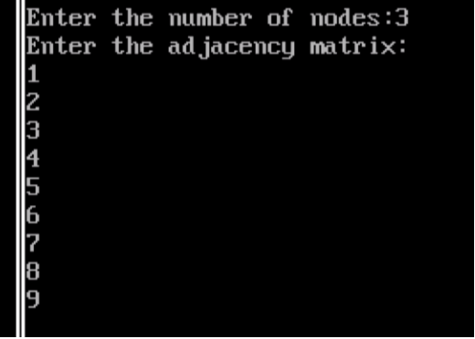

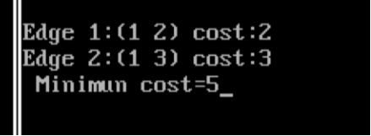

**Conclusion:** Implementing Prim's algorithm has proven to be effective in generating minimum spanning trees, efficiently connecting all nodes in a graph while minimizing total edge weight. This experiment underscores the algorithm's practical applicability in optimizing network connectivity, demonstrating its importance in various real-world scenarios.

Top of Form