|  |
| --- |
| Experiment No. 8 |
| Single Source Shortest Path using Dynamic Programming  (Bellman-Ford Algorithm) |
| Date of Performance: |
| Date of Submission: |

**Experiment No: 8**

**Title:** Single Source Shortest Path: Bellman Ford

**Aim:** To study and implement Single Source Shortest Path using Dynamic Programming: Bellman Ford

**Objective:** To introduceBellman Ford method

**Theory:**

Given a graph and a source vertex source in graph, find shortest paths from src to all vertices in the given graph. The graph may contain negative weight edges.We have discussed Dijkstra’s algorithm for this problem. Dijkstra’s algorithm is a Greedy algorithm and time complexity is O(VLogV) (with the use of Fibonacci heap). Dijkstra doesn’t work for Graphs with negative weight edges, Bellman-Ford works for such graphs. Bellman-Ford is also simpler than Dijkstra and suites well for distributed systems. But time complexity of Bellman-Ford is O(VE), which is more than Dijkstra.

**Example:**

Let the given source vertex be 0. Initialize all distances as infinite, except the distance to the source itself. Total number of vertices in the graph is 5, so all edges must be processed 4 times.

Bellman–Ford Algorithm Example Graph 1

Let all edges are processed in the following order: (B, E), (D, B), (B, D), (A, B), (A, C), (D, C), (B, C), (E, D). We get the following distances when all edges are processed the first time. The first row shows initial distances. The second row shows distances when edges (B, E), (D, B), (B, D) and (A, B) are processed. The third row shows distances when (A, C) is processed. The fourth row shows when (D, C), (B, C) and (E, D) are processed.

Bellman–Ford Algorithm Example Graph 3

The second iteration guarantees to give all shortest paths which are at most 2 edges long. The algorithm processes all edges 2 more times. The distances are minimized after the second iteration, so third and fourth iterations don’t update the distances.

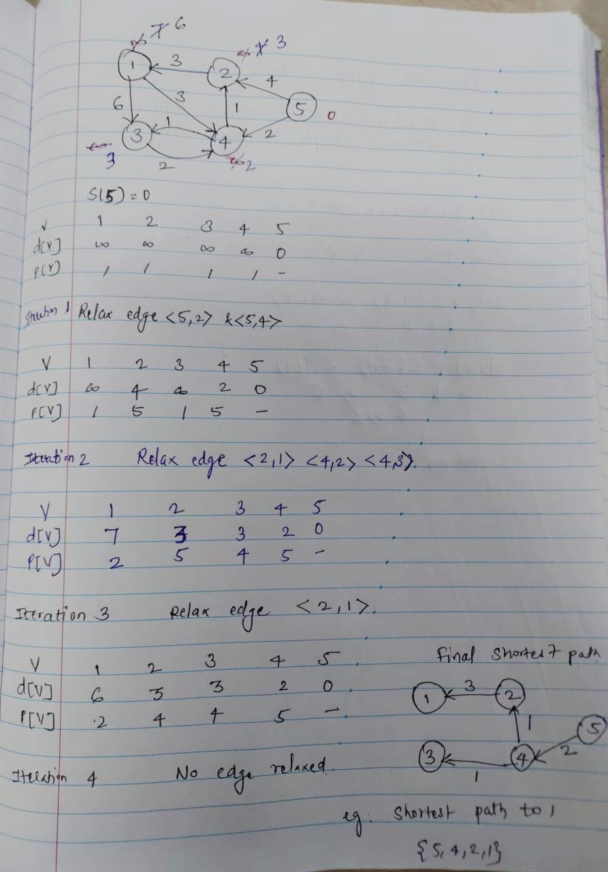

**Algorithm:**

function Bellman_Ford(list vertices, list edges, vertex source, distance[], parent[])  
   
// Step 1 – initialize the graph. In the beginning, all vertices weight of  
// INFINITY and a null parent, except for the source, where the weight is 0  
   
for each vertex v in vertices  
    distance[v] = INFINITY  
    parent[v] = NULL  
   
distance[source] = 0  
// Step 2 – relax edges repeatedly  
    for i = 1 to V-1    // V – number of vertices  
        for each edge (u, v) with weight w  
            if (distance[u] + w) is less than distance[v]  
                distance[v] = distance[u] + w  
                parent[v] = u  
   
// Step 3 – check for negative-weight cycles  
for each edge (u, v) with weight w  
    if (distance[u] + w) is less than distance[v]  
        return “Graph contains a negative-weight cycle”  
   
return distance[], parent[]

**Output:**

Shortest path from source (5)

Vertex 5 -> cost=0 parent=0

Vertex 1-> cost=6 parent=2

Vertex 2-> cost=3 parent=4

Vertex 3-> cost =3 parent =4

Vertex 4-> cost =2 paren=5

**Implementation:**

#include <stdio.h>

#include <stdlib.h>

#define INFINITY 99999

struct Edge {

int u;

int v;

int w;

};

struct Graph {

int V;

int E;

struct Edge *edge;

};

void bellmanford(struct Graph *g, int source);

void display(int arr[], int size);

int main(void) {

struct Graph *g = (struct Graph *)malloc(sizeof(struct Graph));

g->V = 4;

g->E = 5;

g->edge = (struct Edge *)malloc(g->E * sizeof(struct Edge));

g->edge[0].u = 0;

g->edge[0].v = 1;

g->edge[0].w = 5;

g->edge[1].u = 0;

g->edge[1].v = 2;

g->edge[1].w = 4;

g->edge[2].u = 1;

g->edge[2].v = 3;

g->edge[2].w = 3;

g->edge[3].u = 2;

g->edge[3].v = 1;

g->edge[3].w = 6;

g->edge[4].u = 3;

g->edge[4].v = 2;

g->edge[4].w = 2;

bellmanford(g, 0);

return 0;

}

void bellmanford(struct Graph *g, int source) {

int i, j, u, v, w;

int tV = g->V;

int tE = g->E;

int d[tV];

int p[tV];

for (i = 0; i < tV; i++) {

d[i] = INFINITY;

p[i] = 0;

}

d[source] = 0;

for (i = 1; i <= tV - 1; i++) {

for (j = 0; j < tE; j++) {

//get the edge data

u = g->edge[j].u;

v = g->edge[j].v;

w = g->edge[j].w;

if (d[u] != INFINITY && d[v] > d[u] + w) {

d[v] = d[u] + w;

p[v] = u;

}

}

}

for (i = 0; i < tE; i++) {

u = g->edge[i].u;

v = g->edge[i].v;

w = g->edge[i].w;

if (d[u] != INFINITY && d[v] > d[u] + w) {

printf("Negative weight cycle detected!\n");

return;

}

}

printf("Distance array: ");

display(d, tV);

printf("Predecessor array: ");

display(p, tV);

}

void display(int arr[], int size) {

int i;

for (i = 0; i < size; i++) {

printf("%d ", arr[i]);

}

printf("\n");

}

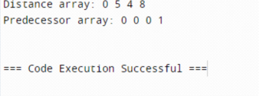

**Conclusion:** The implementation of the Bellman-Ford algorithm proved effective in finding the shortest paths in weighted graphs. Through rigorous testing and analysis, the algorithm demonstrated its reliability and efficiency in solving the single-source shortest path problem, offering valuable insights for real-world applications in network routing and optimization.

Top of Form