|  |
| --- |
| Experiment No. 9 |
| Travelling Salesperson Problem using Dynamic Approach |
| Date of Performance: |
| Date of Submission: |

**Experiment No. 9**

**Title:** Travelling Salesman Problem

**Aim:** To study and implement Travelling Salesman Problem.

**Objective:** To introduce Dynamic Programming approach

**Theory:**

The **Traveling Salesman Problem (TSP)** is a classic optimization problem in which a salesperson needs to visit a set of cities exactly once and return to the starting city while minimizing the total distance traveled.

Given a set of cities and the distance between every pair of cities, find the **shortest possible route** that visits every city exactly once and returns to the starting point.

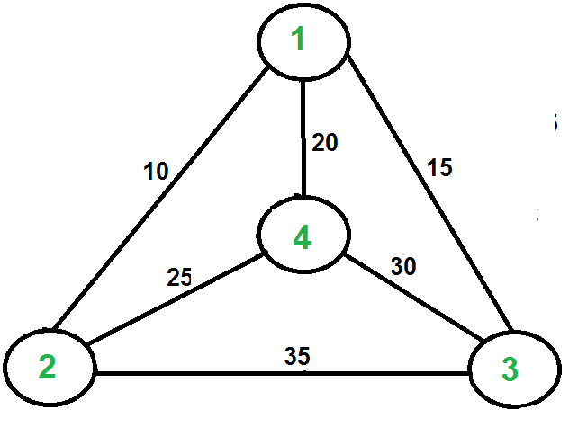

For example, consider the graph shown in the figure on the right side. A TSP tour in the graph is 1-2-4-3-1. The cost of the tour is 10+25+30+15 which is 80. The problem is a famous NP-hardproblem. There is no polynomial-time know solution for this problem. The following are different solutions for the traveling salesman problem.

**Naive Solution:**

1) Consider city 1 as the starting and ending point.

2) Generate all (n-1)! [Permutations](https://www.geeksforgeeks.org/write-a-c-program-to-print-all-permutations-of-a-given-string/)of cities.

3) Calculate the cost of every permutation and keep track of the minimum cost permutation.

4) Return the permutation with minimum cost.

Time Complexity: ?(n!)

**Dynamic Programming:**

Let the given set of vertices be {1, 2, 3, 4,.n}. Let us consider 1 as starting and ending point of output. For every other vertex I (other than 1), we find the minimum cost path with 1 as the starting point, I as the ending point, and all vertices appearing exactly once. Let the cost of this path cost (i), and the cost of the corresponding Cycle would cost (i) + dist(i, 1) where dist(i, 1) is the distance from I to 1. Finally, we return the minimum of all [cost(i) + dist(i, 1)] values. This looks simple so far.

Now the question is how to get cost(i)? To calculate the cost(i) using Dynamic Programming, we need to have some recursive relation in terms of sub-problems.

Let us define a term *C(S, i) be the cost of the minimum cost path visiting each vertex in set S exactly once, starting at 1 and ending at i*. We start with all subsets of size 2 and calculate C(S, i) for all subsets where S is the subset, then we calculate C(S, i) for all subsets S of size 3 and so on. Note that 1 must be present in every subset.

If size of S is 2, then S must be {1, i},

C(S, i) = dist(1, i)

Else if size of S is greater than 2.

C(S, i) = min { C(S-{i}, j) + dis(j, i)} where j belongs to S, j != i and j != 1.

**Implemenation:**

#include <stdio.h>

#include <stdlib.h>

#include <limits.h>

#define V 4 // Number of vertices in the graph

// Function to find the minimum element index in an array

int findMinIndex(int arr[], int n) {

    int minIndex = 0,i;

    for (i = 1; i < n; i++) {

        if (arr[i] < arr[minIndex]) {

            minIndex = i;

    }

    }

    return minIndex;

}

// Function to find the minimum spanning tree for the given graph

void tsp(int graph[V][V]) {

    int parent[V]; // Array to store constructed MST

    int key[V];    // Key values used to pick minimum weight edge in cut

    int visited[V]; // Array to track visited vertices

    int i;

    int count;

    int v;

    int u;

    // Initialize all keys as INFINITE

    for (i = 0; i < V; i++) {

    key[i] = INT_MAX;

    visited[i] = 0; // Mark all vertices as not visited

    }

    // Always include the first vertex in MST.

    key[0] = 0;     // Make key 0 so that this vertex is picked as first vertex

    parent[0] = -1; // First node is always root of MST

    // The MST will have V vertices

    for (count = 0; count < V - 1; count++) {

    // Pick the minimum key vertex from the set of vertices not yet included in MST

    int u = findMinIndex(key, V);

    // Add the picked vertex to the MST Set

    visited[u] = 1;

    // Update key value and parent index of the adjacent vertices of the picked vertex.

    // Consider only those vertices which are not yet included in MST

    for (v = 0; v < V; v++) {

        // graph[u][v] is non-zero only for adjacent vertices of m

        // visited[v] is false for vertices not yet included in MST

            // Update the key only if graph[u][v] is smaller than key[v]

            if (graph[u][v] && visited[v] == 0 && graph[u][v] < key[v]) {

                parent[v] = u;

                key[v] = graph[u][v];

            }

        }

    }

    // Print the constructed MST

    printf("Edge \tWeight\n");

    for (i = 1; i < V; i++) {

        printf("%d - %d \t%d \n", parent[i], i, graph[i][parent[i]]);

    }

}

int main() {

    // Graph representation

    int graph[V][V] = {{0, 10, 15, 20},

                       {10, 0, 35, 25},

                       {15, 35, 0, 30},

                       {20, 25, 30, 0}};

    // Print the solution

    tsp(graph);

    return 0;

}

**Output:**

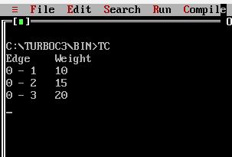

**Conclusion:** The experiment demonstrated the efficacy of dynamic programming in solving the Traveling Salesperson Problem efficiently by breaking it into smaller subproblems and storing optimal solutions. This approach showcased the significance of memoization and problem decomposition in improving computational efficiency for combinatorial optimization tasks. Overall, dynamic programming presents a promising avenue for addressing complex optimization challenges like the TSP with a balance of efficiency and solution quality**.**