EXP-1

Github link:-

https://github.com/GautamDC09/SE_04_OS/blob/main/exp%201.pdf

Output:-

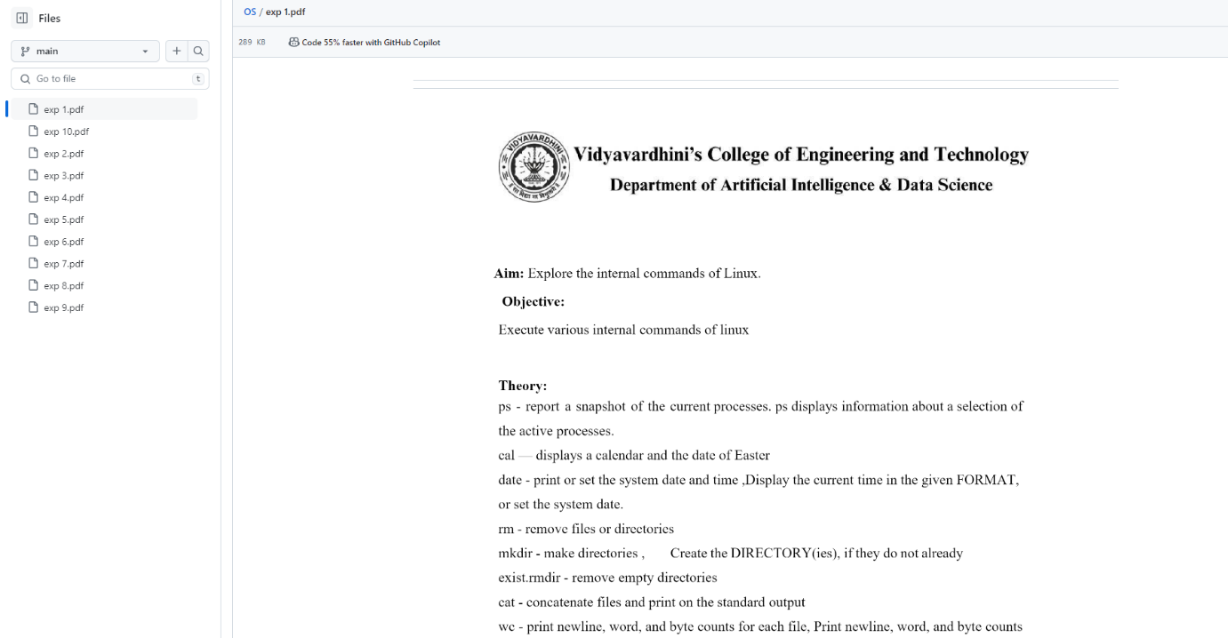

EXP-2

Github link:-

https://github.com/GautamDC09/SE_04_OS/blob/main/exp%202.pdf

Output:-

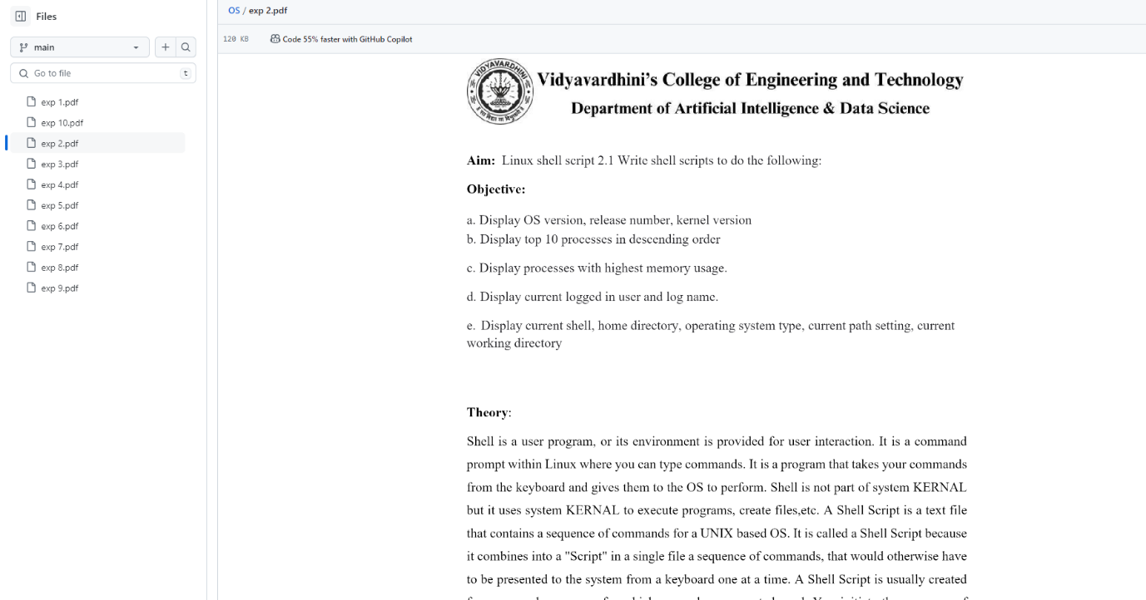

EXP-3

Github link:-

https://github.com/GautamDC09/SE_04_OS/blob/main/exp%203.pdf

Output:-

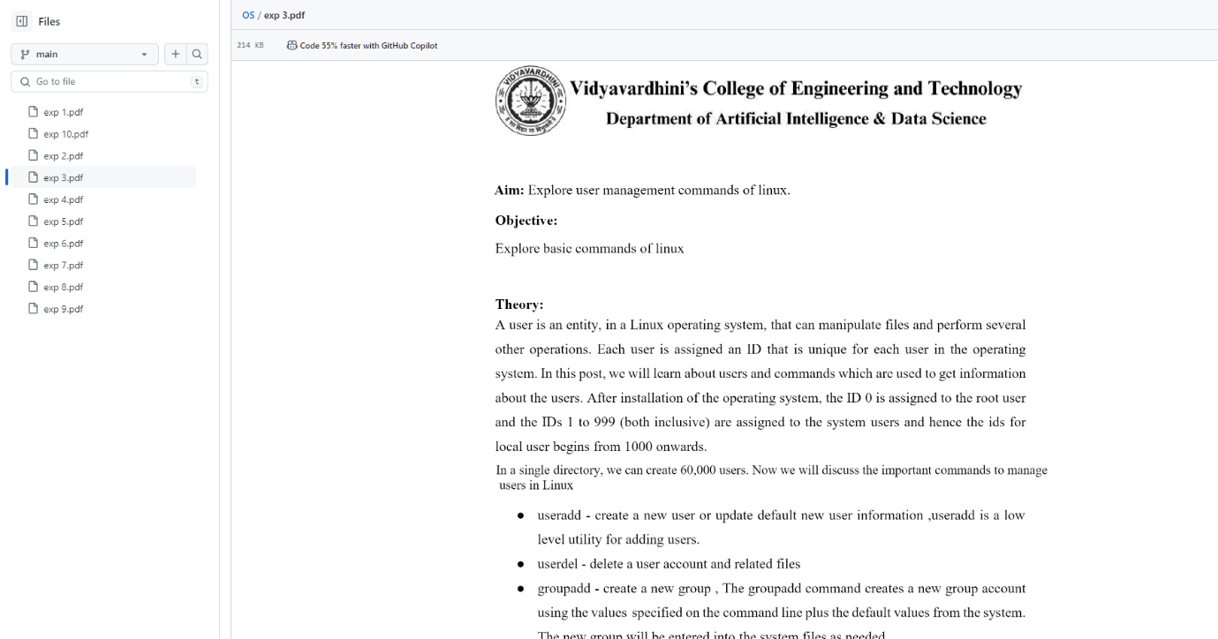

EXP-4

Github link:-

https://github.com/GautamDC09/SE_04_OS/blob/main/exp%204.pdf

Output:-

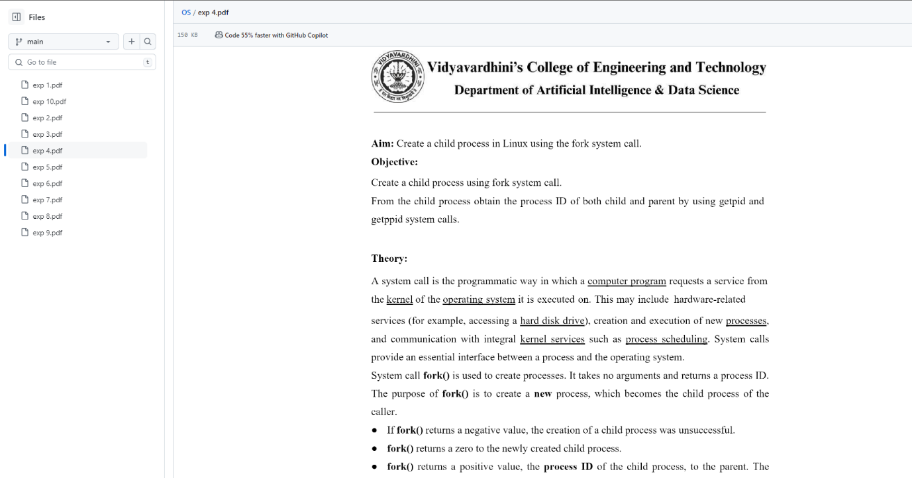

EXP-5

Github link:-

https://github.com/GautamDC09/SE_04_OS/blob/main/exp%205.pdf

Output:-

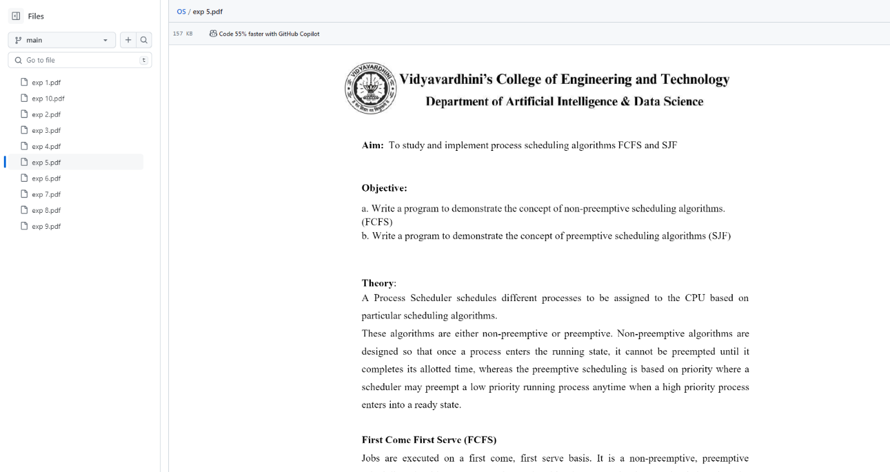

EXP-6

Github link:-

https://github.com/GautamDC09/SE_04_OS/blob/main/exp%206.pdf

Output:-

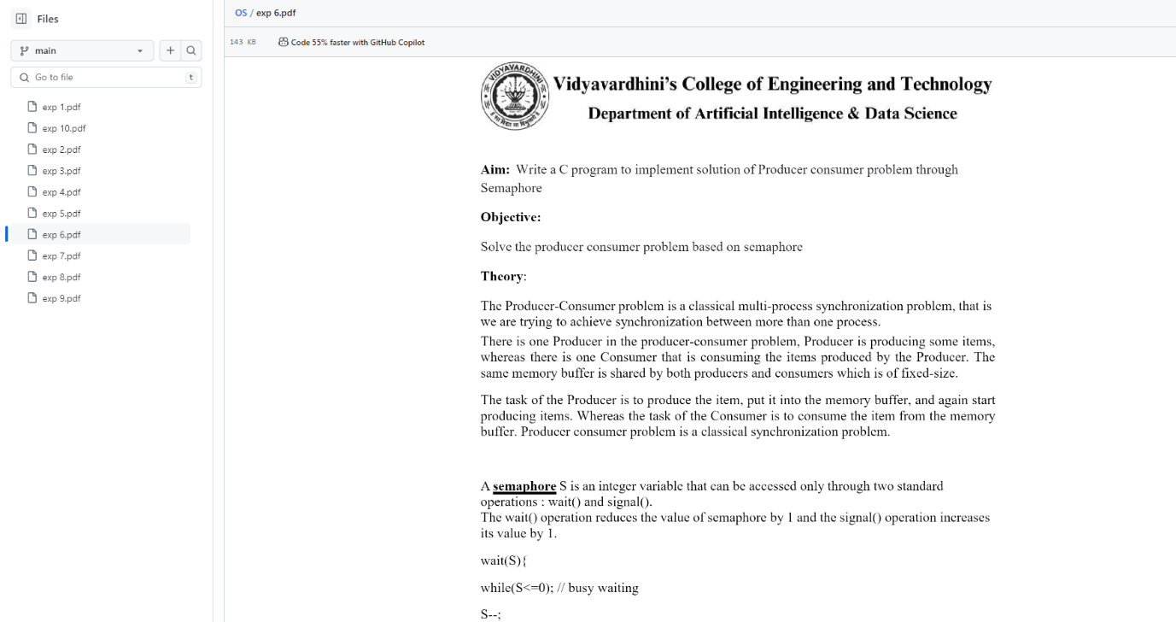

EXP-7

Github link:-

https://github.com/GautamDC09/SE_04_OS/blob/main/exp%207.pdf

Output:-

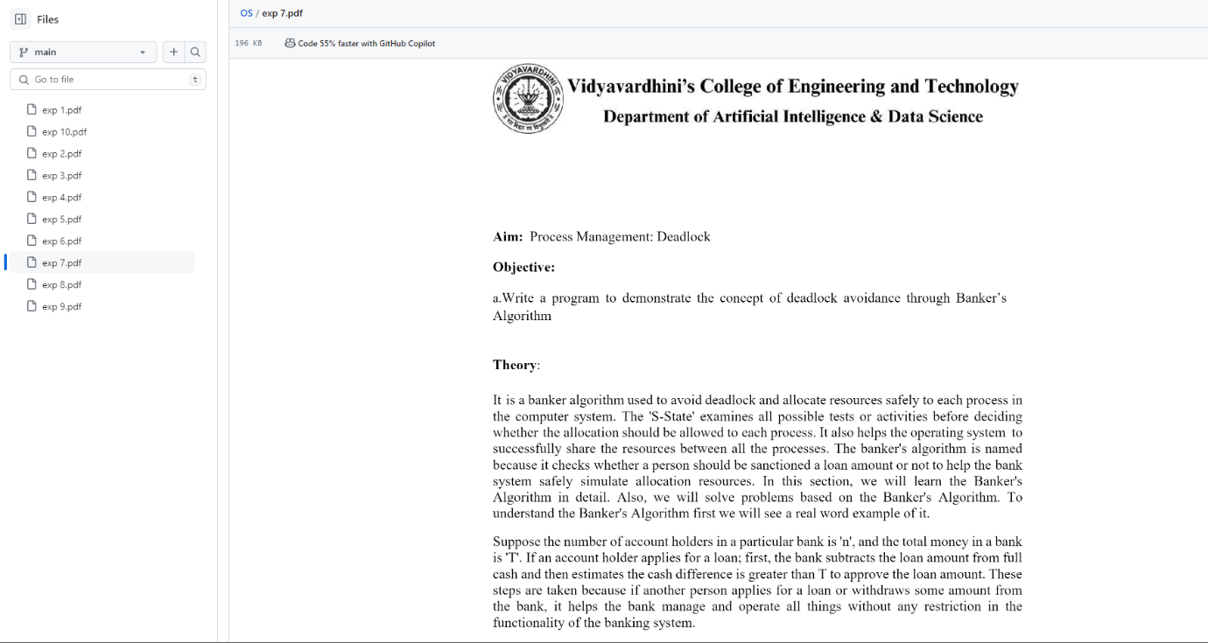

EXP-8

Github link:-

https://github.com/GautamDC09/SE_04_OS/blob/main/exp%208.pdf

Output:-

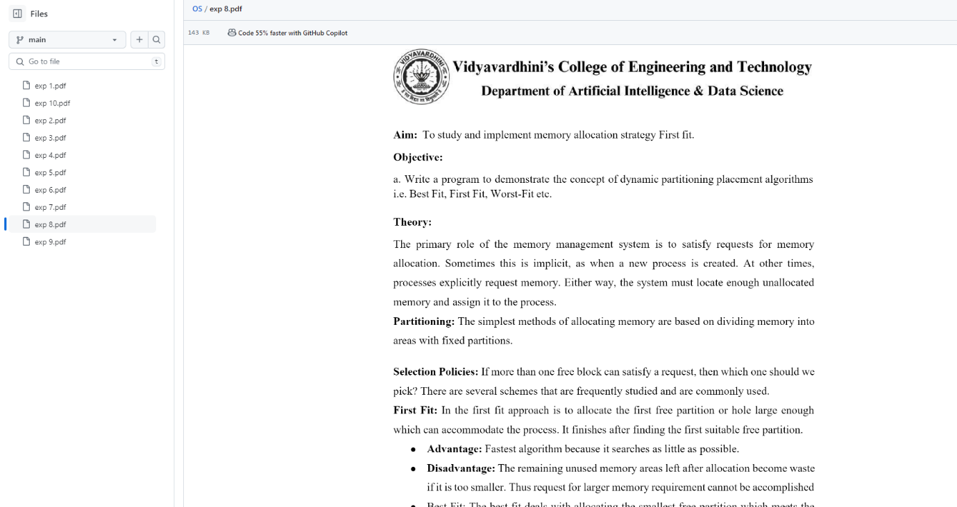

EXP-9

Github link:-

https://github.com/GautamDC09/SE_04_OS/blob/main/exp%209.pdf

Output:-

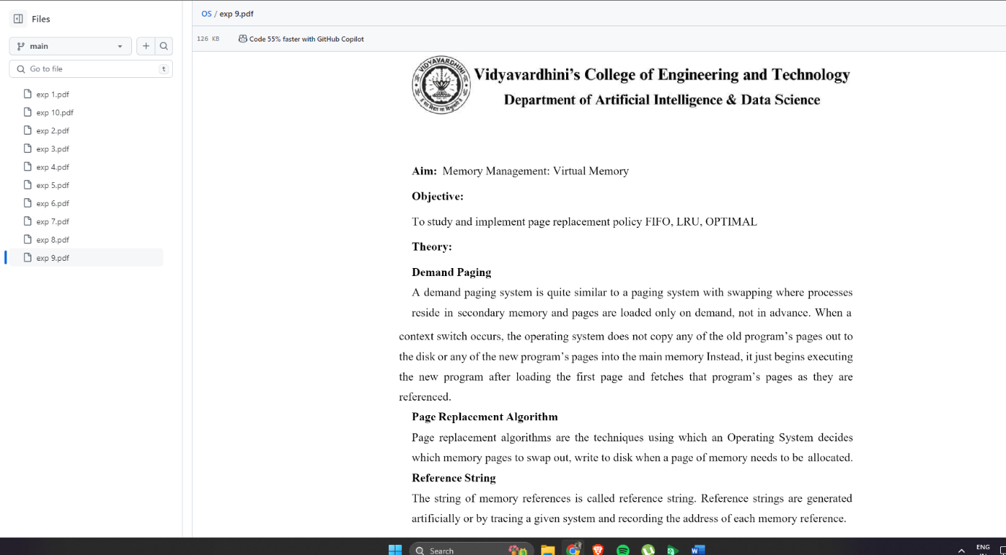

EXP-10

Github link:-

https://github.com/GautamDC09/SE_04_OS/blob/main/exp%2010.pdf

Output:-

