## Gujarat Technological University Government Engineering College, Sector-28, Gandhinagar Gandhinagar-382028

**A Report on**

**“FACE RECOGNITION” Subject**

**PYTHON PROGRAMMING**

**BY**

|  |  |
| --- | --- |
| **Name of Student** | **Enrollment No.** |
| **HANI DHOLAKIYA** | **170130107024** |
| **CHARMI KANSARA** | **180133107039** |
| **PARITA LEUVA** | **180133107044** |
| **JAINIL DARJI** | **180133107005** |
| **NIRAV KARATHIYA** | **180133107012** |

**Under Guidance of Prof. Pinal Patel**

**Head of Department Dr. D A Parikh**

**Department of Computer Engineering**

**GOVERNMENT ENGINEERING COLLEGE GANDHINAGAR**

**CERTIFICATE**

This is to certify that the project report entitled “**FACE RECOGNITION**”is submitted by our team under the guidance of **Prof. PINAL PATEL** impartial SSS fulfillment of the Bachelor of Engineering in Computer Engineering from Gujarat Technological University during the academic year 2020-2021.

#### Prof. Pinal Patel Dr. D A Parikh

**INTRODUCTION**

* Face detection can be thought of as such a problem where we detect human faces in an image.
* Face recognition is a method of identifying or verifying the identity of an individual using their face.
* There are various algorithms that can do face recognition but their accuracy might vary.
* In computer vision, one essential problem we are trying to figure out is to automatically detect objects in an image without human intervention.

**OBJECTIVE**

* Reducing manual work and save time.
* Reduce complex paper work.
* To observe all human activity.

**TOOLS AND TECHNOLOGY**

* **Tools**
  + - VS Code
    - Desktop
* **Technology**
  + - Python with OpenCV

**LIBRARIES**

* Numpy
  + - Provides objects for multi-dimensional arrays
* Cv2
  + - For all sorts of image and video analysis, like facial recognition and detection, license plate reading, photo editing, advanced robotic vision, optical character recognition, and a whole lot more
* faceRecognition
  + Recognize and manipulate faces from Python or from the command line

**BLOCK DIAGRAM**

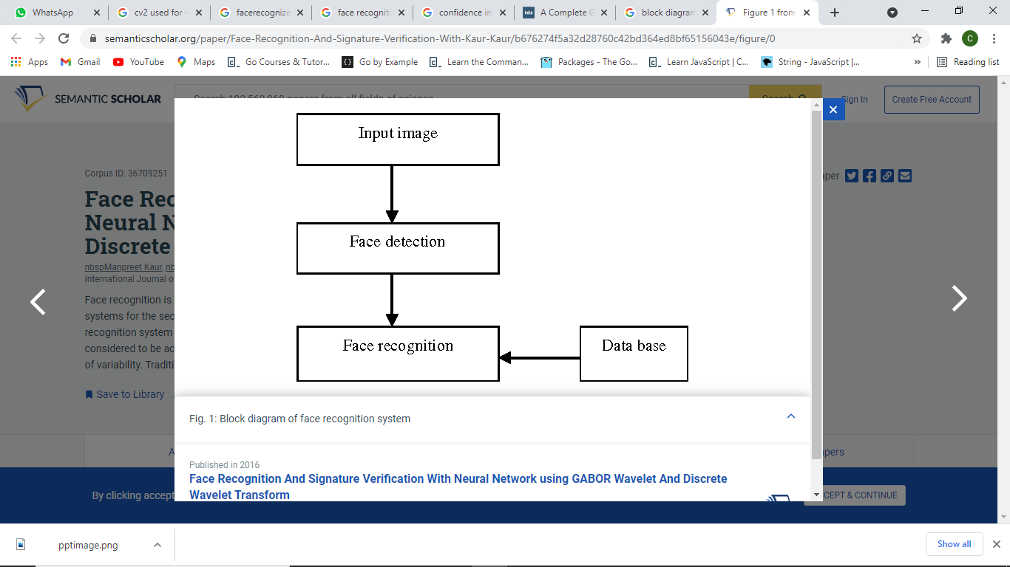

**STEPS FOLLOWED**

* Training the dataset
* Labeling for face recognition
* Calculating confidence:
  + Confidence: The confidence interval is a range of values. In the ideal condition, it should contain the best estimate of a statistical parameter. It is expressed as a percentage

**FACE DETECTION**

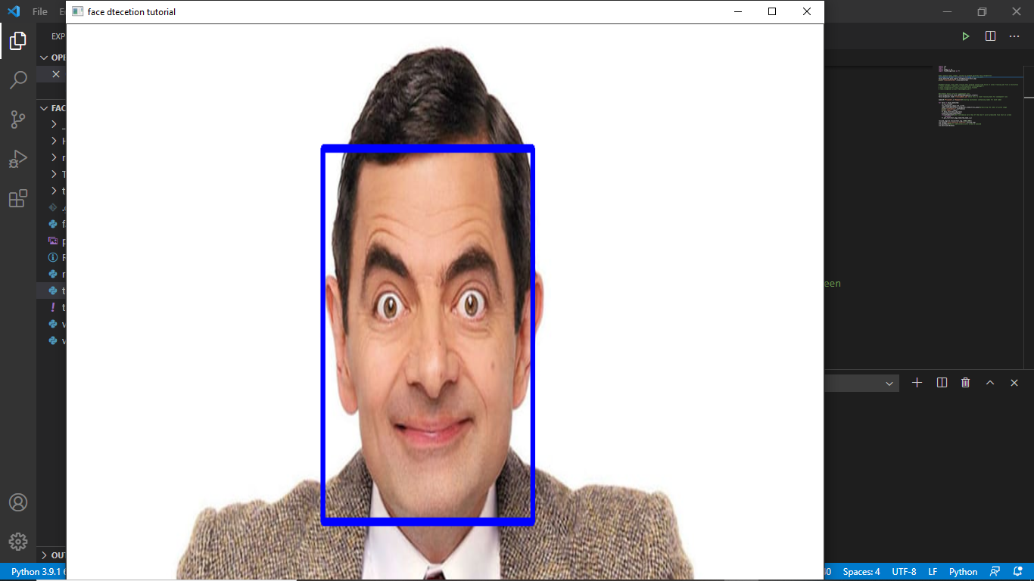

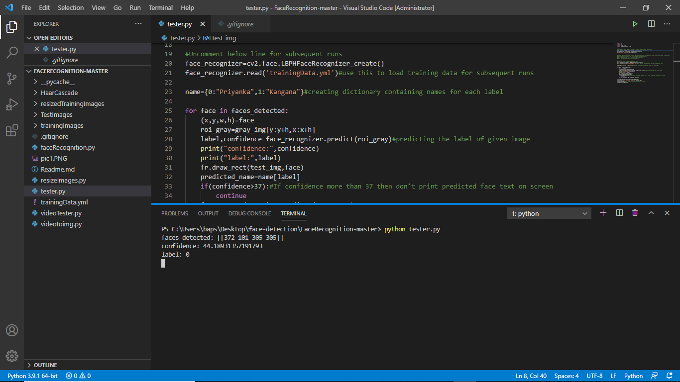

**FACE RECOGNITION**

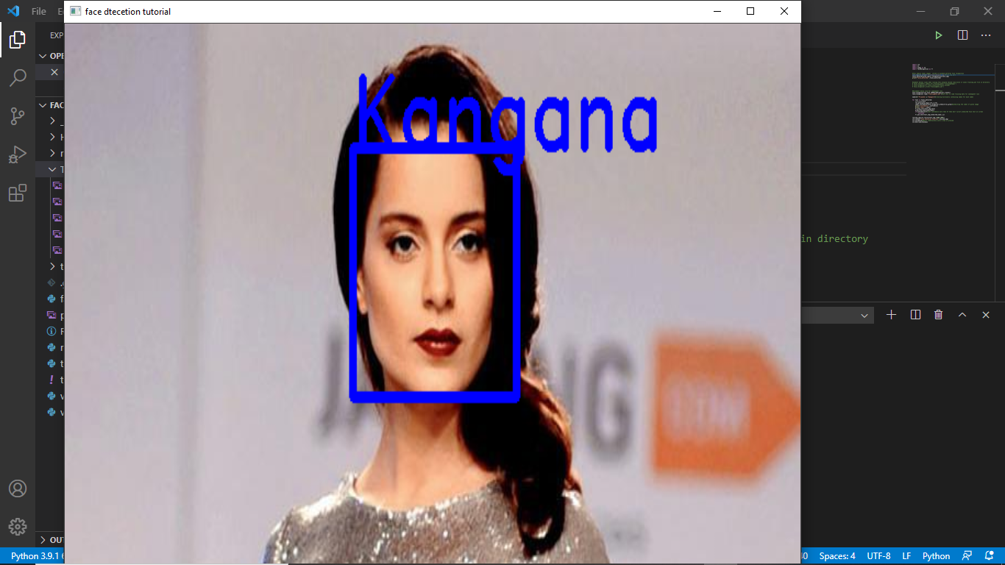

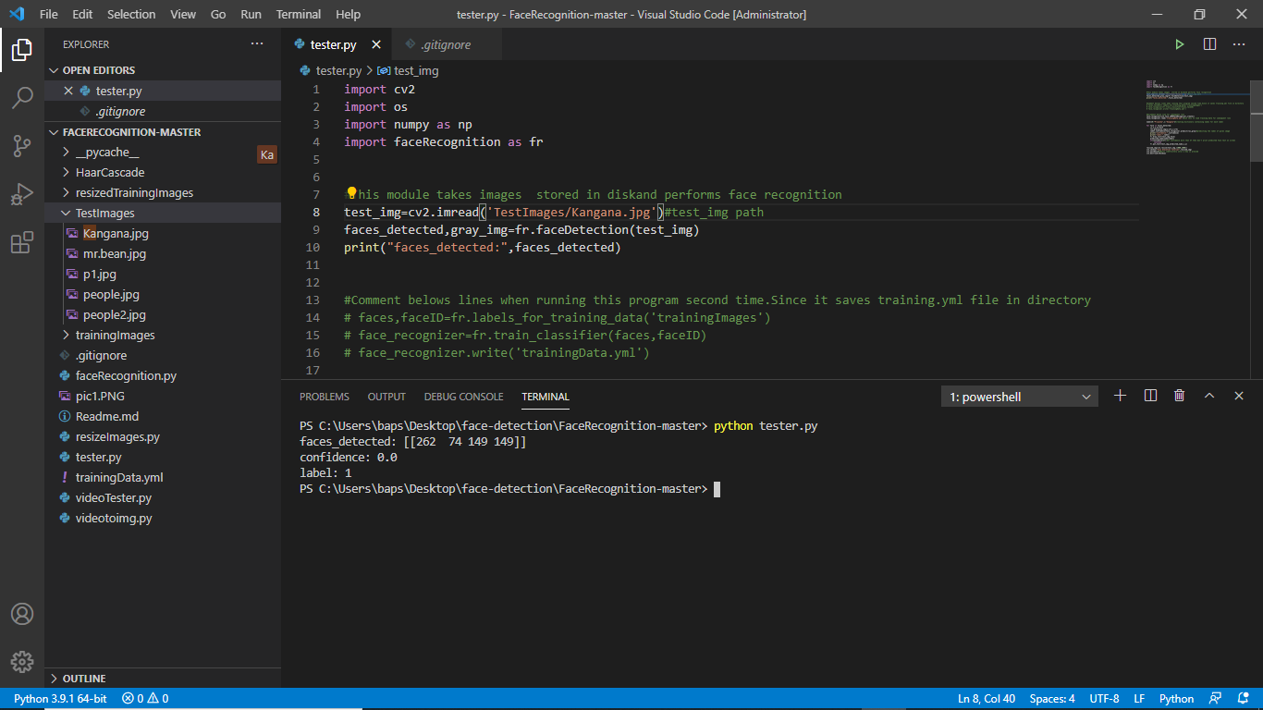

**THANK YOU**