Q: Create a windows Vm machine in AWS and connect with RDP open CMD in windows share the about system info.

OUTPUTS:

Initially launched an instance- AWSTASK1

Used Windows Server 22 base, used existing keypair

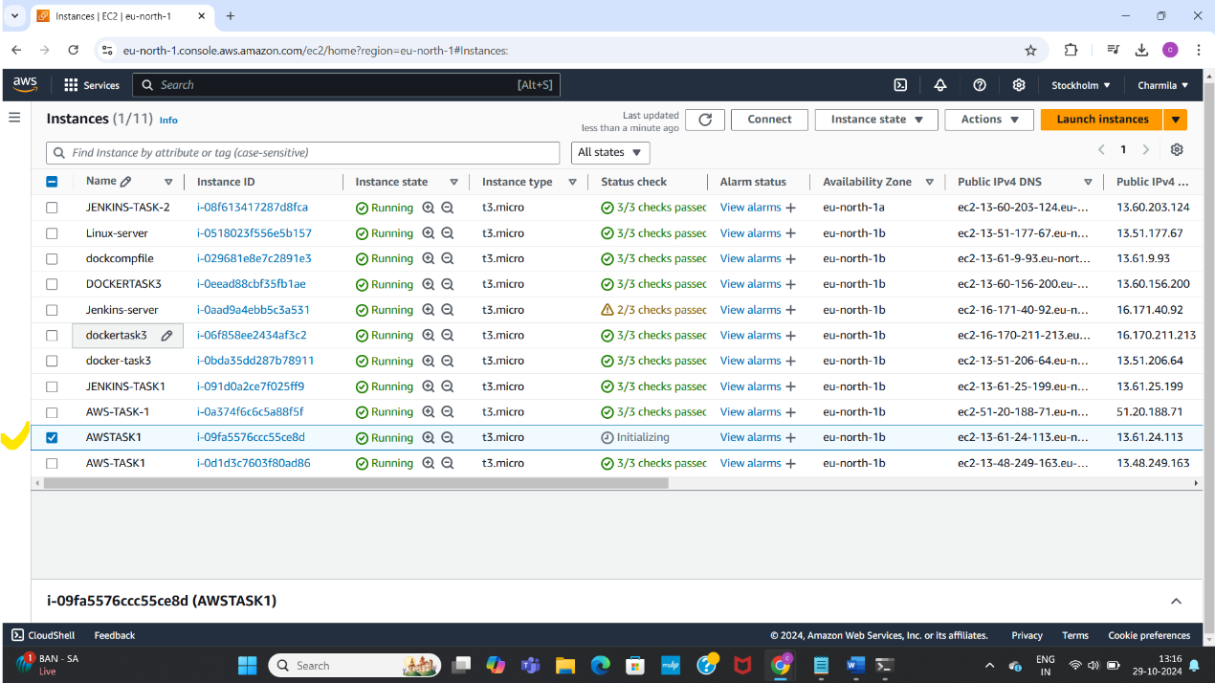

Edited the inbound rules, used RDP for port range 3389

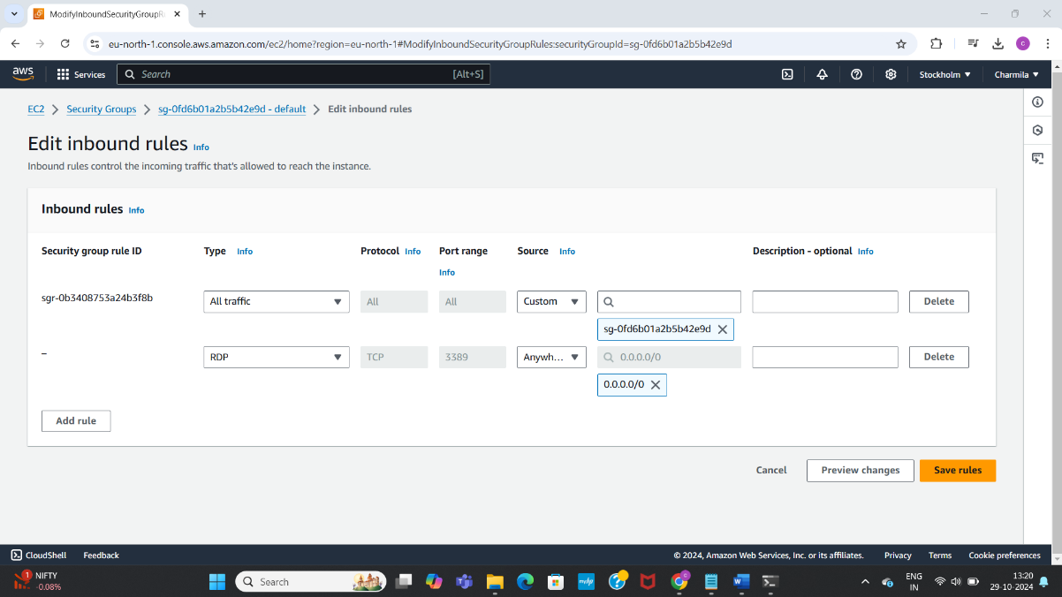

Connected using RDP client

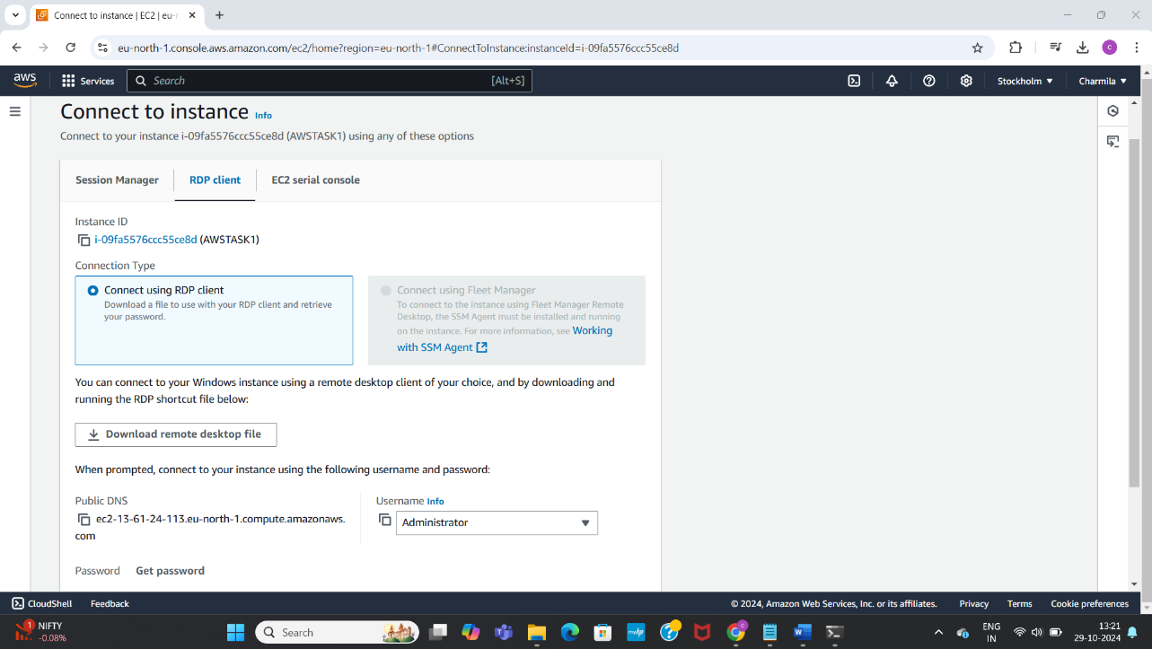

Decrypted the password using .pem file

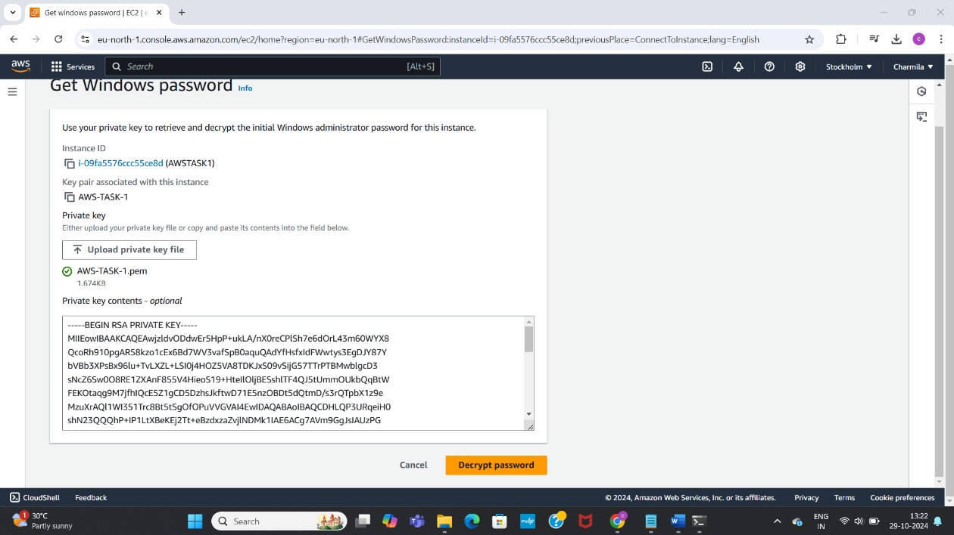

Opened RDP in local machine

Used public IP, user name and decrypted password to switch to it

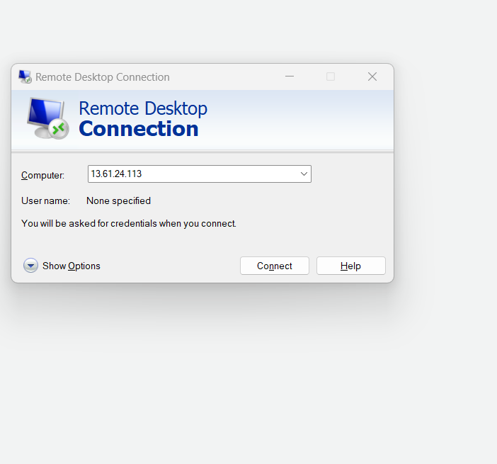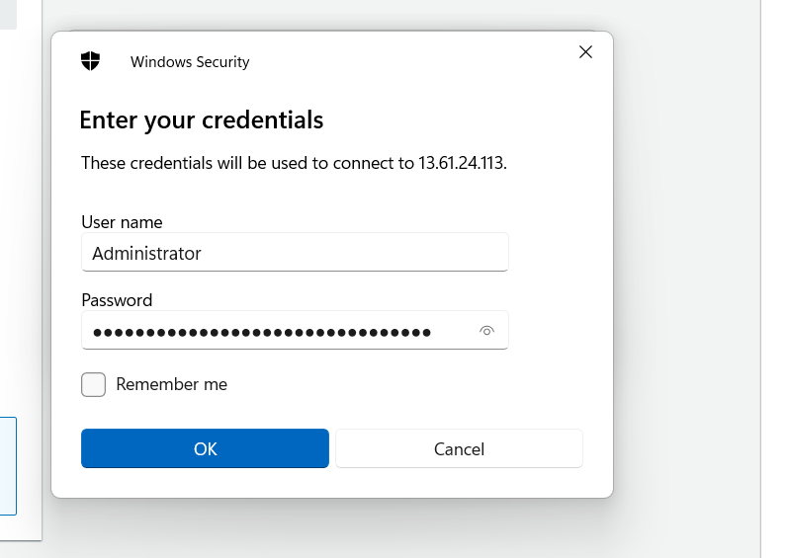

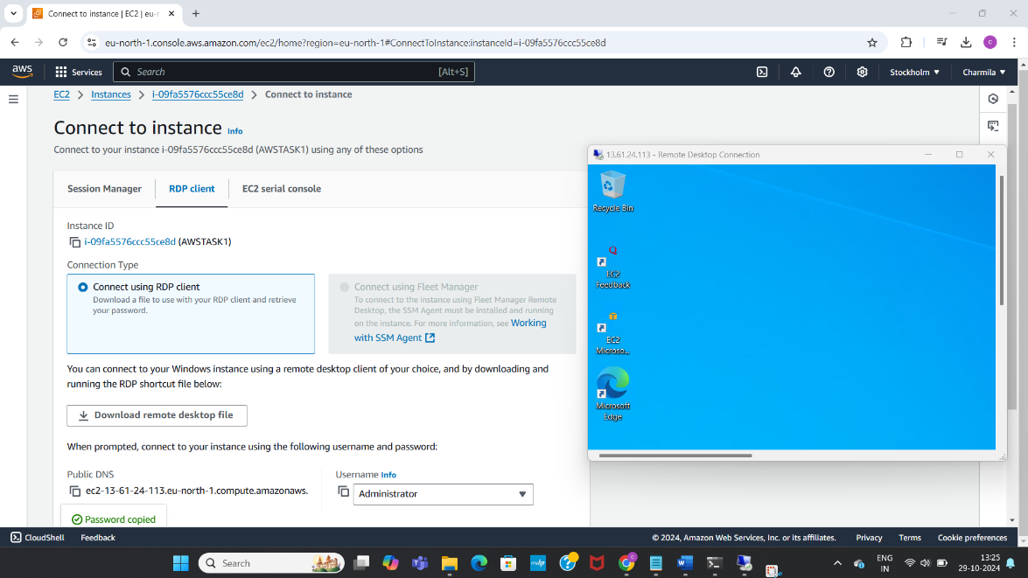

Opened command prompt and viewed the system information

