Q: Set up a VPC with an Internet gateway, create a public subnet with 256 IP addresses, a private subnet with 256 IP addresses, make a route table connecting the Internet gateway and the subnets, and launch a Linux EC2 instance by using the above VPC and public subnet.

OUTPUTS:

Initially created a VPC -MYVPC

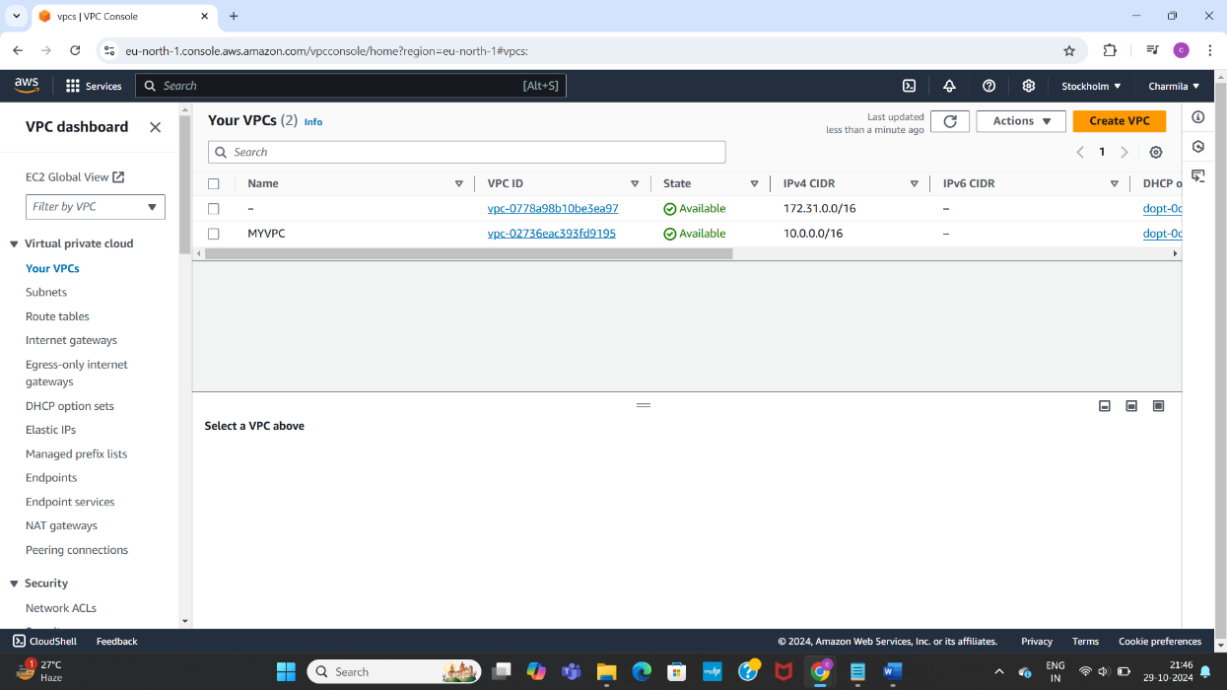

Created internet gateway: AWS-TASK2IG, attached it to MYVPC

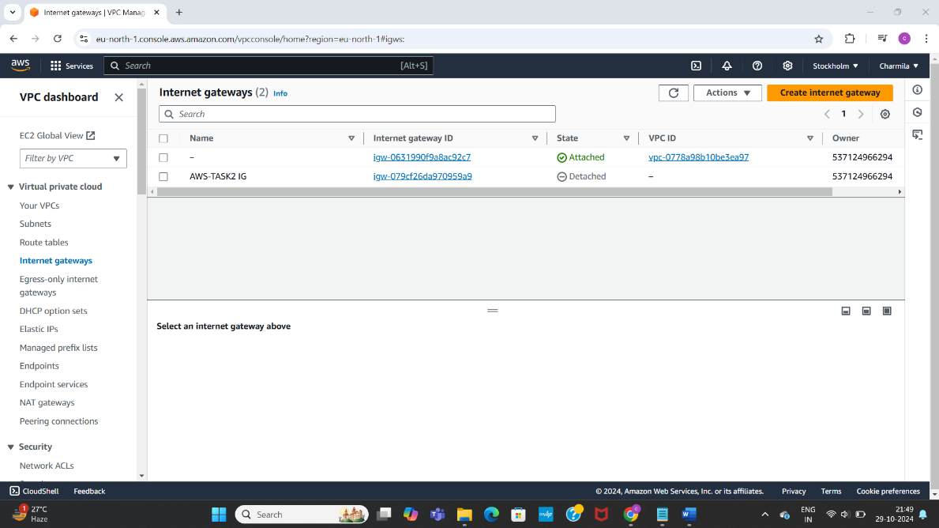

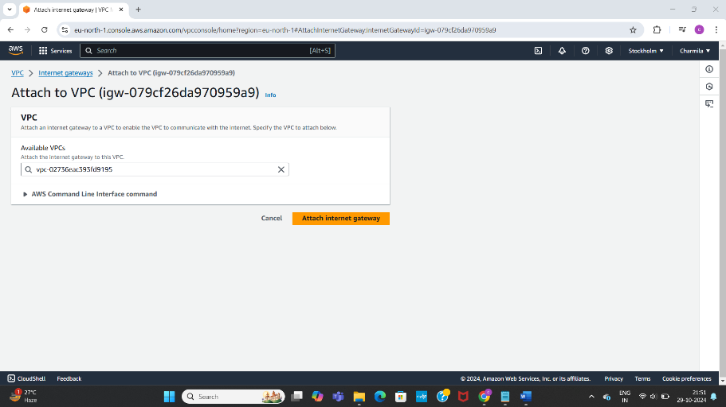

Created two subnets-public and private subnets

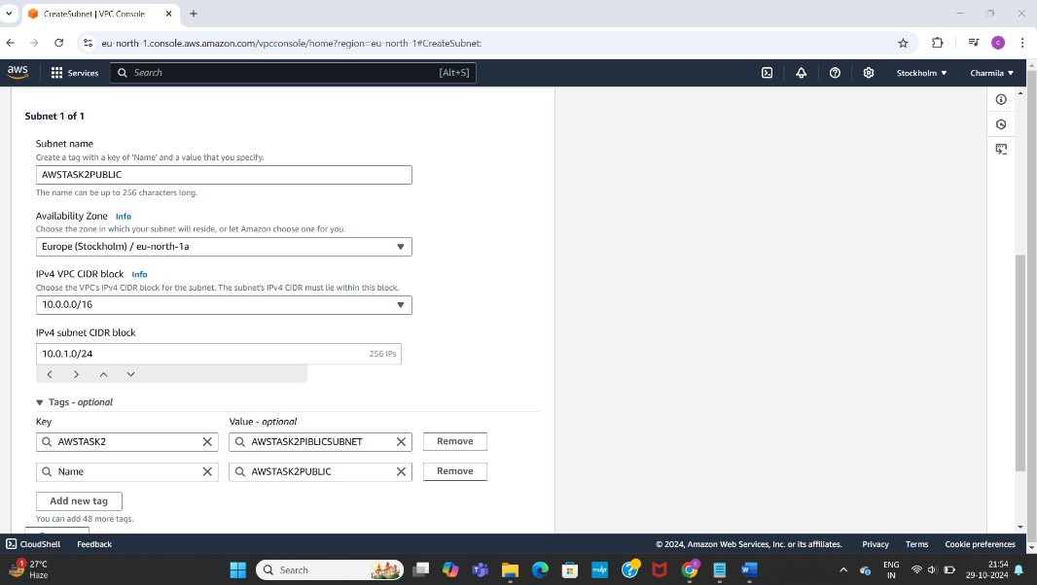

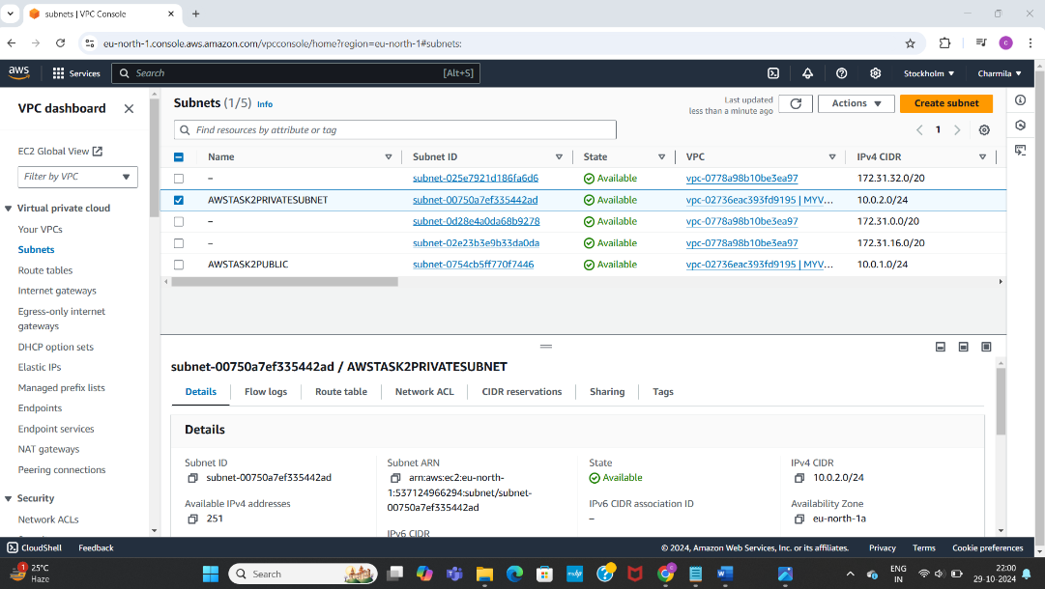

Created a route table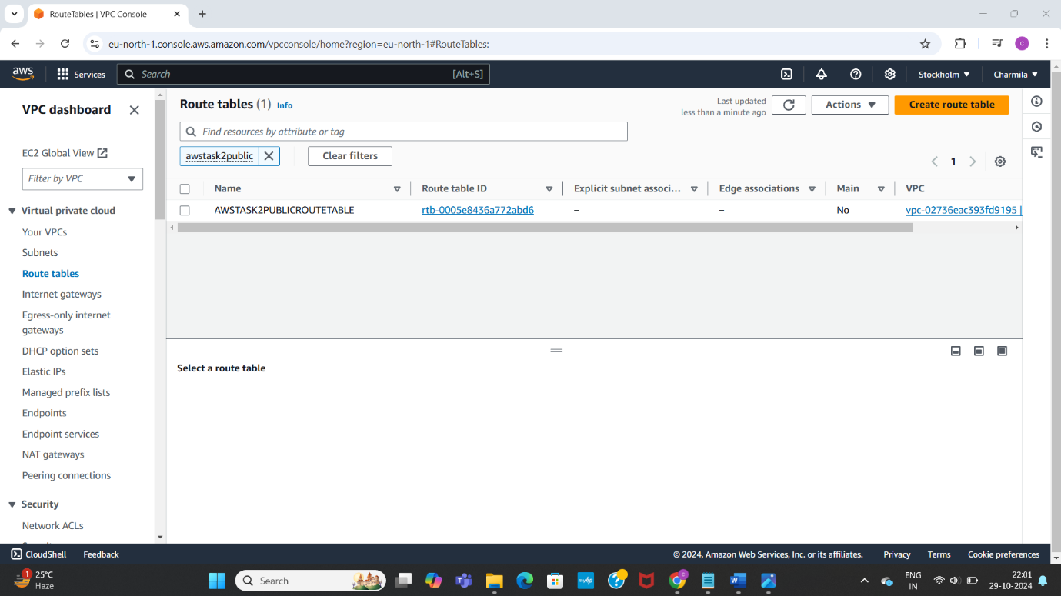

Added a route newly

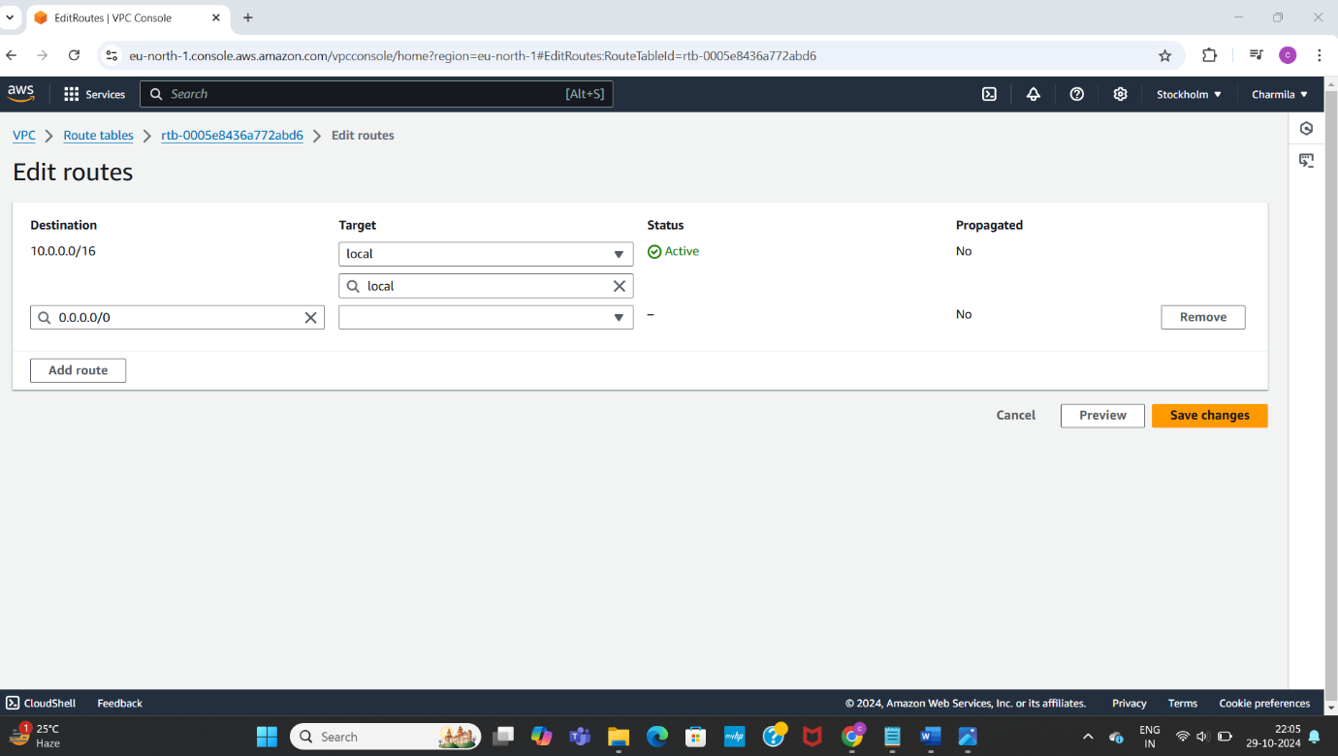

Selected route table>>subnet associations, edit subnet associations

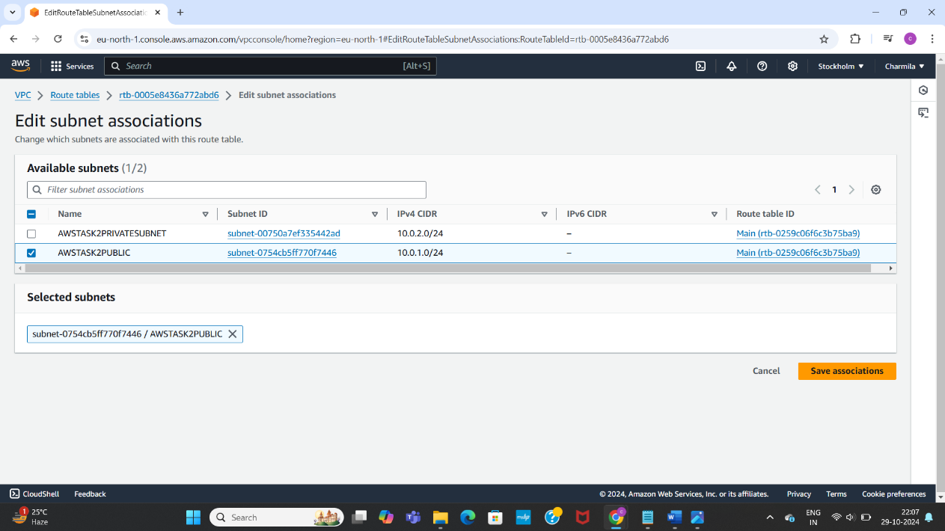

Launched a AWS instance on EC2 dashboard

Auto enabled public IP in network settings

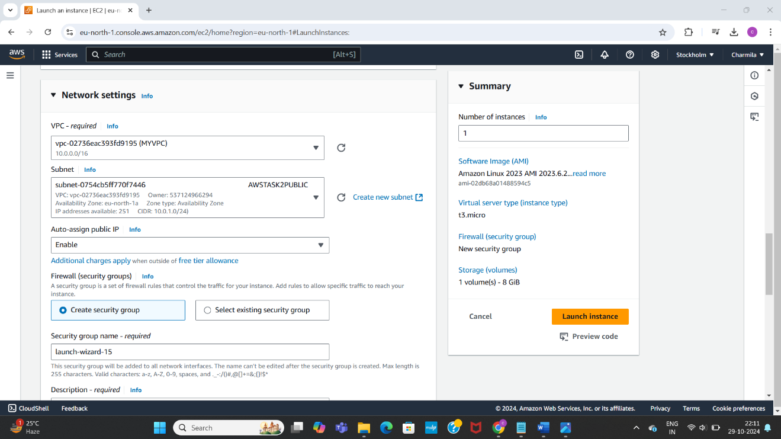

Verified subnets, route table, VPC, EC2 instance if set up is correct

Checked in local terminal

