AWSTASK-4:

Q: Launch an EC2 instance (Linux and Windows) along with a web server. Then, create an EBS volume of 5 GB, attach it to an EC2 machine (Linux and Windows), and take a snapshot. Finally, create an EBS volume using the taken snapshot.

OUTPUTS:

Initially launched two instances one with Amazon linux and one with Windows

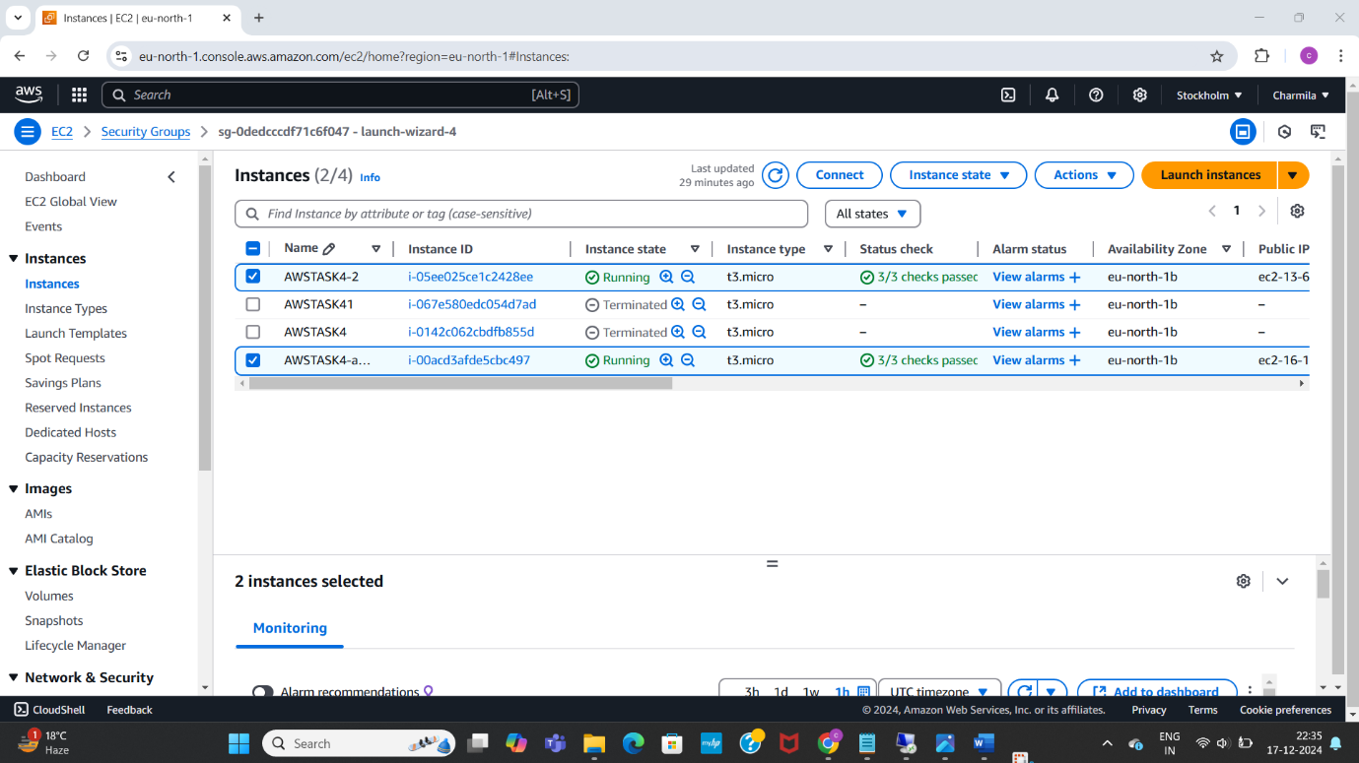

Installed Apache for Linux and tested the web server using public IP addres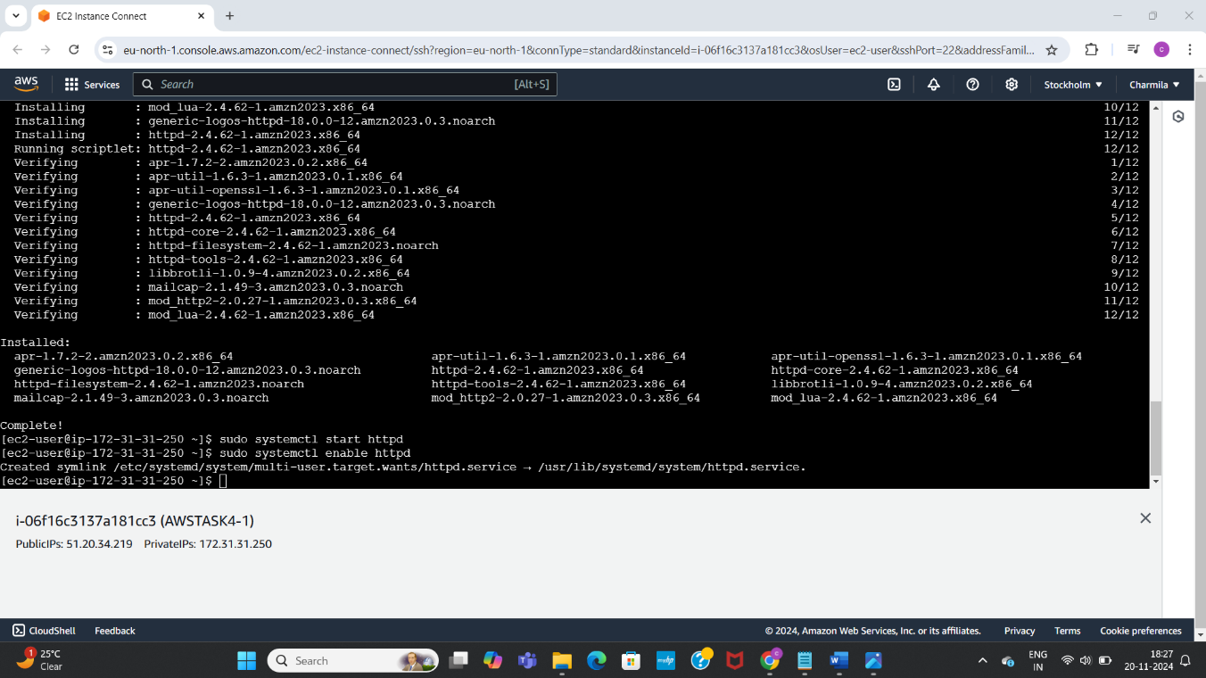

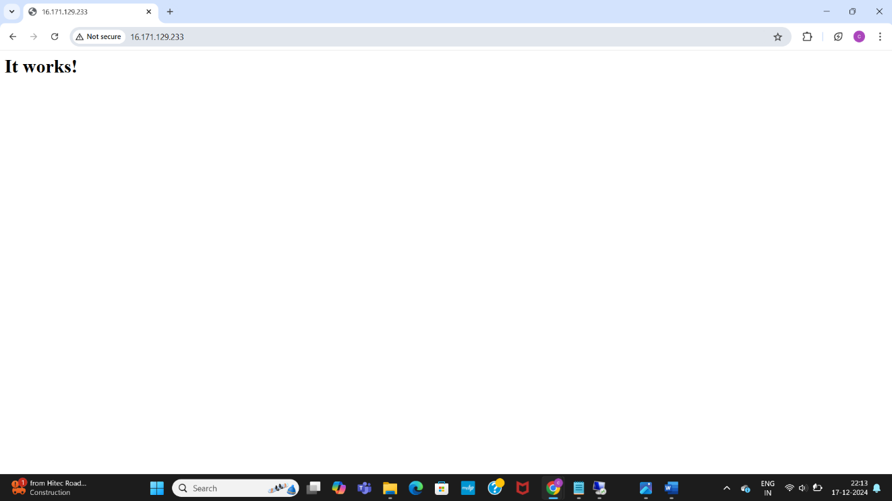

RDP into the windows

Tested web server

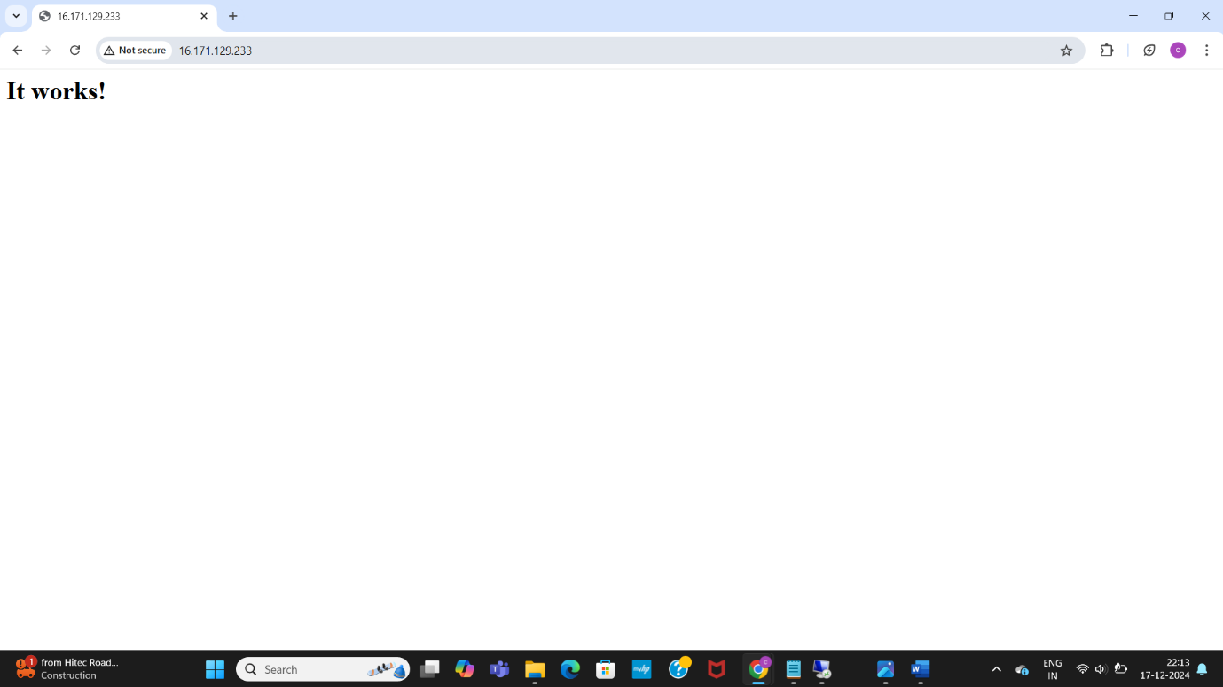

Created volumes

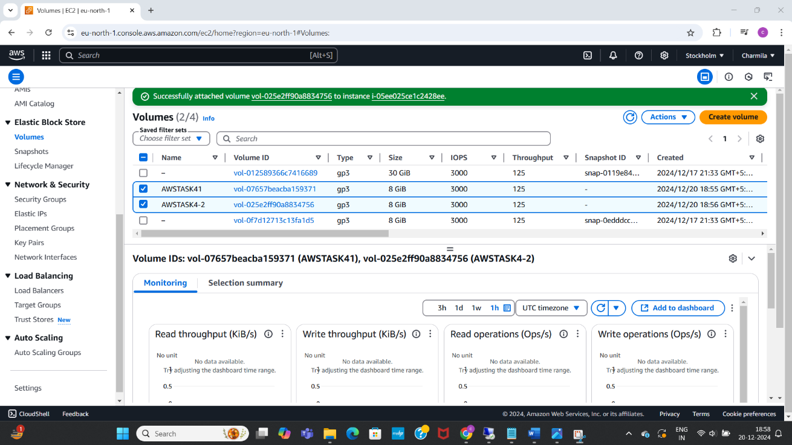

Attached volumes to instances

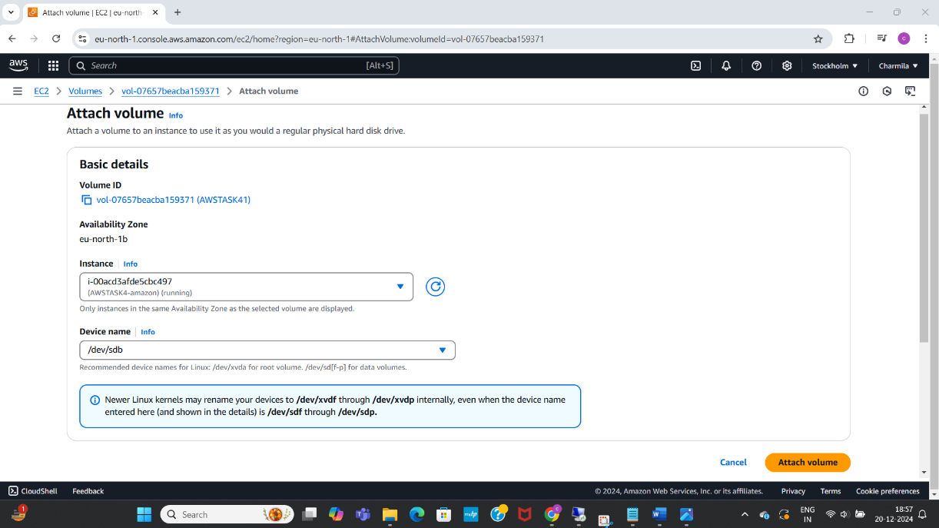

Formatted and mounted the volume, checked block devices,

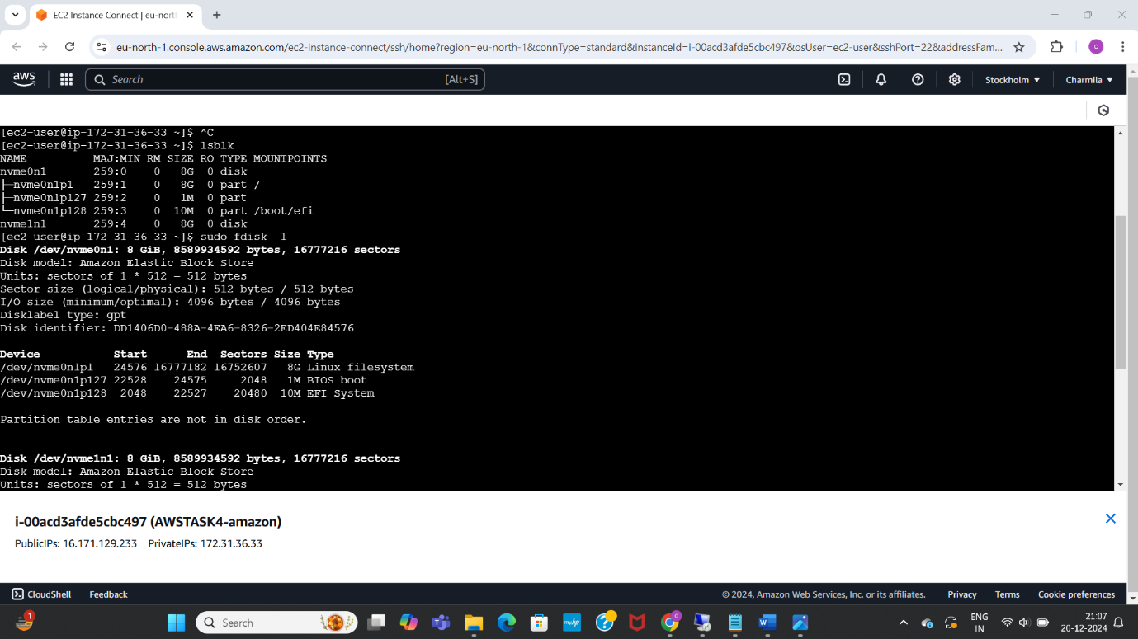

Rdp into windows instance, checked storage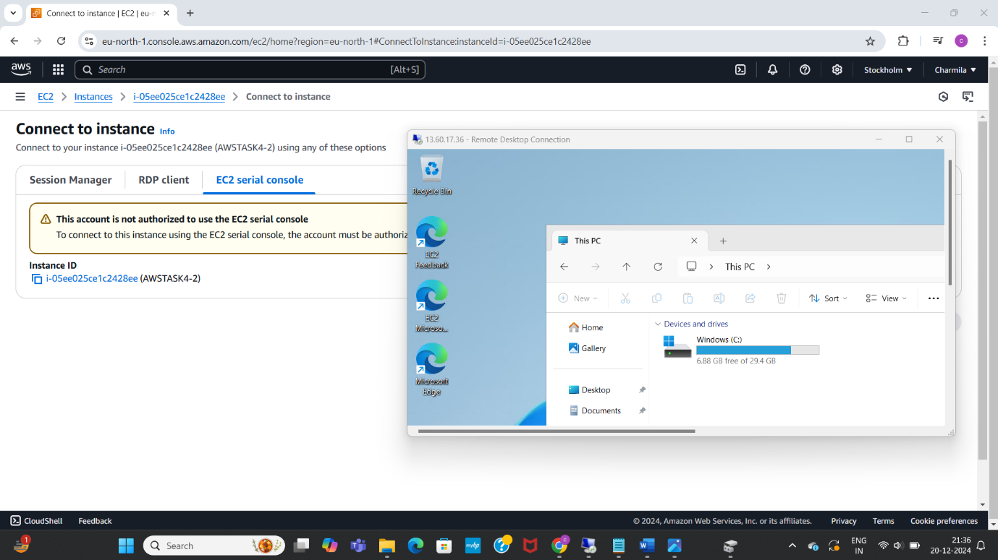

Created snapshots

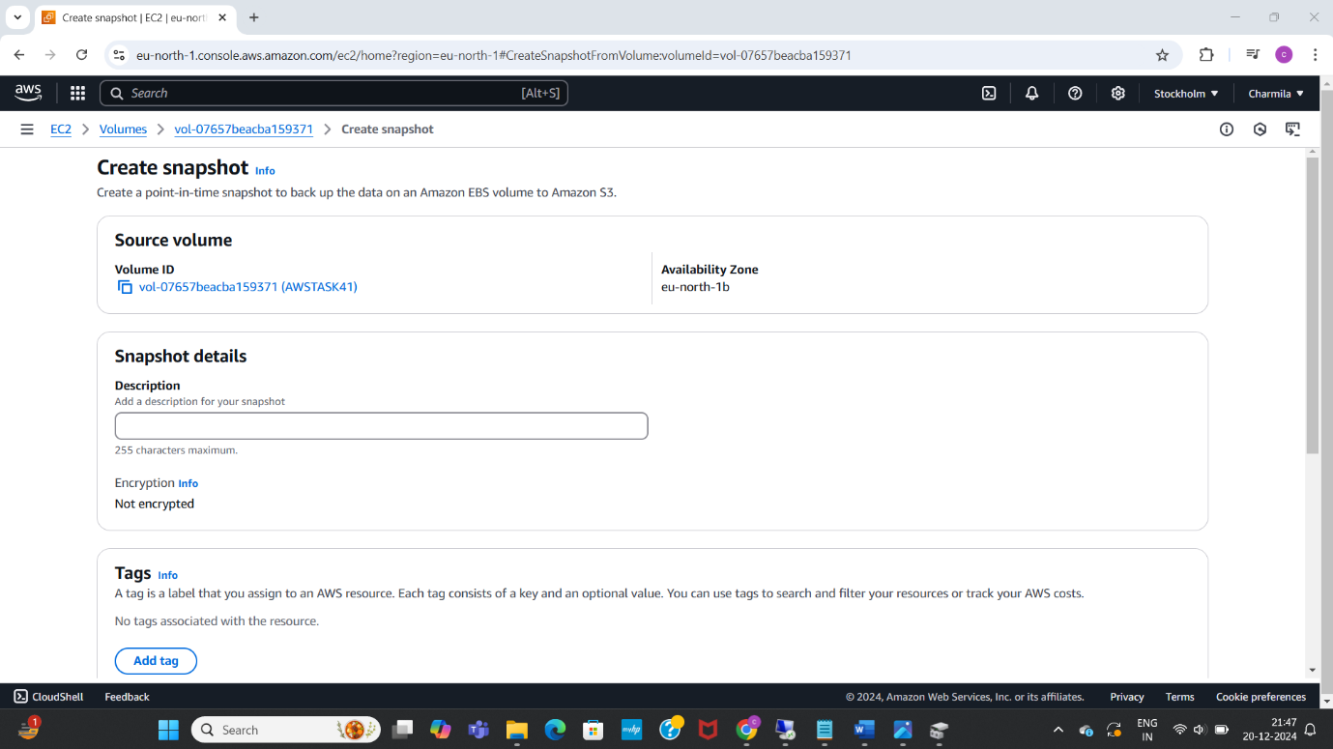

Using the created snapshots created new volumes using 5GB

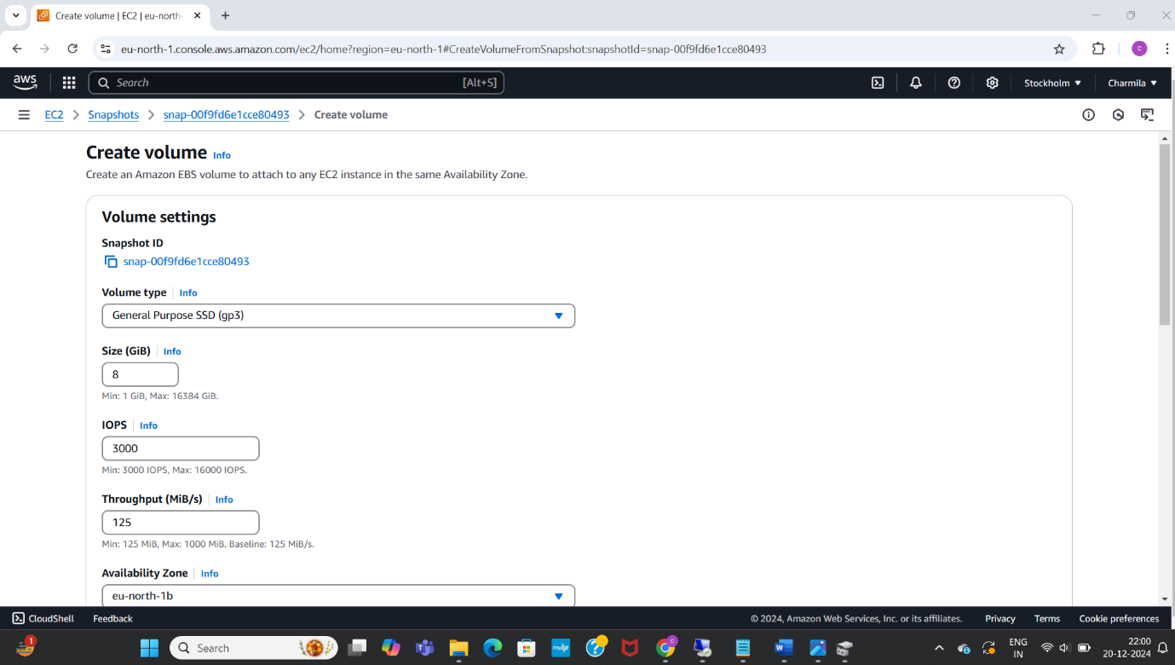

Attached the created volume to both linux instance and windows instance

