DOCKER-TASK3

Q: Create a custom docker image for nginx and deploy it using docker compose, where the volume bind mount should be at /var/opt/nginx location. Push the created custom docker image to your docker-hub.

OUTPUTS:

Launched an AWS EC2 instance

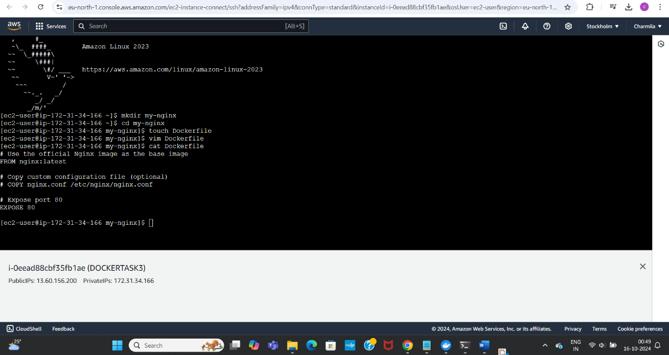

Installed docker, checked status of it and started docker

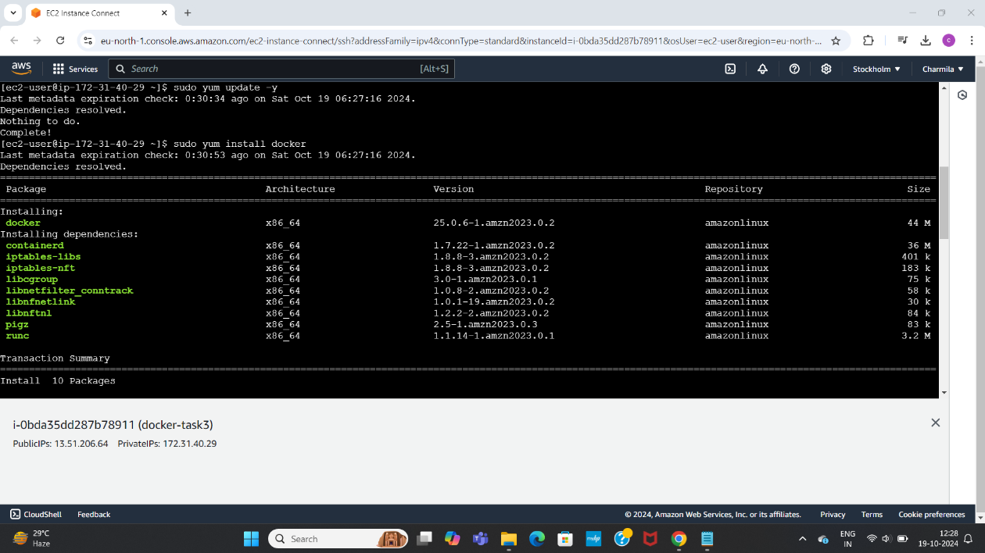

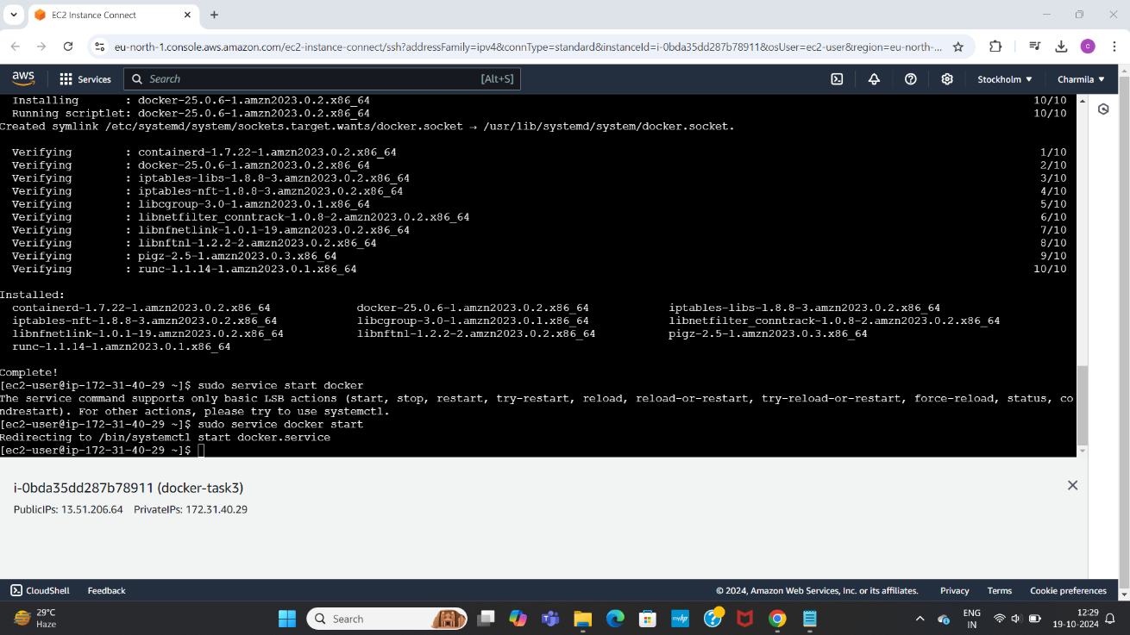

Installed docker compose

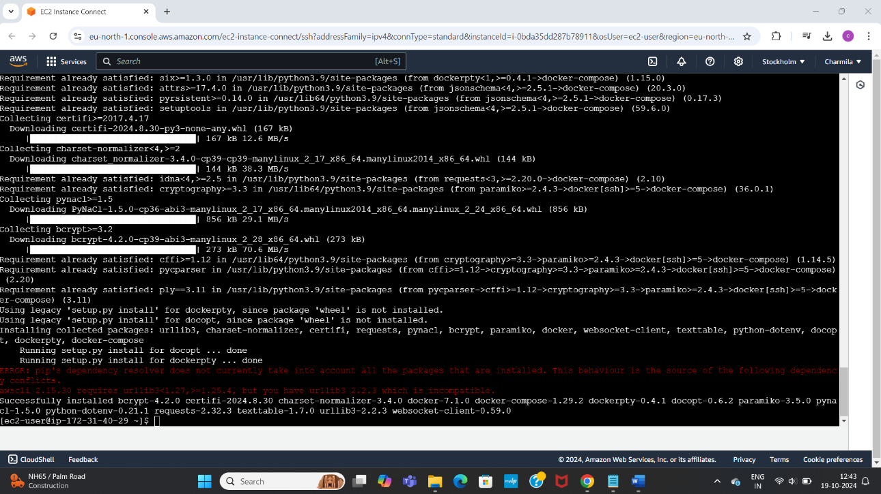

Created a custom docker image by creating a directory, dockerfile, inserted data into file using vim editor and displayed it using cat command

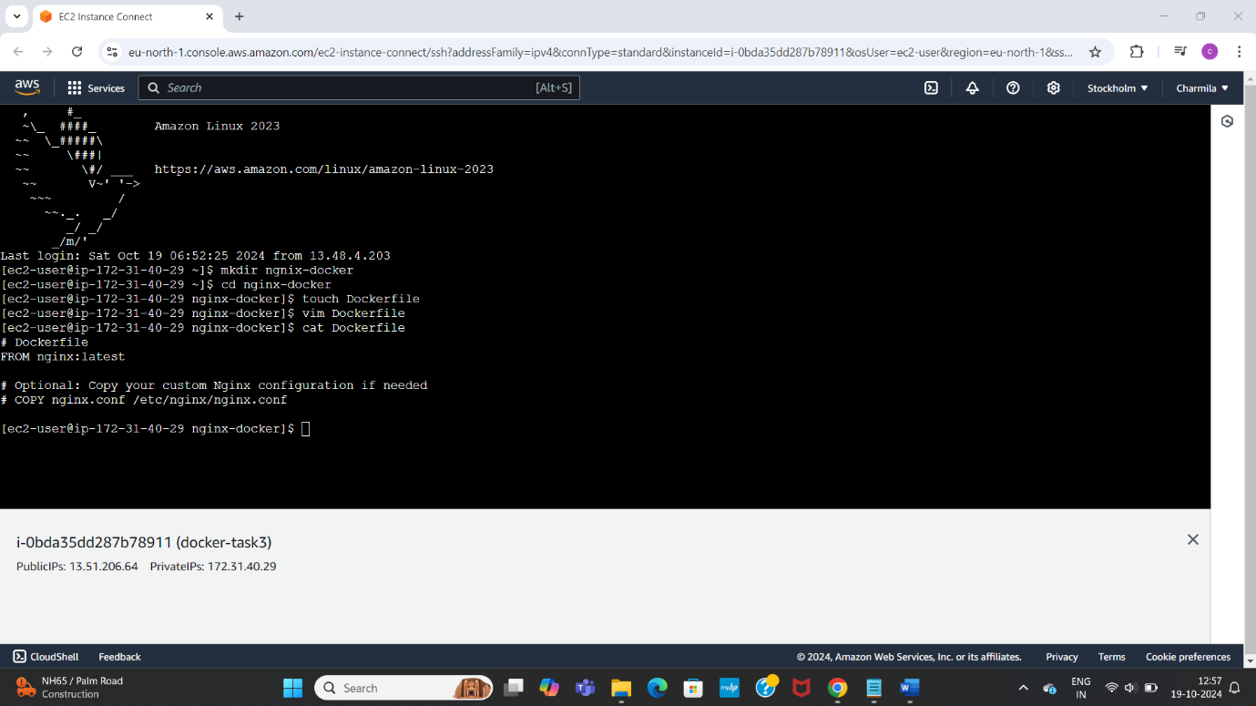

Created docker compose file, inserted data into it and ran it using command

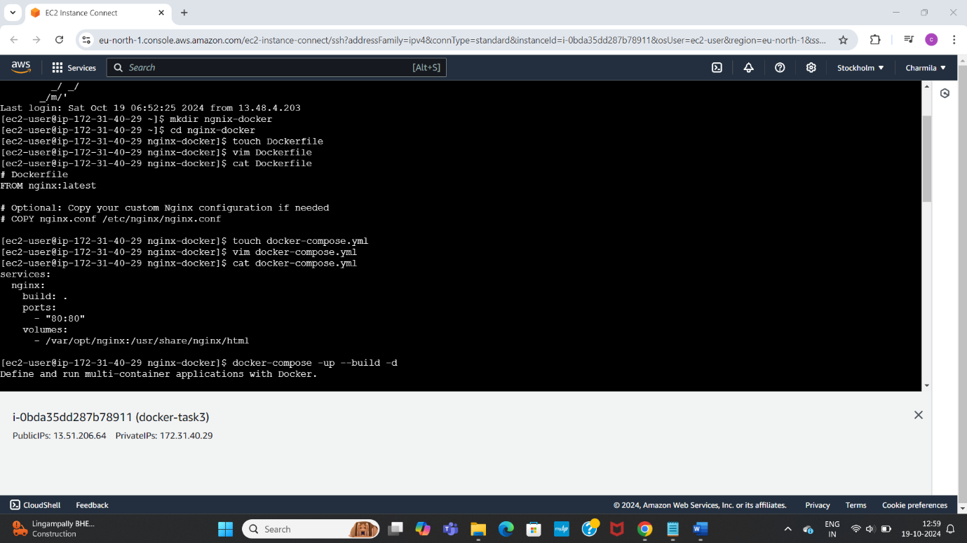

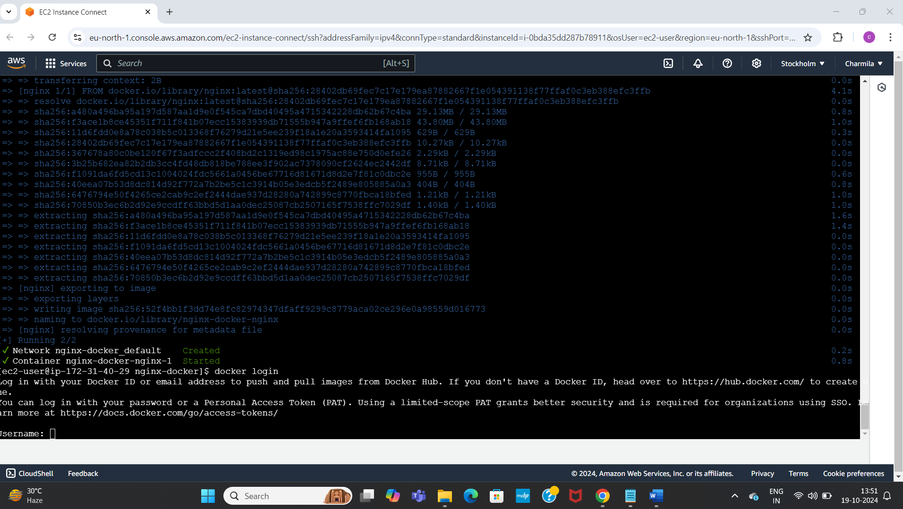

Logged into docker

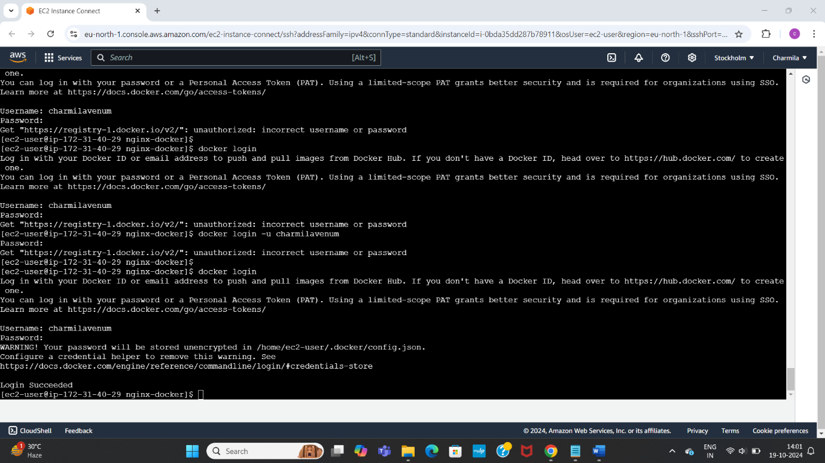

Pushed the image created to docker hub

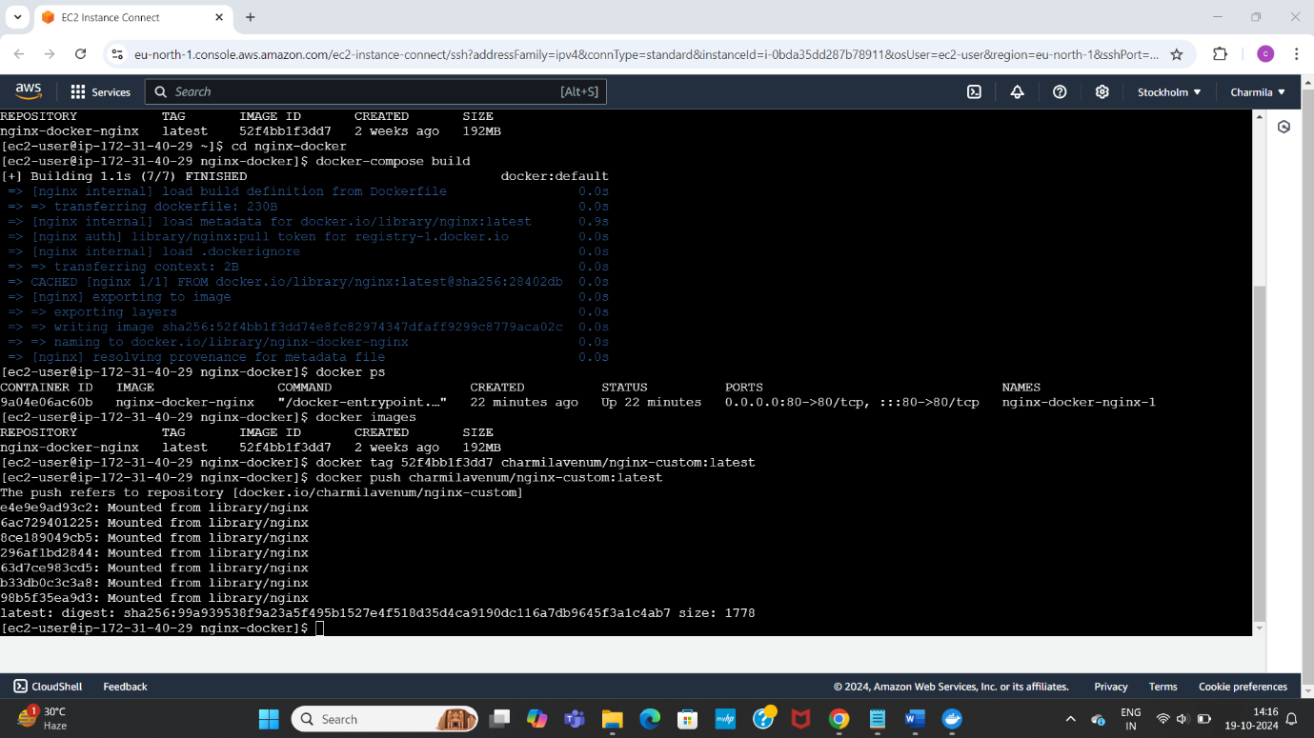

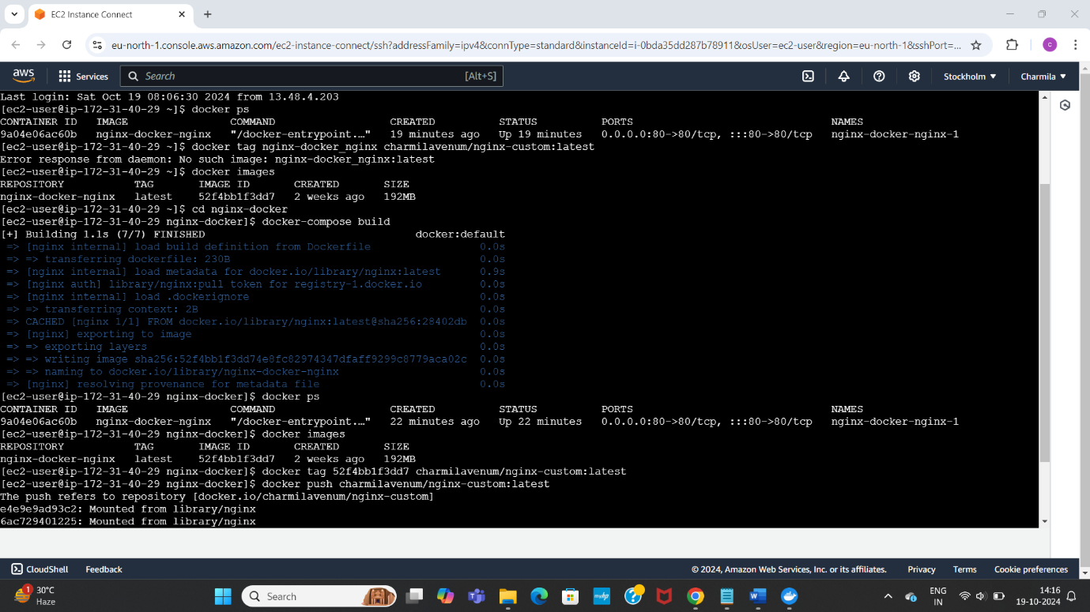

Finally verified it in the docker hub in the repository section