JENKINS-TASK-2

Q: Create a simple script file and push it to repo. Create a project in Jenkins connected to your GitHub repository. When a commit is made to your repo, automatically build must get triggered from Jenkins and the output must be shared to me via email.

OUTPUTS:

Launched an instance

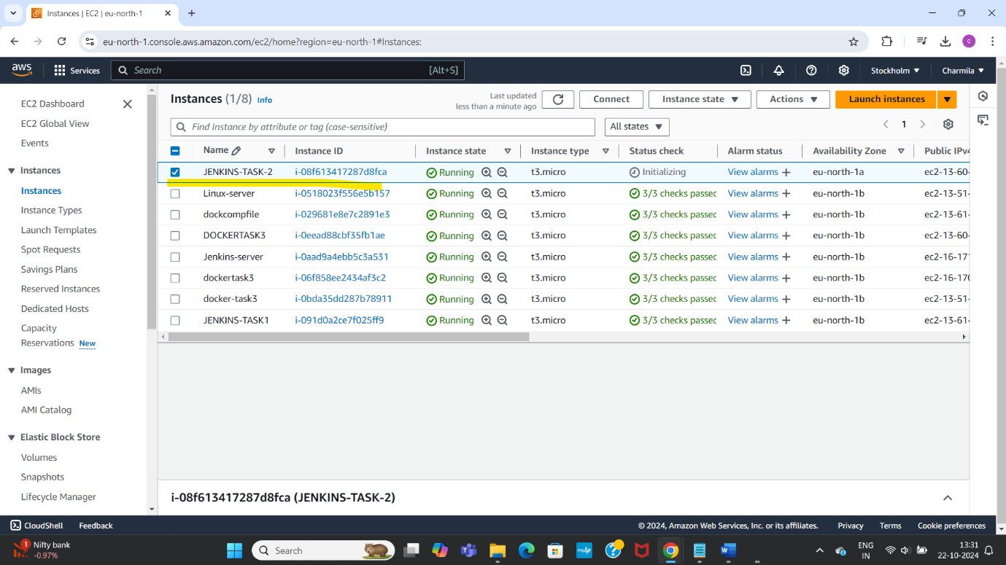

Installed java

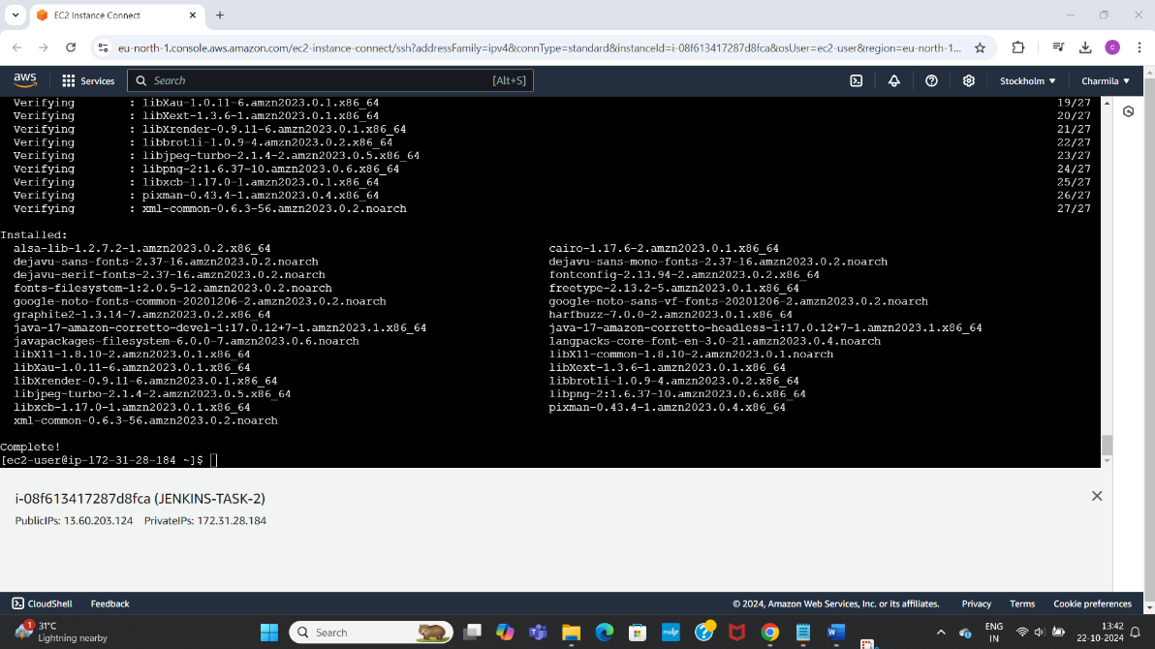

Installed Jenkins

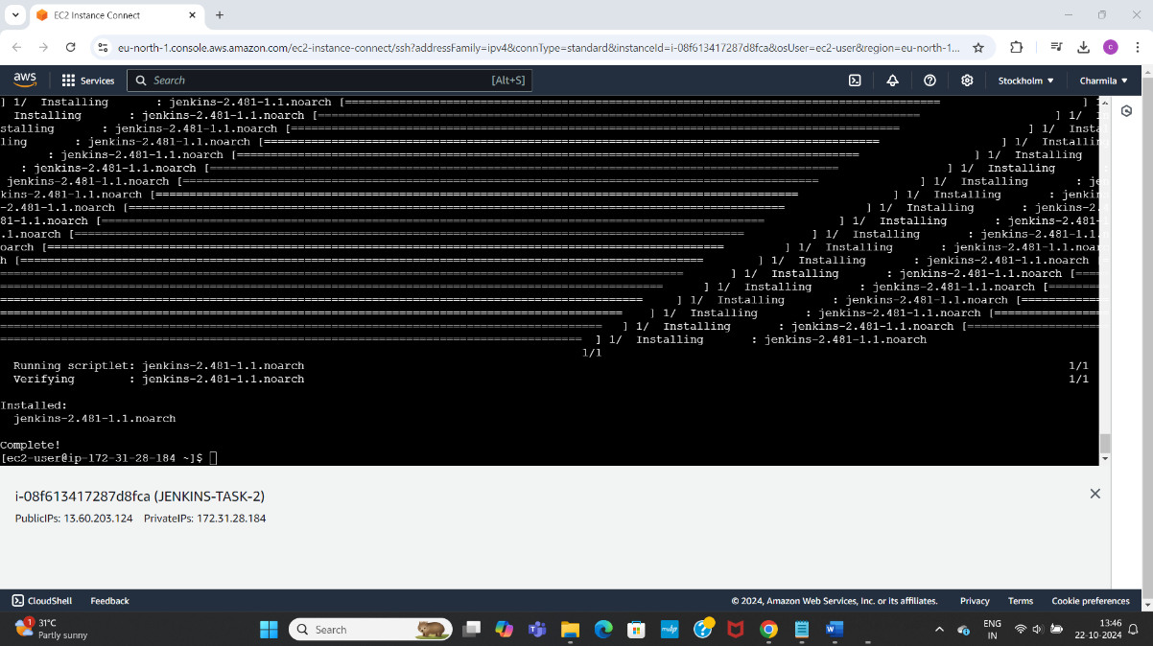

Checked status of Jenkins, started it, checked if running active

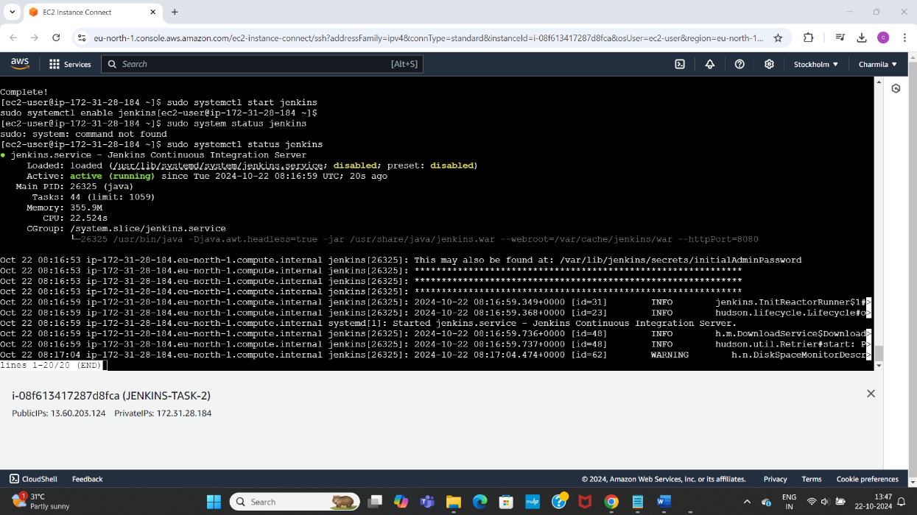

Navigated to URL to open the Jenkins web page

<http://13.60.203.124:8080>

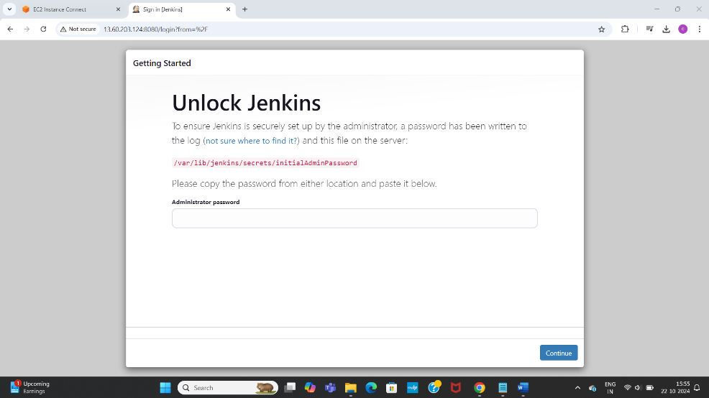

Unlock Jenkins using the initial admin password found at sudo cat /var/lib/jenkins/secrets/initialAdminPassword

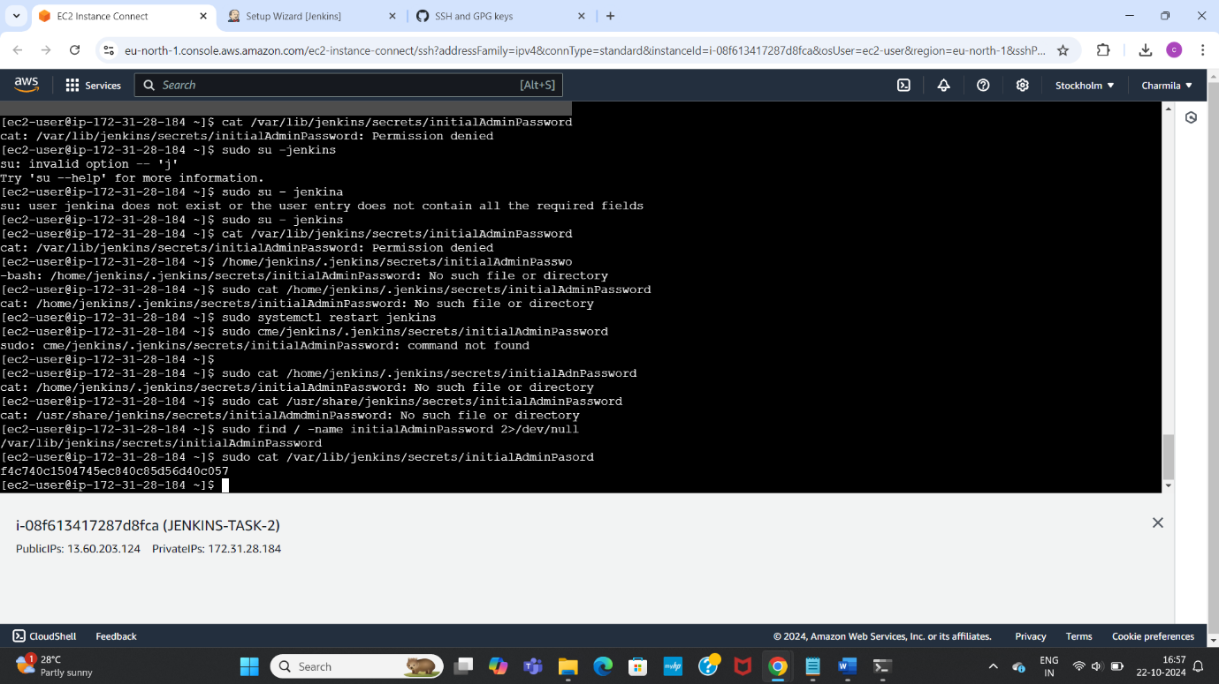

Configured Jenkins, created Jenkins project, created user

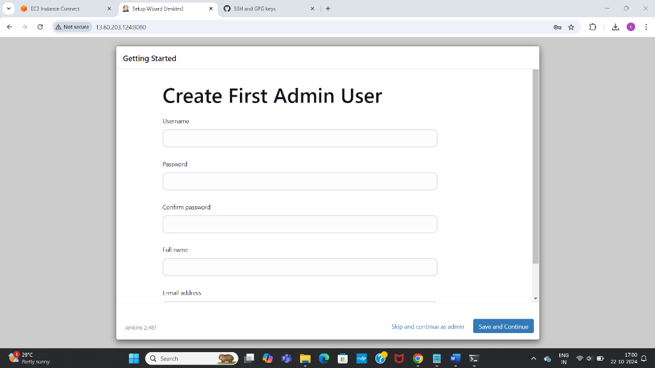

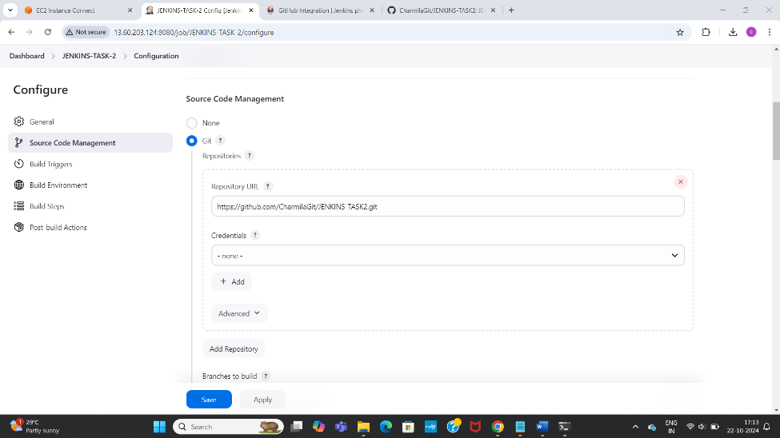

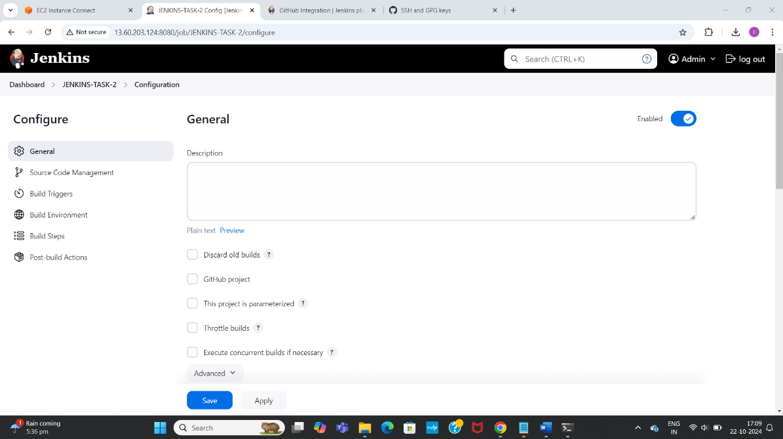

Installed required email plugins,

Set up and configured webhook

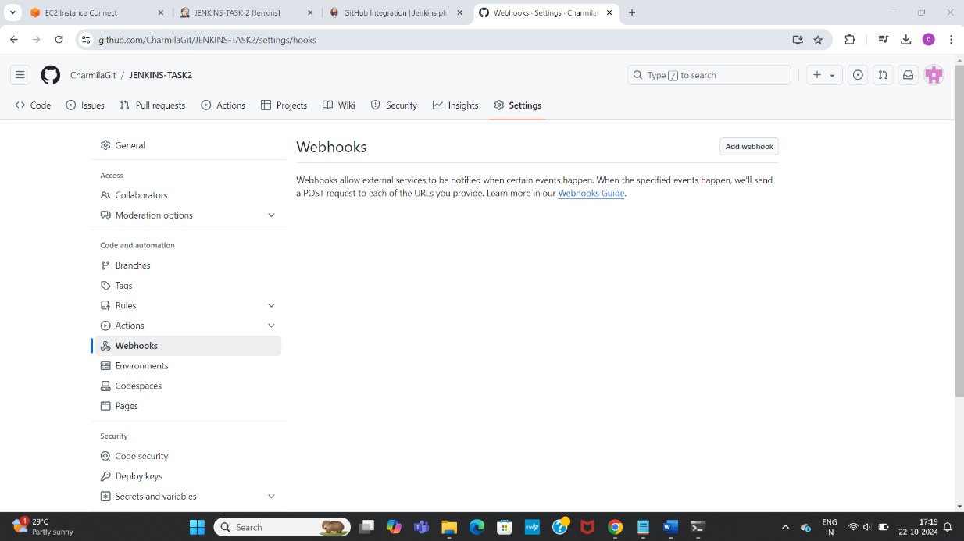

Made commit to repo

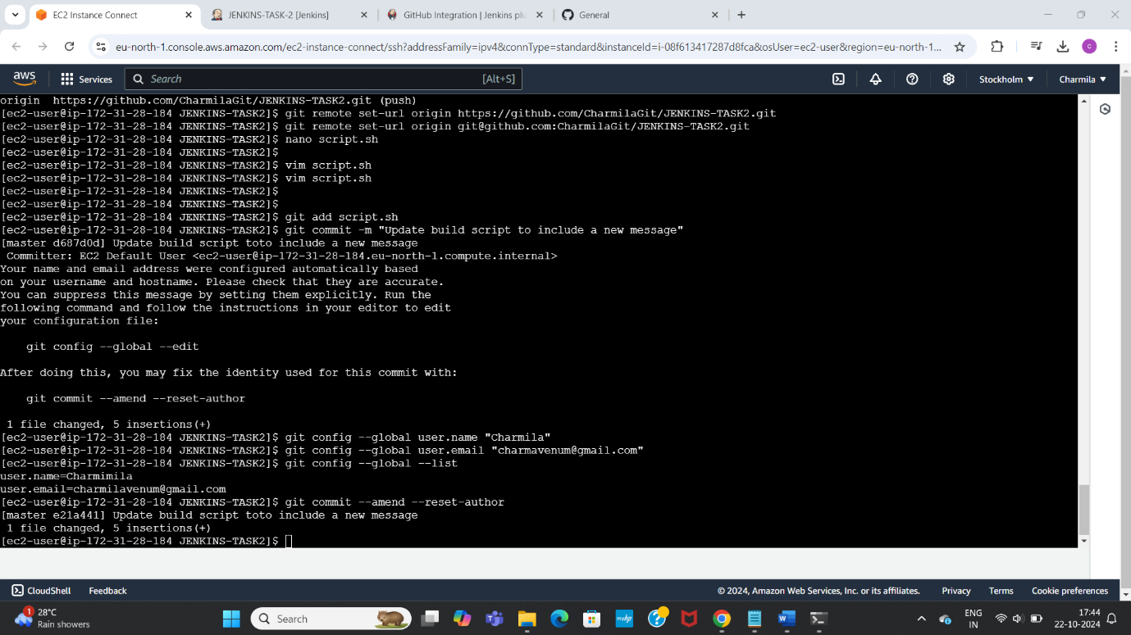

Checked and set up the SMTP settings, tried sending test email notification-sent successfully

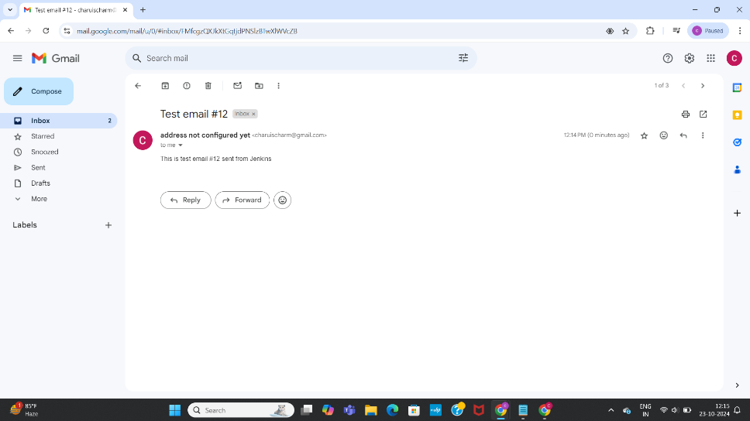

After making commit, tried checking if build automatically triggered but not

Also in post build on—below are grayed out



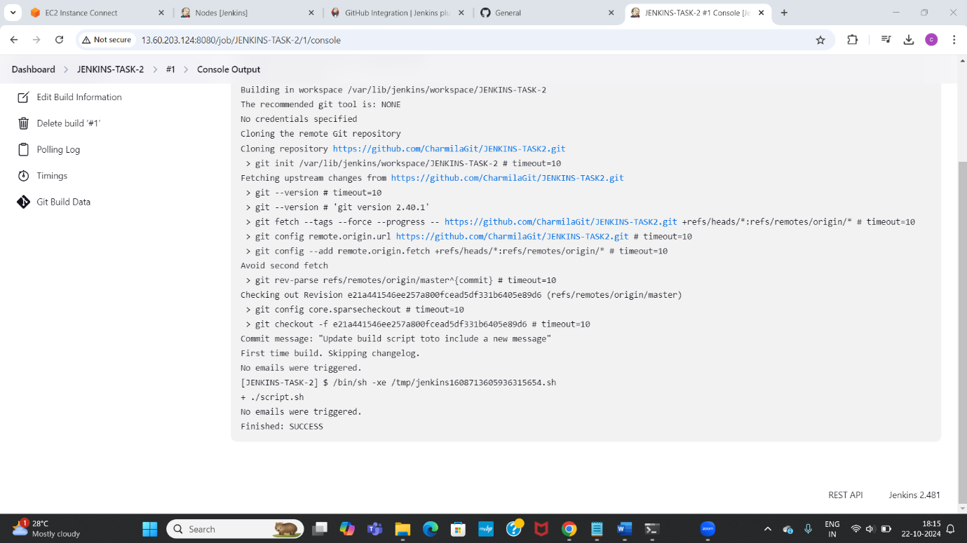need to check this last step and execute again