KUBERNETES-TASK-1

Q: Setup minikube at your local and explore creating namespaces (Go through official documentation).

OUTPUT: tried doing the task locally but machine is not supporting, hence used AWS

Initially launched an EC2 instance

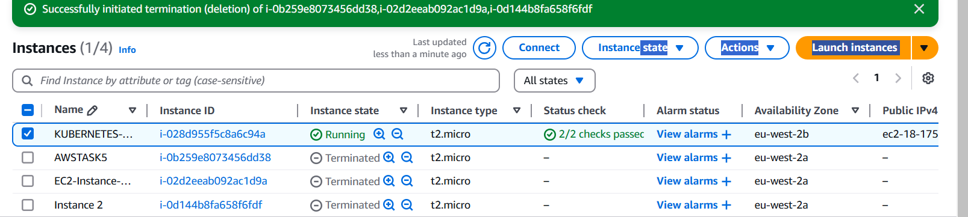

Connected via SSH

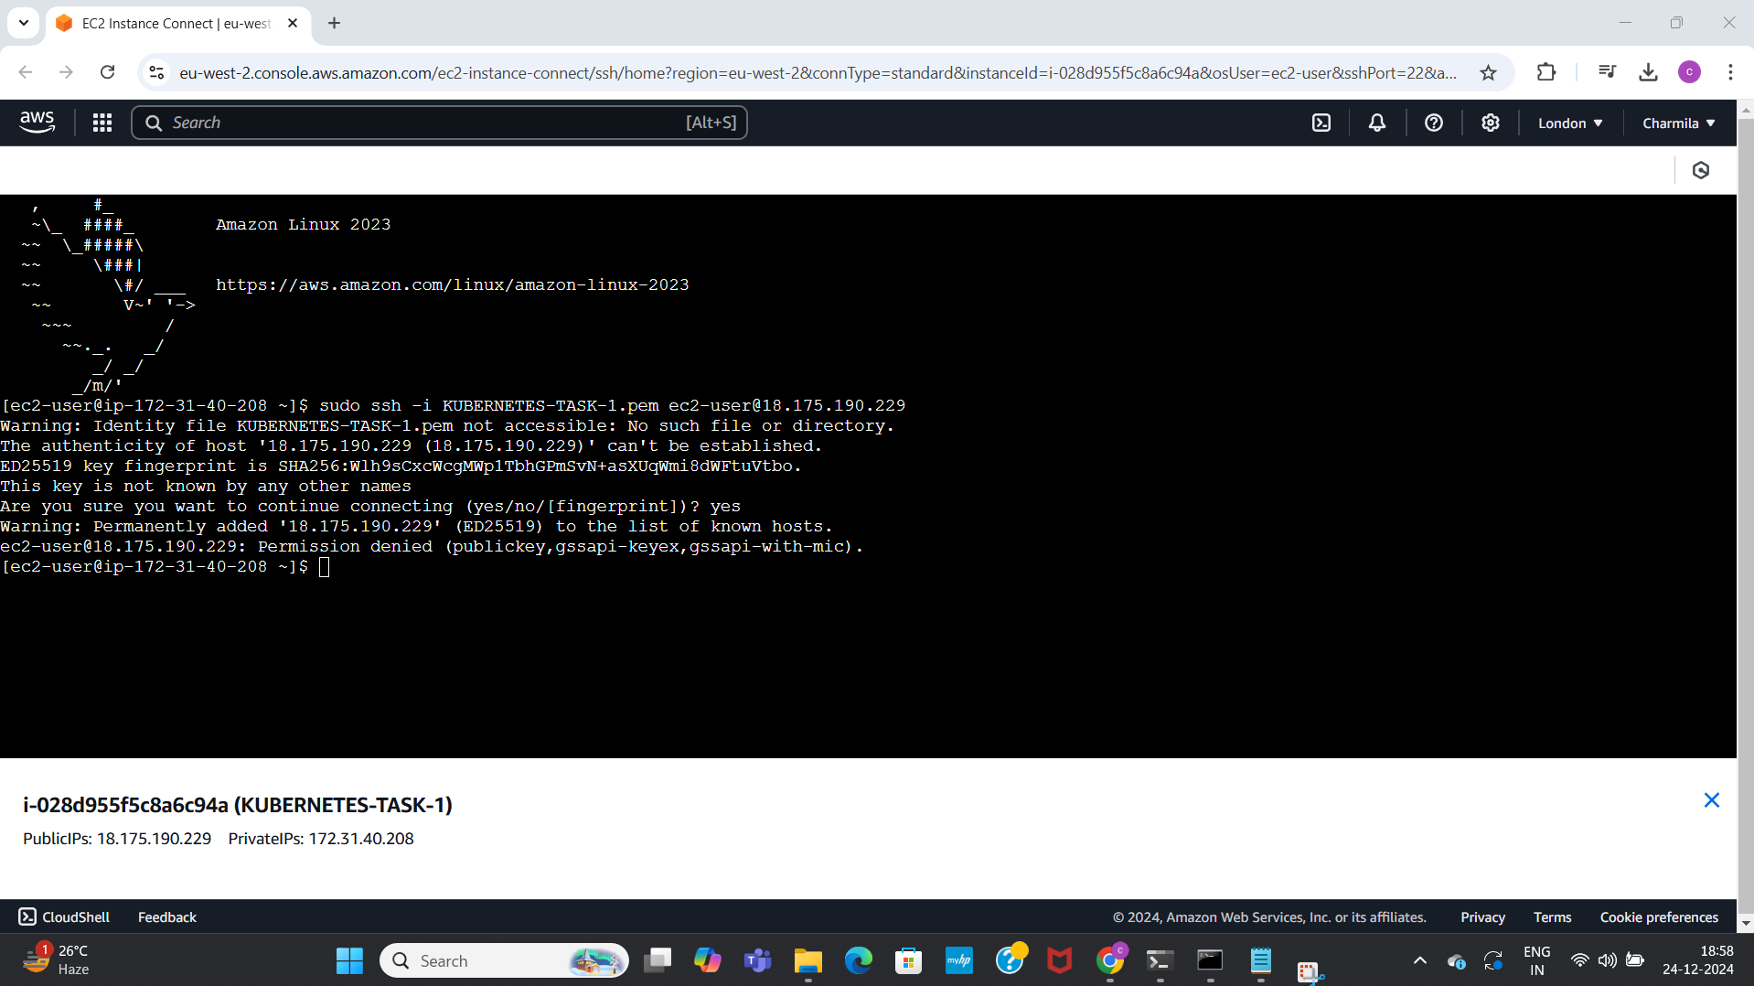

Installed docker, checked status, started docker, its active running, verified version

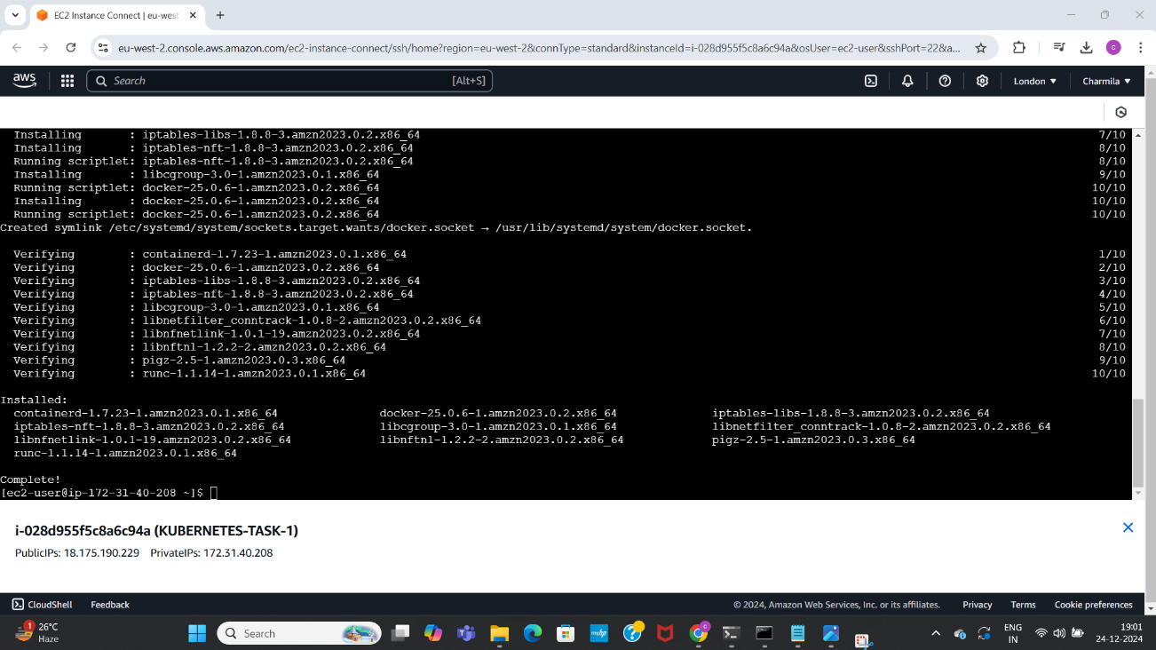

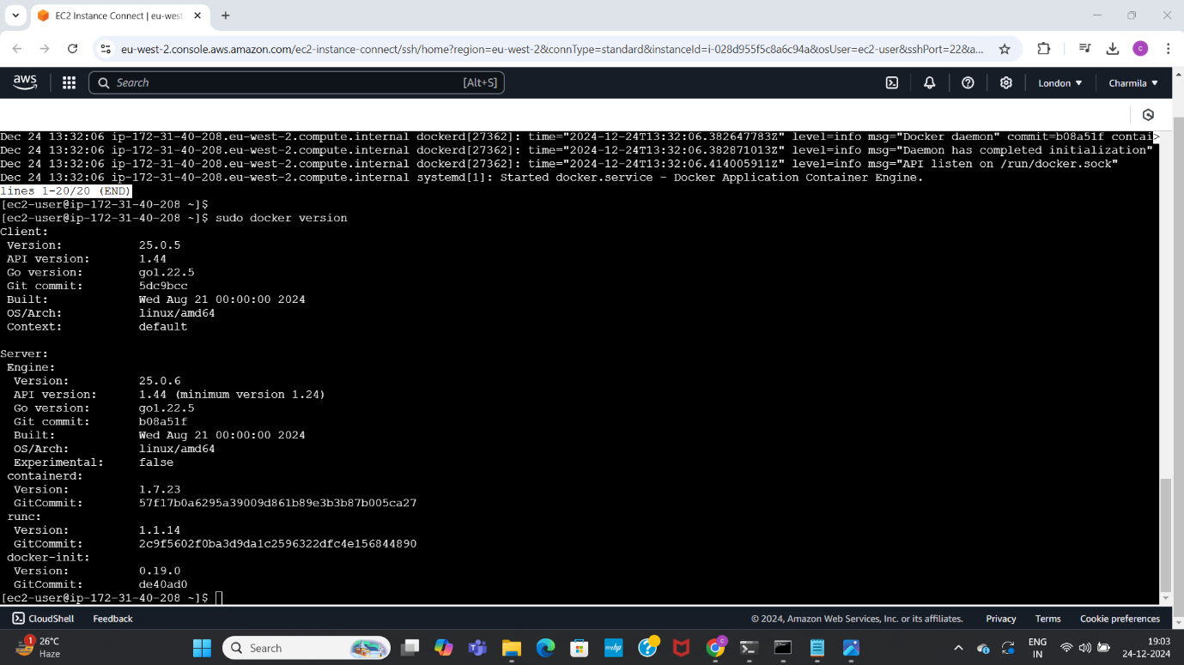

installed kubectl, verified version

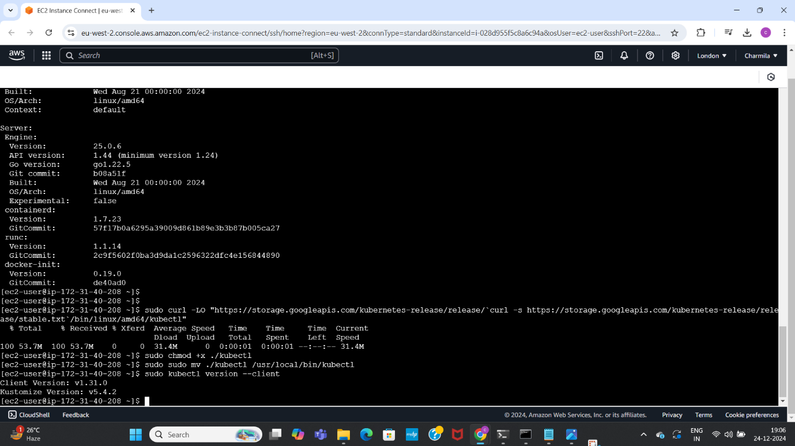

Installed minikube, checked version

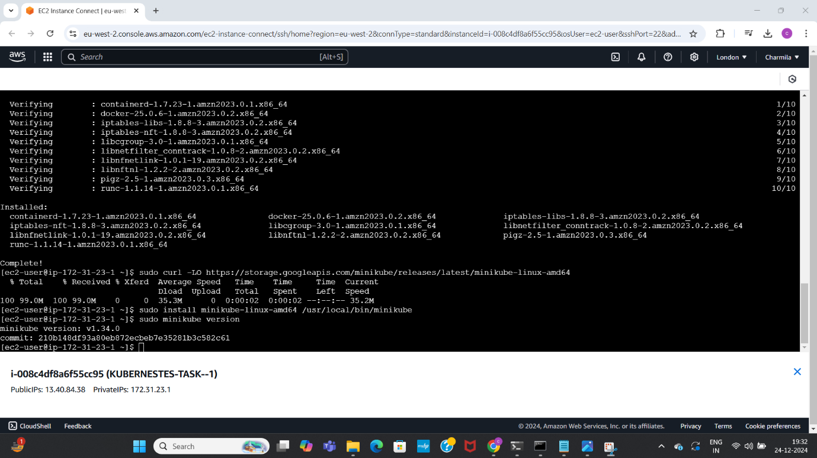

As getting errors, used force command to act as root user

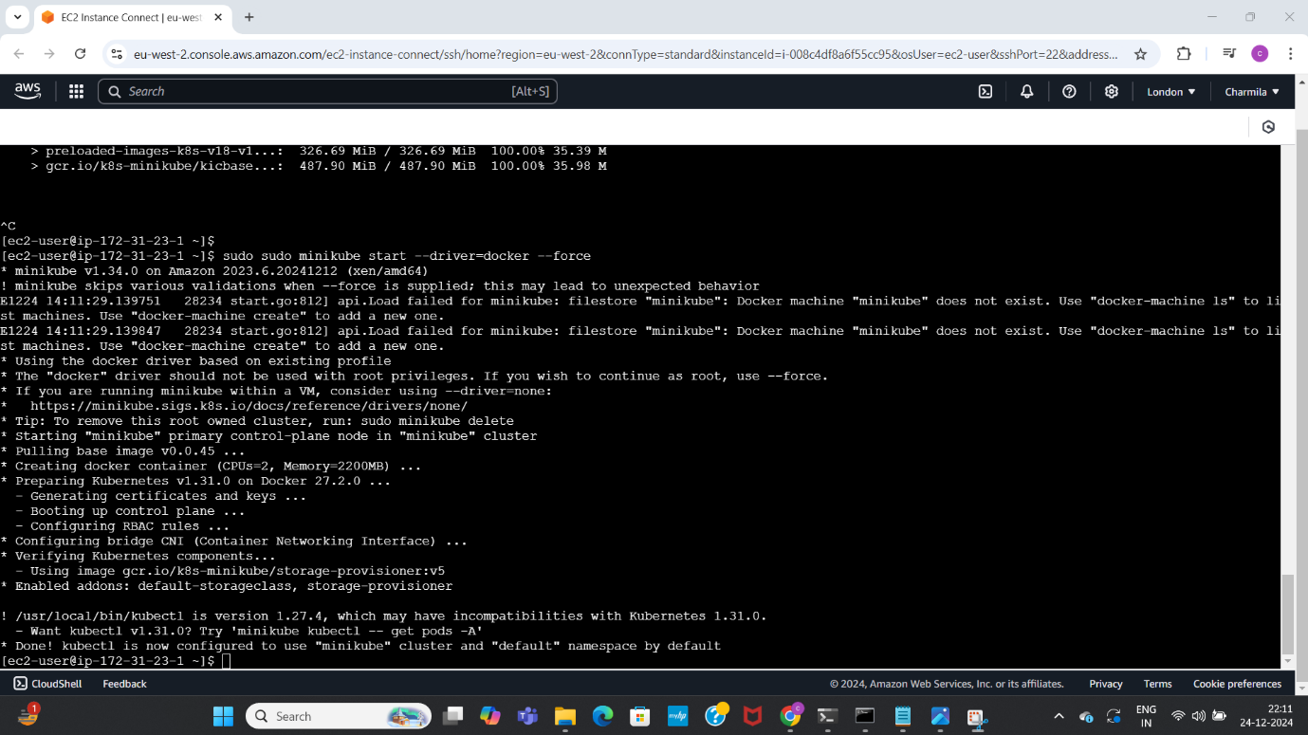

Explored creating namespaces

