TERRAFORM-TASK-2

Q: Create 2 EC2 instances on 2 different regions and install nginx using terraform script.

OUTPUT: Initially checked terraform version, aws version, aws configuration, created a directory terraformtask2, created terraform config file main2.tf

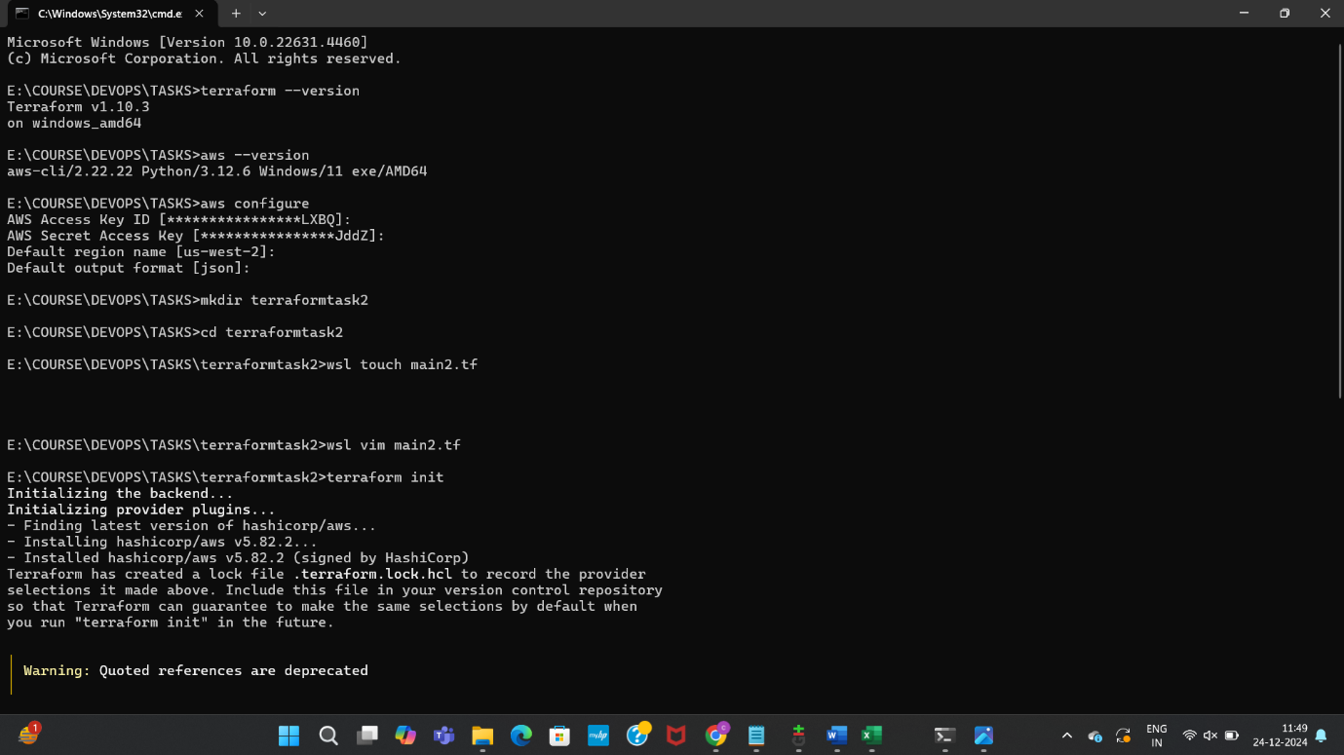

Terraform config file

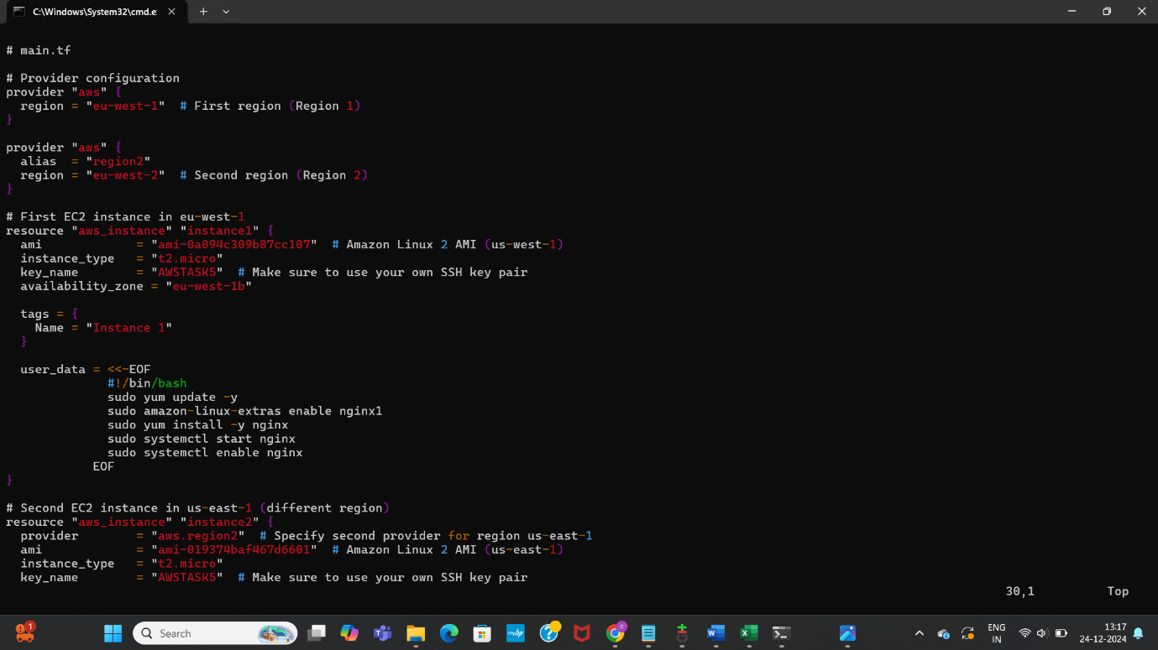

Initiated terraform

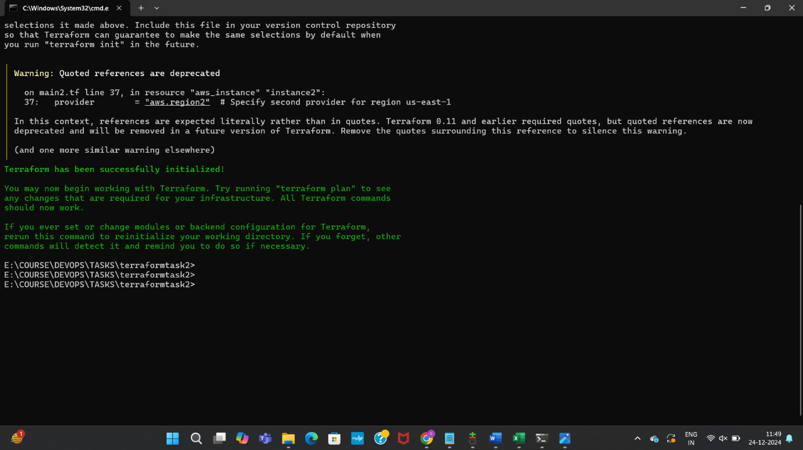

Got error when launching instances, regarding key pairs, AMI ID, rectified the same

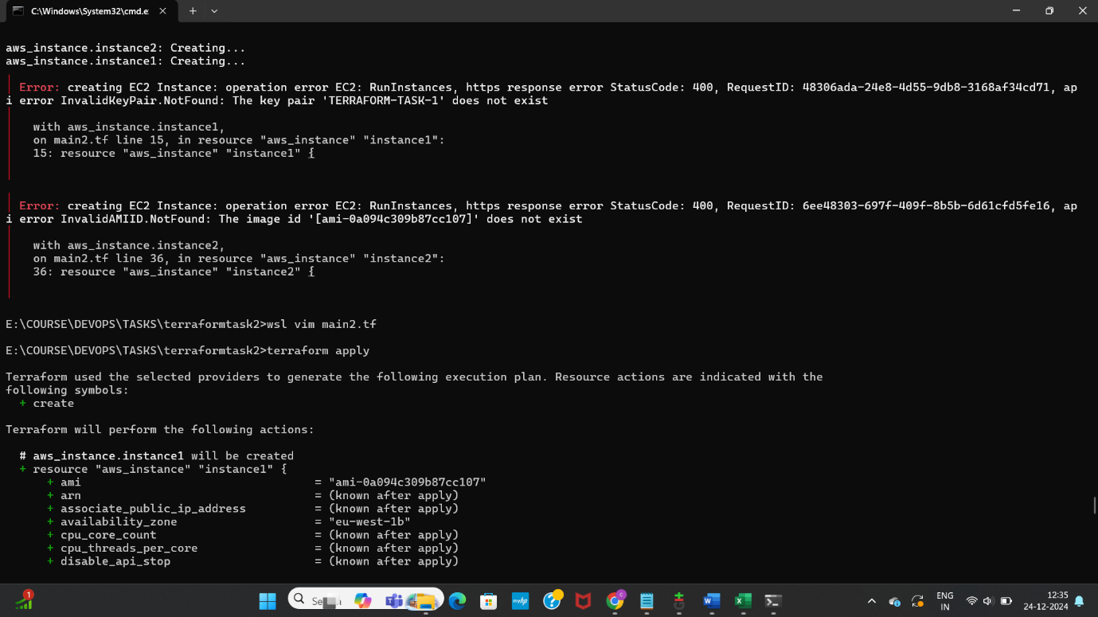

Launched the EC2 instances

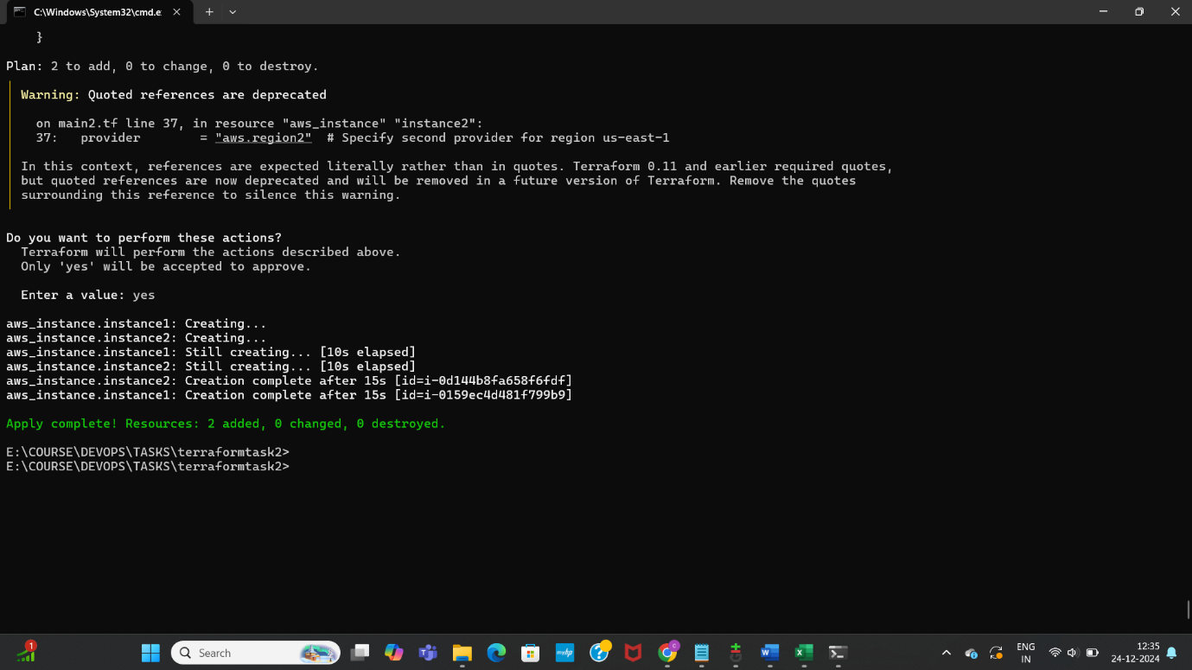

SSH into each EC2 instance in different region, installed nignx, checked status of it

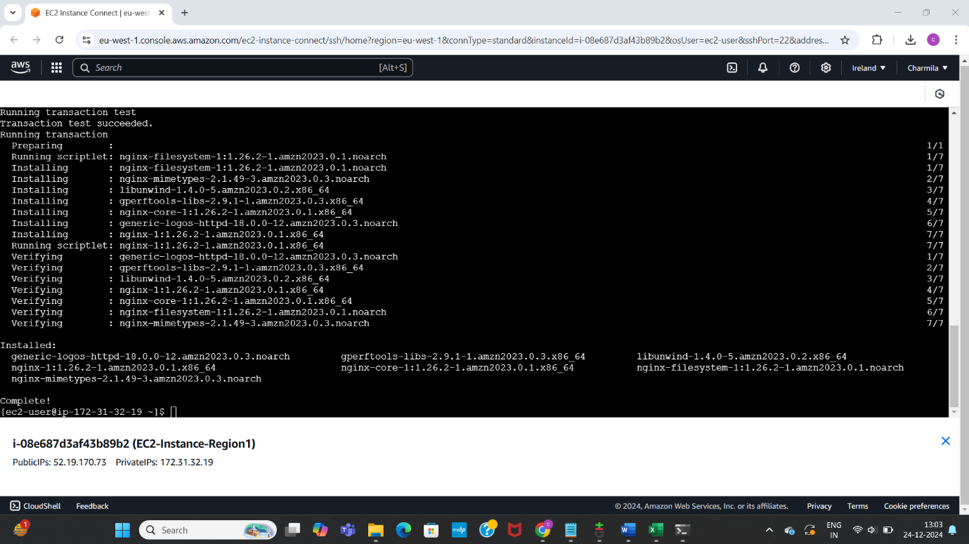

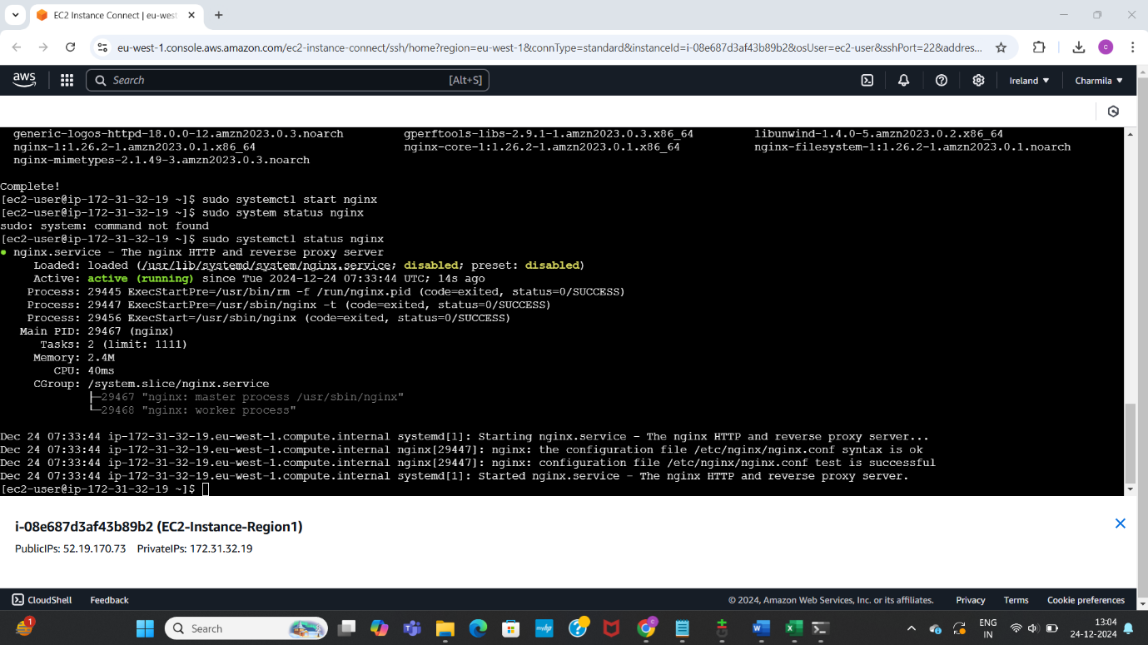

Checked nginx page using public IP of first instance

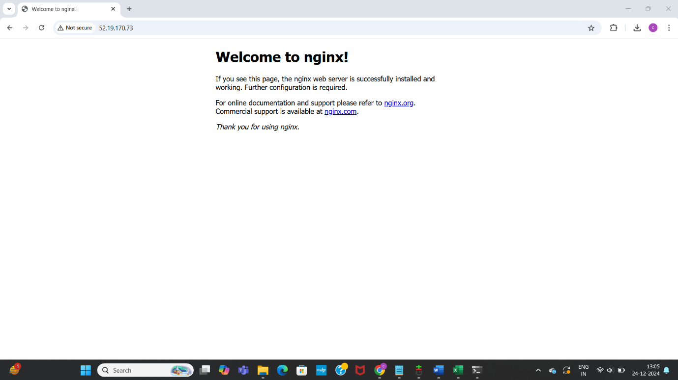

Repeated same process and checked nignx page for second instance too as below with public IP, made changes and edited inbound rules using SSH port 22

